6-K 1 ef20084802_6k.htm 6-K

UNITED STATES
SECURITIES AND EXCHANGE COMMISSION
WASHINGTON, D.C. 20549

FORM 6-K

Report of Foreign Private
Issuer Pursuant to Rule
13a-16 or 15d-16 of the
Securities Exchange Act
of 1934
For the month of November 2026
Commission File
Number: 001-38283

InflaRx N.V.
(Exact name of Registrant as Specified in Its Charter)

Winzerlaer Str. 2
07745 Jena,
Germany
(+49) 3641508180

(Address of principal executive offices)

Indicate by check mark whether the registrant files or will file annual reports under cover of Form 20-F or Form 40-F.

Form 20-F ☒ Form 40-F ☐

EXPLANATORY NOTE

On November 3, 2026, InflaRx N.V. (the “Company”) issued a press release titled “InflaRx Highlights Izicopan Development Path and Commercial Opportunity in ANCA-Associated Vasculitis at Capital Markets Day.”

The Company today announced that, with a goal of providing multiple datasets demonstrating differentiated efficacy and safety in multiple ANCA-associated vasculitis (“AAV”) settings, it intends to begin two Phase 2 trials of izicopan, its oral C5a receptor (C5aR) inhibitor, in 2027, with first data readout anticipated in 2028. The Company is executing an AAV program which includes a randomized, placebo-controlled Phase 2 study in patients with AAV with renal involvement (i.e., renal vasculitis), with trial site initiation expected to begin in early 2027, to assess izicopan’s ability to drive meaningful signals of clinical efficacy. The trial design has been optimized to demonstrate potential benefits related to renal function and renal injury recovery when tested in comparison to placebo, both on top of standard of care. Additionally, the Company intends to initiate an open-label Phase 2 trial in 2027 in newly diagnosed or relapsing AAV patients in need of remission induction therapy. The trial will assess the ability of izicopan to replace glucocorticoid (“GC”) treatment during remission induction.

In addition, the Company announced that it has formed an AAV and renal disease Advisory Board, comprised of internationally recognized experts across vasculitis, nephrology, autoimmunity and immune-mediated kidney disease. The Advisory Board is expected to provide independent expert perspectives on disease biology, patient care, clinical development and the evolving treatment landscape. Its input will help inform the Company’s efforts to advance complement-targeted therapeutic candidates for patients with serious inflammatory and renal diseases.

A copy of the press release and a copy of the Company’s presentation are attached as Exhibit 99.1 and Exhibit 99.2, respectively. Both Exhibit 99.1 and 99.2 shall not be deemed “filed” for purposes of Section 18 of the Securities Exchange Act of 1934, as amended (the “Exchange Act”), or otherwise subject to the liabilities of that section, nor shall they be deemed incorporated by reference in any filing under the Securities Act of 1933, as amended, or the Exchange Act.

FORWARD-LOOKING STATEMENTS

This Report contains forward-looking statements. All statements other than statements of historical fact are forward-looking statements, which are often indicated by terms such as “may,” “will,” “should,” “expect,” “plan,” “anticipate,” “could,” “intend,” “target,” “project,” “estimate,” “believe,” “predict,” “potential” or “continue,” among others. Forward-looking statements appear in a number of places throughout this Report and may include statements regarding our intentions, beliefs, projections, outlook, analyses, current expectations and the risks, uncertainties and other factors described under the headings, “Risk factors” and “Cautionary statement regarding forward looking statements,” in our periodic filings with the U.S. Securities and Exchange Commission. These statements speak only as of the date of this Report and involve known and unknown risks, uncertainties and other important factors that may cause our actual results, performance or achievements to be materially different from any future results, performance or achievements expressed or implied by the forward-looking statements. Given these risks, uncertainties and other factors, you should not place undue reliance on these forward-looking statements, and we assume no obligation to update these forward-looking statements, even if new information becomes available in the future, except as required by law.

EXHIBIT INDEX

Exhibit No. | Description
99.1 | Press Release, dated November 3, 2026.
99.2 | Corporate Presentation, dated November 3, 2026.

SIGNATURES

Pursuant to the requirements of the Securities Exchange Act of 1934, the registrant has duly caused this report to be signed on its behalf by the undersigned, thereunto duly authorized.

 | INFLARX N.V.
Date: November 3, 2026 | By: | /s/ Niels Riedemann
 |  | Name: Niels Riedemann
 |  | Title: Chief Executive Officer

EX-99.1 2 ef20054802_ex99-1.htm EXHIBIT 99.1

Exhibit 99.1

InflaRx Highlights Izicopan Development Path and Commercial Opportunity in ANCA-Associated Vasculitis at Capital Markets Day

• | With a goal of providing multiple data sets demonstrating differentiated efficacy and safety in multiple ANCA-associated vasculitis (AAV) settings, InflaRx intends to begin two Phase 2 trials in 2027, with first data readout anticipated in 2028

• | Phase 2 AAV izicopan program expected to include a placebo-controlled randomized study in patients with renal involvement with site initiation in early 2027, as well as an open-label “all-comers” study to demonstrate the ability to replace corticosteroids

• | Initial data from an investigator-initiated open-label pilot study in atypical hemolytic uremic syndrome (aHUS) anticipated in the second half of 2027

• | InflaRx planning pilot study in IgA nephropathy (IgAN) to be initiated in 2027, with expected early data readout in 2028

• | InflaRx announces Advisory Board comprised of leading international experts in vasculitis, nephrology and immune-mediated renal disease

• | InflaRx proprietary research indicates izicopan’s product profile supports the potential for significant AAV market expansion, with an estimated peak sales potential in the range of $1.5 - 2.0 billion

• | BDB-001, a vilobelimab cell line-produced antibody targeting C5a and being evaluated by InflaRx’s collaborator, Staidson BioPharmaceuticals Co., Ltd. (Staidson), is currently in a Phase 3 trial in AAV in China, with data anticipated in 2H 2028

• | Cash, cash equivalents and marketable securities totaled €153.3 million on September 30, 2026, expected to fund ongoing operations and clinical development through 2029

Jena, Germany, November 3, 2026 – InflaRx N.V. (Nasdaq: IFRX), a biopharmaceutical company pioneering anti-inflammatory therapeutics by targeting the complement system, today is presenting its clinical development strategy and commercial vision for izicopan at the Company’s Capital Markets Day.

InflaRx is executing an AAV program with the goal of enabling rapid study starts and the generation of differentiating efficacy and safety data sets, which will allow the Company to continue discussions with the FDA. InflaRx expects trial site initiation to begin in early 2027 for a randomized, placebo-controlled Phase 2 study in patients with AAV with renal involvement (i.e., renal vasculitis) to assess izicopan’s ability to drive meaningful signals of clinical efficacy. The trial design has been optimized to demonstrate potential benefits related to renal function and renal injury recovery when tested in comparison to placebo, both on top of standard of care. The trial is expected to be conducted internationally, with a currently planned enrollment period of approximately 18 months.

In addition, InflaRx intends to initiate an open-label Phase 2 trial in 2027 in newly diagnosed or relapsing AAV patients in need of remission induction therapy, exploring safety and efficacy in patients when replacing glucocorticoid (GC) treatment. First data from this open-label study are expected in 2028. Given their different enrollment criteria and planned separate center selection, InflaRx does not expect the concurrent running of these studies to negatively impact speed of enrollment.

“Our Capital Markets Day underscores our conviction that izicopan has the potential to become a differentiated therapy for patients with ANCA-associated vasculitis and other renal diseases,” said Prof. Dr. Niels Riedemann, Chief Executive Officer and Founder of InflaRx. “C5aR inhibition has been clinically and commercially validated, and izicopan was specifically optimized to build on that foundation. Its rapid and sustained target inhibition, improved metabolic profile and potential for more convenient dosing support a compelling product profile. Combined with our focused development strategy, we believe izicopan is well positioned to address important unmet needs in AAV and potentially establish a broader renal-disease franchise. We have benefited from the expert guidance of the distinguished clinicians and researchers who now comprise our AAV and renal disease Advisory Board, and we look forward to continuing to work closely with them as we advance izicopan in AAV and explore its potential across additional renal diseases.”

AAV development path

To leverage the strengths of izicopan’s pharmacologic properties against the substantial unmet need that exists in AAV, InflaRx’s izicopan AAV program is targeting the generation of multiple differentiating efficacy and safety data sets in a variety of AAV settings with different strategic goals.

InflaRx expects trial site initiation to begin in early 2027 in a randomized, double-blind, placebo-controlled Phase 2 trial evaluating two izicopan doses on top of standard of care, including rituximab and GC tapering. The current design contemplates approximately 35 patients per arm and 12 months of treatment, with key data readouts occurring at 24 weeks. Efficacy assessments are expected to include disease remission, renal function, proteinuria, hematuria and renal recovery endpoints alongside safety and other efficacy assessments, as well as GC use. The enrollment period is expected to be approximately 18 months. The trial design will focus on AAV patients with defined renal involvement (renal vasculitis) and has been optimized to detect potential efficacy signals of izicopan on renal function and renal injury recovery when compared to placebo treatment.

In addition, InflaRx intends to initiate an open-label Phase 2 trial in 2027 in newly diagnosed or relapsing AAV patients in need of remission induction therapy, exploring safety and efficacy in patients when replacing GC treatment. For this, a two-stage design is planned in which a rapid taper of GC is applied in Stage 1, during remission induction therapy (e.g., in conjunction with rituximab). Upon safety assessment, a planned complete replacement strategy will be explored in Stage 2. First data from this study are expected in 2028. The trial will assess the ability of izicopan to replace GC treatment during remission induction without impacting patient safety.

This open-label trial is informed by a recently conducted Phase 1/2 trial with BDB-001, a vilobelimab cell line-produced antibody targeting C5a licensed to the Company’s Chinese partner, Staidson, in which a complete GC replacement at enrollment was successfully conducted and yielded numerically favorable remission rates when compared to the open-label control arm. The trial is further supported by external market research indicating the value that physicians ascribe to data demonstrating the ability to minimize GC use in AAV.

As currently planned, the randomized placebo-controlled Phase 2 study has been informed by first interactions with the FDA and is designed to evaluate efficacy signals focusing on renal and disease activity endpoints. InflaRx continues to evaluate options to transition as quickly as possible into registrational phase.

InflaRx continues to anticipate engaging with EMA regarding both vilobelimab and izicopan to likewise evaluate the regulatory path for InflaRx to the AAV market in that geography.

In addition, BDB-001, a vilobelimab cell line-produced antibody targeting C5a which is being evaluated by InflaRx’s collaborator Staidson, is currently in a Phase 3 trial in AAV in China, with data anticipated in 2H 2028.

Izicopan commercial potential

C5aR inhibition is an established therapeutic approach in AAV, while persistent limitations in the current standard of care create an opportunity for a next-generation therapy such as izicopan, which InflaRx believes has the potential to provide faster and deeper target inhibition, an improved safety profile (with no safety signals of concern observed to date in the 197 human subjects dosed with izicopan) and more convenient dosing. InflaRx believes izicopan has the potential to serve a greater proportion of AAV patients and to significantly expand the commercial market, with an estimated peak sales potential in the range of $1.5 - 2.0 billion, based on an independent commercial assessment.

Izicopan in broader renal disease

In addition to its efforts in AAV, InflaRx anticipates multiple proof-of-concept studies with izicopan in rare renal diseases. The Company believes izicopan’s improved pharmacologic properties are applicable to the considerable unmet needs in these areas as well, including the potential for once-daily oral dosing, lack of membrane attack complex (MAC) inhibition, and lack of vaccine requirement.

Efforts in broader renal disease include the initiation of an investigator-initiated trial (IIT) in aHUS that is expected to provide initial select patient data in 2H 2027. In addition, the Company plans to initiate a pilot study in patients with IgAN and rapidly progressive IgAN (rapidly progressive glomerulonephritis (RPGN) in IgAN patients), with initial data from patients targeted for 2028. Signal finding studies in additional rare renal disorders are contemplated as well.

To facilitate enrollment in China, a pharmacokinetic (PK) bridging study with izicopan in China is expected to have data in the first half of 2027.

AAV and renal disease advisory board

InflaRx has formed an AAV and renal disease Advisory Board, comprised of internationally recognized experts across vasculitis, nephrology, autoimmunity and immune-mediated kidney disease who have been advising the Company on its recent efforts, covering the scientific, clinical and development considerations relevant to its programs in AAV and select renal diseases. The Advisory Board is expected to provide independent expert perspectives on disease biology, patient care, clinical development and the evolving treatment landscape. Its input will help inform InflaRx’s efforts to advance complement-targeted therapeutic candidates for patients with serious inflammatory and renal diseases.

Current members of the Advisory Board include:

Professor Jonathan Barratt, PhD, FRCP

Prof. Dr. med. Jürgen Floege

Prof. Dr. med. Bernhard Hellmich

David Jayne, MD, FMedSci

Prof. Dr. med. Andreas Kronbichler

Peter A. Merkel, MD, MPH

Prof. Dr. Ming-Hui Zhao

Additional information related to the Advisory Board members, including affiliations and biographies, can be found on the InflaRx website.

InflaRx financial position

With a strong intellectual property position and an expected cash runway through 2029, InflaRx believes it is positioned to advance izicopan in AAV while selectively expanding its renal-development portfolio.

About izicopan

Izicopan is an orally administered, small molecule inhibitor of the C5a receptor (C5aR) that has shown anti-inflammatory therapeutic effects in several pre-clinical disease models and in human studies. InflaRx is planning for development of izicopan in ANCA-associated vasculitis (AAV) and additional renal indications.

In contrast to the marketed C5aR inhibitor, in vitro experiments demonstrated that izicopan does not exhibit time-dependent inhibition of cytochrome P450 3A4 (CYP3A4/5), which plays an important role in the metabolism of a variety of metabolites and drugs, including glucocorticoids. Izicopan has also demonstrated a favorable reactive metabolite profile in human liver microsomes. Reported results from a first-in-human study demonstrated that izicopan was well tolerated in treated subjects and exhibited no safety signals of concern in single doses ranging from 3 mg to 240 mg or multiple doses ranging from 30 mg once per day to 90 mg twice per day for 14 days. Pharmacokinetic / pharmacodynamic data support the best-in-class potential of izicopan, with a ≥90% blockade of C5a-induced neutrophil activation achieved over the 14-day dosing period. Topline Phase 2a data further support the safety profile of izicopan, with no reported safety signals of concern. In patients with hidradenitis suppurativa, over 4 weeks of therapy, izicopan provided rapid and clinically meaningful reductions in abscesses and nodules and draining tunnels, robust HiSCR responses that continued to deepen four weeks after the treatment period, and substantial reductions in patient-reported pain scores, overall demonstrating the potential for biologic-like efficacy. In chronic spontaneous urticaria, InflaRx observed substantial reductions in the 7-day Urticaria Activity Score (UAS7) broadly across patients and particularly in those with severe disease, as well as improved disease control as measured by the Urticaria Control Test (UCT7).

About InflaRx

InflaRx (Nasdaq: IFRX) is a biopharmaceutical company pioneering anti-inflammatory therapeutics by applying its proprietary anti-C5a and anti-C5aR technologies to discover, develop and commercialize highly potent and specific inhibitors of the complement activation factor C5a and its receptor, C5aR. C5a is a powerful inflammatory mediator involved in the progression of a wide variety of inflammatory diseases. InflaRx‘s lead program is izicopan, an orally administered small molecule inhibitor of C5a-induced signaling via the C5a receptor, which has shown promising PK/PD characteristics as well as therapeutic potential in Phase 1 and Phase 2a clinical studies. The Company is developing izicopan for the treatment of ANCA-associated vasculitis and additional renal diseases. InflaRx also has developed vilobelimab, a novel, intravenously delivered, first-in-class, anti-C5a monoclonal antibody that selectively binds to free C5a and has demonstrated disease-modifying clinical activity and tolerability in multiple clinical studies.

InflaRx has offices and subsidiaries in Jena and Munich, Germany, as well as Ann Arbor, MI, USA. For further information, please visit www.inflarx.de. Follow InflaRx on LinkedIn. InflaRx GmbH (Germany) and InflaRx Pharmaceuticals Inc. (USA) are wholly owned subsidiaries of InflaRx N.V. (together, InflaRx).

Contacts:

InflaRx N.V. | MC Services AG
Jan Medina, CFA  Vice President, Head of Investor Relations  Email: IR@inflarx.de | Katja Arnold, Laurie Doyle, Dr. Regina Lutz  Email: inflarx@mc-services.eu  Europe: +49 89-210 2280  U.S.: +1-339-832-0752


FORWARD-LOOKING STATEMENTS

This press release contains forward-looking statements. All statements other than statements of historical fact are forward-looking statements, which are often indicated by terms such as “may,” “will,” “should,” “expect,” “plan,” “anticipate,” “could,” “intend,” “target,” “project,” “estimate,” “believe,” “predict,” “potential” or “continue,” among others. Forward-looking statements appear in a number of places throughout this release and may include statements regarding our intentions, beliefs, projections, outlook, analyses and current expectations concerning, among other things, the therapeutic potential of izicopan in renal and other complement-mediated diseases; the success of our future clinical trials for izicopan’s treatment of AAV and other renal diseases, including aHUS, IgAN and C3G, as well as our assessment of a broader development and registrational strategy in Europe following the revocation of the marketing authorization for Tavneos (avacopan) in the European Union, the United Kingdom and other jurisdictions, and our ability to establish proof of concept for izicopan across such indications; the timing of initiation, enrollment and data readouts of our planned Phase 2 trials of izicopan in AAV, the investigator-initiated trial in aHUS, our planned pilot study in IgAN and our PK bridging study in China; the timing, progress and results of the Phase 3 trial of BDB-001 being conducted by our collaborator Staidson in China; the timing, progress and results of preclinical studies and clinical trials of vilobelimab, izicopan and any other of our product candidates; our interactions with regulators regarding the results of clinical trials and potential regulatory approval pathways, including potential regulatory paths in AAV for vilobelimab and izicopan and related discussions with the FDA and EMA; the timing and outcome of any discussions or submission of filings for regulatory approval of vilobelimab, izicopan or any other product candidate, and the timing of and our ability to obtain and maintain full regulatory approval and/or marketing authorization for any indication; potential strategic transactions or collaborations, including a potential partnership of izicopan or vilobelimab for PG, HS, CSU or any other indications; our expectations regarding the size of the patient populations for, the market opportunity for and the potential peak sales of izicopan, if approved; whether the FDA, EMA or any comparable foreign regulatory authority will accept or agree with the number, design, size, conduct or implementation of our clinical trials, including any proposed primary or secondary endpoints for such trials; whether the results of our future clinical trials will reflect results seen in previously conducted preclinical studies and clinical trials, and the limitations of cross-study comparisons of izicopan to other product candidates or approved products, including avacopan; our ability to leverage our proprietary anti-C5a and anti-C5aR technologies to discover and develop therapies to treat complement-mediated immunological and inflammatory diseases; our ability to protect, maintain and enforce our intellectual property protection for vilobelimab, izicopan and any other product candidates, and the scope of such protection; our manufacturing capabilities and strategy, including the scalability and cost of our manufacturing methods and processes, the optimization of our manufacturing methods and processes, and our ability to rely on existing third-party manufacturers or engage additional third-party manufacturers for planned future clinical trials and commercial supply; our estimates of our expenses, ongoing losses, future revenue, capital requirements and our needs for or ability to obtain additional financing, and the period through which our existing cash, cash equivalents and marketable securities will be sufficient to fund our operations; our ability to defend against liability claims resulting from the testing of our product candidates in the clinic or, if approved or authorized, any commercial sales; if any of our product candidates obtain regulatory approval or authorization, our ability to comply with and satisfy ongoing drug regulatory obligations and continued regulatory oversight; our ability to comply with enacted and future legislation in seeking marketing approval, authorization or commercialization; our future growth and ability to compete, which depends on our retaining key personnel and recruiting additional qualified personnel; our competitive position and the development of and projections relating to our competitors in the development of C5a and C5aR inhibitors (including avacopan) and other therapeutic products being developed in similar medical conditions in which vilobelimab, izicopan or any other of our product candidates is being developed or our industry; risks related to our reliance on foreign third-party manufacturers and suppliers, including those located in China; and the risks, uncertainties and other factors described under the heading “Risk Factors” in our periodic filings with the SEC. These statements speak only as of the date of this press release and involve known and unknown risks, uncertainties and other important factors that may cause our actual results, performance or achievements to be materially different from any future results, performance or achievements expressed or implied by the forward-looking statements. Given these risks, uncertainties and other factors, you should not place undue reliance on these forward-looking statements, and we assume no obligation to update these forward-looking statements, even if new information becomes available in the future, except as required by law.

EX-99.2 3 ef20054802_ex99-2.htm EXHIBIT 99.2

Exhibit 99.2


Capital Markets Day November 3, 2026

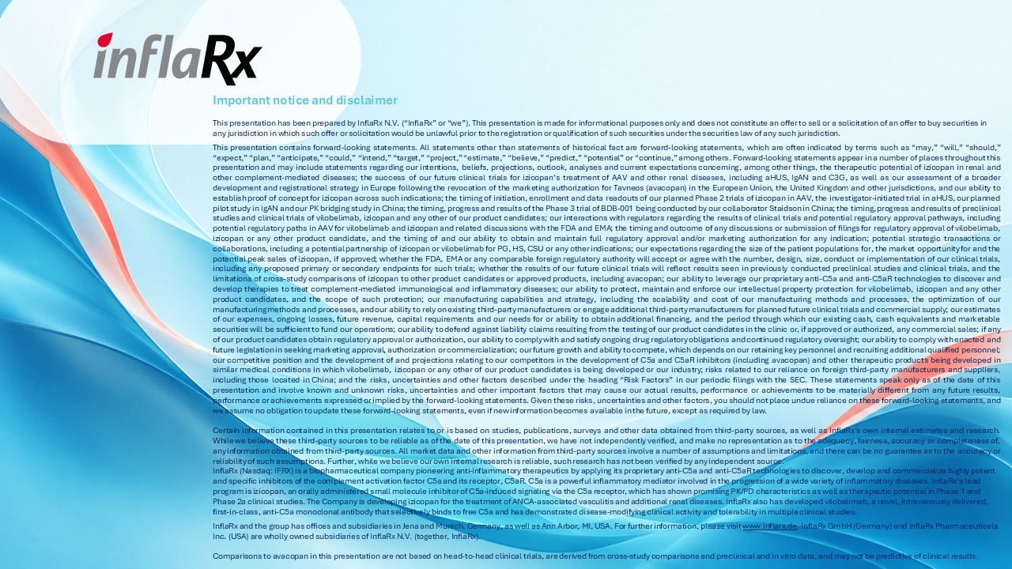
Important notice and disclaimer This presentation has been prepared by InflaRx N.V. (“InflaRx” or “we”). This presentation is made for informational purposes only and does not constitute an offer to sell or a solicitation of an offer to buy securities in any jurisdiction in which such offer or solicitation would be unlawful prior to the registration or qualification of such securities under the securities law of any such jurisdiction. This presentation contains forward-looking statements. All statements other than statements of historical fact are forward-looking statements, which are often indicated by terms such as “may,” “will,” “should,” “expect,” “plan,” “anticipate,” “could,” “intend,” “target,” “project,” “estimate,” “believe,” “predict,” “potential” or “continue,” among others. Forward-looking statements appear in a number of places throughout this presentation and may include statements regarding our intentions, beliefs, projections, outlook, analyses and current expectations concerning, among other things, the therapeutic potential of izicopan in renal and other complement-mediated diseases; the success of our future clinical trials for izicopan’s treatment of AAV and other renal diseases, including aHUS, IgAN and C3G, as well as our assessment of a broader development and registrational strategy in Europe following the revocation of the marketing authorization for Tavneos (avacopan) in the European Union, the United Kingdom and other jurisdictions, and our ability to establish proof of concept for izicopan across such indications; the timing of initiation, enrollment and data readouts of our planned Phase 2 trials of izicopan in AAV, the investigator-initiated trial in aHUS, our planned pilot study in IgAN and our PK bridging study in China; the timing, progress and results of the Phase 3 trial of BDB-001 being conducted by our collaborator Staidson in China; the timing, progress and results of preclinical studies and clinical trials of vilobelimab, izicopan and any other of our product candidates; our interactions with regulators regarding the results of clinical trials and potential regulatory approval pathways, including potential regulatory paths in AAV for vilobelimab and izicopan and related discussions with the FDA and EMA; the timing and outcome of any discussions or submission of filings for regulatory approval of vilobelimab, izicopan or any other product candidate, and the timing of and our ability to obtain and maintain full regulatory approval and/or marketing authorization for any indication; potential strategic transactions or collaborations, including a potential partnership of izicopan or vilobelimab for PG, HS, CSU or any other indications; our expectations regarding the size of the patient populations for, the market opportunity for and the potential peak sales of izicopan, if approved; whether the FDA, EMA or any comparable foreign regulatory authority will accept or agree with the number, design, size, conduct or implementation of our clinical trials, including any proposed primary or secondary endpoints for such trials; whether the results of our future clinical trials will reflect results seen in previously conducted preclinical studies and clinical trials, and the limitations of cross-study comparisons of izicopan to other product candidates or approved products, including avacopan; our ability to leverage our proprietary anti-C5a and anti-C5aR technologies to discover and develop therapies to treat complement-mediated immunological and inflammatory diseases; our ability to protect, maintain and enforce our intellectual property protection for vilobelimab, izicopan and any other product candidates, and the scope of such protection; our manufacturing capabilities and strategy, including the scalability and cost of our manufacturing methods and processes, the optimization of our manufacturing methods and processes, and our ability to rely on existing third-party manufacturers or engage additional third-party manufacturers for planned future clinical trials and commercial supply; our estimates of our expenses, ongoing losses, future revenue, capital requirements and our needs for or ability to obtain additional financing, and the period through which our existing cash, cash equivalents and marketable securities will be sufficient to fund our operations; our ability to defend against liability claims resulting from the testing of our product candidates in the clinic or, if approved or authorized, any commercial sales; if any of our product candidates obtain regulatory approval or authorization, our ability to comply with and satisfy ongoing drug regulatory obligations and continued regulatory oversight; our ability to comply with enacted and future legislation in seeking marketing approval, authorization or commercialization; our future growth and ability to compete, which depends on our retaining key personnel and recruiting additional qualified personnel; our competitive position and the development of and projections relating to our competitors in the development of C5a and C5aR inhibitors (including avacopan) and other therapeutic products being developed in similar medical conditions in which vilobelimab, izicopan or any other of our product candidates is being developed or our industry; risks related to our reliance on foreign third-party manufacturers and suppliers, including those located in China; and the risks, uncertainties and other factors described under the heading “Risk Factors” in our periodic filings with the SEC. These statements speak only as of the date of this presentation and involve known and unknown risks, uncertainties and other important factors that may cause our actual results, performance or achievements to be materially different from any future results, performance or achievements expressed or implied by the forward-looking statements. Given these risks, uncertainties and other factors, you should not place undue reliance on these forward-looking statements, and we assume no obligation to update these forward-looking statements, even if new information becomes available in the future, except as required by law. Certain information contained in this presentation relates to or is based on studies, publications, surveys and other data obtained from third-party sources, as well as InflaRx’s own internal estimates and research. While we believe these third-party sources to be reliable as of the date of this presentation, we have not independently verified, and make no representation as to the adequacy, fairness, accuracy or completeness of, any information obtained from third-party sources. All market data and other information from third-party sources involve a number of assumptions and limitations, and there can be no guarantee as to the accuracy or reliability of such assumptions. Further, while we believe our own internal research is reliable, such research has not been verified by any independent source. InflaRx (Nasdaq: IFRX) is a biopharmaceutical company pioneering anti-inflammatory therapeutics by applying its proprietary anti-C5a and anti-C5aR technologies to discover, develop and commercialize highly potent and specific inhibitors of the complement activation factor C5a and its receptor, C5aR. C5a is a powerful inflammatory mediator involved in the progression of a wide variety of inflammatory diseases. InflaRx‘s lead program is izicopan, an orally administered small molecule inhibitor of C5a-induced signaling via the C5a receptor, which has shown promising PK/PD characteristics as well as therapeutic potential in Phase 1 and Phase 2a clinical studies. The Company is developing izicopan for the treatment of ANCA-associated vasculitis and additional renal diseases. InflaRx also has developed vilobelimab, a novel, intravenously delivered, first-in-class, anti-C5a monoclonal antibody that selectively binds to free C5a and has demonstrated disease-modifying clinical activity and tolerability in multiple clinical studies. InflaRx and the group has offices and subsidiaries in Jena and Munich, Germany, as well as Ann Arbor, MI, USA. For further information, please visit www.inflarx.de. InflaRx GmbH (Germany) and InflaRx Pharmaceuticals Inc. (USA) are wholly owned subsidiaries of InflaRx N.V. (together, InflaRx). Comparisons to avacopan in this presentation are not based on head-to-head clinical trials, are derived from cross-study comparisons and preclinical and in vitro data, and may not be predictive of clinical results.

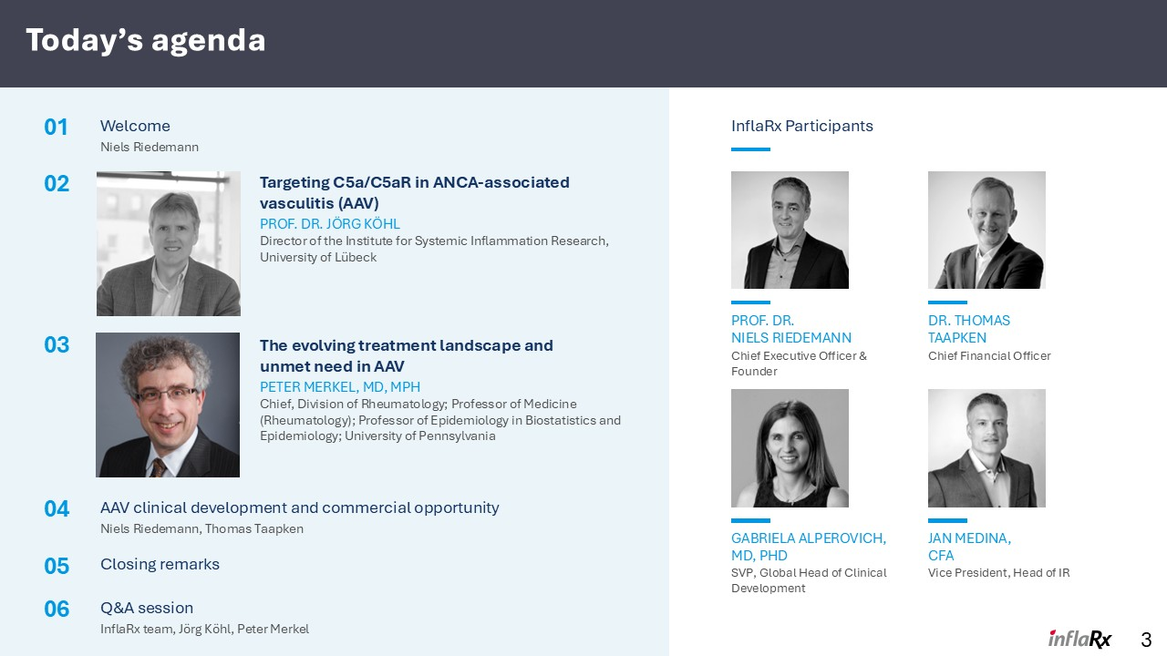
Today’s agenda 01 Welcome Niels Riedemann 04 AAV clinical development and commercial opportunity Niels Riedemann, Thomas Taapken 05 Closing remarks 06 Q&A session InflaRx team, Jörg Köhl, Peter Merkel PROF. DR. NIELS RIEDEMANN Chief Executive Officer & Founder DR. THOMAS TAAPKEN Chief Financial Officer GABRIELA ALPEROVICH,MD, PHD SVP, Global Head of Clinical Development JAN MEDINA, CFA Vice President, Head of IR 3 02 Targeting C5a/C5aR in ANCA-associated vasculitis (AAV) PROF. DR. JÖRG KÖHL Director of the Institute for Systemic Inflammation Research, University of Lübeck 03 The evolving treatment landscape and unmet need in AAV PETER MERKEL, MD, MPH Chief, Division of Rheumatology; Professor of Medicine (Rheumatology); Professor of Epidemiology in Biostatistics and Epidemiology; University of Pennsylvania InflaRx Participants

Izicopan Next-generation oral C5aR inhibitor

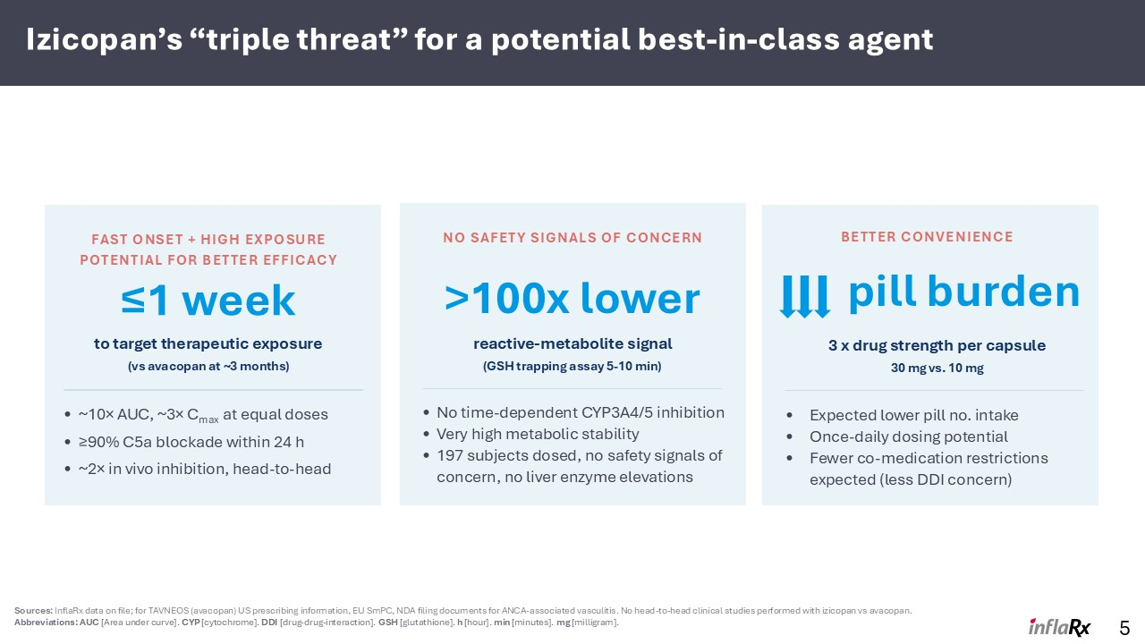
Izicopan’s “triple threat” for a potential best-in-class agent 5 Sources: InflaRx data on file; for TAVNEOS (avacopan) US prescribing information, EU SmPC, NDA filing documents for ANCA-associated vasculitis. No head-to-head clinical studies performed with izicopan vs avacopan. Abbreviations: AUC [Area under curve]. CYP [cytochrome]. DDI [drug-drug-interaction]. GSH [glutathione]. h [hour]. min [minutes]. mg [milligram]. FAST ONSET + HIGH EXPOSURE POTENTIAL FOR BETTER EFFICACY ≤1 week to target therapeutic exposure (vs avacopan at ~3 months) ~10× AUC, ~3× Cmax at equal doses ≥90% C5a blockade within 24 h ~2× in vivo inhibition, head-to-head NO SAFETY SIGNALS OF CONCERN >100x lower reactive-metabolite signal (GSH trapping assay 5-10 min) No time-dependent CYP3A4/5 inhibition Very high metabolic stability 197 subjects dosed, no safety signals of concern, no liver enzyme elevations BETTER CONVENIENCE pill burden 3 x drug strength per capsule 30 mg vs. 10 mg Expected lower pill no. intake Once-daily dosing potential Fewer co-medication restrictions expected (less DDI concern)

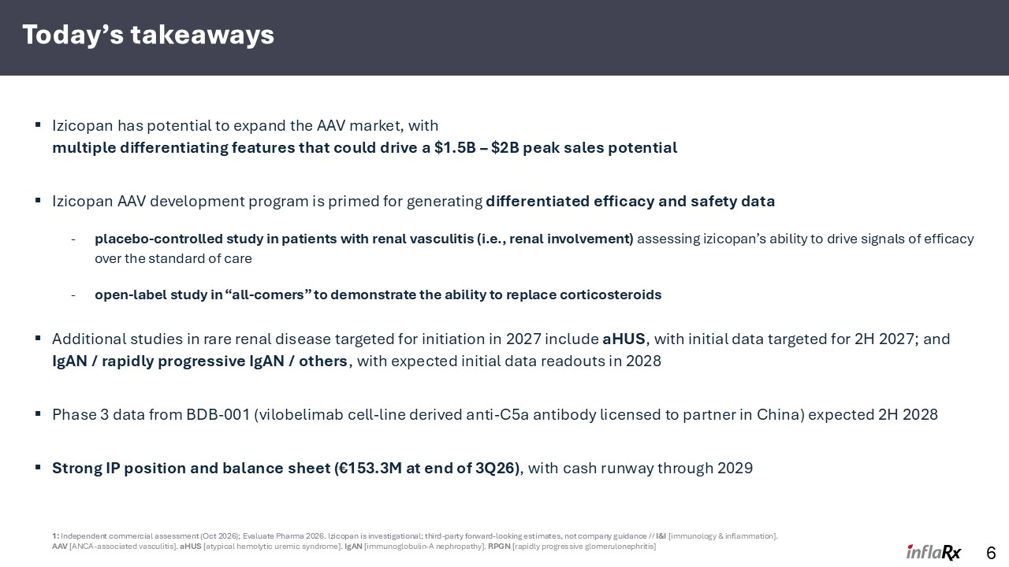
Today’s takeaways Izicopan has potential to expand the AAV market, with multiple differentiating features that could drive a $1.5B – $2B peak sales potential Izicopan AAV development program is primed for generating differentiated efficacy and safety data placebo-controlled study in patients with renal vasculitis (i.e., renal involvement) assessing izicopan’s ability to drive signals of efficacy over the standard of care open-label study in “all-comers” to demonstrate the ability to replace corticosteroids Additional studies in rare renal disease targeted for initiation in 2027 include aHUS, with initial data targeted for 2H 2027; and IgAN / rapidly progressive IgAN / others, with expected initial data readouts in 2028 Phase 3 data from BDB-001 (vilobelimab cell-line derived anti-C5a antibody licensed to partner in China) expected 2H 2028 Strong IP position and balance sheet (€153.3M at end of 3Q26), with cash runway through 2029 6 1: Independent commercial assessment (Oct 2026); Evaluate Pharma 2026. Izicopan is investigational; third-party forward-looking estimates, not company guidance // I&I [immunology & inflammation]. AAV [ANCA-associated vasculitis]. aHUS [atypical hemolytic uremic syndrome]. IgAN [immunoglobulin-A nephropathy]. RPGN [rapidly progressive glomerulonephritis]


Prof. Dr. Jörg Köhl Targeting C5aR1-driven inflammation in ANCA vasculitis and beyond

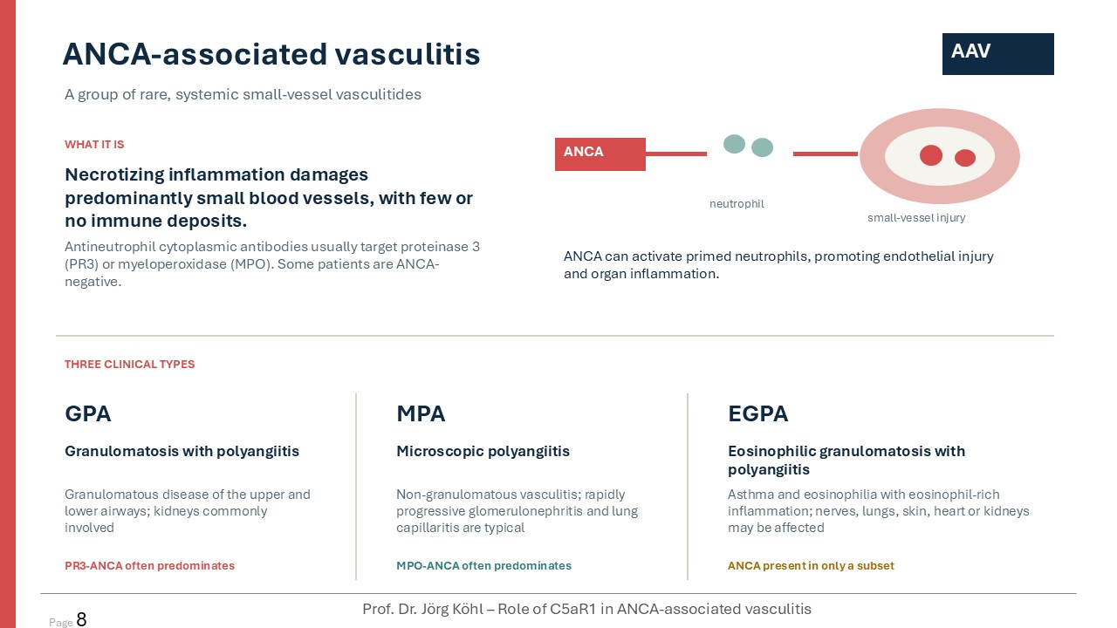
ANCA-associated vasculitis A group of rare, systemic small-vessel vasculitides AAV WHAT IT IS Necrotizing inflammation damages predominantly small blood vessels, with few or no immune deposits. Antineutrophil cytoplasmic antibodies usually target proteinase 3 (PR3) or myeloperoxidase (MPO). Some patients are ANCA-negative. ANCA neutrophil small-vessel injury ANCA can activate primed neutrophils, promoting endothelial injury and organ inflammation. THREE CLINICAL TYPES GPA Granulomatosis with polyangiitis Granulomatous disease of the upper and lower airways; kidneys commonly involved PR3-ANCA often predominates MPA Microscopic polyangiitis Non-granulomatous vasculitis; rapidly progressive glomerulonephritis and lung capillaritis are typical MPO-ANCA often predominates EGPA Eosinophilic granulomatosis with polyangiitis Asthma and eosinophilia with eosinophil-rich inflammation; nerves, lungs, skin, heart or kidneys may be affected ANCA present in only a subset Prof. Dr. Jörg Köhl – Role of C5aR1 in ANCA-associated vasculitis Page 8

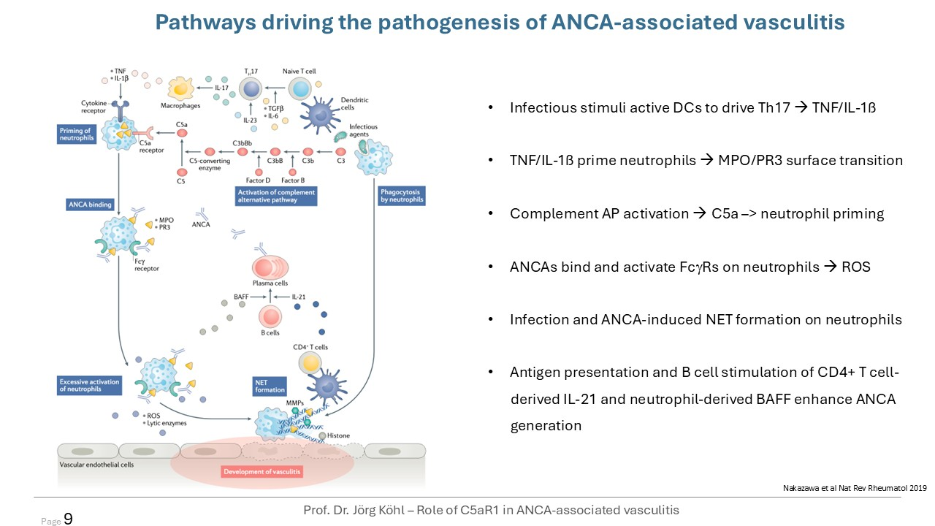
Nakazawa et al Nat Rev Rheumatol 2019 Pathways driving the pathogenesis of ANCA-associated vasculitis Infectious stimuli active DCs to drive Th17 → TNF/IL-1ß TNF/IL-1ß prime neutrophils → MPO/PR3 surface transition Complement AP activation → C5a –> neutrophil priming ANCAs bind and activate FcgRs on neutrophils → ROS Infection and ANCA-induced NET formation on neutrophils Antigen presentation and B cell stimulation of CD4+ T cell- derived IL-21 and neutrophil-derived BAFF enhance ANCA generation Prof. Dr. Jörg Köhl – Role of C5aR1 in ANCA-associated vasculitis Page 9

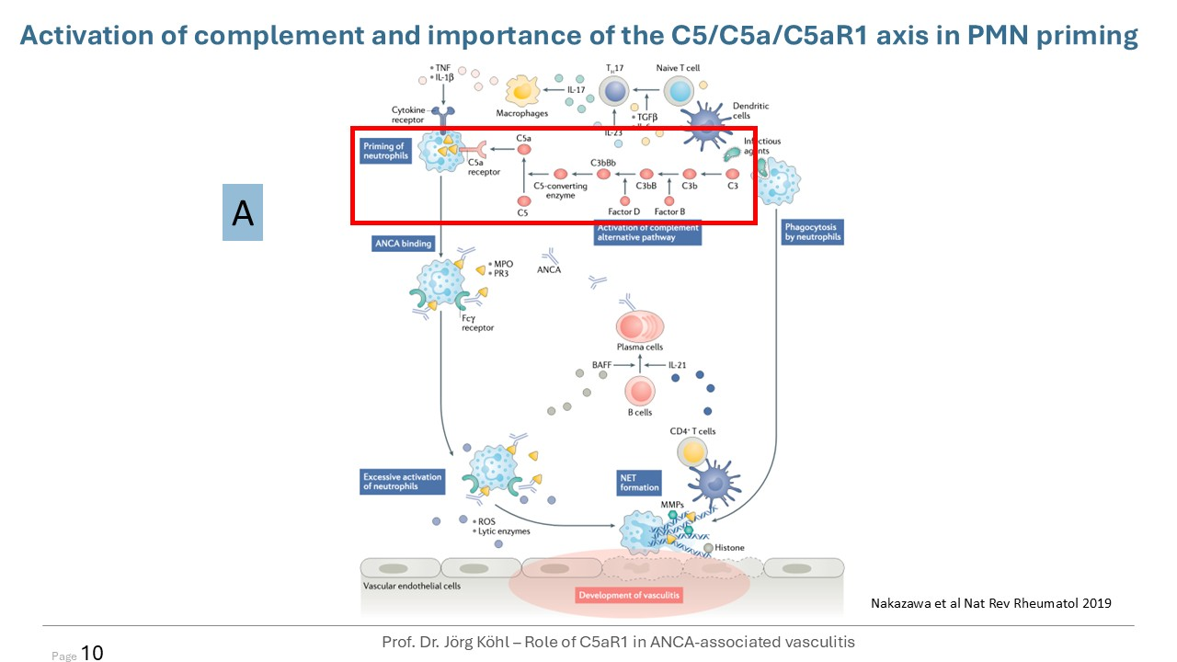
A Nakazawa et al Nat Rev Rheumatol 2019 Activation of complement and importance of the C5/C5a/C5aR1 axis in PMN priming Prof. Dr. Jörg Köhl – Role of C5aR1 in ANCA-associated vasculitis Page 10

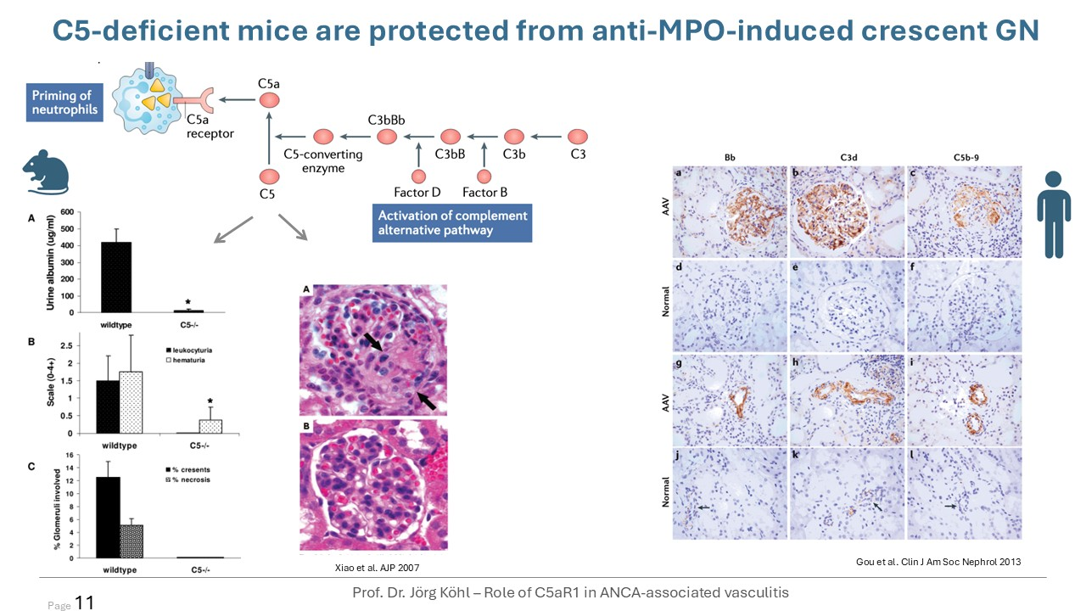
C5-deficient mice are protected from anti-MPO-induced crescent GN Xiao et al. AJP 2007 Prof. Dr. Jörg Köhl – Role of C5aR1 in ANCA-associated vasculitis Page 11 Gou et al. Clin J Am Soc Nephrol 2013

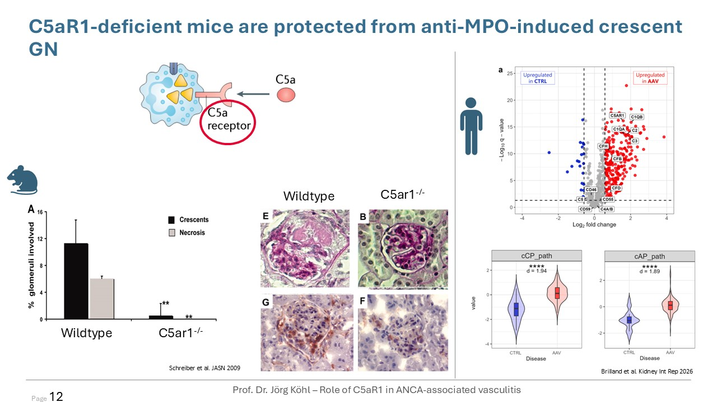
Schreiber et al. JASN 2009 C5aR1-deficient mice are protected from anti-MPO-induced crescent GN C5ar1-/- Wildtype Wildtype C5ar1-/- Prof. Dr. Jörg Köhl – Role of C5aR1 in ANCA-associated vasculitis Page 12 Brilland et al. Kidney Int Rep 2026

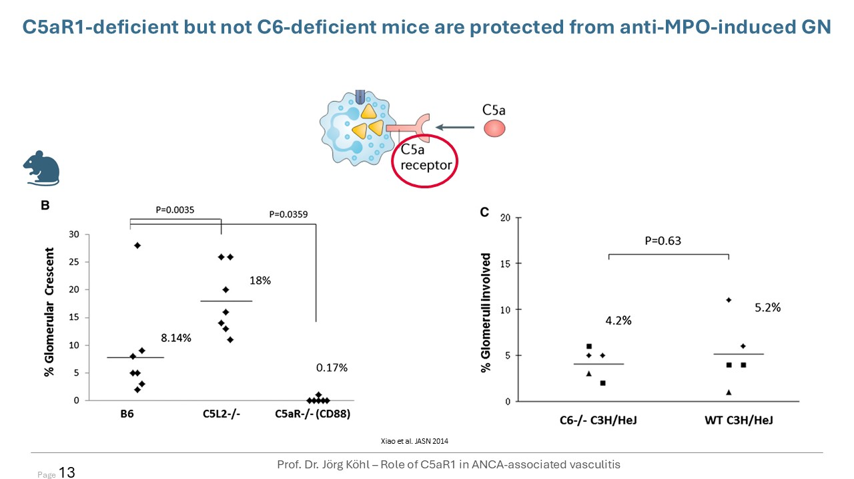
Xiao et al. JASN 2014 C5aR1-deficient but not C6-deficient mice are protected from anti-MPO-induced GN Prof. Dr. Jörg Köhl – Role of C5aR1 in ANCA-associated vasculitis Page 13

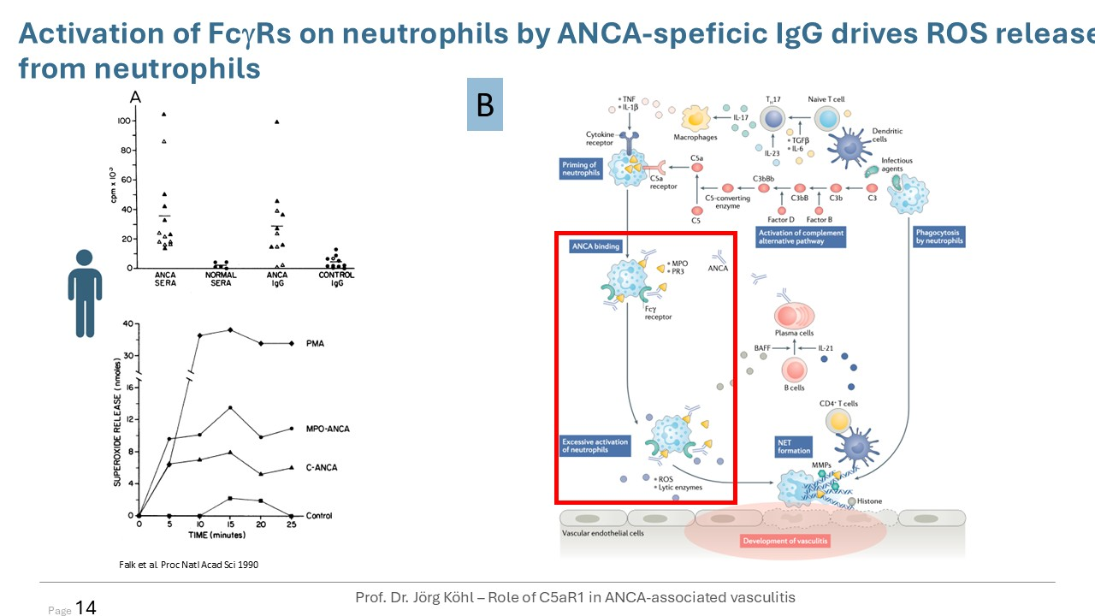
B Falk et al. Proc Natl Acad Sci 1990 Activation of FcgRs on neutrophils by ANCA-speficic IgG drives ROS release from neutrophils Prof. Dr. Jörg Köhl – Role of C5aR1 in ANCA-associated vasculitis Page 14

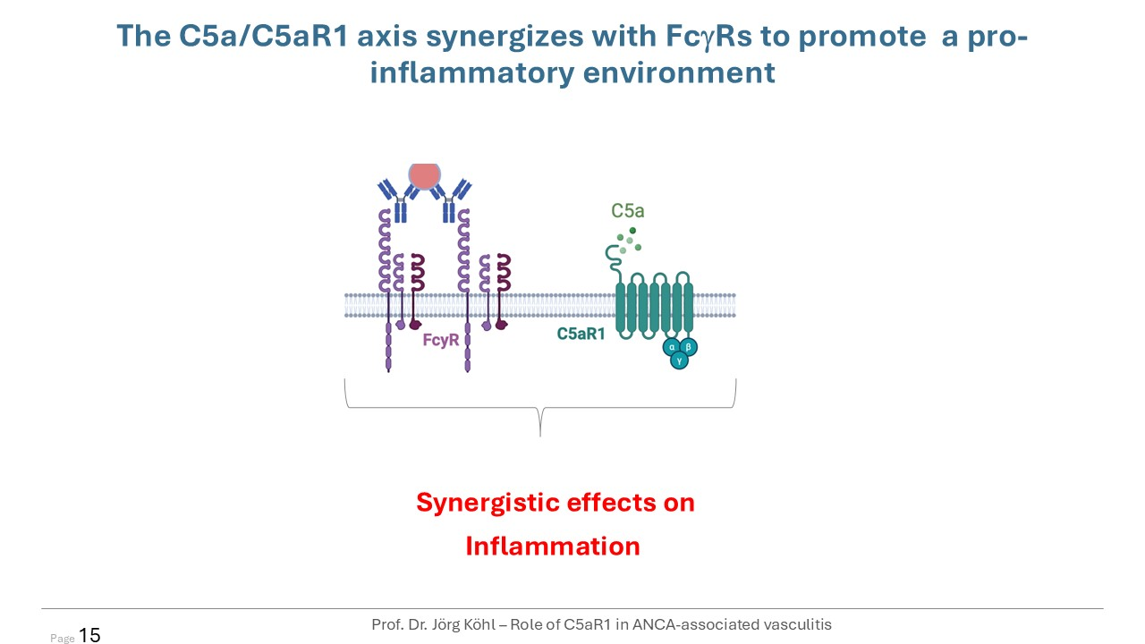
The C5a/C5aR1 axis synergizes with FcgRs to promote a pro-inflammatory environment Synergistic effects on Inflammation Prof. Dr. Jörg Köhl – Role of C5aR1 in ANCA-associated vasculitis Page 15

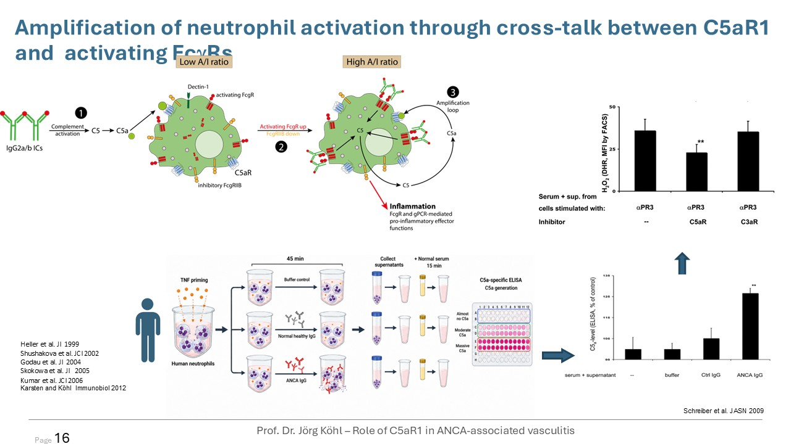
Amplification of neutrophil activation through cross-talk between C5aR1 and activating FcgRs Heller et al. JI 1999 Shushakova et al. JCI 2002 Godau et al. JI 2004 Skokowa et al. JI 2005 Kumar et al. JCI 2006 Karsten and Köhl Immunobiol 2012 Schreiber et al. JASN 2009 Prof. Dr. Jörg Köhl – Role of C5aR1 in ANCA-associated vasculitis Page 16

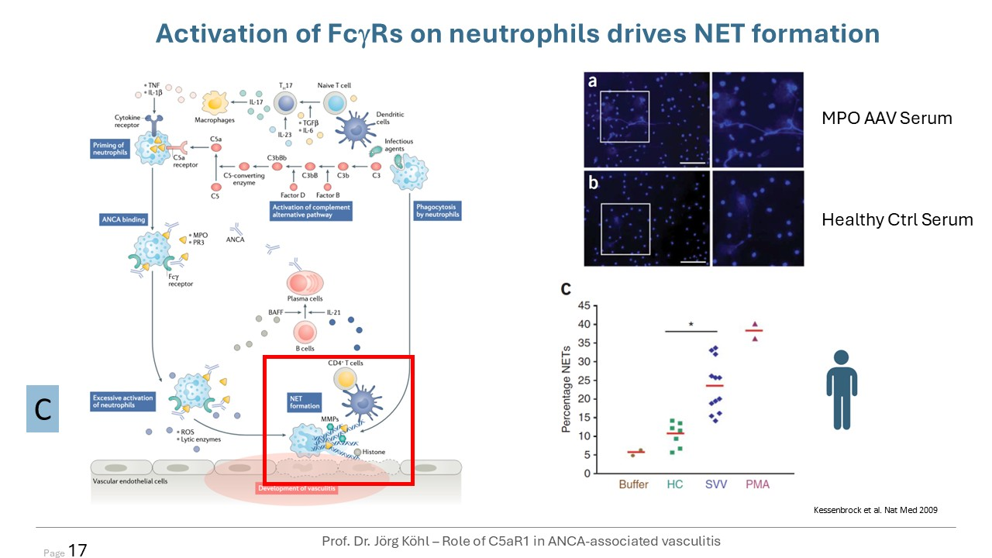
C Activation of FcgRs on neutrophils drives NET formation Kessenbrock et al. Nat Med 2009 Healthy Ctrl Serum MPO AAV Serum Prof. Dr. Jörg Köhl – Role of C5aR1 in ANCA-associated vasculitis Page 17

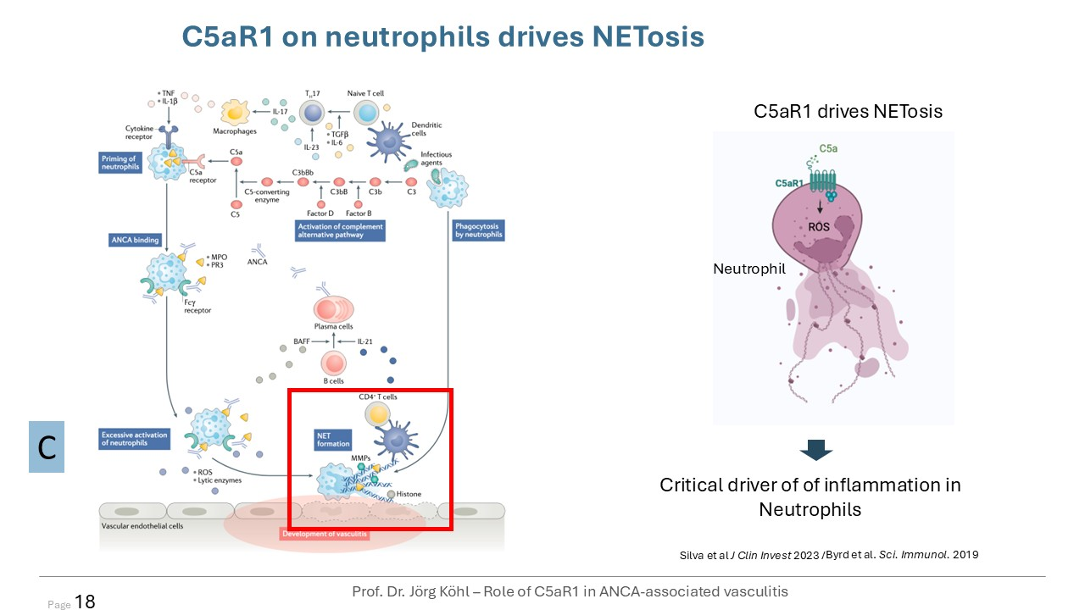
C C5aR1 drives NETosis Neutrophil Critical driver of of inflammation in Neutrophils Silva et al J Clin Invest 2023 / Byrd et al. Sci. Immunol. 2019 C5aR1 on neutrophils drives NETosis Prof. Dr. Jörg Köhl – Role of C5aR1 in ANCA-associated vasculitis Page 18

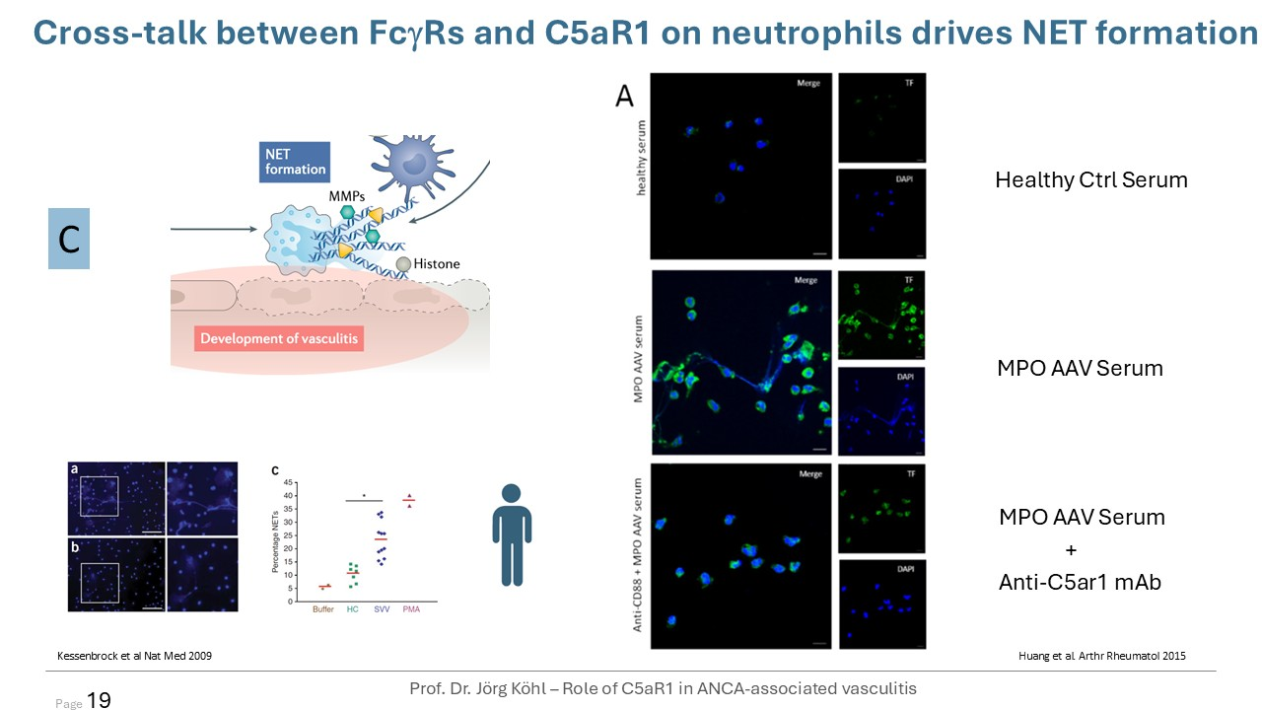
C Kessenbrock et al Nat Med 2009 Huang et al. Arthr Rheumatol 2015 Healthy Ctrl Serum MPO AAV Serum MPO AAV Serum Anti-C5ar1 mAb + Cross-talk between FcgRs and C5aR1 on neutrophils drives NET formation Prof. Dr. Jörg Köhl – Role of C5aR1 in ANCA-associated vasculitis Page 19

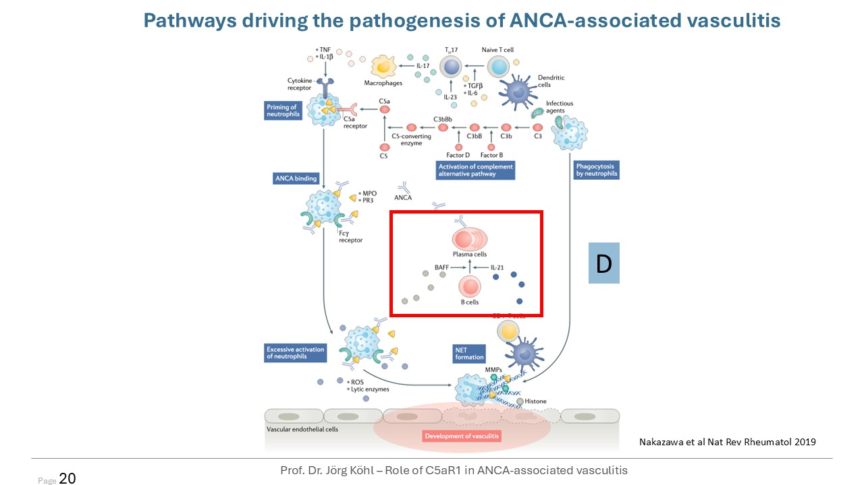
Nakazawa et al Nat Rev Rheumatol 2019 Pathways driving the pathogenesis of ANCA-associated vasculitis Prof. Dr. Jörg Köhl – Role of C5aR1 in ANCA-associated vasculitis D Page 20

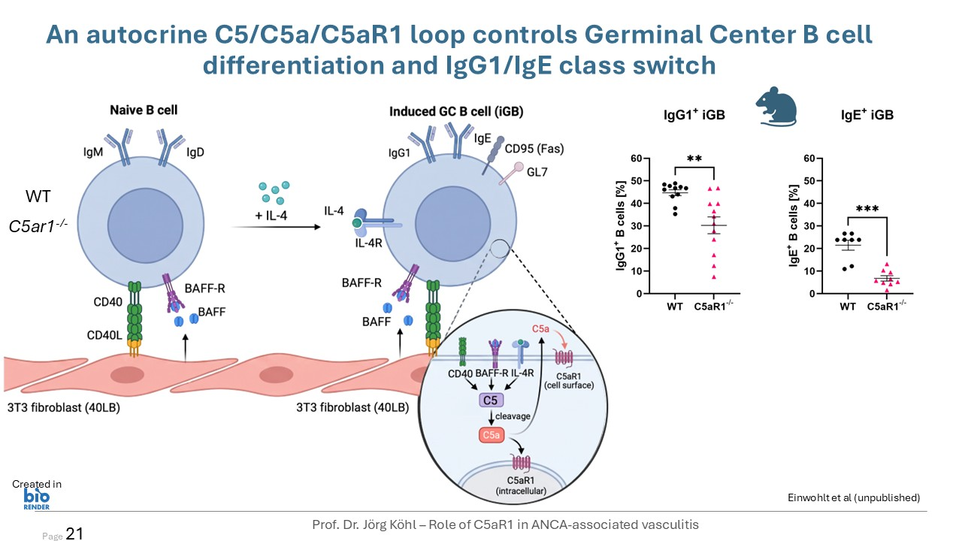
An autocrine C5/C5a/C5aR1 loop controls Germinal Center B cell differentiation and IgG1/IgE class switch WT C5ar1-/- Prof. Dr. Jörg Köhl – Role of C5aR1 in ANCA-associated vasculitis Created in Page 21 Einwohlt et al (unpublished)

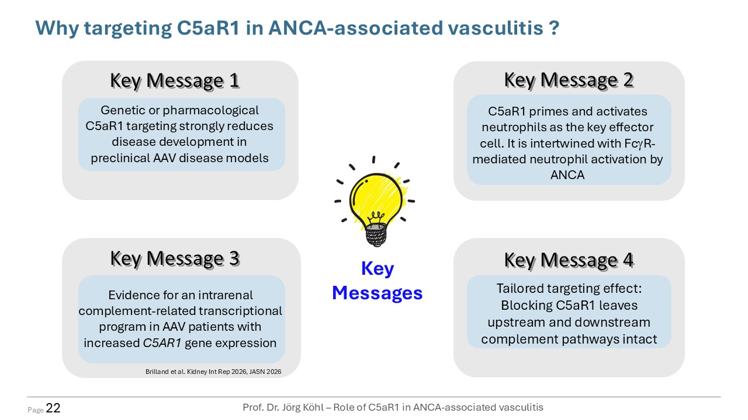
Key Messages Why targeting C5aR1 in ANCA-associated vasculitis ? Key Message 2 C5aR1 primes and activates neutrophils as the key effector cell. It is intertwined with FcgR-mediated neutrophil activation by ANCA Key Message 4 Tailored targeting effect: Blocking C5aR1 leaves upstream and downstream complement pathways intact Key Message 1 Genetic or pharmacological C5aR1 targeting strongly reduces disease development in preclinical AAV disease models Prof. Dr. Jörg Köhl – Role of C5aR1 in ANCA-associated vasculitis Key Message 3 Evidence for an intrarenal complement-related transcriptional program in AAV patients with increased C5AR1 gene expression Brilland et al. Kidney Int Rep 2026, JASN 2026 Page 22

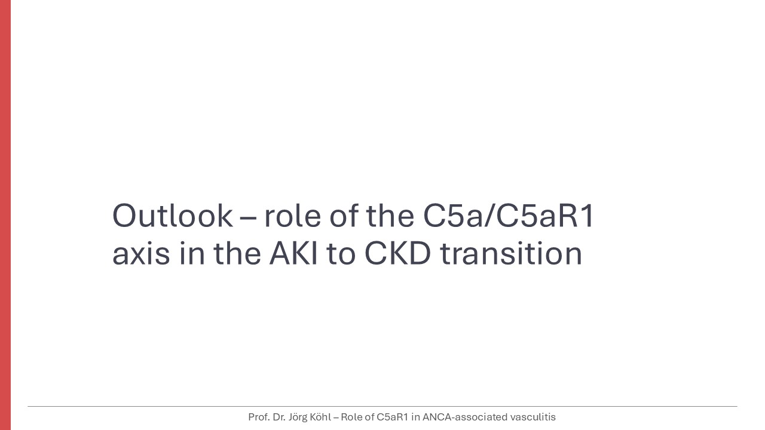
Outlook – role of the C5a/C5aR1axis in the AKI to CKD transition Prof. Dr. Jörg Köhl – Role of C5aR1 in ANCA-associated vasculitis

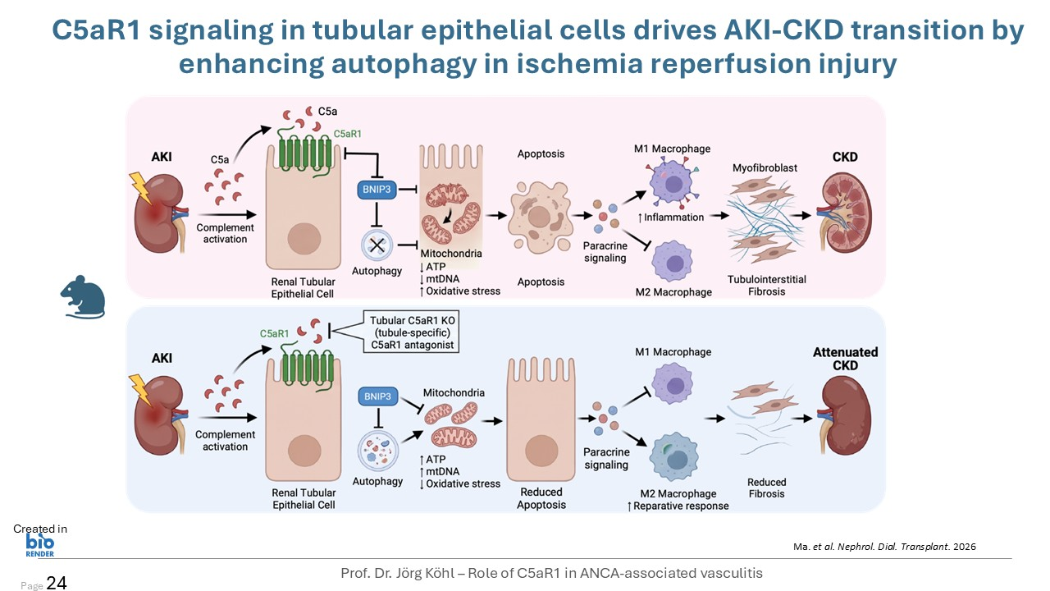
Ma. et al. Nephrol. Dial. Transplant. 2026 Created in C5aR1 signaling in tubular epithelial cells drives AKI-CKD transition by enhancing autophagy in ischemia reperfusion injury Prof. Dr. Jörg Köhl – Role of C5aR1 in ANCA-associated vasculitis Page 24

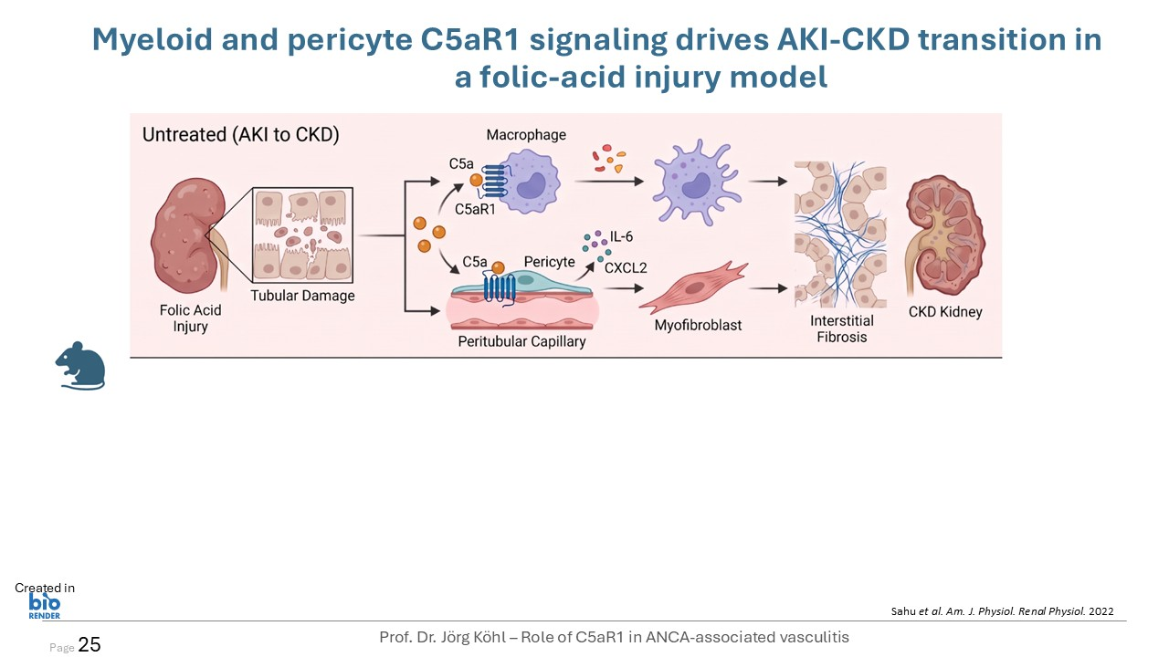
Sahu et al. Am. J. Physiol. Renal Physiol. 2022 Created in Myeloid and pericyte C5aR1 signaling drives AKI-CKD transition in a folic-acid injury model Prof. Dr. Jörg Köhl – Role of C5aR1 in ANCA-associated vasculitis Page 25

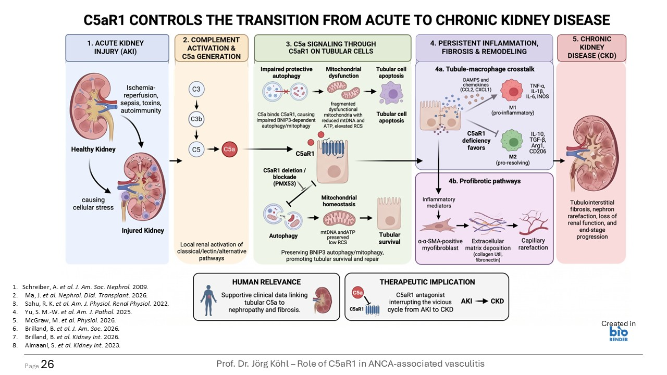
Page 26 Schreiber, A. et al. J. Am. Soc. Nephrol. 2009. Ma, J. et al. Nephrol. Dial. Transplant. 2026. Sahu, R. K. et al. Am. J. Physiol. Renal Physiol. 2022. Yu, S. M.-W. et al. Am. J. Pathol. 2025. McGraw, M. et al. Physiol. 2026. Brilland, B. et al. J. Am. Soc. 2026. Brilland, B. et al. Kidney Int. 2026. Almaani, S. et al. Kidney Int. 2023. Prof. Dr. Jörg Köhl – Role of C5aR1 in ANCA-associated vasculitis Created in

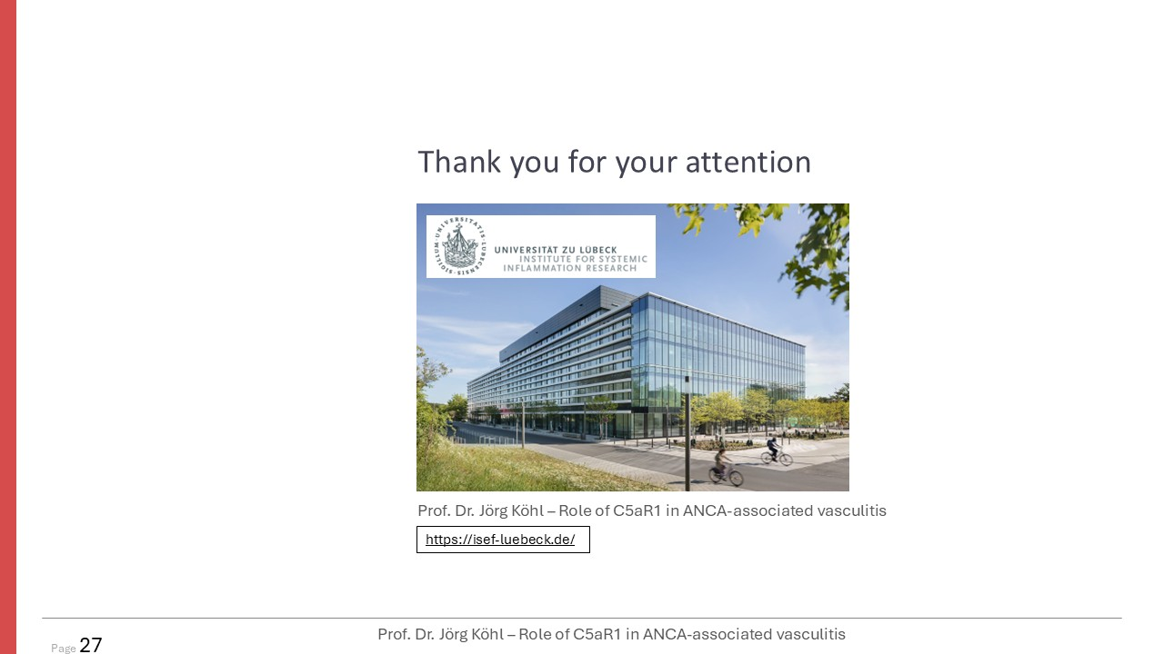
Prof. Dr. Jörg Köhl – Role of C5aR1 in ANCA-associated vasculitis https://isef-luebeck.de/ Page 27 Prof. Dr. Jörg Köhl – Role of C5aR1 in ANCA-associated vasculitis Thank you for your attention

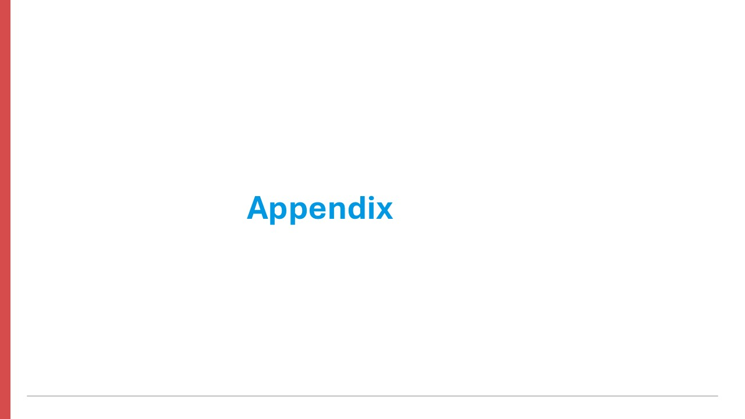
Appendix

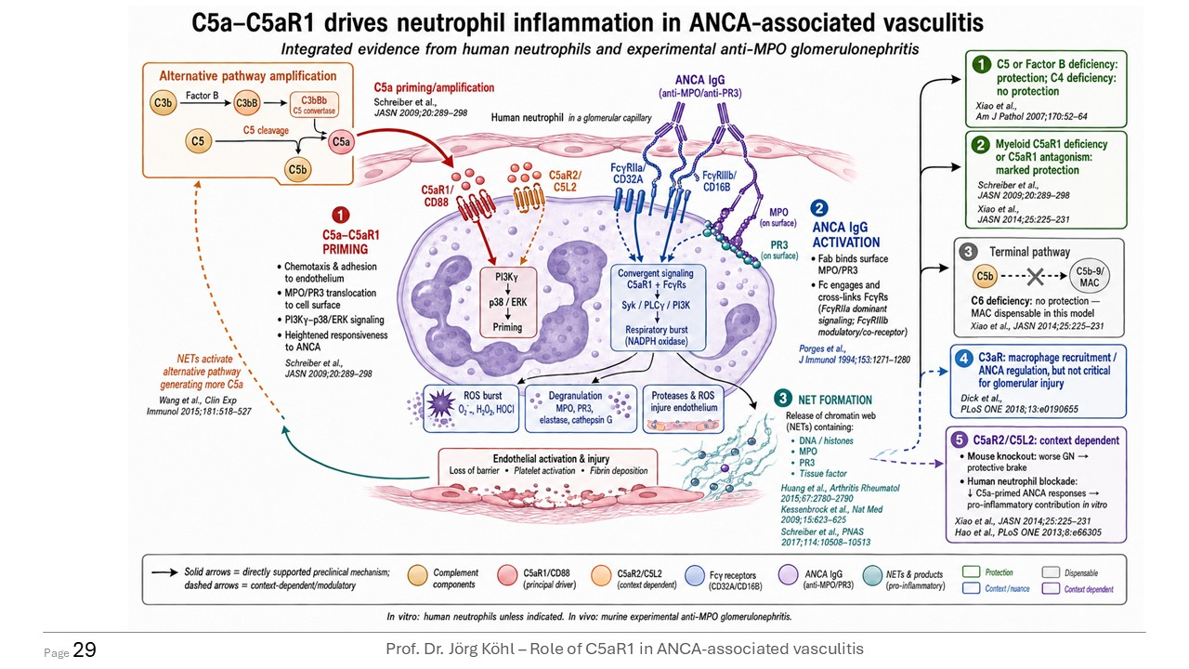
Page 29 Prof. Dr. Jörg Köhl – Role of C5aR1 in ANCA-associated vasculitis


Peter Merkel, MD, MPH Chief, Division of Rheumatology; Professor of Medicine (Rheumatology); Professor of Epidemiology in Biostatistics and Epidemiology; University of Pennsylvania

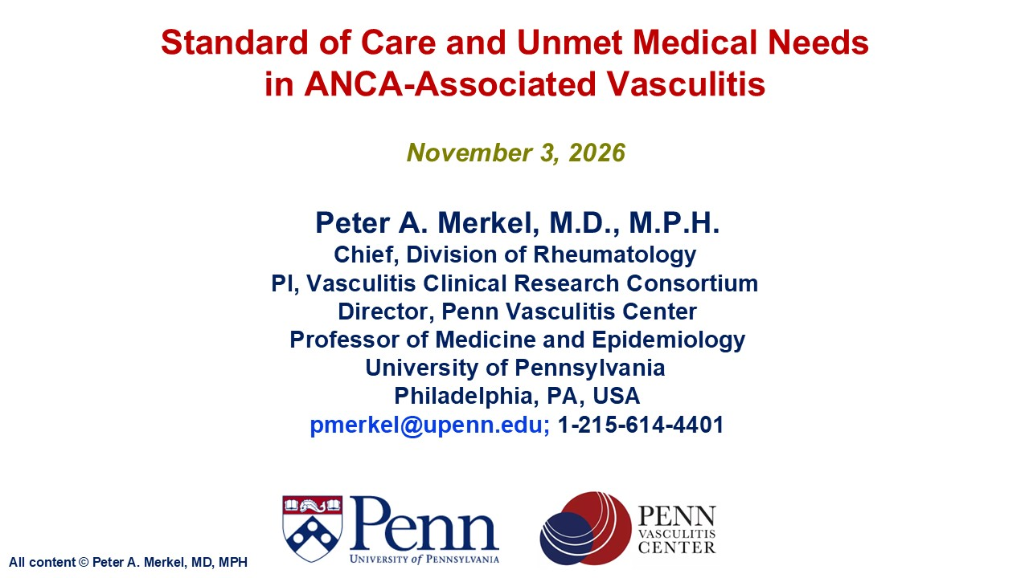
Standard of Care and Unmet Medical Needs in ANCA-Associated Vasculitis Peter A. Merkel, M.D., M.P.H.Chief, Division of RheumatologyPI, Vasculitis Clinical Research Consortium Director, Penn Vasculitis Center Professor of Medicine and EpidemiologyUniversity of Pennsylvania Philadelphia, PA, USA pmerkel@upenn.edu; 1-215-614-4401 November 3, 2026 All content © Peter A. Merkel, MD, MPH

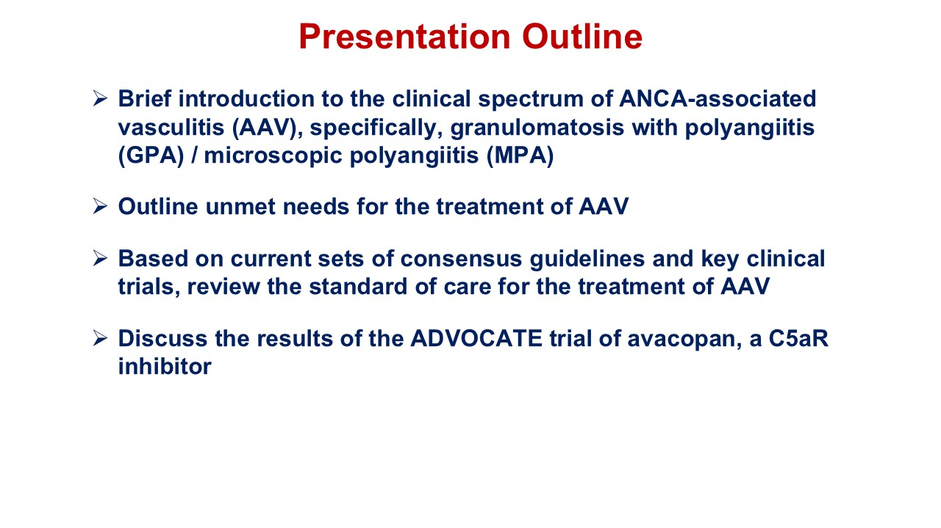
Presentation Outline Brief introduction to the clinical spectrum of ANCA-associated vasculitis (AAV), specifically, granulomatosis with polyangiitis (GPA) / microscopic polyangiitis (MPA) Outline unmet needs for the treatment of AAV Based on current sets of consensus guidelines and key clinical trials, review the standard of care for the treatment of AAV Discuss the results of the ADVOCATE trial of avacopan, a C5aR inhibitor

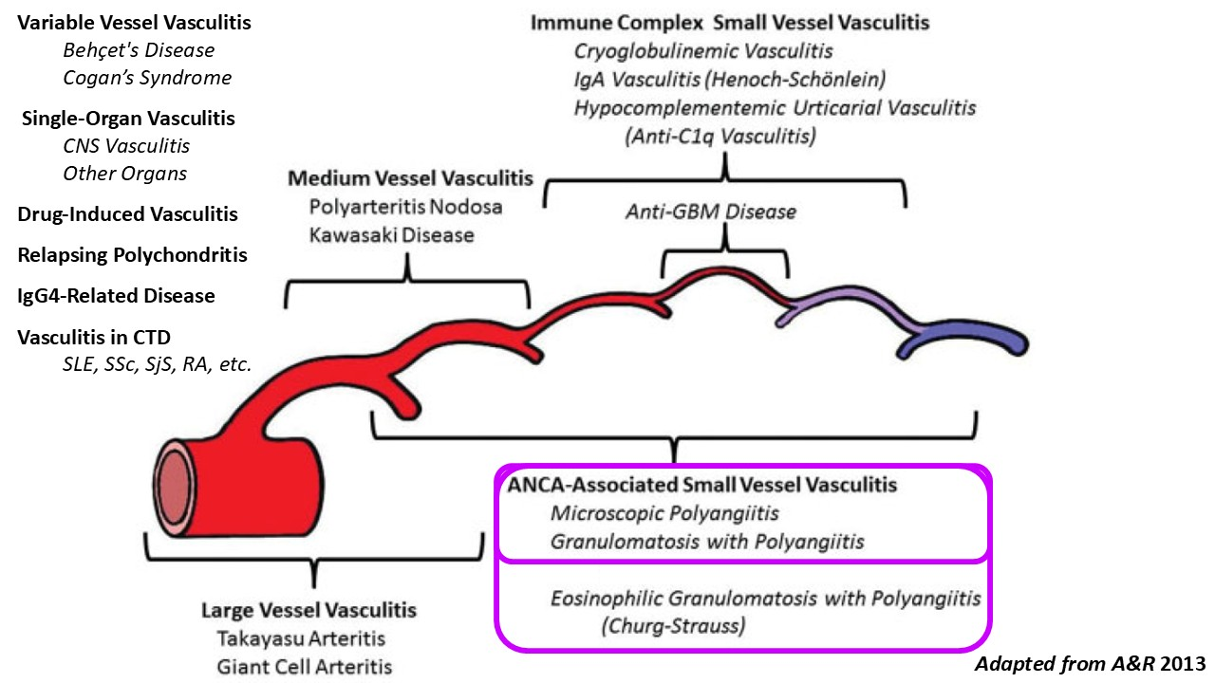
Adapted from A&R 2013 Variable Vessel Vasculitis Behçet's Disease Cogan’s Syndrome Single-Organ Vasculitis CNS Vasculitis Other Organs Drug-Induced Vasculitis Relapsing Polychondritis IgG4-Related Disease Vasculitis in CTD SLE, SSc, SjS, RA, etc.

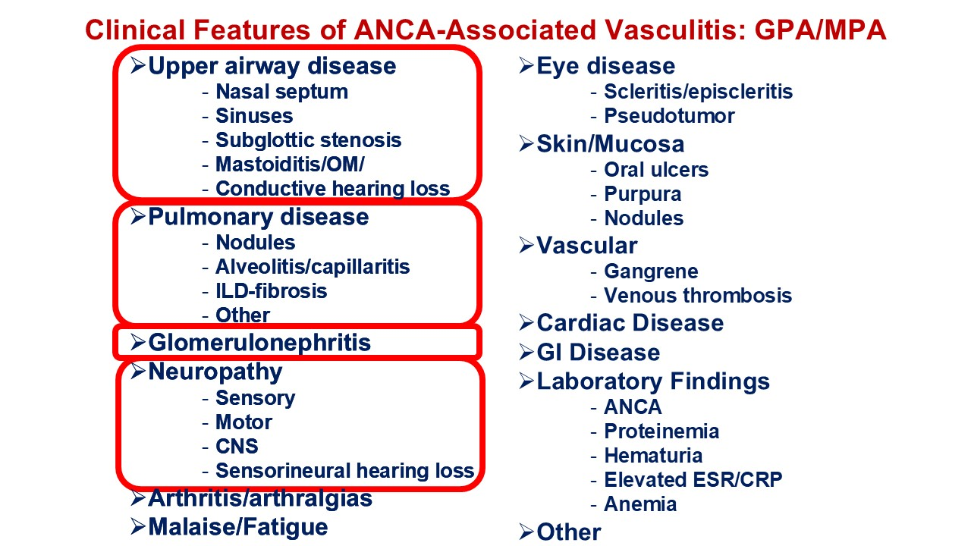
Clinical Features of ANCA-Associated Vasculitis: GPA/MPA Upper airway disease Nasal septum Sinuses Subglottic stenosis Mastoiditis/OM/ Conductive hearing loss Pulmonary disease Nodules Alveolitis/capillaritis ILD-fibrosis Other Glomerulonephritis Neuropathy Sensory Motor CNS Sensorineural hearing loss Arthritis/arthralgias Malaise/Fatigue Eye disease Scleritis/episcleritis Pseudotumor Skin/Mucosa Oral ulcers Purpura Nodules Vascular Gangrene Venous thrombosis Cardiac Disease GI Disease Laboratory Findings ANCA Proteinemia Hematuria Elevated ESR/CRP Anemia Other Upper airway disease Nasal septum Sinuses Subglottic stenosis Mastoiditis/OM/ Conductive hearing loss Pulmonary disease Nodules Alveolitis/capillaritis ILD-fibrosis Other Glomerulonephritis Neuropathy Sensory Motor CNS Sensorineural hearing loss Arthritis/arthralgias Malaise/Fatigue

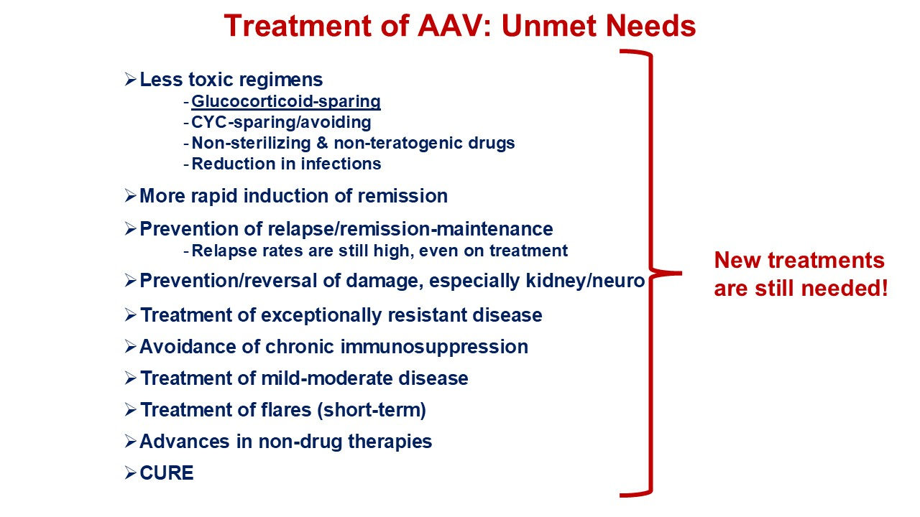
Treatment of AAV: Unmet Needs Less toxic regimens Glucocorticoid-sparing CYC-sparing/avoiding Non-sterilizing & non-teratogenic drugs Reduction in infections More rapid induction of remission Prevention of relapse/remission-maintenance Relapse rates are still high, even on treatment Prevention/reversal of damage, especially kidney/neuro Treatment of exceptionally resistant disease Avoidance of chronic immunosuppression Treatment of mild-moderate disease Treatment of flares (short-term) Advances in non-drug therapies CURE New treatments are still needed!

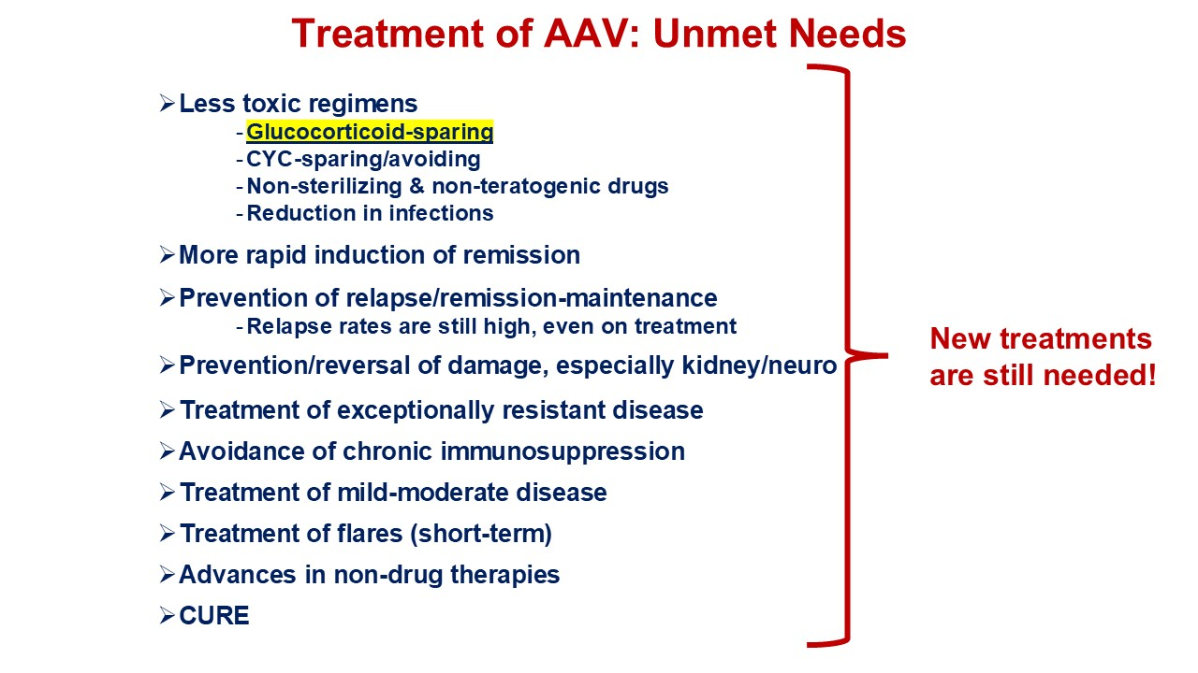
Treatment of AAV: Unmet Needs Less toxic regimens Glucocorticoid-sparing CYC-sparing/avoiding Non-sterilizing & non-teratogenic drugs Reduction in infections More rapid induction of remission Prevention of relapse/remission-maintenance Relapse rates are still high, even on treatment Prevention/reversal of damage, especially kidney/neuro Treatment of exceptionally resistant disease Avoidance of chronic immunosuppression Treatment of mild-moderate disease Treatment of flares (short-term) Advances in non-drug therapies CURE New treatments are still needed!

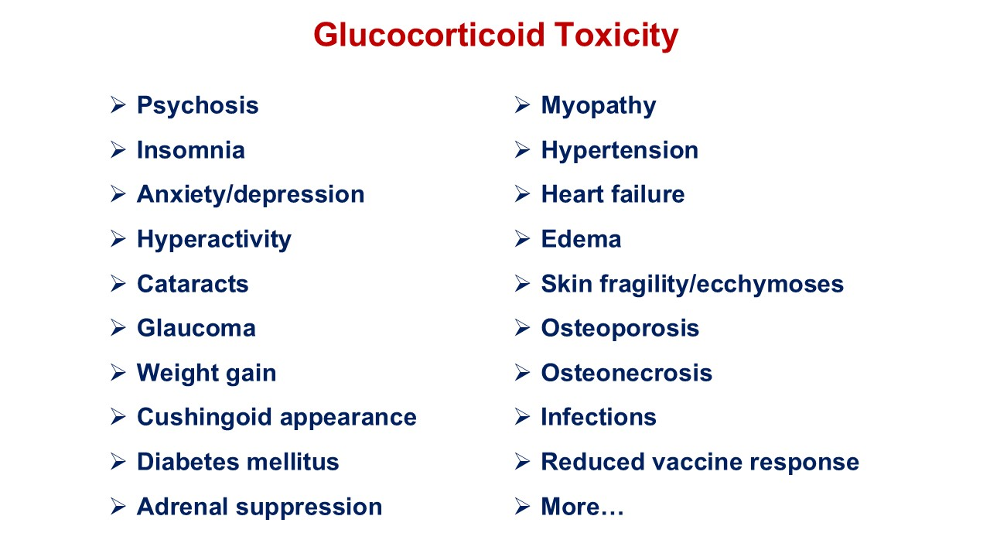
Glucocorticoid Toxicity Psychosis Insomnia Anxiety/depression Hyperactivity Cataracts Glaucoma Weight gain Cushingoid appearance Diabetes mellitus Adrenal suppression Myopathy Hypertension Heart failure Edema Skin fragility/ecchymoses Osteoporosis Osteonecrosis Infections Reduced vaccine response More…

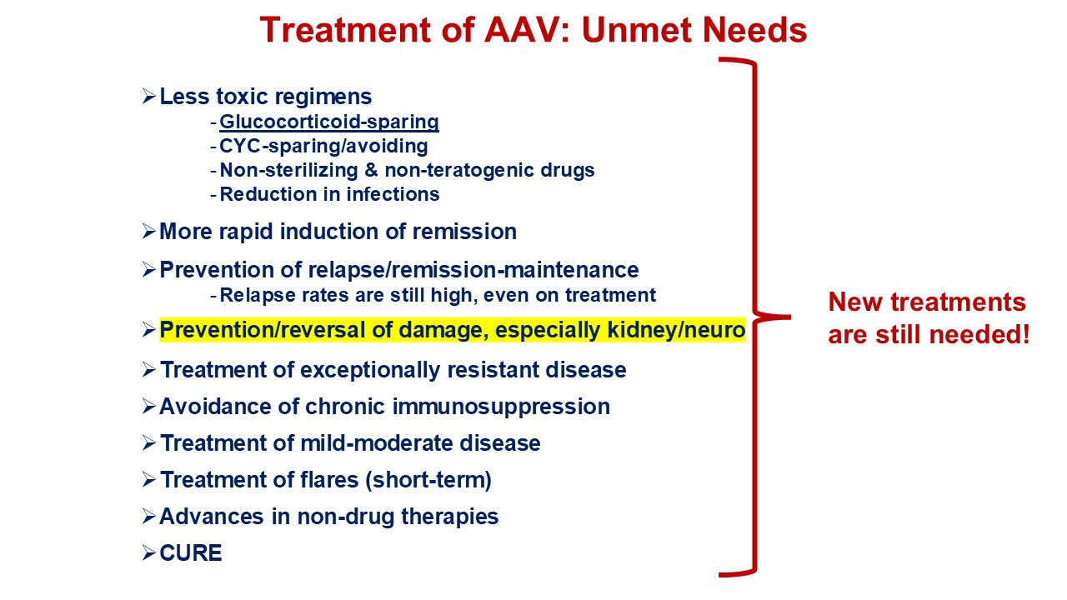
Treatment of AAV: Unmet Needs Less toxic regimens Glucocorticoid-sparing CYC-sparing/avoiding Non-sterilizing & non-teratogenic drugs Reduction in infections More rapid induction of remission Prevention of relapse/remission-maintenance Relapse rates are still high, even on treatment Prevention/reversal of damage, especially kidney/neuro Treatment of exceptionally resistant disease Avoidance of chronic immunosuppression Treatment of mild-moderate disease Treatment of flares (short-term) Advances in non-drug therapies CURE New treatments are still needed!

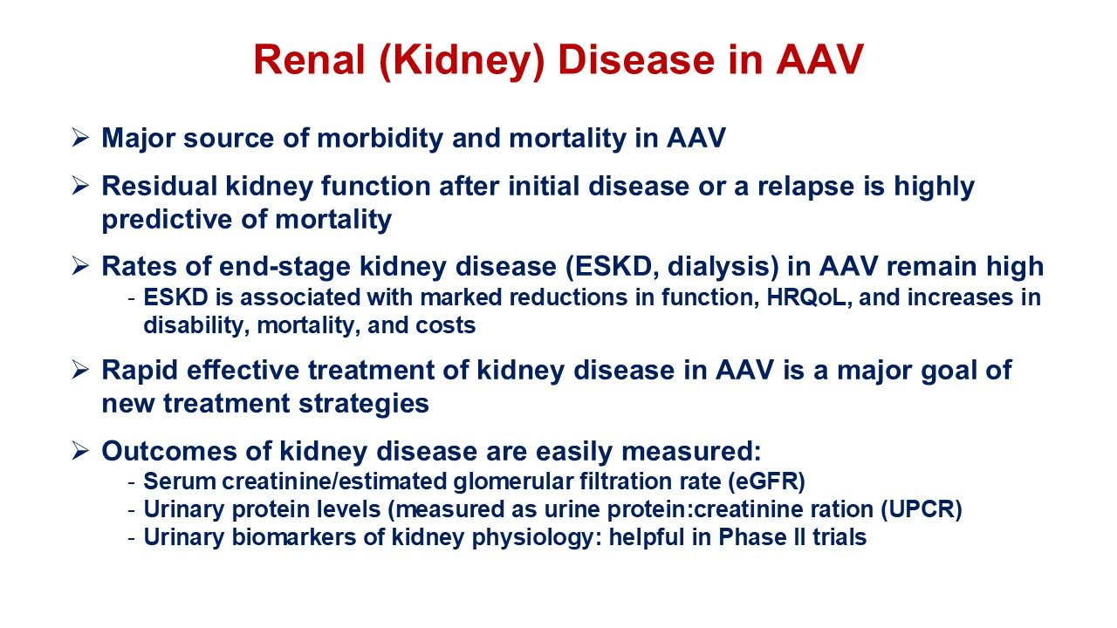
Renal (Kidney) Disease in AAV Major source of morbidity and mortality in AAV Residual kidney function after initial disease or a relapse is highly predictive of mortality Rates of end-stage kidney disease (ESKD, dialysis) in AAV remain high ESKD is associated with marked reductions in function, HRQoL, and increases in disability, mortality, and costs Rapid effective treatment of kidney disease in AAV is a major goal of new treatment strategies Outcomes of kidney disease are easily measured: Serum creatinine/estimated glomerular filtration rate (eGFR) Urinary protein levels (measured as urine protein:creatinine ration (UPCR) Urinary biomarkers of kidney physiology: helpful in Phase II trials

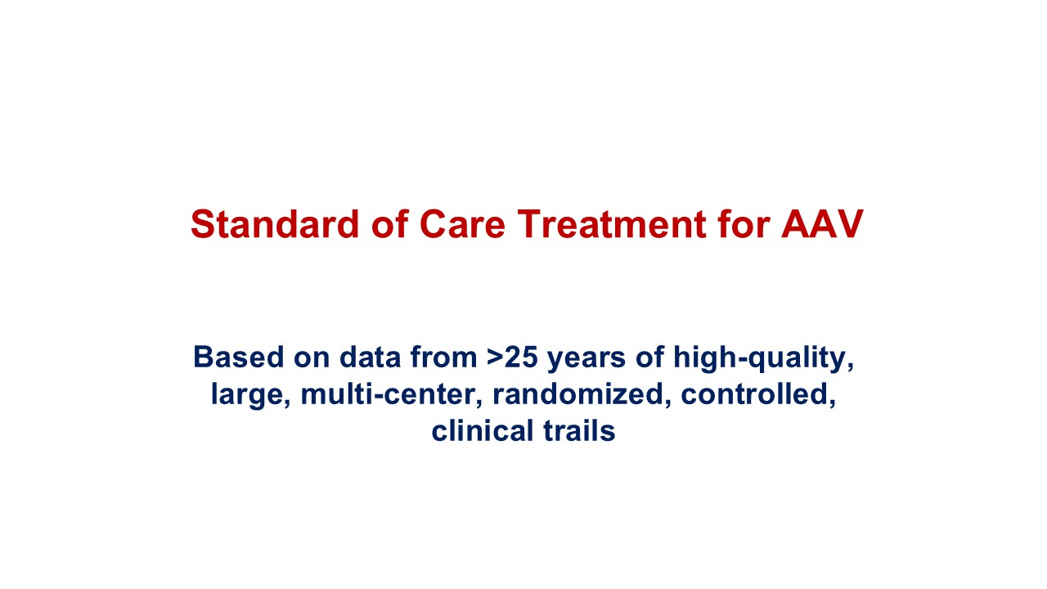
Standard of Care Treatment for AAV Based on data from >25 years of high-quality, large, multi-center, randomized, controlled, clinical trails

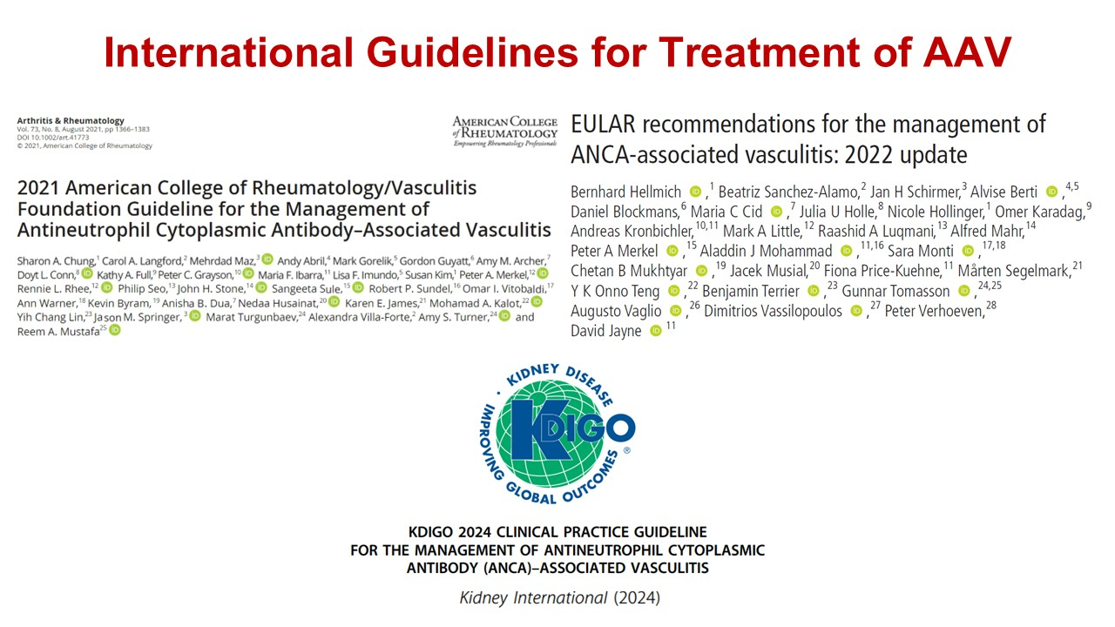
International Guidelines for Treatment of AAV

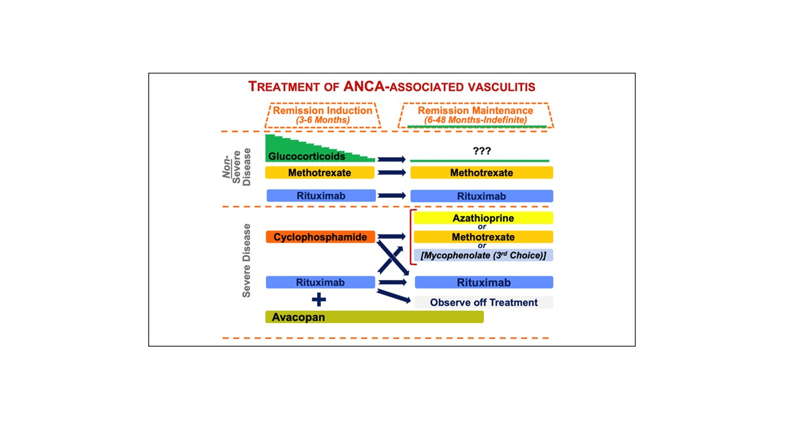

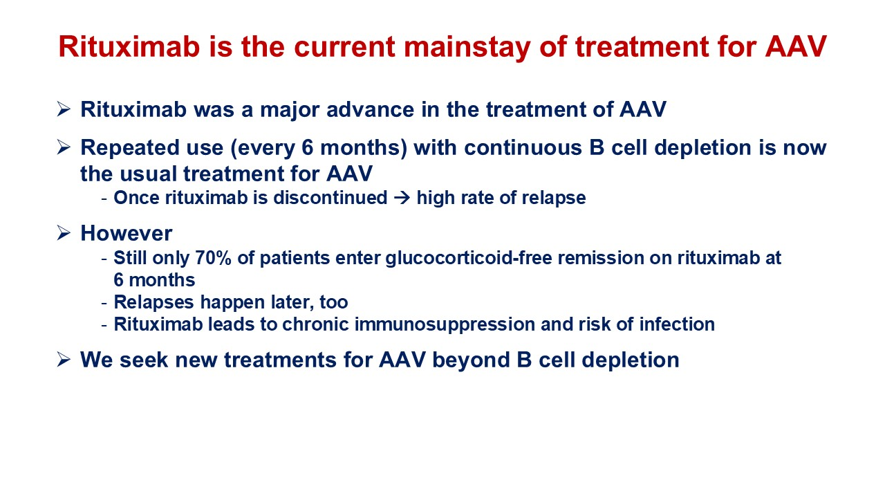
Rituximab is the current mainstay of treatment for AAV Rituximab was a major advance in the treatment of AAV Repeated use (every 6 months) with continuous B cell depletion is now the usual treatment for AAV Once rituximab is discontinued → high rate of relapse However Still only 70% of patients enter glucocorticoid-free remission on rituximab at 6 months Relapses happen later, too Rituximab leads to chronic immunosuppression and risk of infection We seek new treatments for AAV beyond B cell depletion

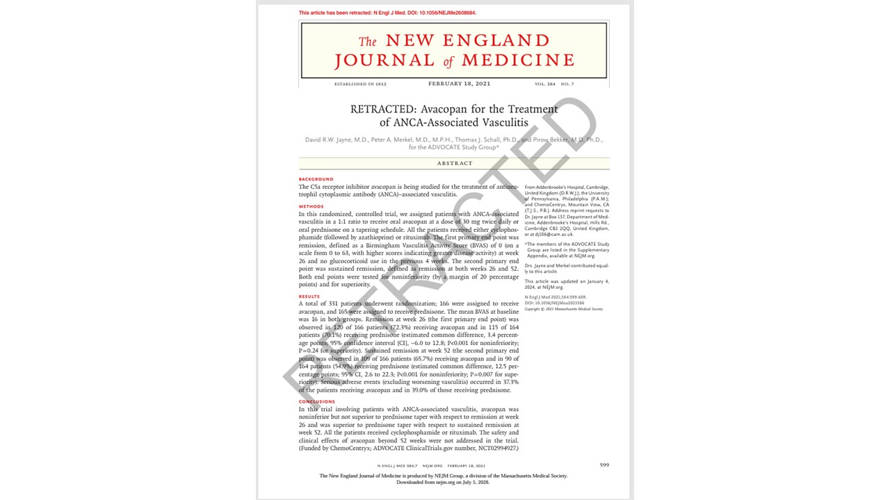

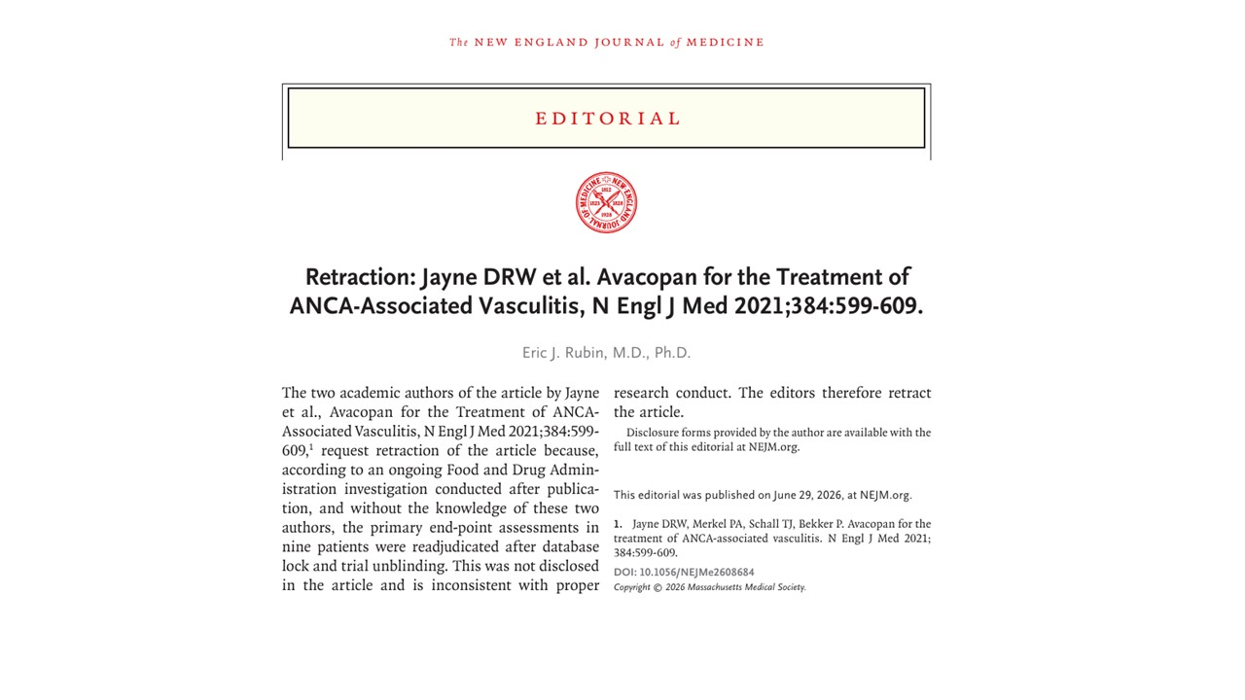

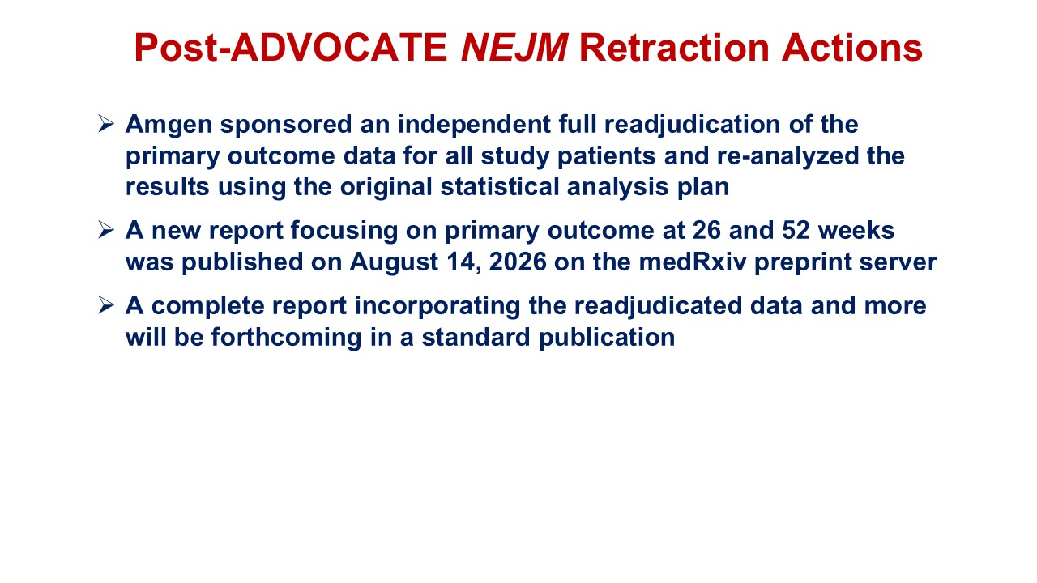
Post-ADVOCATE NEJM Retraction Actions Amgen sponsored an independent full readjudication of the primary outcome data for all study patients and re-analyzed the results using the original statistical analysis plan A new report focusing on primary outcome at 26 and 52 weeks was published on August 14, 2026 on the medRxiv preprint server A complete report incorporating the readjudicated data and more will be forthcoming in a standard publication

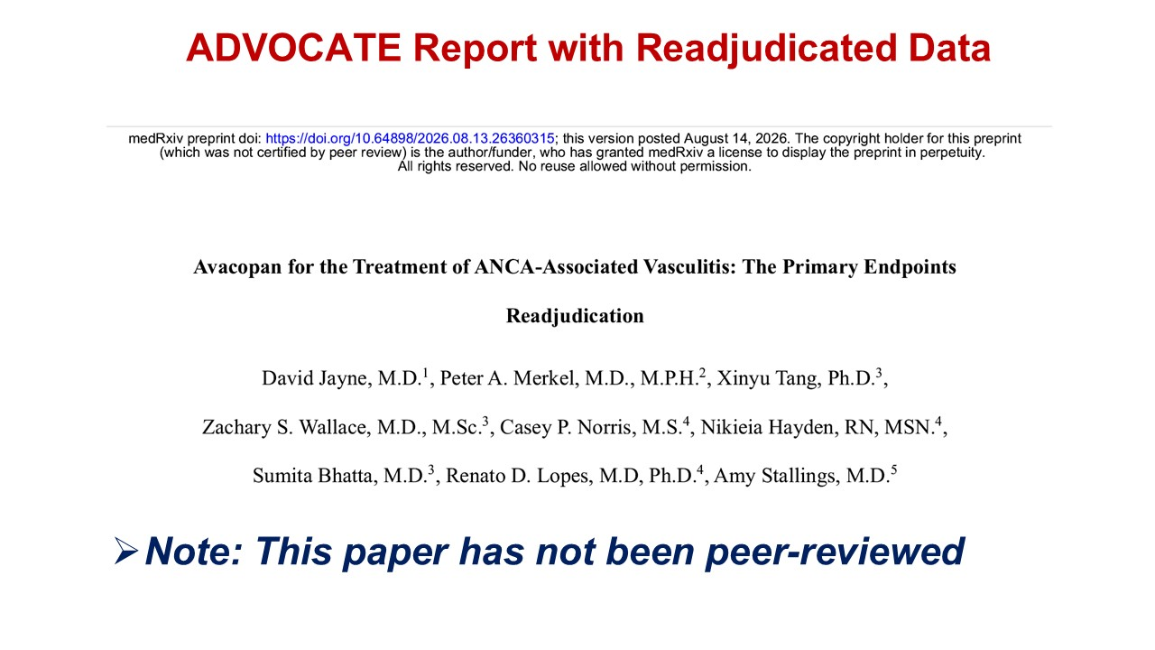
ADVOCATE Report with Readjudicated Data Note: This paper has not been peer-reviewed

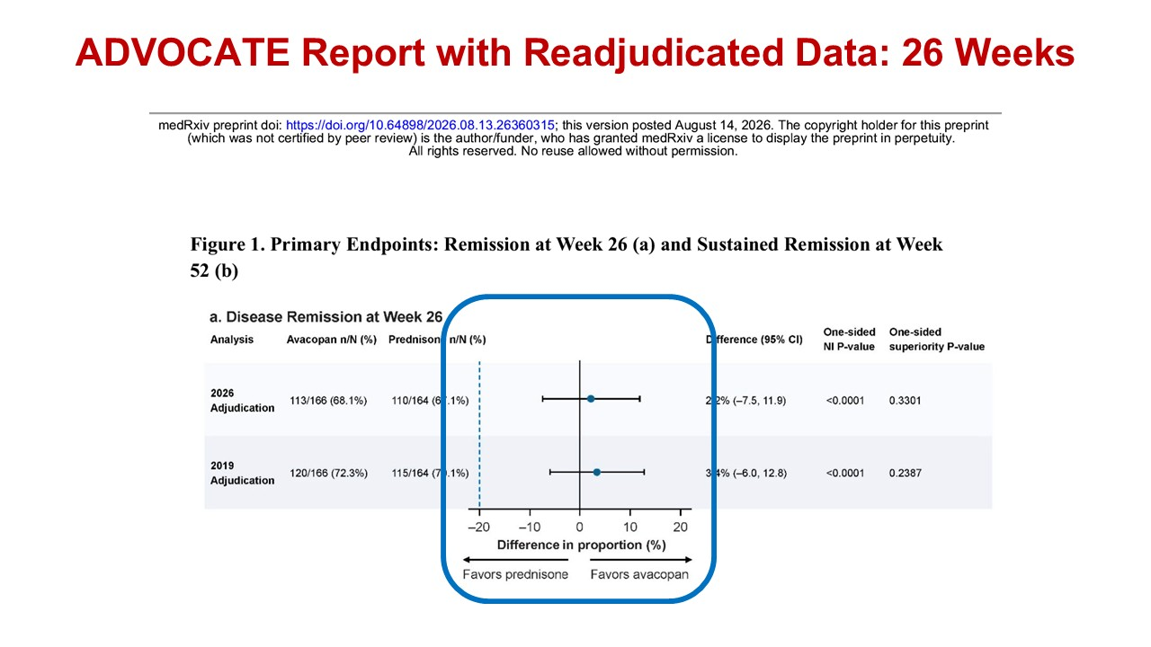
ADVOCATE Report with Readjudicated Data: 26 Weeks

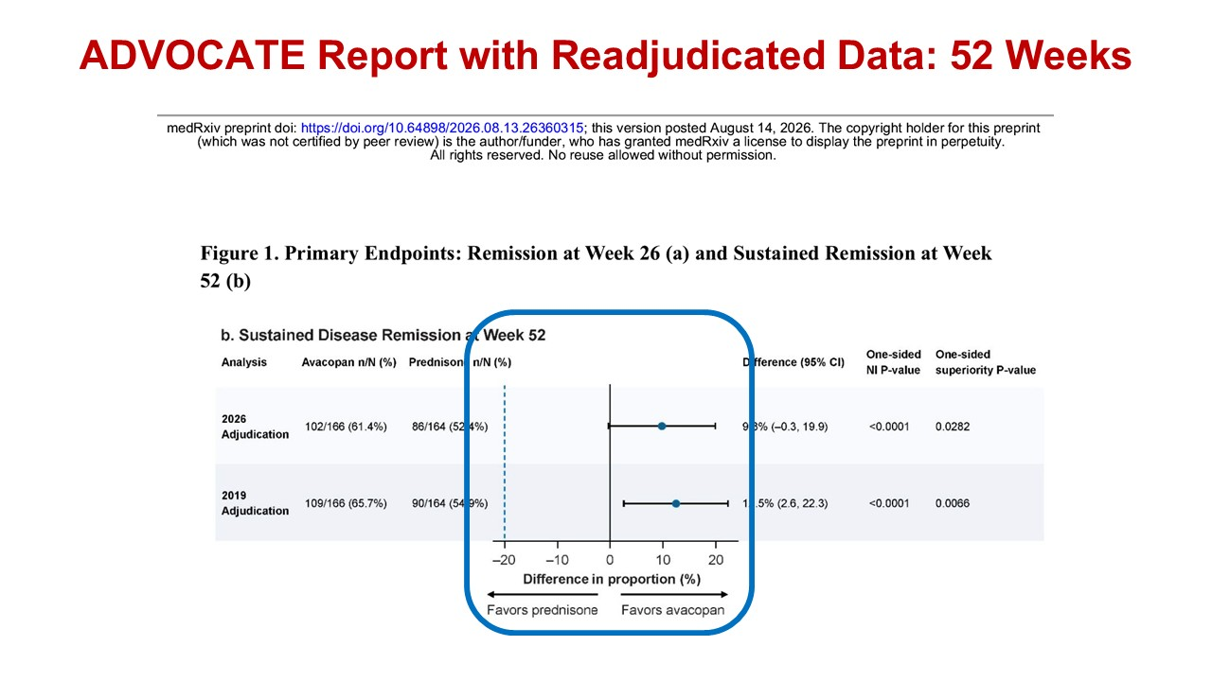
ADVOCATE Report with Readjudicated Data: 52 Weeks

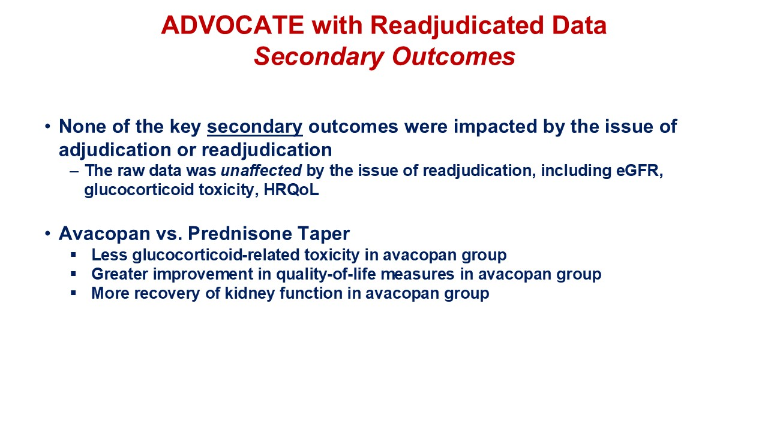
ADVOCATE with Readjudicated Data Secondary Outcomes None of the key secondary outcomes were impacted by the issue of adjudication or readjudication The raw data was unaffected by the issue of readjudication, including eGFR, glucocorticoid toxicity, HRQoL Avacopan vs. Prednisone Taper Less glucocorticoid-related toxicity in avacopan group Greater improvement in quality-of-life measures in avacopan group More recovery of kidney function in avacopan group

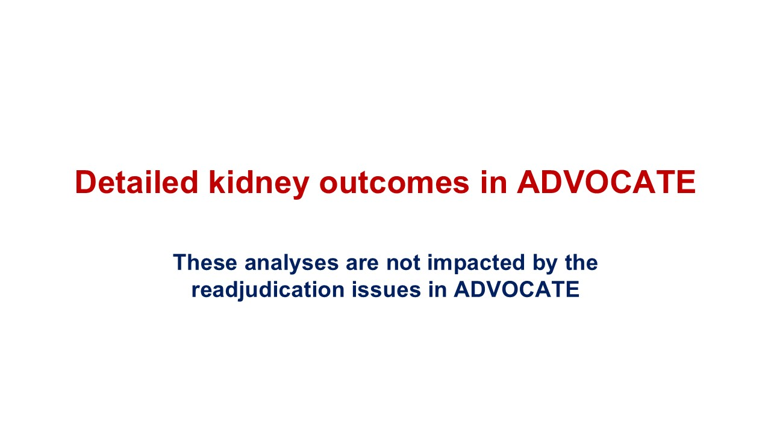
Detailed kidney outcomes in ADVOCATE These analyses are not impacted by the readjudication issues in ADVOCATE

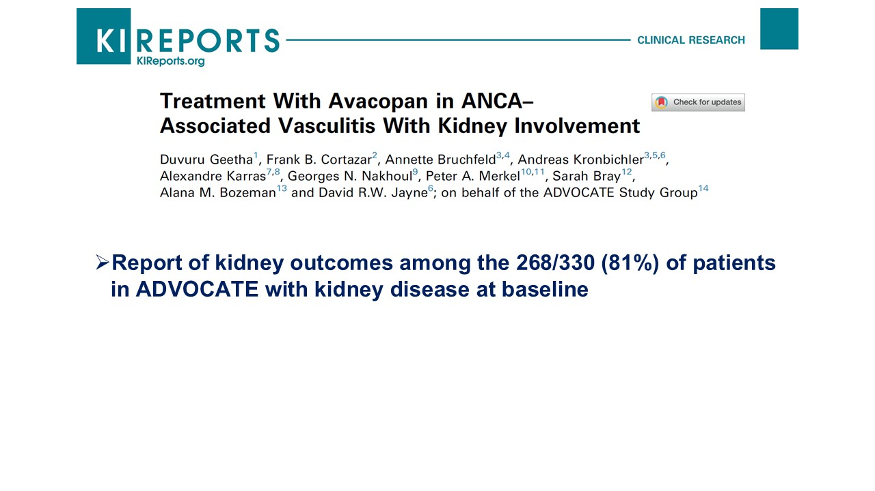
Report of kidney outcomes among the 268/330 (81%) of patients in ADVOCATE with kidney disease at baseline

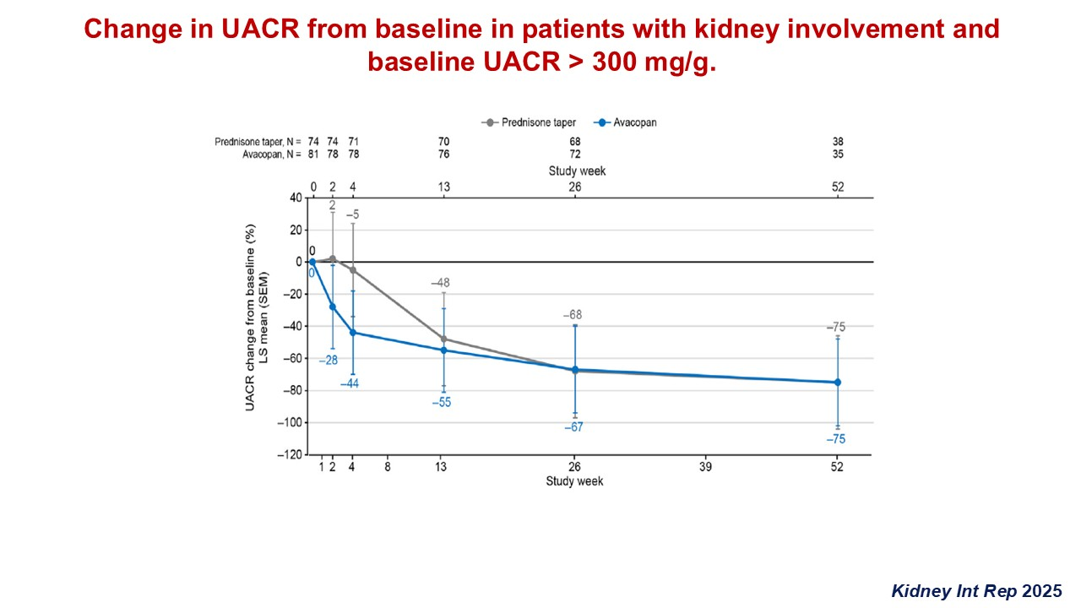
Change in UACR from baseline in patients with kidney involvement andbaseline UACR > 300 mg/g. Kidney Int Rep 2025

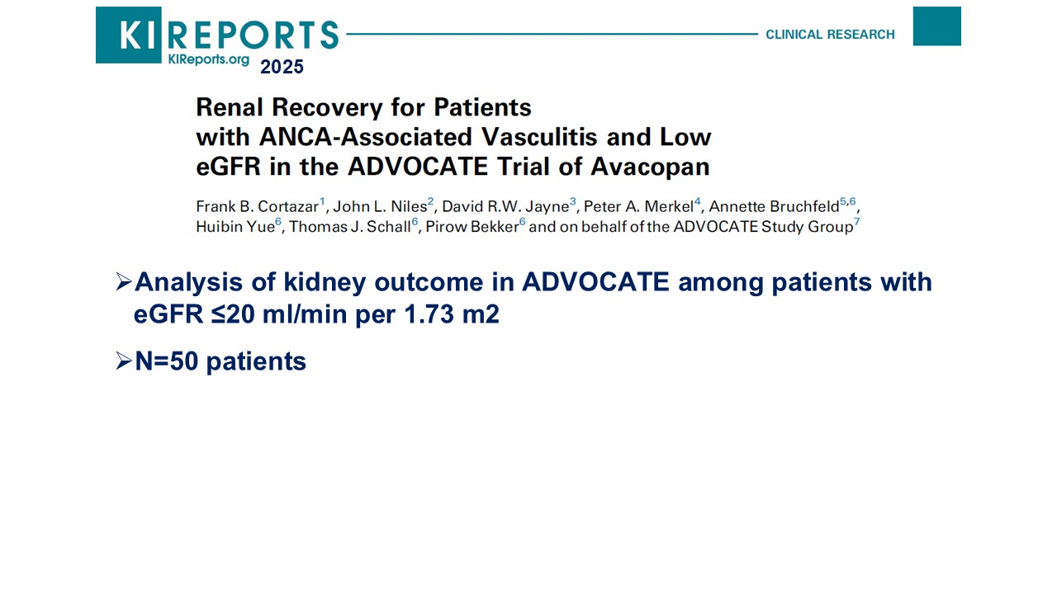
Analysis of kidney outcome in ADVOCATE among patients with eGFR ≤20 ml/min per 1.73 m2 N=50 patients 2025

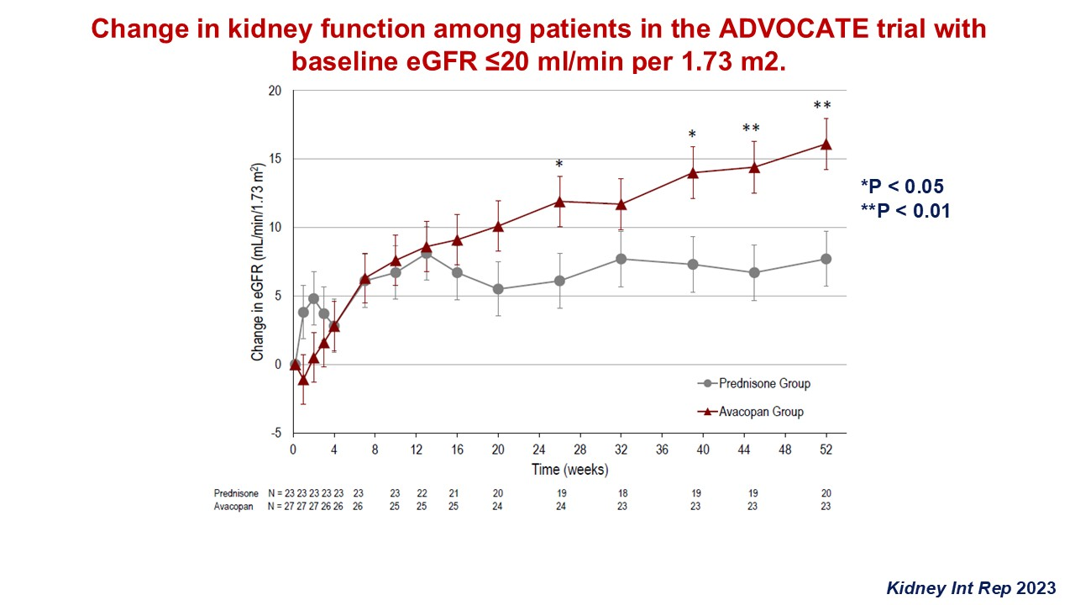
Change in kidney function among patients in the ADVOCATE trial with baseline eGFR ≤20 ml/min per 1.73 m2. *P < 0.05 **P < 0.01 Kidney Int Rep 2023

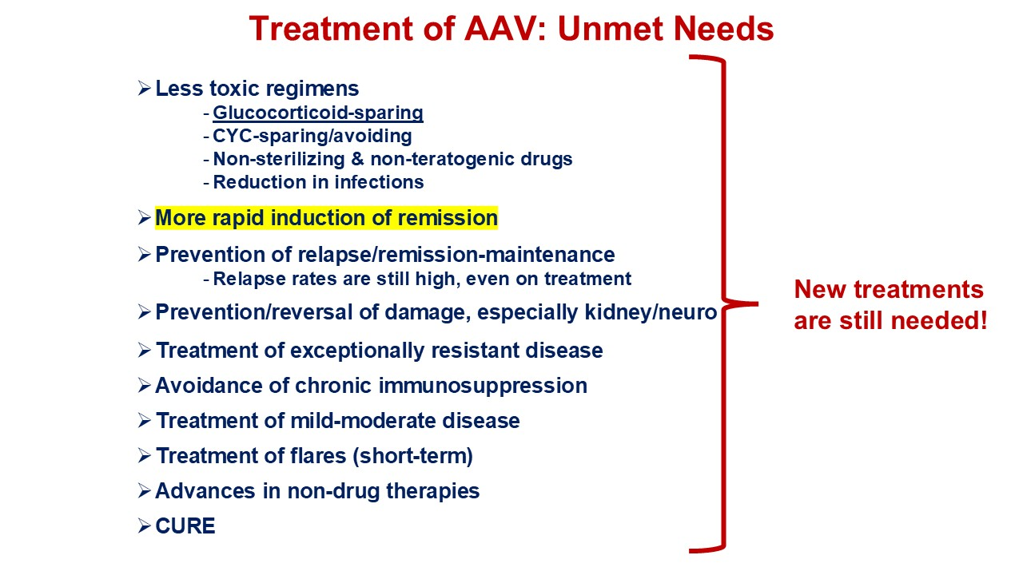
Treatment of AAV: Unmet Needs Less toxic regimens Glucocorticoid-sparing CYC-sparing/avoiding Non-sterilizing & non-teratogenic drugs Reduction in infections More rapid induction of remission Prevention of relapse/remission-maintenance Relapse rates are still high, even on treatment Prevention/reversal of damage, especially kidney/neuro Treatment of exceptionally resistant disease Avoidance of chronic immunosuppression Treatment of mild-moderate disease Treatment of flares (short-term) Advances in non-drug therapies CURE New treatments are still needed!

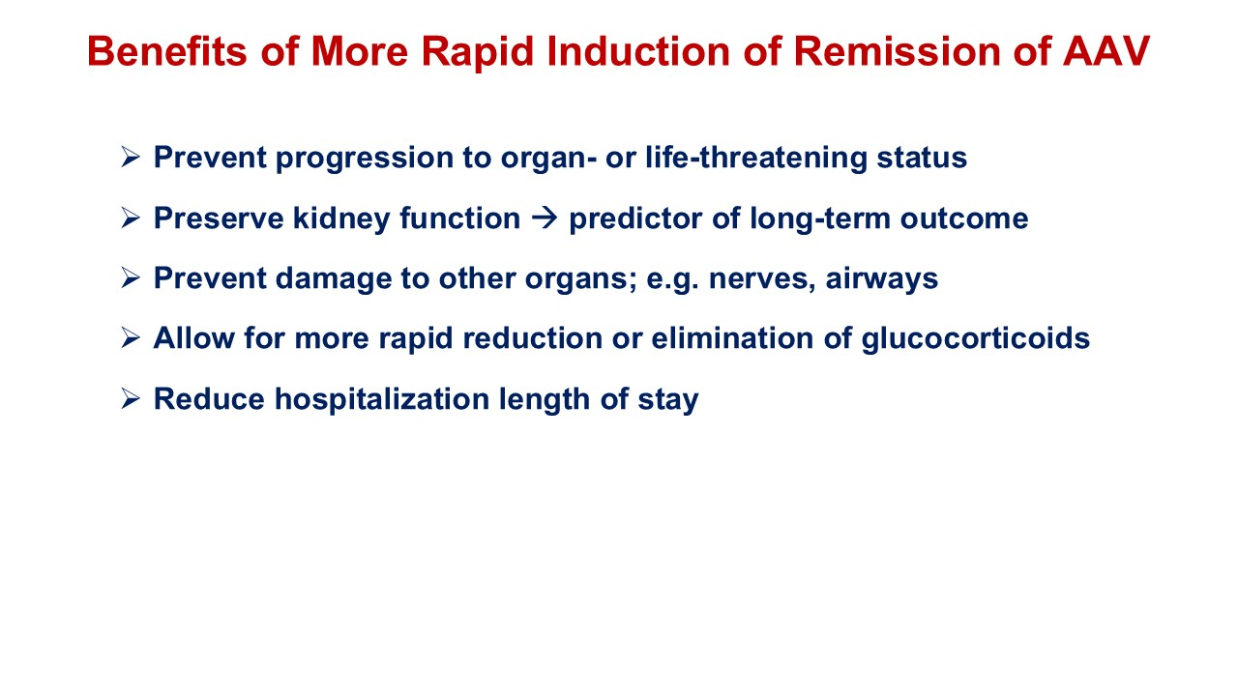
Benefits of More Rapid Induction of Remission of AAV Prevent progression to organ- or life-threatening status Preserve kidney function → predictor of long-term outcome Prevent damage to other organs; e.g. nerves, airways Allow for more rapid reduction or elimination of glucocorticoids Reduce hospitalization length of stay

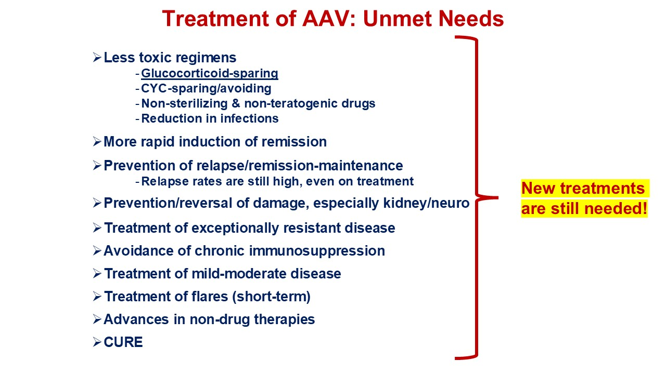
Treatment of AAV: Unmet Needs Less toxic regimens Glucocorticoid-sparing CYC-sparing/avoiding Non-sterilizing & non-teratogenic drugs Reduction in infections More rapid induction of remission Prevention of relapse/remission-maintenance Relapse rates are still high, even on treatment Prevention/reversal of damage, especially kidney/neuro Treatment of exceptionally resistant disease Avoidance of chronic immunosuppression Treatment of mild-moderate disease Treatment of flares (short-term) Advances in non-drug therapies CURE New treatments are still needed!

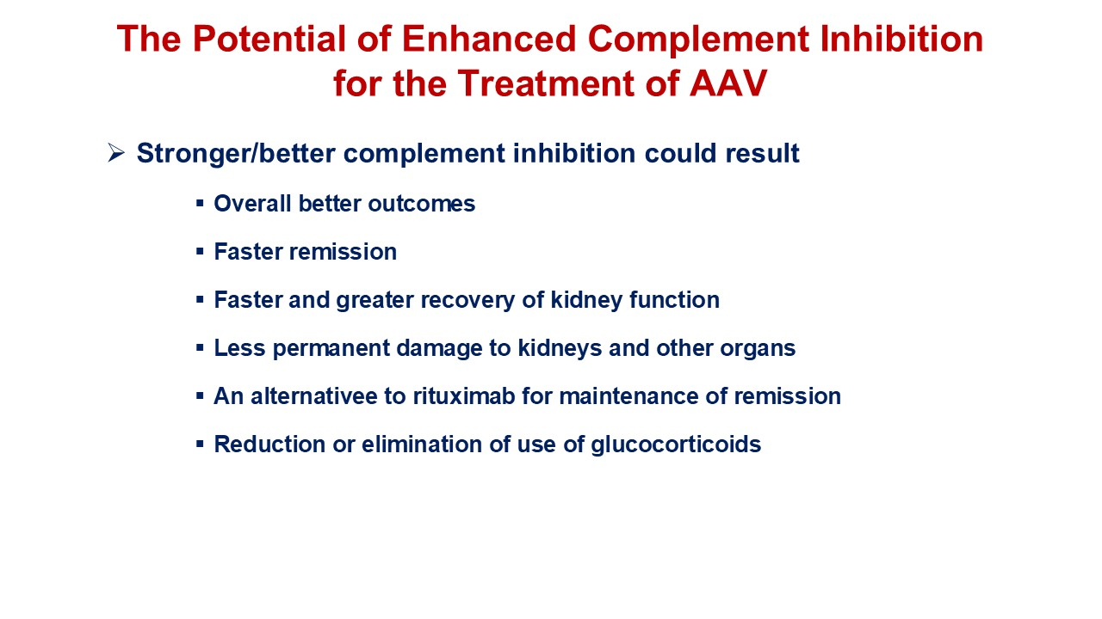
The Potential of Enhanced Complement Inhibition for the Treatment of AAV Stronger/better complement inhibition could result Overall better outcomes Faster remission Faster and greater recovery of kidney function Less permanent damage to kidneys and other organs An alternativee to rituximab for maintenance of remission Reduction or elimination of use of glucocorticoids

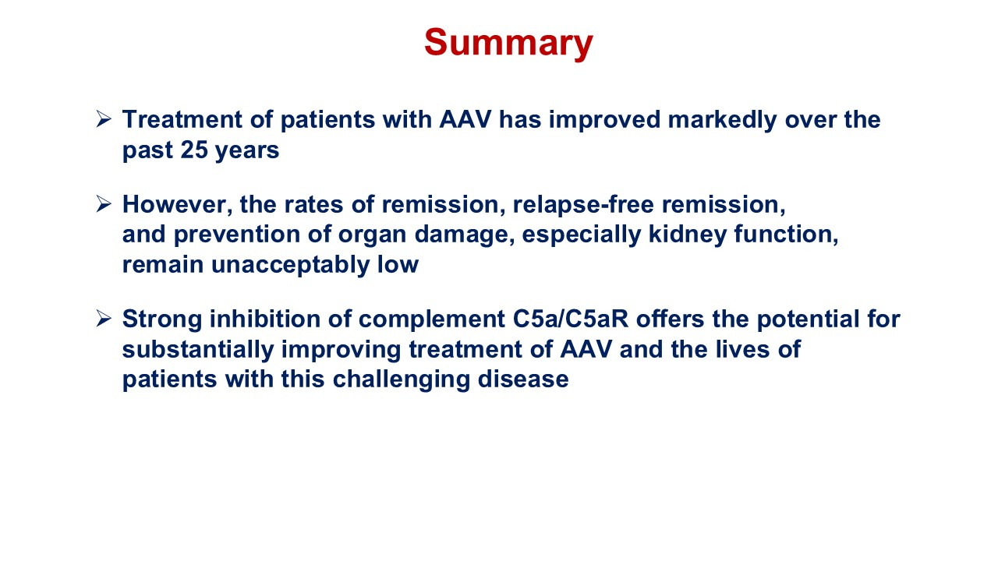
Summary Treatment of patients with AAV has improved markedly over the past 25 years However, the rates of remission, relapse-free remission, and prevention of organ damage, especially kidney function, remain unacceptably low Strong inhibition of complement C5a/C5aR offers the potential for substantially improving treatment of AAV and the lives of patients with this challenging disease

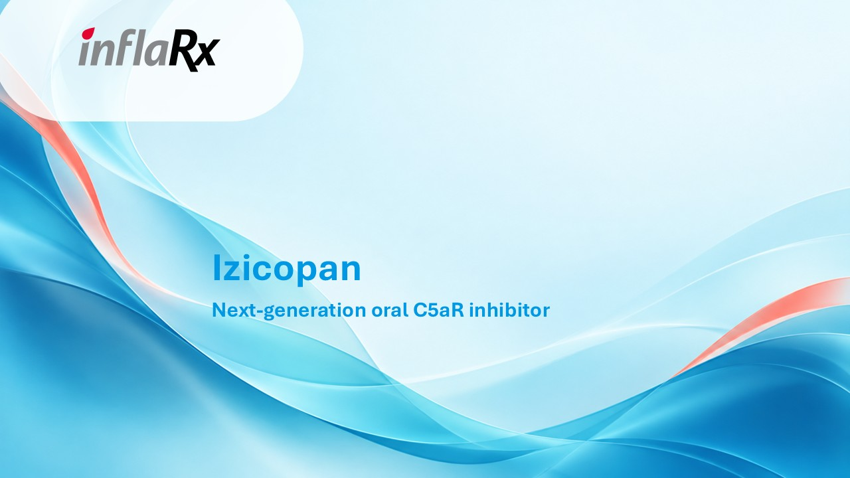
Izicopan Next-generation oral C5aR inhibitor

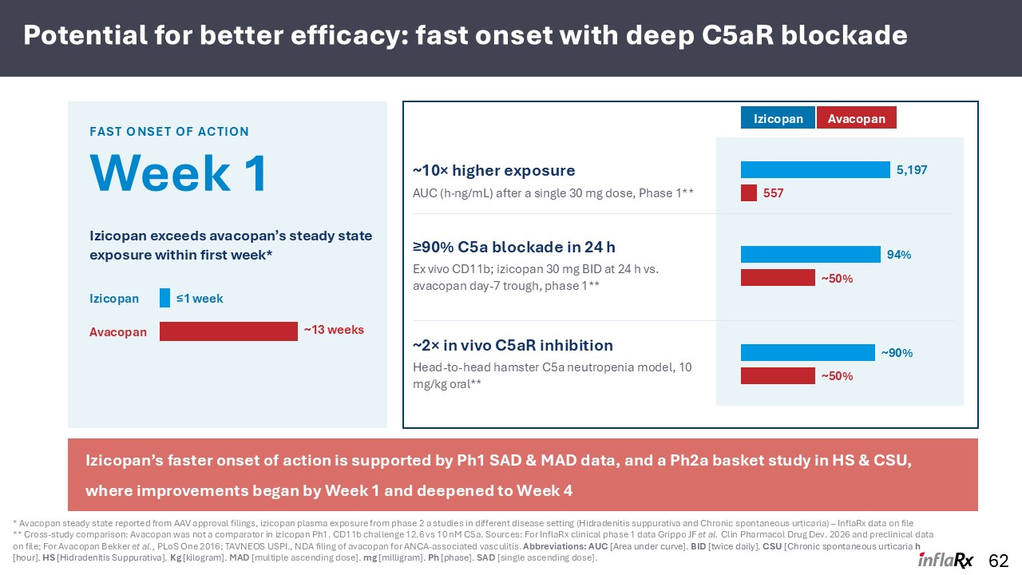
Potential for better efficacy: fast onset with deep C5aR blockade 62 FAST ONSET OF ACTION Week 1 Izicopan exceeds avacopan’s steady state exposure within first week* Izicopan ≤1 week Avacopan ~13 weeks Izicopan Avacopan ~10× higher exposure AUC (h·ng/mL) after a single 30 mg dose, Phase 1** 5,197 557 ≥90% C5a blockade in 24 h Ex vivo CD11b; izicopan 30 mg BID at 24 h vs. avacopan day-7 trough, phase 1** 94% ~50% ~2× in vivo C5aR inhibition Head-to-head hamster C5a neutropenia model, 10 mg/kg oral** ~90% ~50% Izicopan’s faster onset of action is supported by Ph1 SAD & MAD data, and a Ph2a basket study in HS & CSU, where improvements began by Week 1 and deepened to Week 4 * Avacopan steady state reported from AAV approval filings, izicopan plasma exposure from phase 2 a studies in different disease setting (Hidradenitis suppurativa and Chronic spontaneous urticaria) – InflaRx data on file ** Cross-study comparison: Avacopan was not a comparator in izicopan Ph1. CD11b challenge 12.6 vs 10 nM C5a. Sources: For InflaRx clinical phase 1 data Grippo JF et al. Clin Pharmacol Drug Dev. 2026 and preclinical data on file; For Avacopan Bekker et al., PLoS One 2016; TAVNEOS USPI., NDA filing of avacopan for ANCA-associated vasculitis. Abbreviations: AUC [Area under curve]. BID [twice daily]. CSU [Chronic spontaneous urticaria h [hour]. HS [Hidradenitis Suppurativa]. Kg [kilogram]. MAD [multiple ascending dose]. mg [milligram]. Ph [phase]. SAD [single ascending dose].

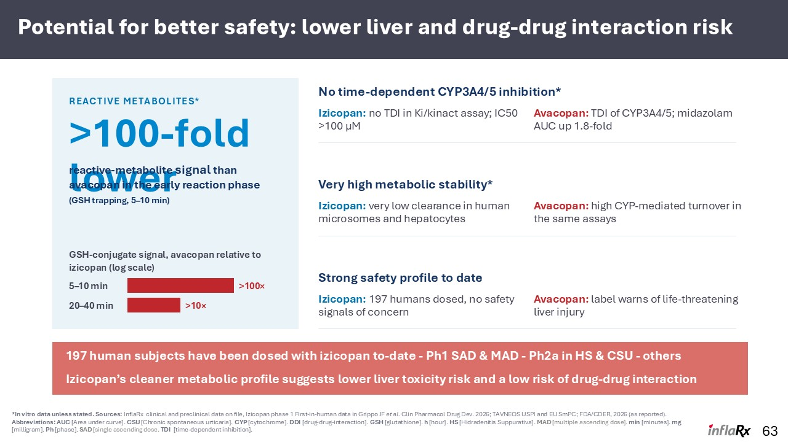
Potential for better safety: lower liver and drug-drug interaction risk 63 REACTIVE METABOLITES* >100-fold lower reactive-metabolite signal than avacopan in the early reaction phase (GSH trapping, 5–10 min) GSH-conjugate signal, avacopan relative to izicopan (log scale) 5–10 min >100× 20–40 min >10× Izicopan: no TDI in Ki/kinact assay; IC50 >100 µM Avacopan: TDI of CYP3A4/5; midazolam AUC up 1.8-fold Izicopan: very low clearance in human microsomes and hepatocytes Avacopan: high CYP-mediated turnover in the same assays Izicopan: 197 humans dosed, no safety signals of concern Avacopan: label warns of life-threatening liver injury 197 human subjects have been dosed with izicopan to-date - Ph1 SAD & MAD - Ph2a in HS & CSU - others Izicopan’s cleaner metabolic profile suggests lower liver toxicity risk and a low risk of drug-drug interaction *In vitro data unless stated. Sources: InflaRx clinical and preclinical data on file, Izicopan phase 1 First-in-human data in Grippo JF et al. Clin Pharmacol Drug Dev. 2026; TAVNEOS USPI and EU SmPC; FDA/CDER, 2026 (as reported). Abbreviations: AUC [Area under curve]. CSU [Chronic spontaneous urticaria]. CYP [cytochrome]. DDI [drug-drug-interaction]. GSH [glutathione]. h [hour]. HS [Hidradenitis Suppurativa]. MAD [multiple ascending dose]. min [minutes]. mg [milligram]. Ph [phase]. SAD [single ascending dose. TDI [time-dependent inhibition]. No time-dependent CYP3A4/5 inhibition* Very high metabolic stability* Strong safety profile to date

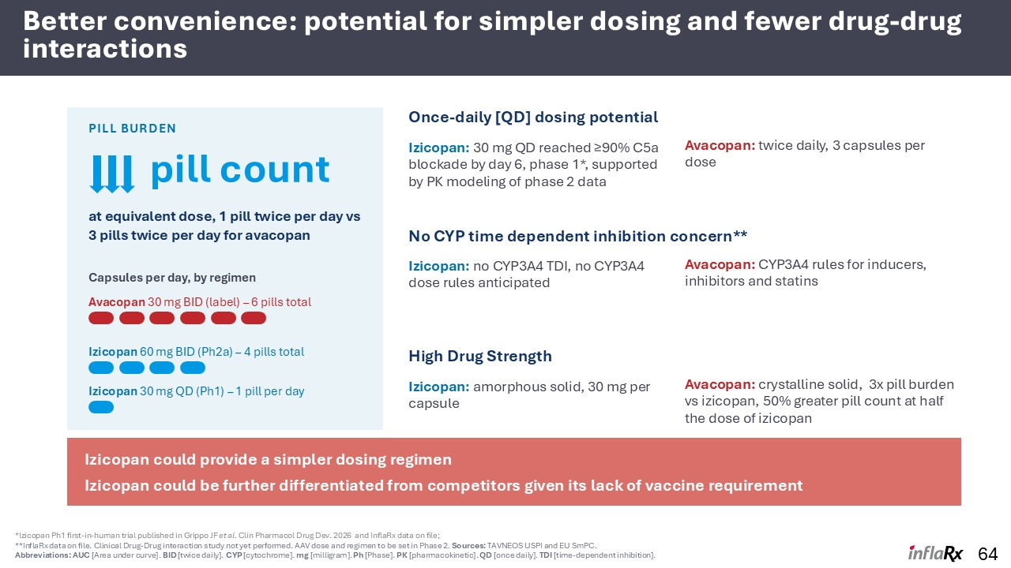
Better convenience: potential for simpler dosing and fewer drug-drug interactions 64 PILL BURDEN at equivalent dose, 1 pill twice per day vs 3 pills twice per day for avacopan Capsules per day, by regimen Avacopan 30 mg BID (label) – 6 pills total Izicopan 60 mg BID (Ph2a) – 4 pills total Izicopan 30 mg QD (Ph1) – 1 pill per day Izicopan could provide a simpler dosing regimen Izicopan could be further differentiated from competitors given its lack of vaccine requirement *Izicopan Ph1 first-in-human trial published in Grippo JF et al. Clin Pharmacol Drug Dev. 2026 and InflaRx data on file; **InflaRx data on file. Clinical Drug-Drug interaction study not yet performed. AAV dose and regimen to be set in Phase 2. Sources: TAVNEOS USPI and EU SmPC. Abbreviations: AUC [Area under curve]. BID [twice daily]. CYP [cytochrome]. mg [milligram]. Ph [Phase]. PK [pharmacokinetic]. QD [once daily]. TDI [time-dependent inhibition]. pill count Once-daily [QD] dosing potential Izicopan: 30 mg QD reached ≥90% C5a blockade by day 6, phase 1*, supported by PK modeling of phase 2 data Avacopan: twice daily, 3 capsules per dose No CYP time dependent inhibition concern** Izicopan: no CYP3A4 TDI, no CYP3A4 dose rules anticipated Avacopan: CYP3A4 rules for inducers, inhibitors and statins High Drug Strength Izicopan: amorphous solid, 30 mg per capsule Avacopan: crystalline solid, 3x pill burden vs izicopan, 50% greater pill count at half the dose of izicopan

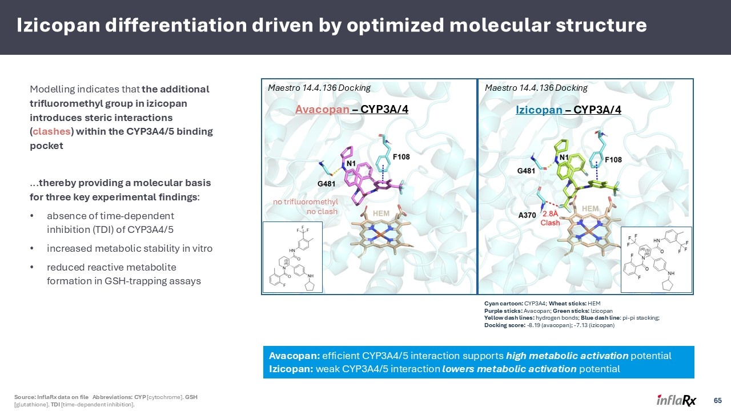
Izicopan differentiation driven by optimized molecular structure Modelling indicates that the additional trifluoromethyl group in izicopan introduces steric interactions (clashes) within the CYP3A4/5 binding pocket ...thereby providing a molecular basis for three key experimental findings: absence of time-dependent inhibition (TDI) of CYP3A4/5 increased metabolic stability in vitro reduced reactive metabolite formation in GSH-trapping assays Avacopan – CYP3A/4 Izicopan – CYP3A/4 no trifluoromethyl no clash Maestro 14.4.136 Docking Maestro 14.4.136 Docking Cyan cartoon: CYP3A4; Wheat sticks: HEM Purple sticks: Avacopan; Green sticks: Izicopan Yellow dash lines: hydrogen bonds; Blue dash line: pi-pi stacking; Docking score: -8.19 (avacopan); -7.13 (izicopan) Avacopan: efficient CYP3A4/5 interaction supports high metabolic activation potential Izicopan: weak CYP3A4/5 interaction lowers metabolic activation potential 65 Source: InflaRx data on file Abbreviations: CYP [cytochrome]. GSH [glutathione]. TDI [time-dependent inhibition].

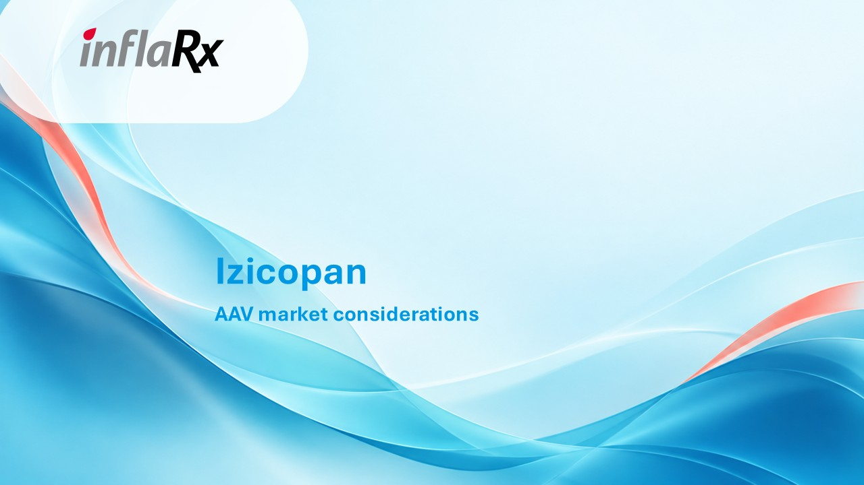
Izicopan AAV market considerations

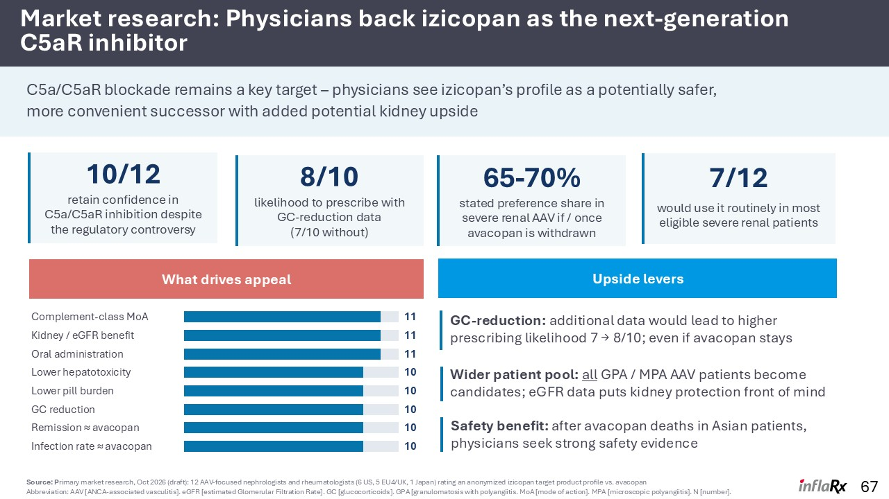
67 Market research: Physicians back izicopan as the next-generation C5aR inhibitor C5a/C5aR blockade remains a key target – physicians see izicopan’s profile as a potentially safer, more convenient successor with added potential kidney upside What drives appeal Complement-class MoA 11 Kidney / eGFR benefit 11 Oral administration 11 Lower hepatotoxicity 10 Lower pill burden 10 GC reduction 10 Remission ≈ avacopan 10 Infection rate ≈ avacopan 10 10/12 retain confidence in C5a/C5aR inhibition despite the regulatory controversy 8/10 likelihood to prescribe with GC-reduction data (7/10 without) 65-70% stated preference share in severe renal AAV if / once avacopan is withdrawn 7/12 would use it routinely in most eligible severe renal patients Upside levers Source: Primary market research, Oct 2026 (draft): 12 AAV-focused nephrologists and rheumatologists (6 US, 5 EU4/UK, 1 Japan) rating an anonymized izicopan target product profile vs. avacopan Abbreviation: AAV [ANCA-associated vasculitis]. eGFR [estimated Glomerular Filtration Rate]. GC [glucocorticoids]. GPA [granulomatosis with polyangiitis. MoA [mode of action]. MPA [microscopic polyangiitis]. N [number]. GC-reduction: additional data would lead to higher prescribing likelihood 7 → 8/10; even if avacopan stays Safety benefit: after avacopan deaths in Asian patients, physicians seek strong safety evidence Wider patient pool: all GPA / MPA AAV patients become candidates; eGFR data puts kidney protection front of mind

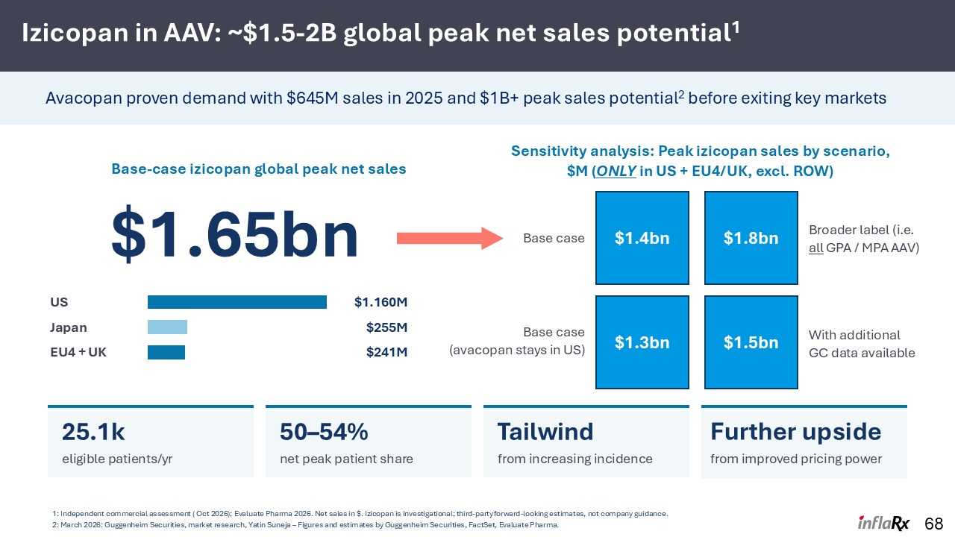
Izicopan in AAV: ~$1.5-2B global peak net sales potential1 68 Base-case izicopan global peak net sales $1.65bn US $1.160M Japan $255M EU4 + UK $241M Sensitivity analysis: Peak izicopan sales by scenario, $M (ONLY in US + EU4/UK, excl. ROW) With additional GC data available 25.1k eligible patients/yr 50–54% net peak patient share Tailwind from increasing incidence Avacopan proven demand with $645M sales in 2025 and $1B+ peak sales potential2 before exiting key markets 1: Independent commercial assessment ( Oct 2026); Evaluate Pharma 2026. Net sales in $. Izicopan is investigational; third-party forward-looking estimates, not company guidance. 2: March 2026: Guggenheim Securities, market research, Yatin Suneja – Figures and estimates by Guggenheim Securities, FactSet, Evaluate Pharma. Further upside from improved pricing power $1.4bn $1.8bn $1.3bn $1.5bn Broader label (i.e. all GPA / MPA AAV) Base case Base case (avacopan stays in US)

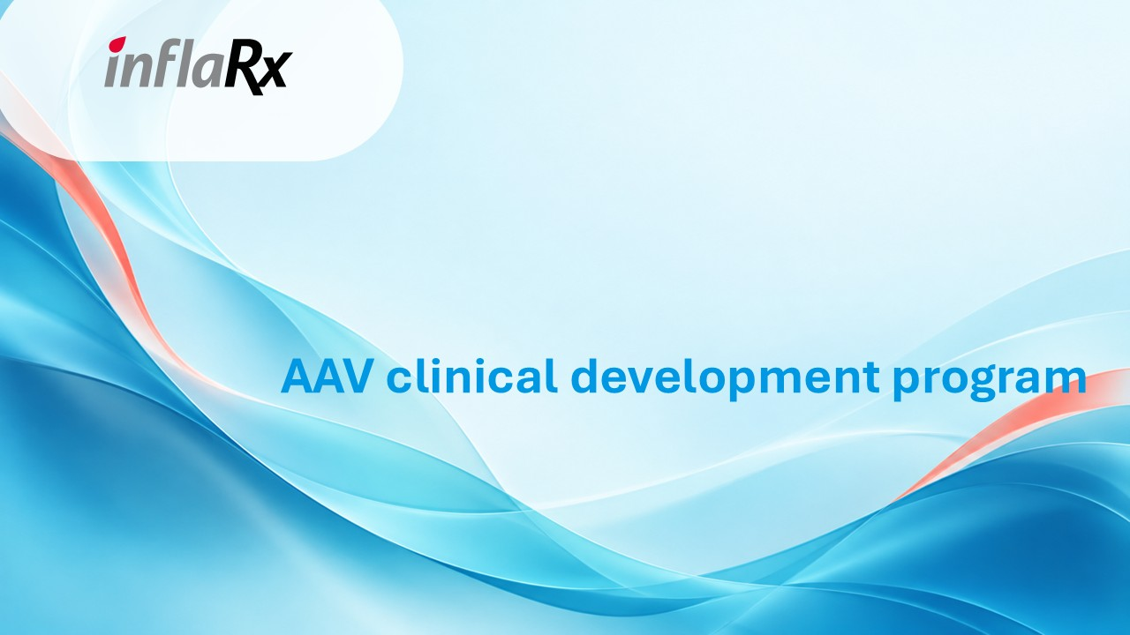
AAV clinical development program

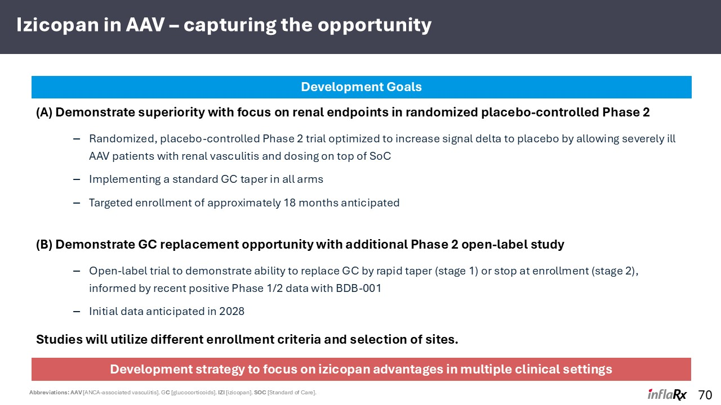
Izicopan in AAV – capturing the opportunity 70 (A) Demonstrate superiority with focus on renal endpoints in randomized placebo-controlled Phase 2 Randomized, placebo-controlled Phase 2 trial optimized to increase signal delta to placebo by allowing severely ill AAV patients with renal vasculitis and dosing on top of SoC Implementing a standard GC taper in all arms Targeted enrollment of approximately 18 months anticipated (B) Demonstrate GC replacement opportunity with additional Phase 2 open-label study Open-label trial to demonstrate ability to replace GC by rapid taper (stage 1) or stop at enrollment (stage 2), informed by recent positive Phase 1/2 data with BDB-001 Initial data anticipated in 2028 Development Goals Development strategy to focus on izicopan advantages in multiple clinical settings Studies will utilize different enrollment criteria and selection of sites. Abbreviations: AAV [ANCA-associated vasculitis]. GC [glucocorticoids]. IZI [izicopan]. SOC [Standard of Care].

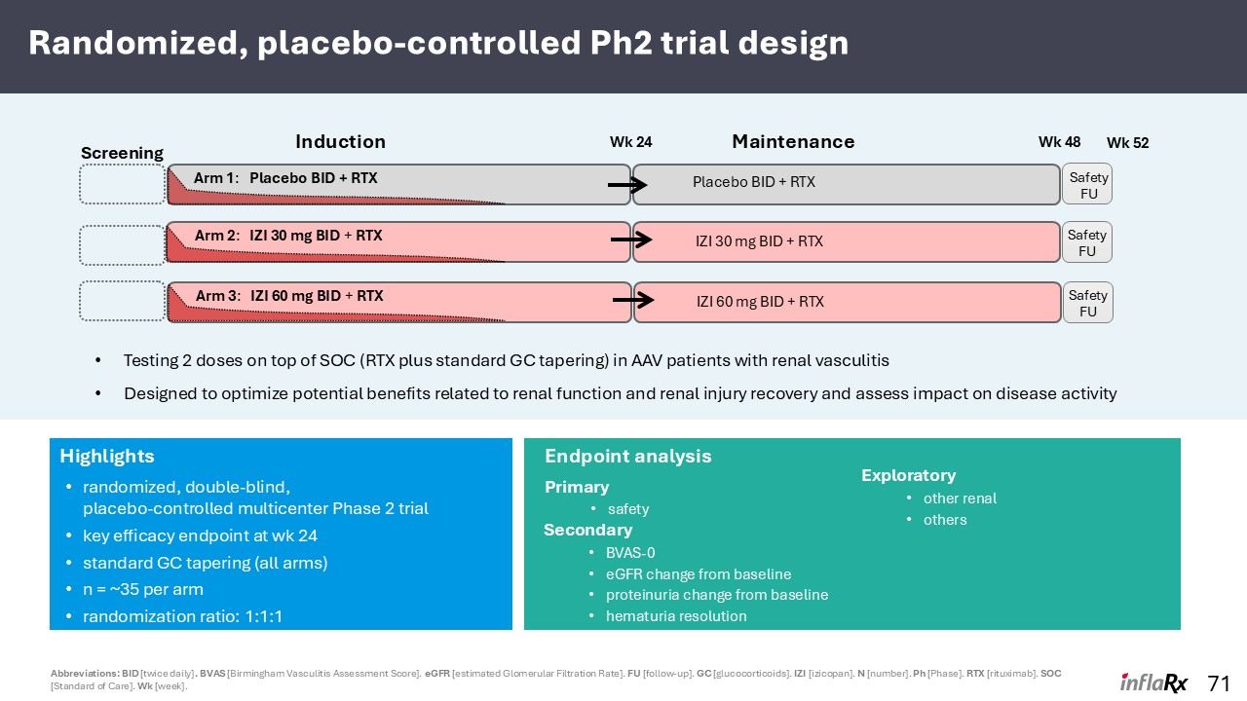
Randomized, placebo-controlled Ph2 trial design Abbreviations: BID [twice daily]. BVAS [Birmingham Vasculitis Assessment Score]. eGFR [estimated Glomerular Filtration Rate]. FU [follow-up]. GC [glucocorticoids]. IZI [izicopan]. N [number]. Ph [Phase]. RTX [rituximab]. SOC [Standard of Care]. Wk [week]. Highlights randomized, double-blind, placebo-controlled multicenter Phase 2 trial key efficacy endpoint at wk 24 standard GC tapering (all arms) n = ~35 per arm randomization ratio: 1:1:1 Endpoint analysis Primary safety Secondary BVAS-0 eGFR change from baseline proteinuria change from baseline hematuria resolution 71 Induction Screening Wk 24 Maintenance Wk 48 Testing 2 doses on top of SOC (RTX plus standard GC tapering) in AAV patients with renal vasculitis Designed to optimize potential benefits related to renal function and renal injury recovery and assess impact on disease activity Safety FU Arm 3: IZI 60 mg BID + RTX IZI 60 mg BID + RTX Safety FU Safety FU Arm 1: Placebo BID + RTX Arm 2: IZI 30 mg BID + RTX Placebo BID + RTX Wk 52 IZI 30 mg BID + RTX Exploratory other renal others

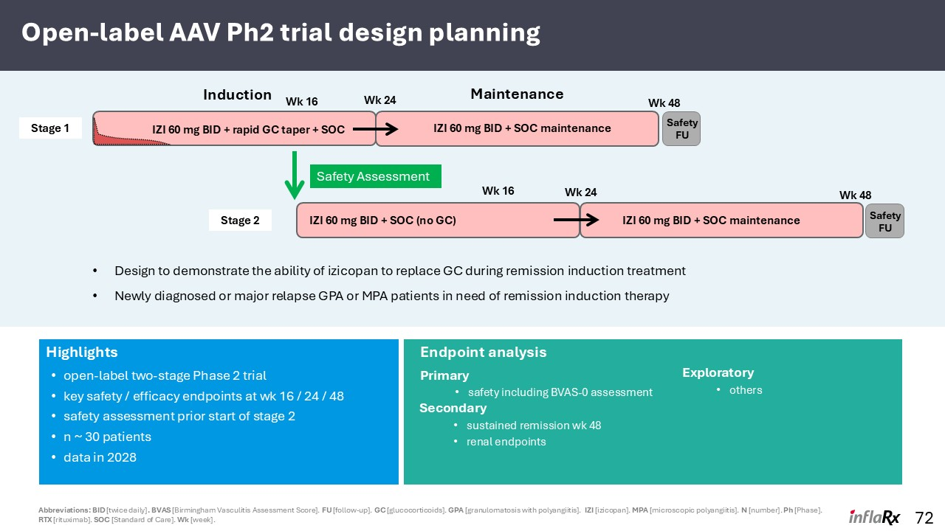
Open-label AAV Ph2 trial design planning Highlights open-label two-stage Phase 2 trial key safety / efficacy endpoints at wk 16 / 24 / 48 safety assessment prior start of stage 2 n ~ 30 patients data in 2028 Endpoint analysis Primary safety including BVAS-0 assessment Secondary sustained remission wk 48 renal endpoints 72 Design to demonstrate the ability of izicopan to replace GC during remission induction treatment Newly diagnosed or major relapse GPA or MPA patients in need of remission induction therapy Exploratory others IZI 60 mg BID + rapid GC taper + SOC Maintenance Induction Safety FU Safety Assessment Wk 16 Wk 24 Wk 48 IZI 60 mg BID + SOC (no GC) Safety FU Wk 16 Wk 24 Wk 48 IZI 60 mg BID + SOC maintenance Stage 1 Stage 2 Abbreviations: BID [twice daily]. BVAS [Birmingham Vasculitis Assessment Score]. FU [follow-up]. GC [glucocorticoids]. GPA [granulomatosis with polyangiitis]. IZI [izicopan]. MPA [microscopic polyangiitis]. N [number]. Ph [Phase]. RTX [rituximab]. SOC [Standard of Care]. Wk [week]. IZI 60 mg BID + SOC maintenance IZI 60 mg BID + SOC maintenance

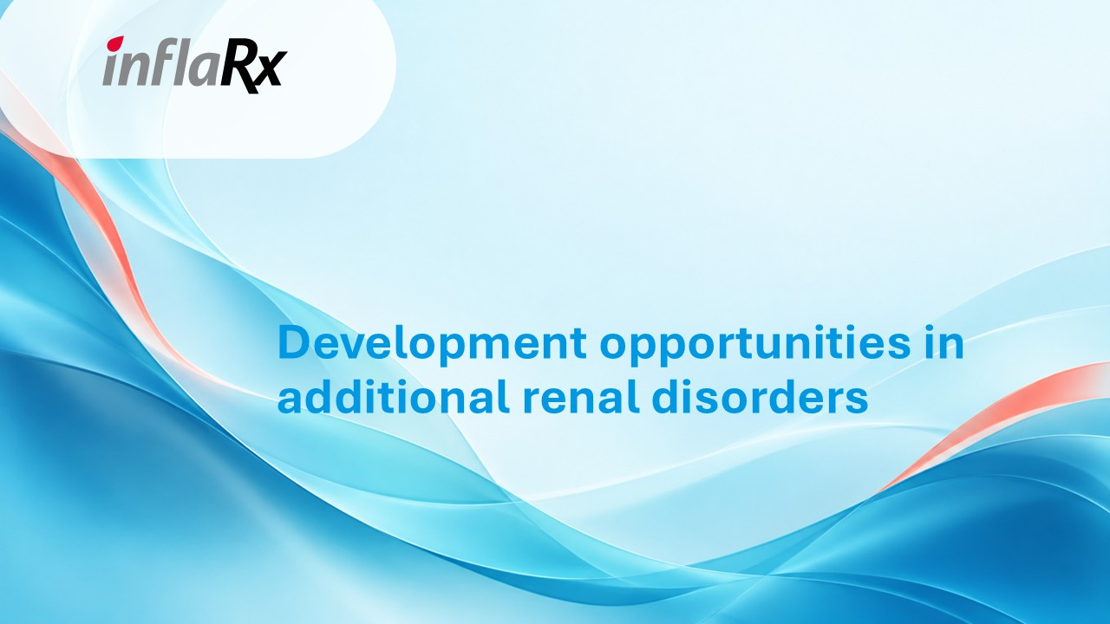
Development opportunities in additional renal disorders

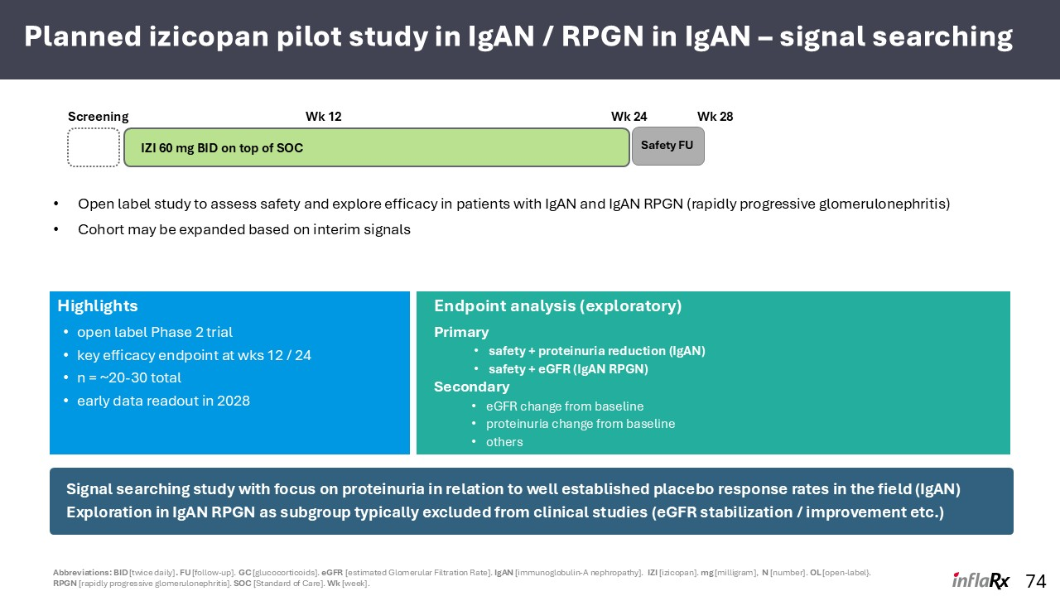
Planned izicopan pilot study in IgAN / RPGN in IgAN – signal searching 74 IZI 60 mg BID on top of SOC Safety FU Open label study to assess safety and explore efficacy in patients with IgAN and IgAN RPGN (rapidly progressive glomerulonephritis) Cohort may be expanded based on interim signals Wk 12 Wk 24 Wk 28 Signal searching study with focus on proteinuria in relation to well established placebo response rates in the field (IgAN) Exploration in IgAN RPGN as subgroup typically excluded from clinical studies (eGFR stabilization / improvement etc.) Highlights open label Phase 2 trial key efficacy endpoint at wks 12 / 24 n = ~20-30 total early data readout in 2028 Endpoint analysis (exploratory) Primary safety + proteinuria reduction (IgAN) safety + eGFR (IgAN RPGN) Secondary eGFR change from baseline proteinuria change from baseline others Abbreviations: BID [twice daily]. FU [follow-up]. GC [glucocorticoids]. eGFR [estimated Glomerular Filtration Rate]. IgAN [immunoglobulin-A nephropathy]. IZI [izicopan]. mg [milligram], N [number]. OL [open-label}. RPGN [rapidly progressive glomerulonephritis]. SOC [Standard of Care]. Wk [week]. Screening

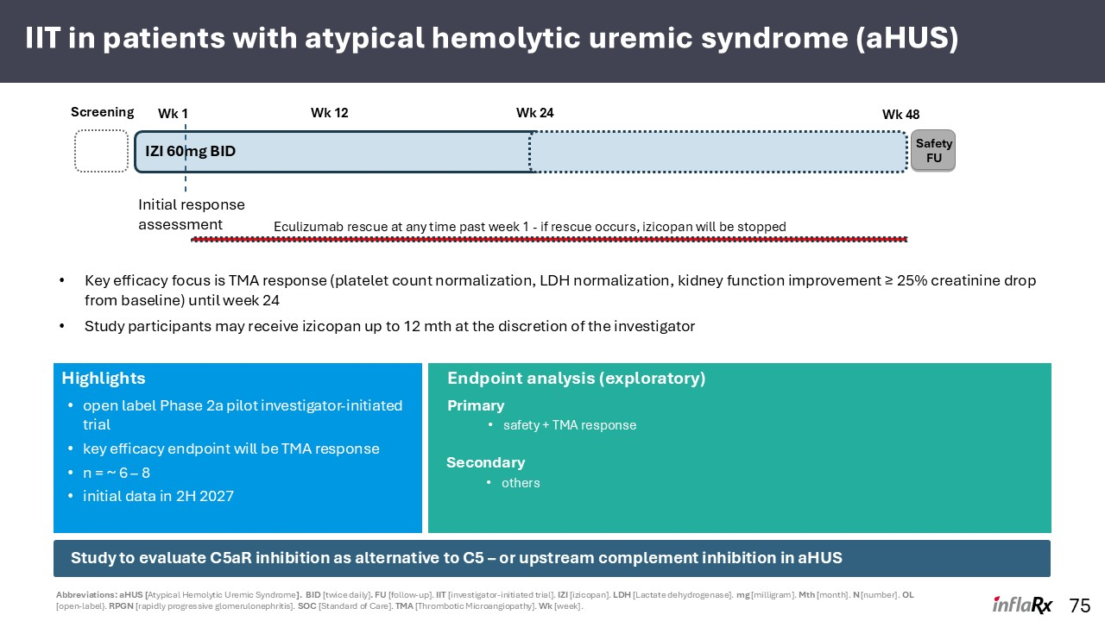
IIT in patients with atypical hemolytic uremic syndrome (aHUS) 75 IZI 60mg BID Safety FU Key efficacy focus is TMA response (platelet count normalization, LDH normalization, kidney function improvement ≥ 25% creatinine drop from baseline) until week 24 Study participants may receive izicopan up to 12 mth at the discretion of the investigator Wk 1 Wk 12 Wk 24 Study to evaluate C5aR inhibition as alternative to C5 – or upstream complement inhibition in aHUS Initial response assessment Eculizumab rescue at any time past week 1 - if rescue occurs, izicopan will be stopped Wk 48 Highlights open label Phase 2a pilot investigator-initiated trial key efficacy endpoint will be TMA response n = ~ 6 – 8 initial data in 2H 2027 Endpoint analysis (exploratory) Primary safety + TMA response Secondary others Screening Abbreviations: aHUS [Atypical Hemolytic Uremic Syndrome]. BID [twice daily]. FU [follow-up]. IIT [investigator-initiated trial]. IZI [izicopan]. LDH [Lactate dehydrogenase]. mg [milligram]. Mth [month]. N [number]. OL [open-label}. RPGN [rapidly progressive glomerulonephritis]. SOC [Standard of Care]. TMA [Thrombotic Microangiopathy]. Wk [week].

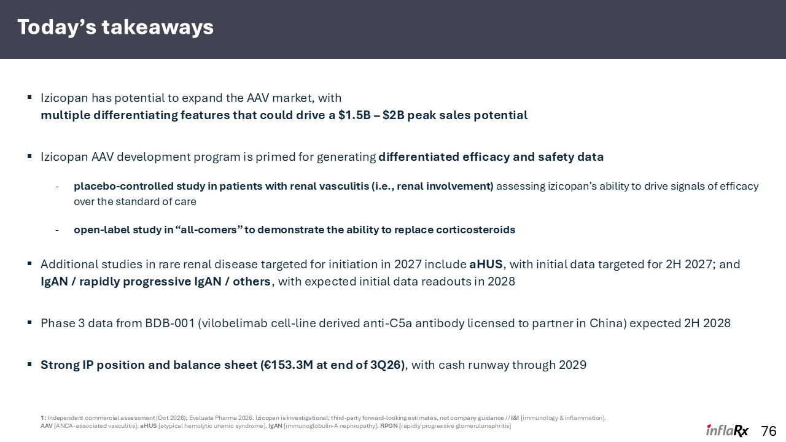
Today’s takeaways Izicopan has potential to expand the AAV market, with multiple differentiating features that could drive a $1.5B – $2B peak sales potential Izicopan AAV development program is primed for generating differentiated efficacy and safety data placebo-controlled study in patients with renal vasculitis (i.e., renal involvement) assessing izicopan’s ability to drive signals of efficacy over the standard of care open-label study in “all-comers” to demonstrate the ability to replace corticosteroids Additional studies in rare renal disease targeted for initiation in 2027 include aHUS, with initial data targeted for 2H 2027; and IgAN / rapidly progressive IgAN / others, with expected initial data readouts in 2028 Phase 3 data from BDB-001 (vilobelimab cell-line derived anti-C5a antibody licensed to partner in China) expected 2H 2028 Strong IP position and balance sheet (€153.3M at end of 3Q26), with cash runway through 2029 76 1: Independent commercial assessment (Oct 2026); Evaluate Pharma 2026. Izicopan is investigational; third-party forward-looking estimates, not company guidance // I&I [immunology & inflammation]. AAV [ANCA-associated vasculitis]. aHUS [atypical hemolytic uremic syndrome]. IgAN [immunoglobulin-A nephropathy]. RPGN [rapidly progressive glomerulonephritis]



