6-K 1 ef20072565_6k.htm 6-K

UNITED STATES
SECURITIES AND EXCHANGE COMMISSION
WASHINGTON, D.C. 20549

FORM 6-K

Report of Foreign Private
Issuer Pursuant to Rule
13a-16 or 15d-16 of the
Securities Exchange Act
of 1934
For the month of May 2026
Commission File
Number: 001-38283

InflaRx N.V.
(Exact name of Registrant as Specified in Its Charter)

Winzerlaer Str. 2
07745 Jena,
Germany
(+49) 3641508180

(Address of principal executive offices)

Indicate by check mark whether the registrant files or will file annual reports under cover of Form 20-F or Form 40-F.

Form 20-F ☒ Form 40-F ☐

EXPLANATORY NOTE

On May 6, 2026, InflaRx N.V. (the “Company”) issued a press release titled “InflaRx Announces Advancement of Izicopan in ANCA-Associated Vasculitis and Select Renal Diseases.”

The Company today announced that it intends to develop izicopan, an oral C5a receptor (C5aR) inhibitor with potential best-in-class properties, in ANCA-associated vasculitis (AAV), a life-threatening kidney disorder. The Company is conducting Phase 2 planning for izicopan in AAV and is evaluating the feasibility of multiple development approaches, including the potential for an expedited path to the commercial market, in an effort to best address the evolving regulatory environment surrounding the currently approved comparator, avacopan.

In addition, the Company announced its goal of establishing rapid proof of concept for izicopan across a broader range of complement-mediated life-threatening kidney diseases by conducting open-label studies that are expected to begin generating clinical data next year in certain indications. These additional renal disease targets include atypical hemolytic uremic syndrome (aHUS), IgA nephropathy (IgAN) and C3 glomerulopathy (C3G), where early evidence already exists for the role of C5a/C5aR inhibition and where izicopan’s favorable clinical profile could be a significant differentiator. Toward these efforts, the Company anticipates conducting a pharmacokinetic bridging study in China this year.

A copy of the press release and a copy of the Company’s presentation are attached as Exhibit 99.1 and Exhibit 99.2, respectively. Both Exhibit 99.1 and 99.2 shall not be deemed “filed” for purposes of Section 18 of the Securities Exchange Act of 1934, as amended (the “Exchange Act”), or otherwise subject to the liabilities of that section, nor shall it be deemed incorporated by reference in any filing under the Securities Act of 1933, as amended, or the Exchange Act.

FORWARD-LOOKING STATEMENTS

This Report contains forward-looking statements. All statements other than statements of historical fact are forward-looking statements, which are often indicated by terms such as “may,” “will,” “should,” “expect,” “plan,” “anticipate,” “could,” “intend,” “target,” “project,” “estimate,” “believe,” “predict,” “potential” or “continue,” among others. Forward-looking statements appear in a number of places throughout this Report and may include statements regarding our intentions, beliefs, projections, outlook, analyses, current expectations and the risks, uncertainties and other factors described under the headings, “Risk factors” and “Cautionary statement regarding forward looking statements,” in our periodic filings with the U.S. Securities and Exchange Commission. These statements speak only as of the date of this Report and involve known and unknown risks, uncertainties and other important factors that may cause our actual results, performance or achievements to be materially different from any future results, performance or achievements expressed or implied by the forward-looking statements. Given these risks, uncertainties and other factors, you should not place undue reliance on these forward-looking statements, and we assume no obligation to update these forward-looking statements, even if new information becomes available in the future, except as required by law.

EXHIBIT INDEX

Exhibit No. | Description
99.1 | Press Release, dated May 6, 2026.
99.2 | Corporate Presentation, dated May 6, 2026.

SIGNATURES

Pursuant to the requirements of the Securities Exchange Act of 1934, the registrant has duly caused this report to be signed on its behalf by the undersigned, thereunto duly authorized.

 | INFLARX N.V.
Date: May 6, 2026 | By: | /s/ Niels Riedemann
 |  | Name: Niels Riedemann
 |  | Title: Chief Executive Officer

EX-99.1 2 ef20072565_ex99-1.htm EXHIBIT 99.1

Exhibit 99.1

InflaRx Announces Advancement of Izicopan in ANCA-Associated Vasculitis and Select Renal Diseases

• | InflaRx intends to develop izicopan in ANCA-associated vasculitis (AAV), with a secondary goal of establishing rapid proof of concept in additional life-threatening renal diseases
• | Capital Markets Day highlighting the promise and potential of izicopan in AAV and broader renal disorders now planned for summer 2026
• | The Company estimates it will have sufficient funds for currently planned clinical development activities and ongoing operations through 2029
• | InflaRx will continue to engage in dialog with potential collaborators to advance its development goals with izicopan across all geographies
• | The Company will host a webcast to discuss its new strategy in AAV and renal disease on Friday, May 8, at 8:30 AM ET / 2:30 PM CET

Jena, Germany, May 6, 2026 – InflaRx N.V. (Nasdaq: IFRX), a biopharmaceutical company pioneering anti-inflammatory therapeutics by targeting the complement system, today announced that it intends to develop izicopan, an oral C5a receptor (C5aR) inhibitor with potential best-in-class properties, in AAV, a life-threatening kidney disorder. InflaRx is conducting Phase 2 planning for izicopan in AAV and is evaluating the feasibility of multiple development approaches, including the potential for an expedited path to the commercial market, in an effort to best address the evolving regulatory environment surrounding the currently approved comparator, avacopan.

In addition, the Company has announced its goal of establishing rapid proof of concept for izicopan across a broader range of complement-mediated life-threatening kidney diseases by conducting open-label studies that are expected to begin generating clinical data next year in certain indications. These additional renal disease targets include atypical hemolytic uremic syndrome (aHUS), IgA nephropathy (IgAN) and C3 glomerulopathy (C3G), where early evidence already exists for the role of C5a/C5aR inhibition and where izicopan’s favorable clinical profile could be a significant differentiator. Toward these efforts, InflaRx anticipates conducting a pharmacokinetic bridging study in China this year.

Prof. Niels C. Riedemann, Chief Executive Officer and Founder of InflaRx, said: “We have elected to pursue development in ANCA-associated vasculitis following our thorough evaluation of the high unmet need in this life-threatening disease and izicopan’s promise as a significantly differentiated inhibitor of C5aR, with potential advantages in efficacy, safety and convenience. Furthermore, with a strong body of evidence supporting the role of the C5a/C5aR axis in multiple kidney diseases, our additional goal is to establish proof of concept in other renal disorders, such as atypical hemolytic uremic syndrome, IgA nephropathy and C3 glomerulopathy.”

InflaRx estimates it will have sufficient funds to execute currently planned development programs through meaningful milestones, including proof-of-concept data readouts in aHUS, IgAN and C3G, the Phase 2 data readout in AAV, as well as ongoing operations, through 2029.

Capital Markets Day

InflaRx expects to host a Capital Markets Day to further detail the potential of izicopan’s best-in-class properties in AAV, aHUS, IgAN and C3G this summer.

Webcast

InflaRx will host a webcast/conference call on Friday, May 8, at 8:30 AM ET / 2:30 PM CET. To participate in the call, participants may pre-register here to receive an invite link and dial-in details.

The live webcast and audio archive of the presentation can be accessed on the InflaRx website at https://www.inflarx.de/Home/Investors/Events.html.

Izicopan for hidradenitis suppurativa (HS)

InflaRx has largely concluded its interactions with FDA regarding an optimized clinical development program for izicopan in HS, and believes a viable path forward exists. The Company believes HS remains a significant opportunity for izicopan, with a market potential that could exceed $1.5 billion per year, with further development currently envisioned only in collaboration with a partner.

About izicopan
Izicopan is an orally administered, small molecule inhibitor of the C5a receptor (C5aR) that has shown anti-inflammatory therapeutic effects in several pre-clinical disease models and in human studies. Further, in contrast to the marketed C5aR inhibitor, in vitro experiments demonstrated that izicopan does not exhibit time-dependent inhibition of cytochrome P450 3A4 (CYP3A4), which plays an important role in the metabolism of a variety of metabolites and drugs, including glucocorticoids. Izicopan has also demonstrated a favorable reactive metabolite profile in human liver microsomes. Reported results from a first-in-human study demonstrated that izicopan was well tolerated in treated subjects and exhibited no safety signals of concern in single doses ranging from 3 mg to 240 mg or multiple doses ranging from 30 mg once per day to 90 mg twice per day for 14 days. Pharmacokinetic / pharmacodynamic data support the best-in-class potential of izicopan, with a ≥90% blockade of C5a-induced neutrophil activation achieved over the 14-day dosing period. Topline Phase 2a data further support the safety profile of izicopan, with no reported safety signals of concern. In patients with hidradenitis suppurativa, over 4 weeks of therapy, izicopan provided rapid and clinically meaningful reductions in abscesses and nodules (ANs) and draining tunnels (dTs), robust HiSCR responses that continued to deepen four weeks after the treatment period, and substantial reductions in patient-reported pain scores, overall demonstrating the potential for biologic-like efficacy. In chronic spontaneous urticaria, InflaRx observed substantial reductions in the 7-day Urticaria Activity Score (UAS7) broadly across patients and particularly in those with severe disease, as well as improved disease control as measured by the Urticaria Control Test (UCT7). In addition, InflaRx has begun planning for development of izicopan in AAV and additional renal indications.

About InflaRx N.V.
InflaRx (Nasdaq: IFRX) is a biopharmaceutical company pioneering anti-inflammatory therapeutics by applying its proprietary anti-C5a and anti-C5aR technologies to discover, develop and commercialize highly potent and specific inhibitors of the complement activation factor C5a and its receptor, C5aR. C5a is a powerful inflammatory mediator involved in the progression of a wide variety of inflammatory diseases. InflaRx‘s lead program is izicopan, an orally administered small molecule inhibitor of C5a-induced signaling via the C5a receptor, which has shown promising PK/PD characteristics as well as therapeutic potential in Phase 1 and Phase 2a clinical studies. The Company is developing izicopan for the treatment of AAV and additional renal diseases. InflaRx also has developed vilobelimab, a novel, intravenously delivered, first-in-class, anti-C5a monoclonal antibody that selectively binds to free C5a and has demonstrated disease-modifying clinical activity and tolerability in multiple clinical studies.


InflaRx was founded in 2007, and the group has offices and subsidiaries in Jena and Munich, Germany, as well as Ann Arbor, MI, USA. For further information, please visit www.inflarx.de. InflaRx GmbH (Germany) and InflaRx Pharmaceuticals Inc. (USA) are wholly owned subsidiaries of InflaRx N.V. (together, InflaRx).

Contacts:
 | InflaRx N.V. |  | MC Services AG
 | Jan Medina, CFA  Vice President, Head of Investor Relations  Email: IR@inflarx.de |  | Katja Arnold, Laurie Doyle, Dr. Regina Lutz  Email: inflarx@mc-services.eu  Europe: +49 89-210 2280  U.S.: +1-339-832-0752

FORWARD-LOOKING STATEMENTS
This press release contains forward-looking statements. All statements other than statements of historical fact are forward-looking statements, which are often indicated by terms such as “may,” “will,” “should,” “expect,” “plan,” “anticipate,” “could,” “intend,” “target,” “project,” “estimate,” “believe,” “predict,” “potential” or “continue,” among others. Forward-looking statements appear in a number of places throughout this release and may include statements regarding our intentions, beliefs, projections, outlook, analyses and current expectations concerning, among other things, the success of our future clinical trials for izicopan’s treatment of anti-neutrophil cytoplasmic AAV and other renal diseases, including aHUS, IgAN and C3G, and our ability to establish proof-of-concept for izicopan across such indications; the success of our future clinical trials for vilobelimab's treatment of other debilitating or life-threatening inflammatory indications, including acute respiratory distress syndrome; potential strategic transactions or collaborations, including a potential partnership of izicopan, or vilobelimab for PG; the success of our future clinical trials for izicopan, and whether such clinical results will reflect results seen in previously conducted pre-clinical studies and clinical trials; the timing, progress and results of pre-clinical studies and clinical trials of vilobelimab, izicopan and any other of our product candidates and statements regarding the timing of initiation and completion of studies or trials and related preparatory work, the period during which the results of the trials will become available, the costs of such trials and our research and development programs generally; our interactions with regulators regarding the results of clinical trials and potential regulatory approval pathways, including related to our biologics license application submission for GOHIBIC (vilobelimab), and our ability to obtain and maintain full regulatory approval of vilobelimab or GOHIBIC (vilobelimab) for any indication; whether the FDA, or any comparable foreign regulatory authority will accept or agree with the number, design, size, conduct or implementation of our clinical trials, including any proposed primary or secondary endpoints for such trials; our ability to leverage our proprietary anti-C5a and anti-C5aR technologies to discover and develop therapies to treat complement-mediated immunological and inflammatory diseases; our ability to protect, maintain and enforce our intellectual property protection for vilobelimab, izicopan and any other product candidates, and the scope of such protection; our manufacturing capabilities and strategy, including the scalability and cost of our manufacturing methods and processes and the optimization of our manufacturing methods and processes, and our ability to continue to rely on our existing third-party manufacturers and our ability to engage additional third-party manufacturers for our planned future clinical trials and for commercial supply of vilobelimab and for the finished product GOHIBIC (vilobelimab); our estimates of our expenses, ongoing losses, future revenue, capital requirements and our needs for or ability to obtain additional financing; our ability to defend against liability claims resulting from the testing of our product candidates in the clinic or, if approved, any commercial sales; if any of our product candidates obtain regulatory approval, our ability to comply with and satisfy ongoing obligations and continued regulatory overview; our ability to comply with enacted and future legislation in seeking marketing approval or commercialization; our future growth and ability to compete, which depends on our retaining key personnel and recruiting additional qualified personnel; and our competitive position and the development of and projections relating to our competitors in the development of C5a and C5aR inhibitors or our industry; and the risks, uncertainties and other factors described under the heading “Risk Factors” in our periodic filings with the SEC. These statements speak only as of the date of this press release and involve known and unknown risks, uncertainties and other important factors that may cause our actual results, performance or achievements to be materially different from any future results, performance or achievements expressed or implied by the forward-looking statements. Given these risks, uncertainties and other factors, you should not place undue reliance on these forward-looking statements, and we assume no obligation to update these forward-looking statements, even if new information becomes available in the future, except as required by law.

EX-99.2 3 ef20072565_ex99-2.htm EXHIBIT 99.2

Exhibit 99.2

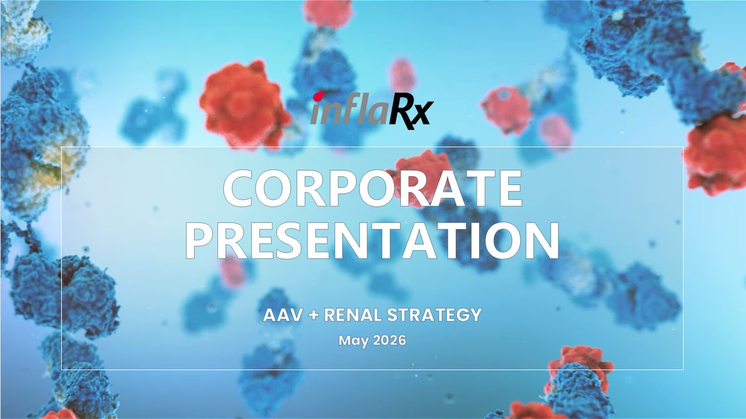
CORPORATE PRESENTATION AAV + RENAL STRATEGY May 2026

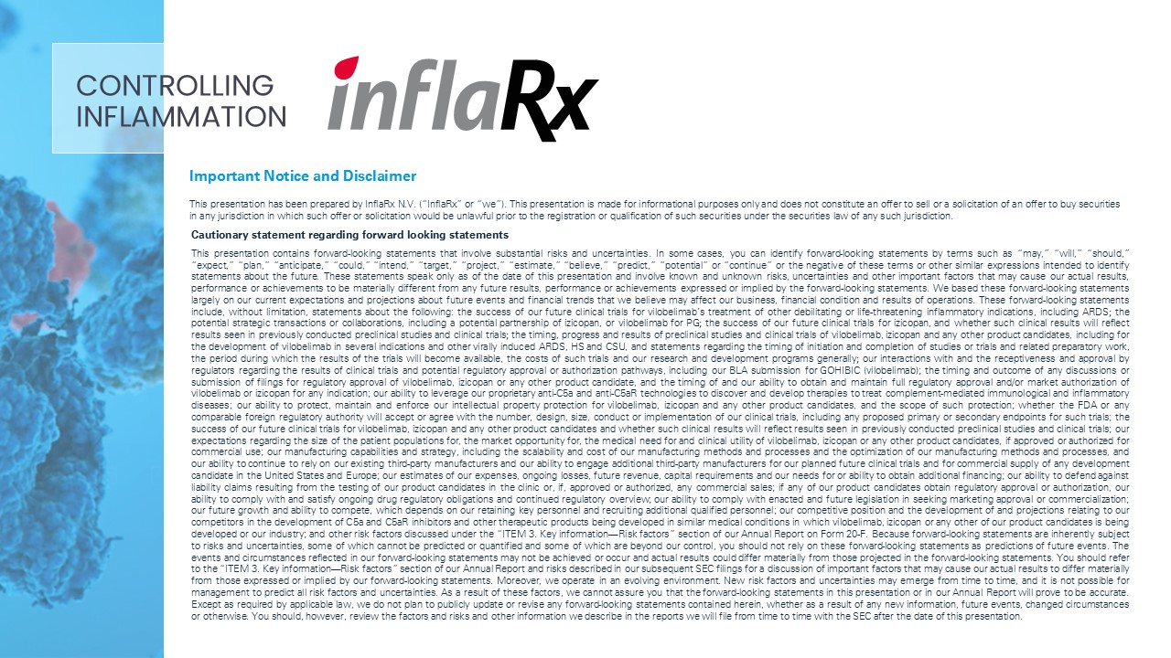
Important Notice and Disclaimer This presentation has been prepared by InflaRx N.V. (“InflaRx” or “we”). This presentation is made for informational purposes only and does not constitute an offer to sell or a solicitation of an offer to buy securities in any jurisdiction in which such offer or solicitation would be unlawful prior to the registration or qualification of such securities under the securities law of any such jurisdiction. Cautionary statement regarding forward looking statements This presentation contains forward-looking statements that involve substantial risks and uncertainties. In some cases, you can identify forward-looking statements by terms such as “may,” “will,” “should,” “expect,” “plan,” “anticipate,” “could,” “intend,” “target,” “project,” “estimate,” “believe,” “predict,” “potential” or “continue” or the negative of these terms or other similar expressions intended to identify statements about the future. These statements speak only as of the date of this presentation and involve known and unknown risks, uncertainties and other important factors that may cause our actual results, performance or achievements to be materially different from any future results, performance or achievements expressed or implied by the forward-looking statements. We based these forward-looking statements largely on our current expectations and projections about future events and financial trends that we believe may affect our business, financial condition and results of operations. These forward-looking statements include, without limitation, statements about the following: the success of our future clinical trials for vilobelimab’s treatment of other debilitating or life-threatening inflammatory indications, including ARDS; the potential strategic transactions or collaborations, including a potential partnership of izicopan, or vilobelimab for PG; the success of our future clinical trials for izicopan, and whether such clinical results will reflect results seen in previously conducted preclinical studies and clinical trials; the timing, progress and results of preclinical studies and clinical trials of vilobelimab, izicopan and any other product candidates, including for the development of vilobelimab in several indications and other virally induced ARDS, HS and CSU, and statements regarding the timing of initiation and completion of studies or trials and related preparatory work, the period during which the results of the trials will become available, the costs of such trials and our research and development programs generally; our interactions with and the receptiveness and approval by regulators regarding the results of clinical trials and potential regulatory approval or authorization pathways, including our BLA submission for GOHIBIC (vilobelimab); the timing and outcome of any discussions or submission of filings for regulatory approval of vilobelimab, izicopan or any other product candidate, and the timing of and our ability to obtain and maintain full regulatory approval and/or market authorization of vilobelimab or izicopan for any indication; our ability to leverage our proprietary anti-C5a and anti-C5aR technologies to discover and develop therapies to treat complement-mediated immunological and inflammatory diseases; our ability to protect, maintain and enforce our intellectual property protection for vilobelimab, izicopan and any other product candidates, and the scope of such protection; whether the FDA or any comparable foreign regulatory authority will accept or agree with the number, design, size, conduct or implementation of our clinical trials, including any proposed primary or secondary endpoints for such trials; the success of our future clinical trials for vilobelimab, izicopan and any other product candidates and whether such clinical results will reflect results seen in previously conducted preclinical studies and clinical trials; our expectations regarding the size of the patient populations for, the market opportunity for, the medical need for and clinical utility of vilobelimab, izicopan or any other product candidates, if approved or authorized for commercial use; our manufacturing capabilities and strategy, including the scalability and cost of our manufacturing methods and processes and the optimization of our manufacturing methods and processes, and our ability to continue to rely on our existing third-party manufacturers and our ability to engage additional third-party manufacturers for our planned future clinical trials and for commercial supply of any development candidate in the United States and Europe; our estimates of our expenses, ongoing losses, future revenue, capital requirements and our needs for or ability to obtain additional financing; our ability to defend against liability claims resulting from the testing of our product candidates in the clinic or, if, approved or authorized, any commercial sales; if any of our product candidates obtain regulatory approval or authorization, our ability to comply with and satisfy ongoing drug regulatory obligations and continued regulatory overview; our ability to comply with enacted and future legislation in seeking marketing approval or commercialization; our future growth and ability to compete, which depends on our retaining key personnel and recruiting additional qualified personnel; our competitive position and the development of and projections relating to our competitors in the development of C5a and C5aR inhibitors and other therapeutic products being developed in similar medical conditions in which vilobelimab, izicopan or any other of our product candidates is being developed or our industry; and other risk factors discussed under the “ITEM 3. Key information––Risk factors” section of our Annual Report on Form 20-F. Because forward-looking statements are inherently subject to risks and uncertainties, some of which cannot be predicted or quantified and some of which are beyond our control, you should not rely on these forward-looking statements as predictions of future events. The events and circumstances reflected in our forward-looking statements may not be achieved or occur and actual results could differ materially from those projected in the forward-looking statements. You should refer to the “ITEM 3. Key information––Risk factors” section of our Annual Report and risks described in our subsequent SEC filings for a discussion of important factors that may cause our actual results to differ materially from those expressed or implied by our forward-looking statements. Moreover, we operate in an evolving environment. New risk factors and uncertainties may emerge from time to time, and it is not possible for management to predict all risk factors and uncertainties. As a result of these factors, we cannot assure you that the forward-looking statements in this presentation or in our Annual Report will prove to be accurate. Except as required by applicable law, we do not plan to publicly update or revise any forward-looking statements contained herein, whether as a result of any new information, future events, changed circumstances or otherwise. You should, however, review the factors and risks and other information we describe in the reports we will file from time to time with the SEC after the date of this presentation. CONTROLLING INFLAMMATION

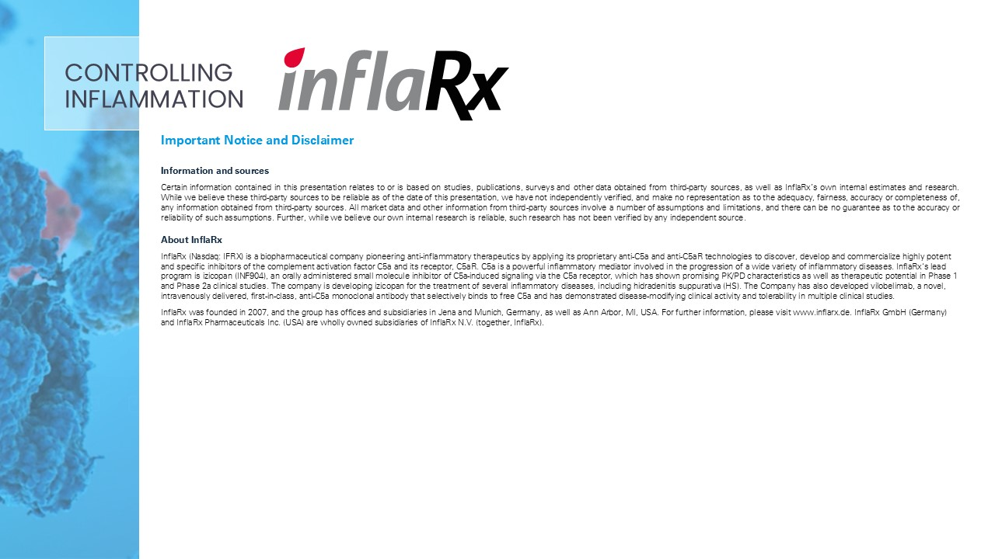
Important Notice and Disclaimer Information and sources Certain information contained in this presentation relates to or is based on studies, publications, surveys and other data obtained from third-party sources, as well as InflaRx’s own internal estimates and research. While we believe these third-party sources to be reliable as of the date of this presentation, we have not independently verified, and make no representation as to the adequacy, fairness, accuracy or completeness of, any information obtained from third-party sources. All market data and other information from third-party sources involve a number of assumptions and limitations, and there can be no guarantee as to the accuracy or reliability of such assumptions. Further, while we believe our own internal research is reliable, such research has not been verified by any independent source. About InflaRx InflaRx (Nasdaq: IFRX) is a biopharmaceutical company pioneering anti-inflammatory therapeutics by applying its proprietary anti-C5a and anti-C5aR technologies to discover, develop and commercialize highly potent and specific inhibitors of the complement activation factor C5a and its receptor, C5aR. C5a is a powerful inflammatory mediator involved in the progression of a wide variety of inflammatory diseases. InflaRx‘s lead program is izicopan (INF904), an orally administered small molecule inhibitor of C5a-induced signaling via the C5a receptor, which has shown promising PK/PD characteristics as well as therapeutic potential in Phase 1 and Phase 2a clinical studies. The company is developing izicopan for the treatment of several inflammatory diseases, including hidradenitis suppurativa (HS). The Company has also developed vilobelimab, a novel, intravenously delivered, first-in-class, anti-C5a monoclonal antibody that selectively binds to free C5a and has demonstrated disease-modifying clinical activity and tolerability in multiple clinical studies. InflaRx was founded in 2007, and the group has offices and subsidiaries in Jena and Munich, Germany, as well as Ann Arbor, MI, USA. For further information, please visit www.inflarx.de. InflaRx GmbH (Germany) and InflaRx Pharmaceuticals Inc. (USA) are wholly owned subsidiaries of InflaRx N.V. (together, InflaRx). CONTROLLING INFLAMMATION

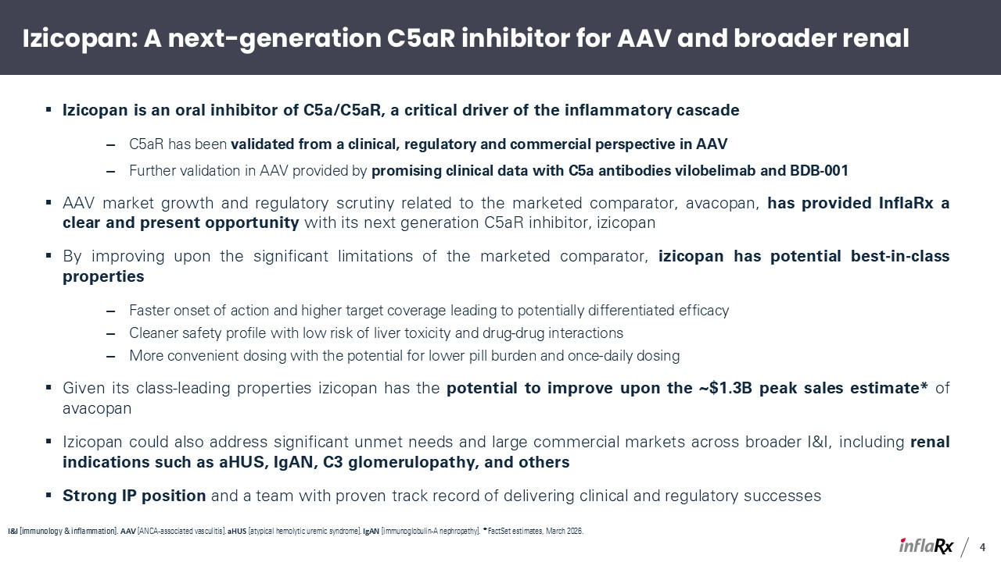
Izicopan: A next-generation C5aR inhibitor for AAV and broader renal Izicopan is an oral inhibitor of C5a/C5aR, a critical driver of the inflammatory cascade C5aR has been validated from a clinical, regulatory and commercial perspective in AAV Further validation in AAV provided by promising clinical data with C5a antibodies vilobelimab and BDB-001 AAV market growth and regulatory scrutiny related to the marketed comparator, avacopan, has provided InflaRx a clear and present opportunity with its next generation C5aR inhibitor, izicopan By improving upon the significant limitations of the marketed comparator, izicopan has potential best-in-class properties Faster onset of action and higher target coverage leading to potentially differentiated efficacy Cleaner safety profile with low risk of liver toxicity and drug-drug interactions More convenient dosing with the potential for lower pill burden and once-daily dosing Given its class-leading properties izicopan has the potential to improve upon the ~$1.3B peak sales estimate* of avacopan Izicopan could also address significant unmet needs and large commercial markets across broader I&I, including renal indications such as aHUS, IgAN, C3 glomerulopathy, and others Strong IP position and a team with proven track record of delivering clinical and regulatory successes I&I [immunology & inflammation]. AAV [ANCA-associated vasculitis]. aHUS [atypical hemolytic uremic syndrome]. IgAN [immunoglobulin-A nephropathy]. * FactSet estimates, March 2026. 4

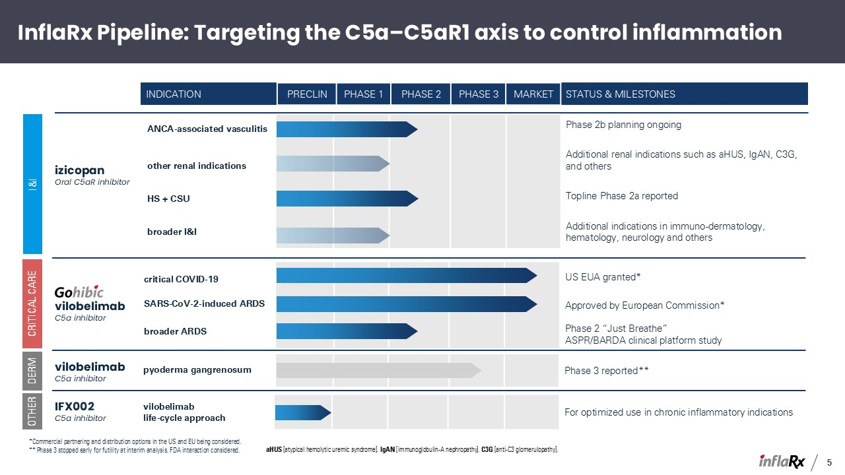
Indication PreClin Phase 1 Phase 2 Phase 3 MARKET STATUS & Milestones ANCA-associated vasculitis other renal indications HS + CSU broader I&I Phase 2b planning ongoing Additional renal indications such as aHUS, IgAN, C3G, and others Topline Phase 2a reported Additional indications in immuno-dermatology, hematology, neurology and others izicopan Oral C5aR inhibitor I&I InflaRx Pipeline: Targeting the C5a–C5aR1 axis to control inflammation vilobelimab C5a inhibitor critical COVID-19 SARS-CoV-2-induced ARDS broader ARDS US EUA granted* Approved by European Commission* Phase 2 “Just Breathe” ASPR/BARDA clinical platform study Critical Care DERM vilobelimab C5a inhibitor pyoderma gangrenosum Phase 3 reported** OTHER IFX002 C5a inhibitor vilobelimab life-cycle approach For optimized use in chronic inflammatory indications *Commercial partnering and distribution options in the US and EU being considered. ** Phase 3 stopped early for futility at interim analysis, FDA interaction considered. aHUS [atypical hemolytic uremic syndrome]. IgAN [immunoglobulin-A nephropathy]. C3G [anti-C3 glomerulopathy]. 5

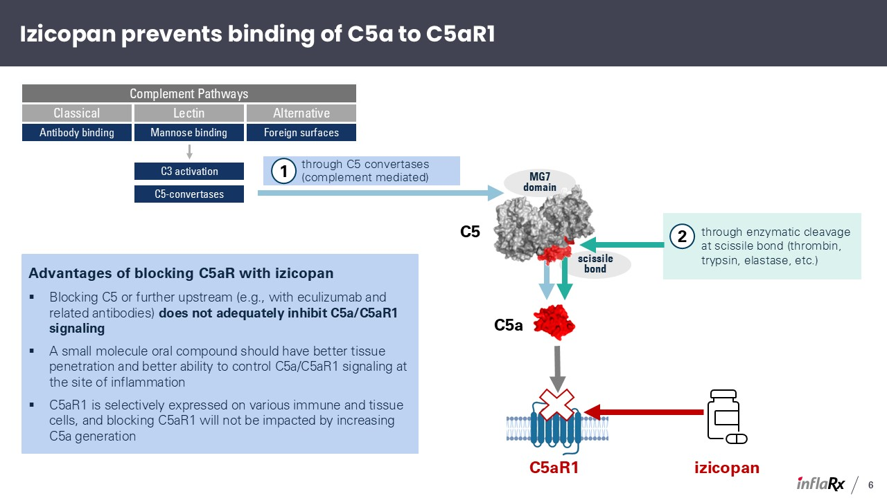
Izicopan prevents binding of C5a to C5aR1 Advantages of blocking C5aR with izicopan Blocking C5 or further upstream (e.g., with eculizumab and related antibodies) does not adequately inhibit C5a/C5aR1 signaling A small molecule oral compound should have better tissue penetration and better ability to control C5a/C5aR1 signaling at the site of inflammation C5aR1 is selectively expressed on various immune and tissue cells, and blocking C5aR1 will not be impacted by increasing C5a generation scissile bond MG7 domain C5a C5aR1 through C5 convertases (complement mediated) through enzymatic cleavage at scissile bond (thrombin, trypsin, elastase, etc.) Classical Lectin Alternative Complement Pathways Antibody binding Mannose binding Foreign surfaces C3 activation C5-convertases 1 2 C5 izicopan 6

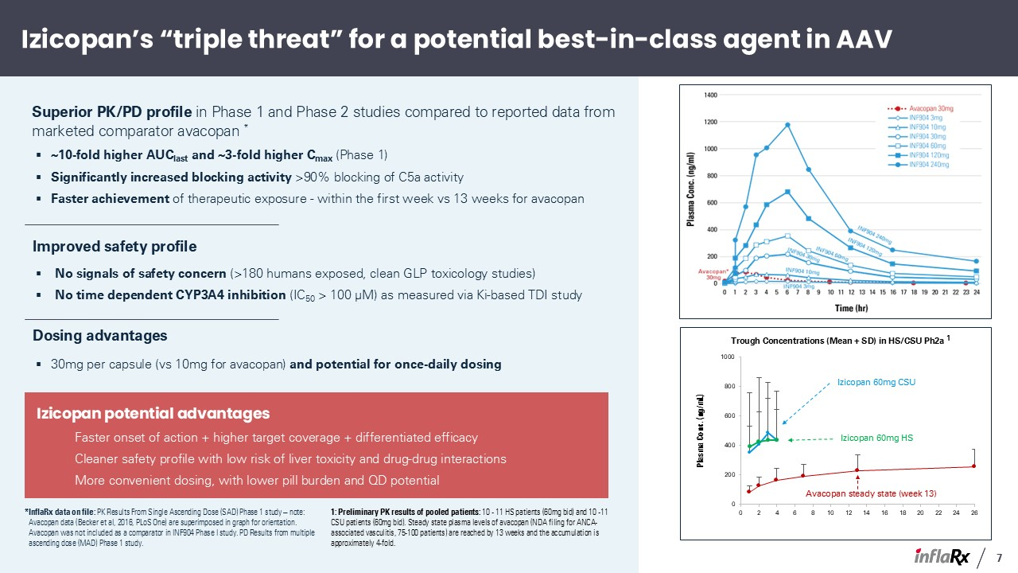
*InflaRx data on file: PK Results From Single Ascending Dose (SAD) Phase 1 study – note: Avacopan data (Becker et al, 2016, PLoS One) are superimposed in graph for orientation. Avacopan was not included as a comparator in INF904 Phase I study. PD Results from multiple ascending dose (MAD) Phase 1 study. Izicopan’s “triple threat” for a potential best-in-class agent in AAV Superior PK/PD profile in Phase 1 and Phase 2 studies compared to reported data from marketed comparator avacopan * ~10-fold higher AUClast and ~3-fold higher Cmax (Phase 1) Significantly increased blocking activity >90% blocking of C5a activity Faster achievement of therapeutic exposure - within the first week vs 13 weeks for avacopan Dosing advantages 30mg per capsule (vs 10mg for avacopan) and potential for once-daily dosing Improved safety profile No signals of safety concern (>180 humans exposed, clean GLP toxicology studies) No time dependent CYP3A4 inhibition (IC50 > 100 μM) as measured via Ki-based TDI study Izicopan potential advantages Faster onset of action + higher target coverage + differentiated efficacy Cleaner safety profile with low risk of liver toxicity and drug-drug interactions More convenient dosing, with lower pill burden and QD potential Avacopan steady state (week 13) Izicopan 60mg CSU Izicopan 60mg HS 1: Preliminary PK results of pooled patients: 10 - 11 HS patients (60mg bid) and 10 -11 CSU patients (60mg bid). Steady state plasma levels of avacopan (NDA filing for ANCA-associated vasculitis, 75-100 patients) are reached by 13 weeks and the accumulation is approximately 4-fold. 7

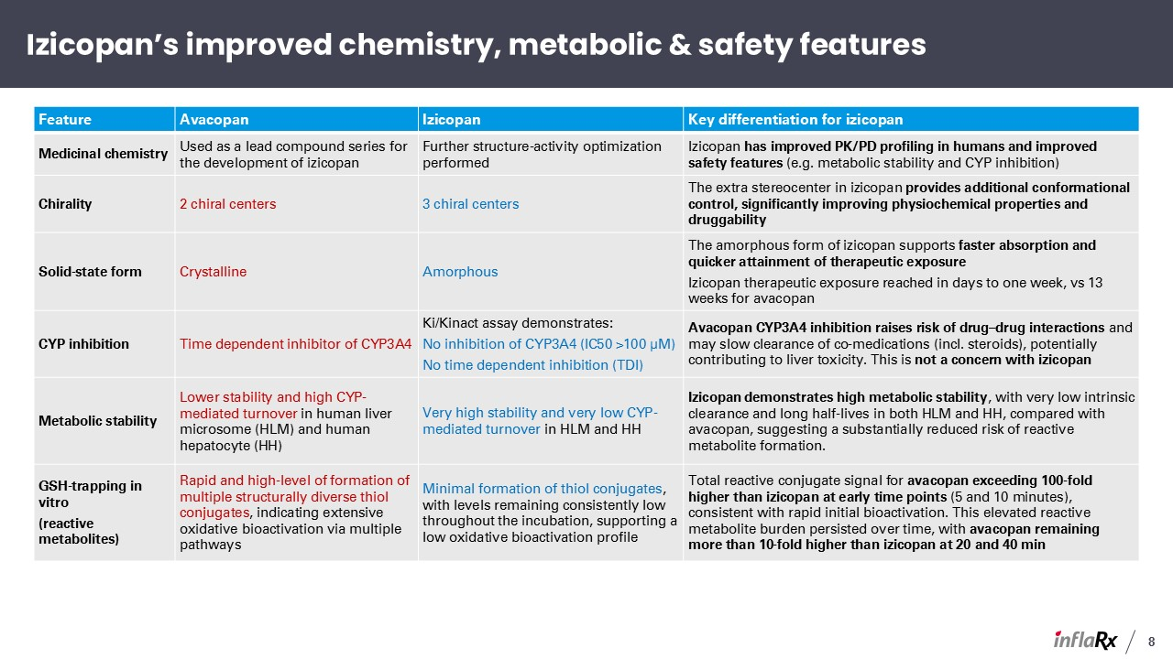
Feature Avacopan Izicopan Key differentiation for izicopan Medicinal chemistry Used as a lead compound series for the development of izicopan Further structure-activity optimization performed Izicopan has improved PK/PD profiling in humans and improved safety features (e.g. metabolic stability and CYP inhibition) Chirality 2 chiral centers 3 chiral centers The extra stereocenter in izicopan provides additional conformational control, significantly improving physiochemical properties and druggability Solid-state form Crystalline Amorphous The amorphous form of izicopan supports faster absorption and quicker attainment of therapeutic exposure Izicopan therapeutic exposure reached in days to one week, vs 13 weeks for avacopan CYP inhibition Time dependent inhibitor of CYP3A4 Ki/Kinact assay demonstrates: No inhibition of CYP3A4 (IC50 >100 μM) No time dependent inhibition (TDI) Avacopan CYP3A4 inhibition raises risk of drug–drug interactions and may slow clearance of co-medications (incl. steroids), potentially contributing to liver toxicity. This is not a concern with izicopan Metabolic stability Lower stability and high CYP-mediated turnover in human liver microsome (HLM) and human hepatocyte (HH) Very high stability and very low CYP-mediated turnover in HLM and HH Izicopan demonstrates high metabolic stability, with very low intrinsic clearance and long half-lives in both HLM and HH, compared with avacopan, suggesting a substantially reduced risk of reactive metabolite formation. GSH-trapping in vitro (reactive metabolites) Rapid and high-level of formation of multiple structurally diverse thiol conjugates, indicating extensive oxidative bioactivation via multiple pathways Minimal formation of thiol conjugates, with levels remaining consistently low throughout the incubation, supporting a low oxidative bioactivation profile Total reactive conjugate signal for avacopan exceeding 100-fold higher than izicopan at early time points (5 and 10 minutes), consistent with rapid initial bioactivation. This elevated reactive metabolite burden persisted over time, with avacopan remaining more than 10-fold higher than izicopan at 20 and 40 min Izicopan’s improved chemistry, metabolic & safety features 8

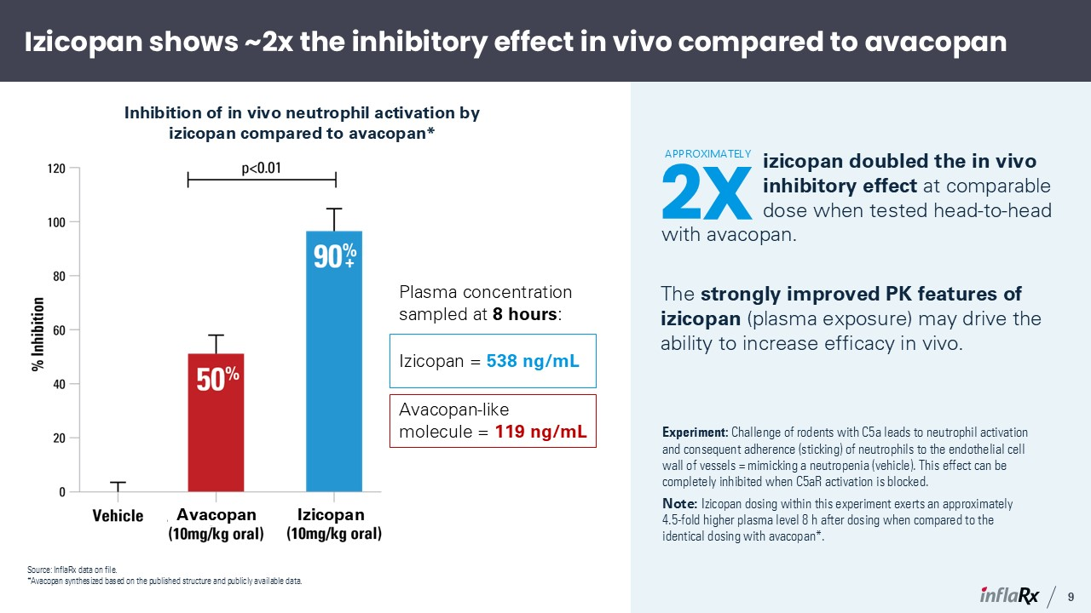
Izicopan shows ~2x the inhibitory effect in vivo compared to avacopan Inhibition of in vivo neutrophil activation by izicopan compared to avacopan* Experiment: Challenge of rodents with C5a leads to neutrophil activation and consequent adherence (sticking) of neutrophils to the endothelial cell wall of vessels = mimicking a neutropenia (vehicle). This effect can be completely inhibited when C5aR activation is blocked. Note: Izicopan dosing within this experiment exerts an approximately 4.5-fold higher plasma level 8 h after dosing when compared to the identical dosing with avacopan*. Plasma concentration sampled at 8 hours: izicopan doubled the in vivo inhibitory effect at comparable dose when tested head-to-head with avacopan. The strongly improved PK features of izicopan (plasma exposure) may drive the ability to increase efficacy in vivo. Izicopan = 538 ng/mL Avacopan-like molecule = 119 ng/mL 2X APPROXIMATELY + 9 Izicopan Source: InflaRx data on file. *Avacopan synthesized based on the published structure and publicly available data. Avacopan

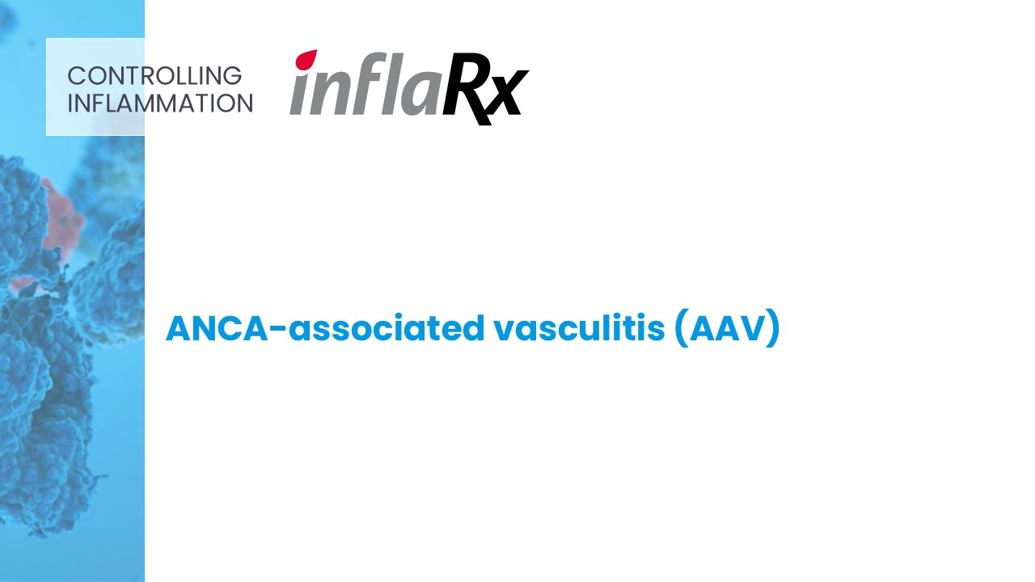
ANCA-associated vasculitis (AAV) CONTROLLING INFLAMMATION

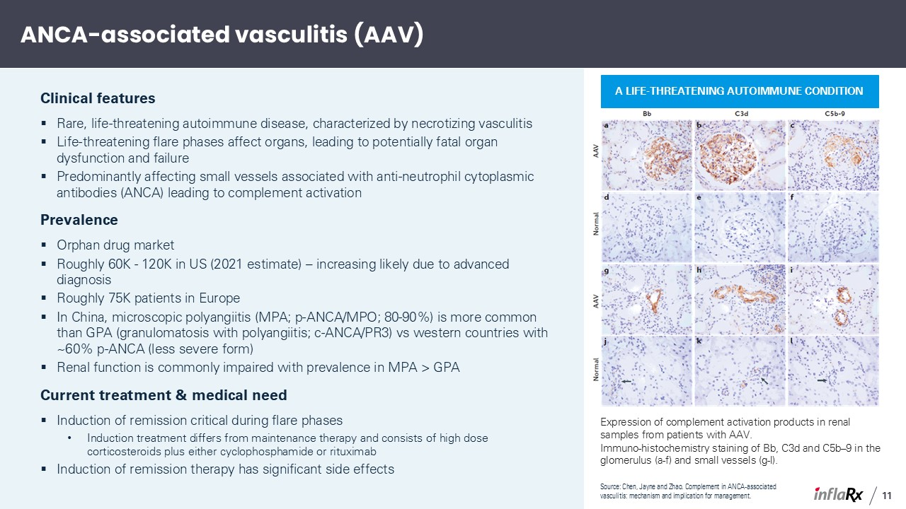
ANCA-associated vasculitis (AAV) Clinical features Rare, life-threatening autoimmune disease, characterized by necrotizing vasculitis Life-threatening flare phases affect organs, leading to potentially fatal organ dysfunction and failure Predominantly affecting small vessels associated with anti-neutrophil cytoplasmic antibodies (ANCA) leading to complement activation Prevalence Orphan drug market Roughly 60K - 120K in US (2021 estimate) – increasing likely due to advanced diagnosis Roughly 75K patients in Europe In China, microscopic polyangiitis (MPA; p-ANCA/MPO; 80-90%) is more common than GPA (granulomatosis with polyangiitis; c-ANCA/PR3) vs western countries with ~60% p-ANCA (less severe form) Renal function is commonly impaired with prevalence in MPA > GPA Current treatment & medical need Induction of remission critical during flare phases Induction treatment differs from maintenance therapy and consists of high dose corticosteroids plus either cyclophosphamide or rituximab Induction of remission therapy has significant side effects Source: Chen, Jayne and Zhao. Complement in ANCA-associated vasculitis: mechanism and implication for management. A life-threatening autoimmune condition Expression of complement activation products in renal samples from patients with AAV. Immuno-histochemistry staining of Bb, C3d and C5b–9 in the glomerulus (a-f) and small vessels (g-l). 11

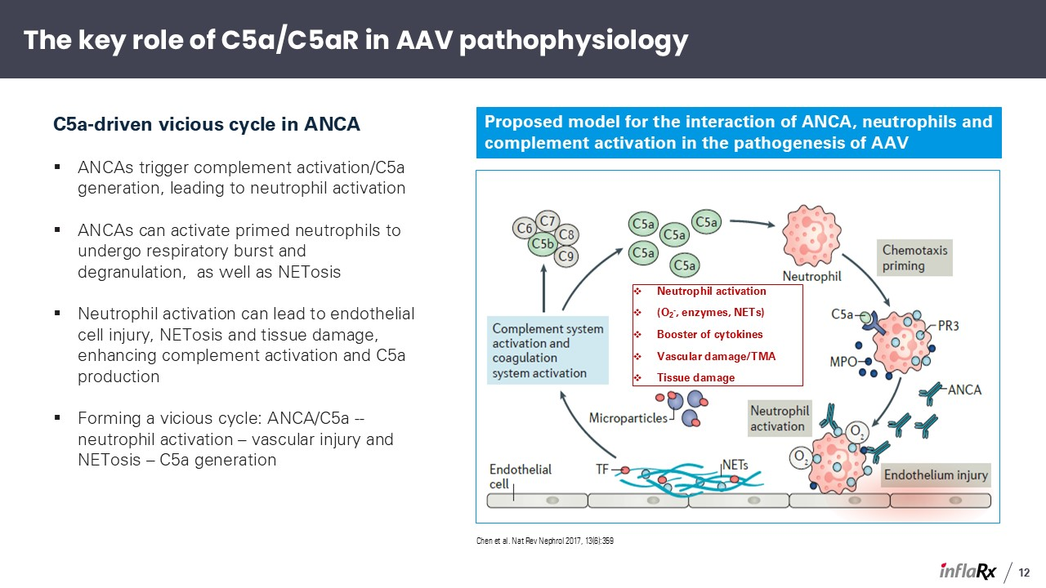
C5a-driven vicious cycle in ANCA ANCAs trigger complement activation/C5a generation, leading to neutrophil activation ANCAs can activate primed neutrophils to undergo respiratory burst and degranulation, as well as NETosis Neutrophil activation can lead to endothelial cell injury, NETosis and tissue damage, enhancing complement activation and C5a production Forming a vicious cycle: ANCA/C5a -- neutrophil activation – vascular injury and NETosis – C5a generation Proposed model for the interaction of ANCA, neutrophils and complement activation in the pathogenesis of AAV Chen et al. Nat Rev Nephrol 2017, 13(6):359 Neutrophil activation (O2-, enzymes, NETs) Booster of cytokines Vascular damage/TMA Tissue damage The key role of C5a/C5aR in AAV pathophysiology 12

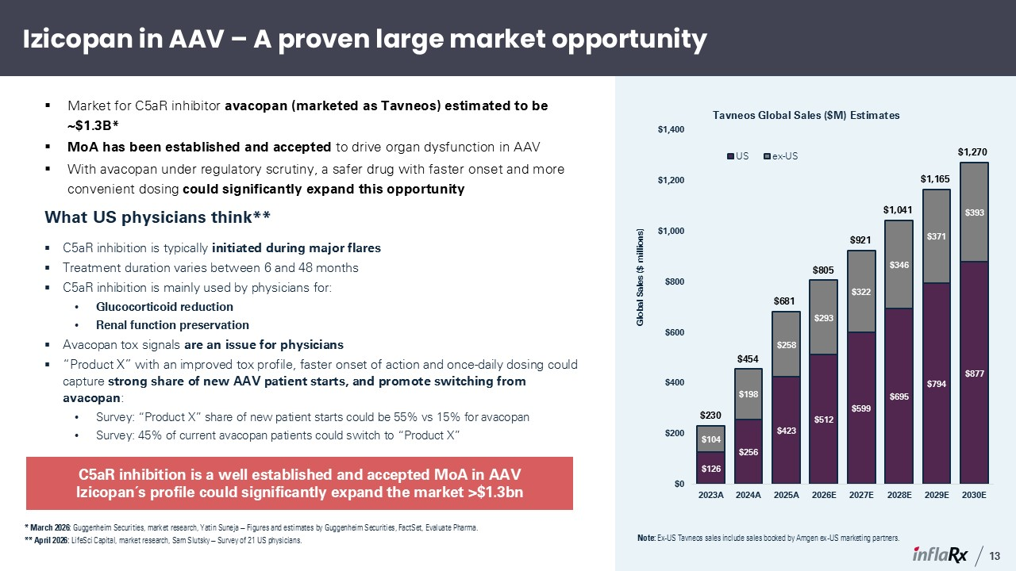
Izicopan in AAV – A proven large market opportunity * March 2026: Guggenheim Securities, market research, Yatin Suneja – Figures and estimates by Guggenheim Securities, FactSet, Evaluate Pharma. ** April 2026: LifeSci Capital, market research, Sam Slutsky – Survey of 21 US physicians. What US physicians think** C5aR inhibition is typically initiated during major flares Treatment duration varies between 6 and 48 months C5aR inhibition is mainly used by physicians for: Glucocorticoid reduction Renal function preservation Avacopan tox signals are an issue for physicians “Product X” with an improved tox profile, faster onset of action and once-daily dosing could capture strong share of new AAV patient starts, and promote switching from avacopan: Survey: “Product X” share of new patient starts could be 55% vs 15% for avacopan Survey: 45% of current avacopan patients could switch to “Product X” C5aR inhibition is a well established and accepted MoA in AAV Izicopan´s profile could significantly expand the market >$1.3bn Market for C5aR inhibitor avacopan (marketed as Tavneos) estimated to be ~$1.3B* MoA has been established and accepted to drive organ dysfunction in AAV With avacopan under regulatory scrutiny, a safer drug with faster onset and more convenient dosing could significantly expand this opportunity $230 $454 $681 $805 $921 $1,041 $1,165 $1,270 Note: Ex-US Tavneos sales include sales booked by Amgen ex-US marketing partners. 13

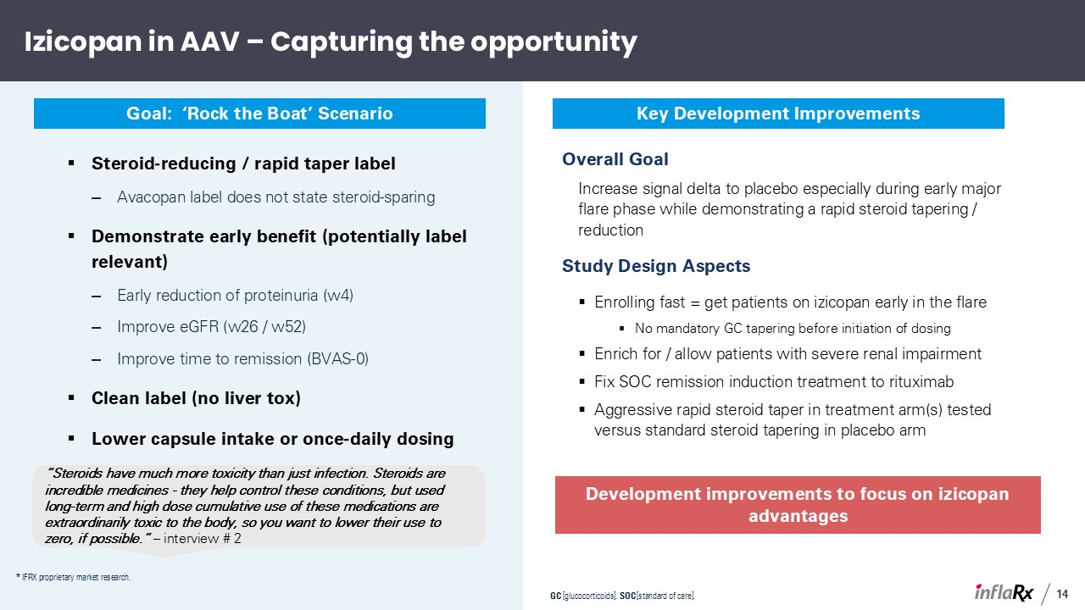
Izicopan in AAV – Capturing the opportunity Steroid-reducing / rapid taper label Avacopan label does not state steroid-sparing Demonstrate early benefit (potentially label relevant) Early reduction of proteinuria (w4) Improve eGFR (w26 / w52) Improve time to remission (BVAS-0) Clean label (no liver tox) Lower capsule intake or once-daily dosing “Steroids have much more toxicity than just infection. Steroids are incredible medicines - they help control these conditions, but used long-term and high dose cumulative use of these medications are extraordinarily toxic to the body, so you want to lower their use to zero, if possible.” – interview # 2 Goal: ‘Rock the Boat’ Scenario Development improvements to focus on izicopan advantages Key Development Improvements Overall Goal Increase signal delta to placebo especially during early major flare phase while demonstrating a rapid steroid tapering / reduction Study Design Aspects Enrolling fast = get patients on izicopan early in the flare No mandatory GC tapering before initiation of dosing Enrich for / allow patients with severe renal impairment Fix SOC remission induction treatment to rituximab Aggressive rapid steroid taper in treatment arm(s) tested versus standard steroid tapering in placebo arm GC [glucocorticoids]. SOC [standard of care]. 14 * IFRX proprietary market research.

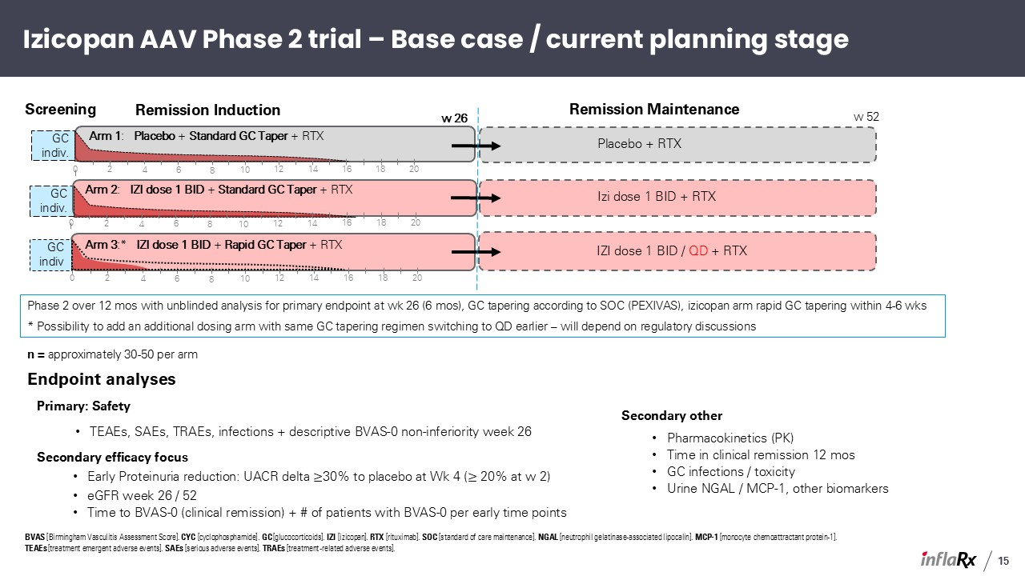
GC indiv. GC indiv. Izicopan AAV Phase 2 trial – Base case / current planning stage BVAS [Birmingham Vasculitis Assessment Score]. CYC [cyclophosphamide]. GC [glucocorticoids]. IZI [izicopan]. RTX [rituximab]. SOC [standard of care maintenance]. NGAL [neutrophil gelatinase-associated lipocalin]. MCP-1 [monocyte chemoattractant protein-1]. TEAEs [treatment emergent adverse events]. SAEs [serious adverse events]. TRAEs [treatment-related adverse events]. Arm 3:* IZI dose 1 BID + Rapid GC Taper + RTX Arm 1: Placebo + Standard GC Taper + RTX w 26 IZI dose 1 BID / QD + RTX Placebo + RTX Remission Maintenance Remission Induction Screening GC indiv 2 4 6 8 10 12 14 16 18 20 0 2 4 6 8 10 12 14 16 18 20 0 Phase 2 over 12 mos with unblinded analysis for primary endpoint at wk 26 (6 mos), GC tapering according to SOC (PEXIVAS), izicopan arm rapid GC tapering within 4-6 wks * Possibility to add an additional dosing arm with same GC tapering regimen switching to QD earlier – will depend on regulatory discussions w 52 Arm 2: IZI dose 1 BID + Standard GC Taper + RTX Izi dose 1 BID + RTX 2 4 6 8 10 12 14 16 18 20 0 Endpoint analyses Primary: Safety TEAEs, SAEs, TRAEs, infections + descriptive BVAS-0 non-inferiority week 26 Secondary efficacy focus Early Proteinuria reduction: UACR delta ≥30% to placebo at Wk 4 (≥ 20% at w 2) eGFR week 26 / 52 Time to BVAS-0 (clinical remission) + # of patients with BVAS-0 per early time points Secondary other Pharmacokinetics (PK) Time in clinical remission 12 mos GC infections / toxicity Urine NGAL / MCP-1, other biomarkers n = approximately 30-50 per arm 15

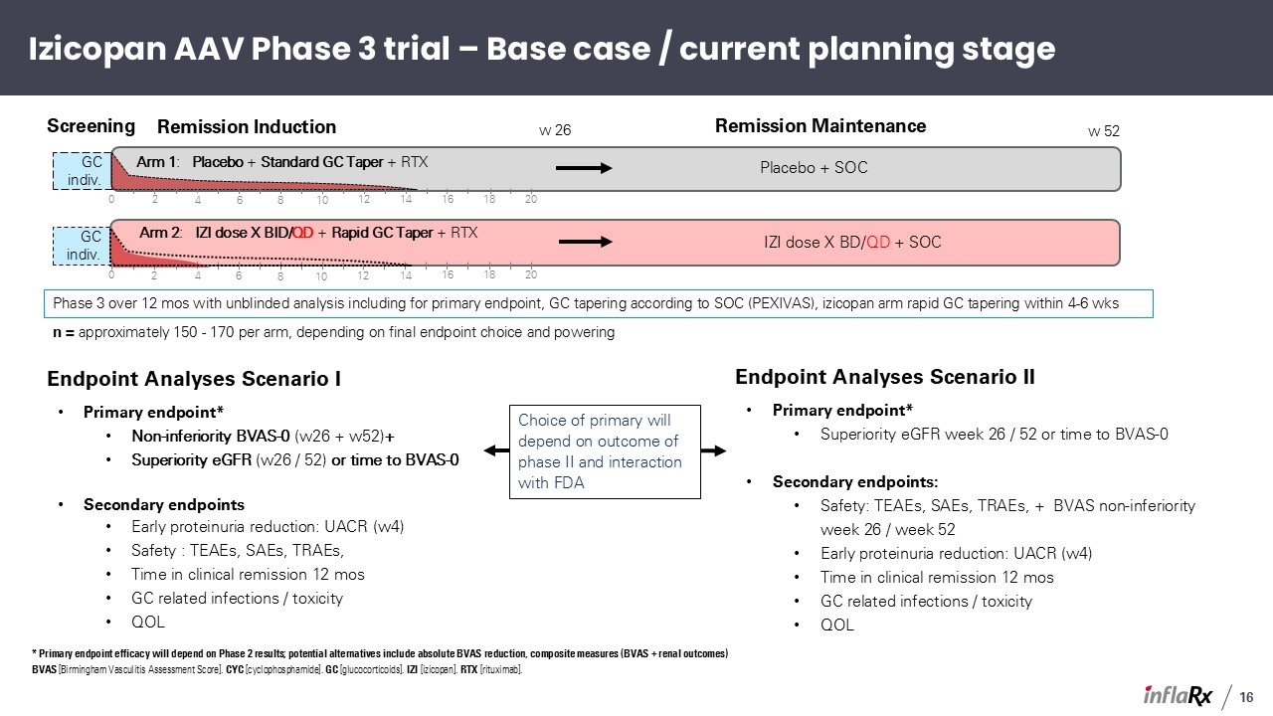
GC indiv. GC indiv. Izicopan AAV Phase 3 trial – Base case / current planning stage Arm 2: IZI dose X BID/QD + Rapid GC Taper + RTX Arm 1: Placebo + Standard GC Taper + RTX w 26 IZI dose X BD/QD + SOC Placebo + SOC Remission Maintenance Remission Induction Screening 2 4 6 8 10 12 14 16 18 20 0 2 4 6 8 10 12 14 16 18 20 0 Phase 3 over 12 mos with unblinded analysis including for primary endpoint, GC tapering according to SOC (PEXIVAS), izicopan arm rapid GC tapering within 4-6 wks w 52 Endpoint Analyses Scenario I Primary endpoint* Non-inferiority BVAS-0 (w26 + w52)+ Superiority eGFR (w26 / 52) or time to BVAS-0 Secondary endpoints Early proteinuria reduction: UACR (w4) Safety : TEAEs, SAEs, TRAEs, Time in clinical remission 12 mos GC related infections / toxicity QOL Endpoint Analyses Scenario II Primary endpoint* Superiority eGFR week 26 / 52 or time to BVAS-0 Secondary endpoints: Safety: TEAEs, SAEs, TRAEs, + BVAS non-inferiority week 26 / week 52 Early proteinuria reduction: UACR (w4) Time in clinical remission 12 mos GC related infections / toxicity QOL Choice of primary will depend on outcome of phase II and interaction with FDA n = approximately 150 - 170 per arm, depending on final endpoint choice and powering * Primary endpoint efficacy will depend on Phase 2 results; potential alternatives include absolute BVAS reduction, composite measures (BVAS + renal outcomes) BVAS [Birmingham Vasculitis Assessment Score]. CYC [cyclophosphamide]. GC [glucocorticoids]. IZI [izicopan]. RTX [rituximab]. 16

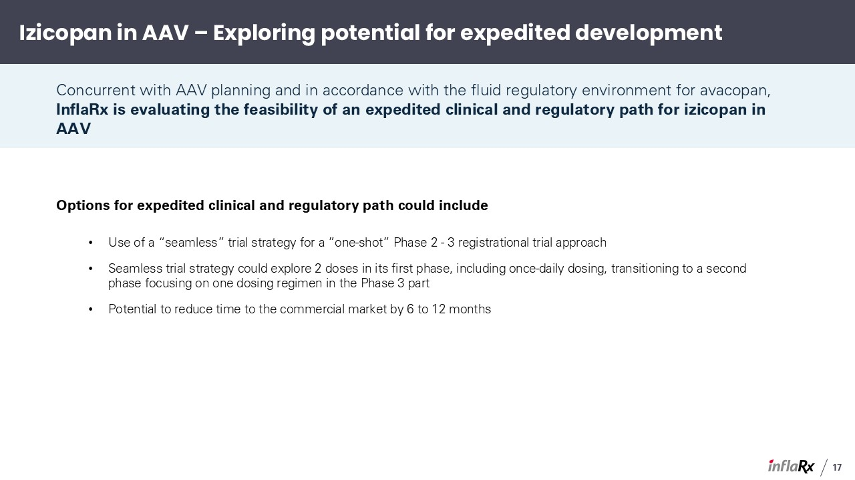
Izicopan in AAV – Exploring potential for expedited development Concurrent with AAV planning and in accordance with the fluid regulatory environment for avacopan, InflaRx is evaluating the feasibility of an expedited clinical and regulatory path for izicopan in AAV Options for expedited clinical and regulatory path could include Use of a “seamless” trial strategy for a ”one-shot” Phase 2 - 3 registrational trial approach Seamless trial strategy could explore 2 doses in its first phase, including once-daily dosing, transitioning to a second phase focusing on one dosing regimen in the Phase 3 part Potential to reduce time to the commercial market by 6 to 12 months 17

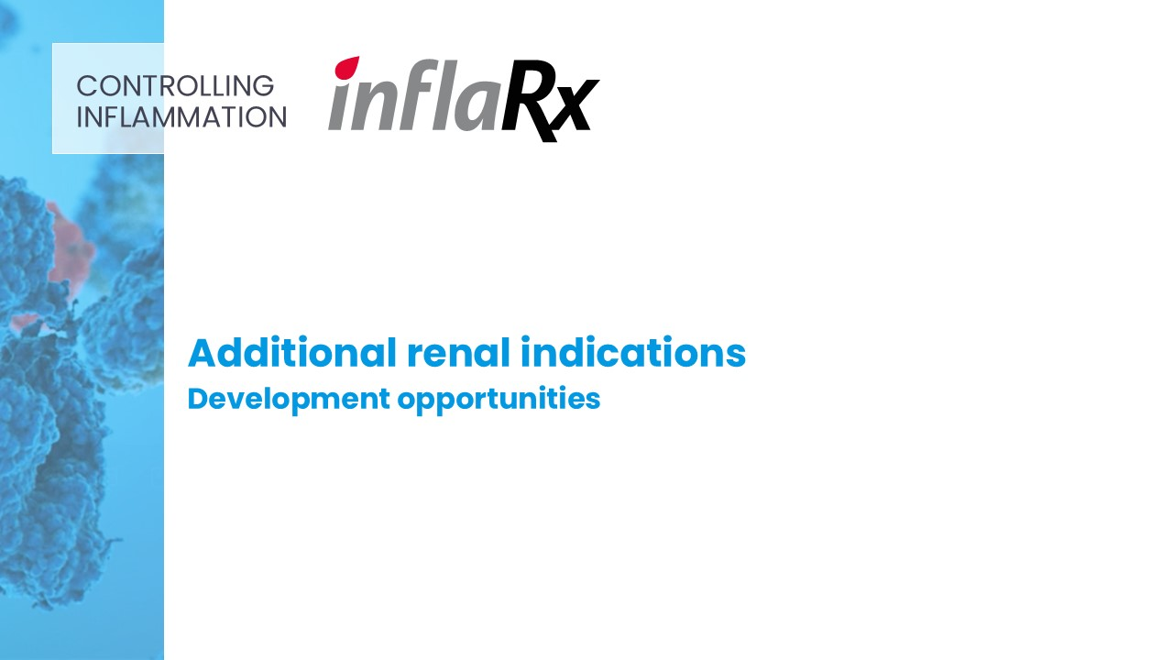
Additional renal indications Development opportunities CONTROLLING INFLAMMATION

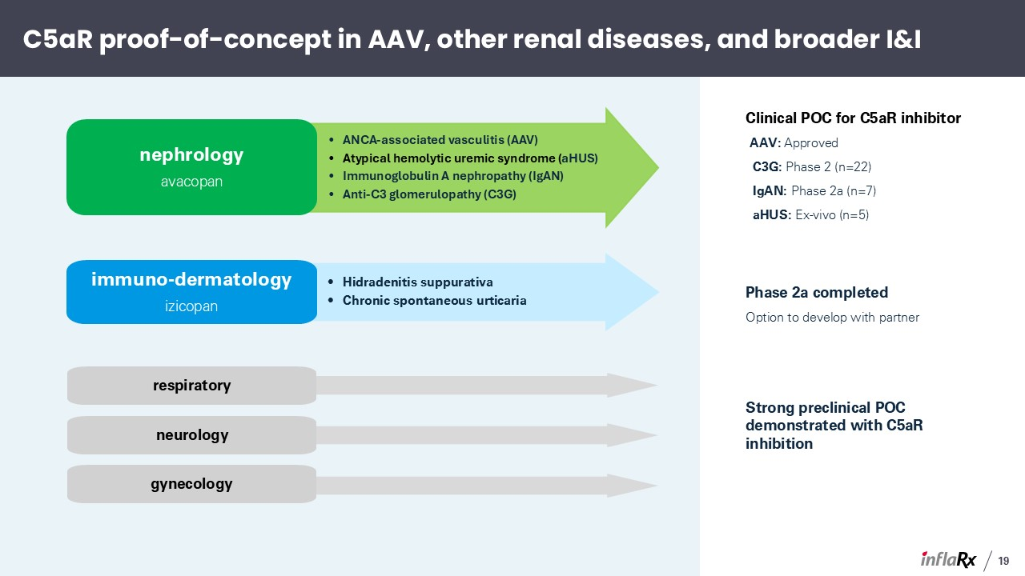
C5aR proof-of-concept in AAV, other renal diseases, and broader I&I ANCA-associated vasculitis (AAV) Atypical hemolytic uremic syndrome (aHUS) Immunoglobulin A nephropathy (IgAN) Anti-C3 glomerulopathy (C3G) nephrology avacopan Clinical POC for C5aR inhibitor AAV: Approved C3G: Phase 2 (n=22) IgAN: Phase 2a (n=7) aHUS: Ex-vivo (n=5) Hidradenitis suppurativa Chronic spontaneous urticaria immuno-dermatology izicopan Phase 2a completed Option to develop with partner Strong preclinical POC demonstrated with C5aR inhibition respiratory gynecology neurology 19

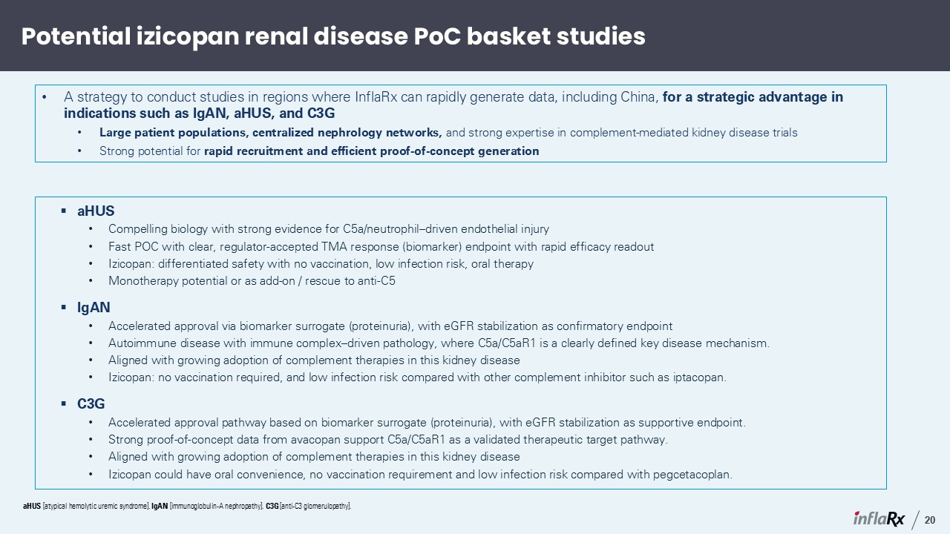
Potential izicopan renal disease PoC basket studies aHUS Compelling biology with strong evidence for C5a/neutrophil–driven endothelial injury Fast POC with clear, regulator-accepted TMA response (biomarker) endpoint with rapid efficacy readout Izicopan: differentiated safety with no vaccination, low infection risk, oral therapy Monotherapy potential or as add-on / rescue to anti-C5 IgAN Accelerated approval via biomarker surrogate (proteinuria), with eGFR stabilization as confirmatory endpoint Autoimmune disease with immune complex–driven pathology, where C5a/C5aR1 is a clearly defined key disease mechanism. Aligned with growing adoption of complement therapies in this kidney disease Izicopan: no vaccination required, and low infection risk compared with other complement inhibitor such as iptacopan. C3G Accelerated approval pathway based on biomarker surrogate (proteinuria), with eGFR stabilization as supportive endpoint. Strong proof-of-concept data from avacopan support C5a/C5aR1 as a validated therapeutic target pathway. Aligned with growing adoption of complement therapies in this kidney disease Izicopan could have oral convenience, no vaccination requirement and low infection risk compared with pegcetacoplan. A strategy to conduct studies in regions where InflaRx can rapidly generate data, including China, for a strategic advantage in indications such as IgAN, aHUS, and C3G Large patient populations, centralized nephrology networks, and strong expertise in complement-mediated kidney disease trials Strong potential for rapid recruitment and efficient proof-of-concept generation aHUS [atypical hemolytic uremic syndrome]. IgAN [immunoglobulin-A nephropathy]. C3G [anti-C3 glomerulopathy]. 20

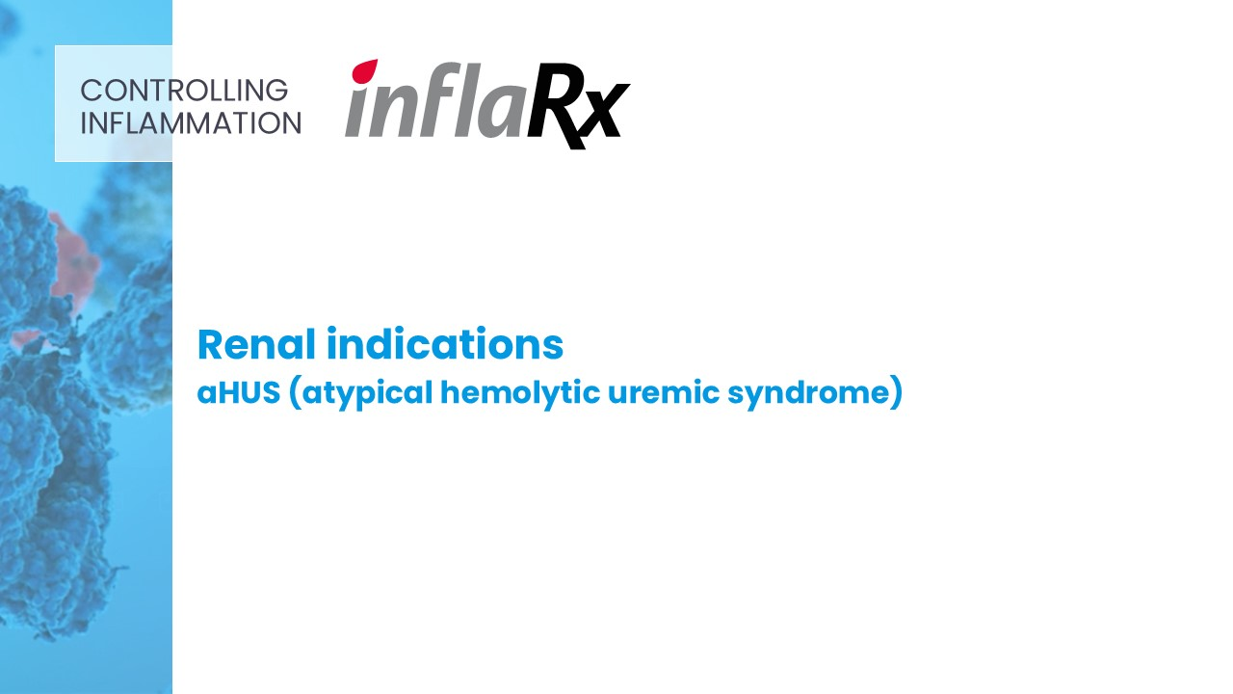
Renal indications aHUS (atypical hemolytic uremic syndrome) CONTROLLING INFLAMMATION

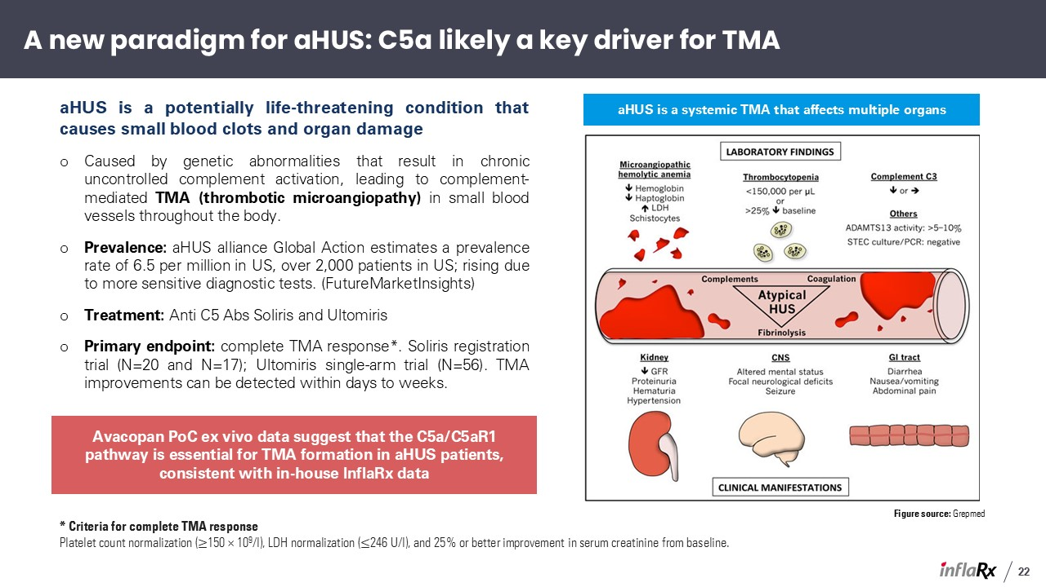
aHUS is a potentially life-threatening condition that causes small blood clots and organ damage Caused by genetic abnormalities that result in chronic uncontrolled complement activation, leading to complement-mediated TMA (thrombotic microangiopathy) in small blood vessels throughout the body. Prevalence: aHUS alliance Global Action estimates a prevalence rate of 6.5 per million in US, over 2,000 patients in US; rising due to more sensitive diagnostic tests. (FutureMarketInsights) Treatment: Anti C5 Abs Soliris and Ultomiris Primary endpoint: complete TMA response*. Soliris registration trial (N=20 and N=17); Ultomiris single-arm trial (N=56). TMA improvements can be detected within days to weeks. Figure source: Grepmed aHUS is a systemic TMA that affects multiple organs * Criteria for complete TMA response Platelet count normalization (≥150 × 109/l), LDH normalization (≤246 U/l), and 25% or better improvement in serum creatinine from baseline. A new paradigm for aHUS: C5a likely a key driver for TMA Avacopan PoC ex vivo data suggest that the C5a/C5aR1 pathway is essential for TMA formation in aHUS patients, consistent with in-house InflaRx data 22

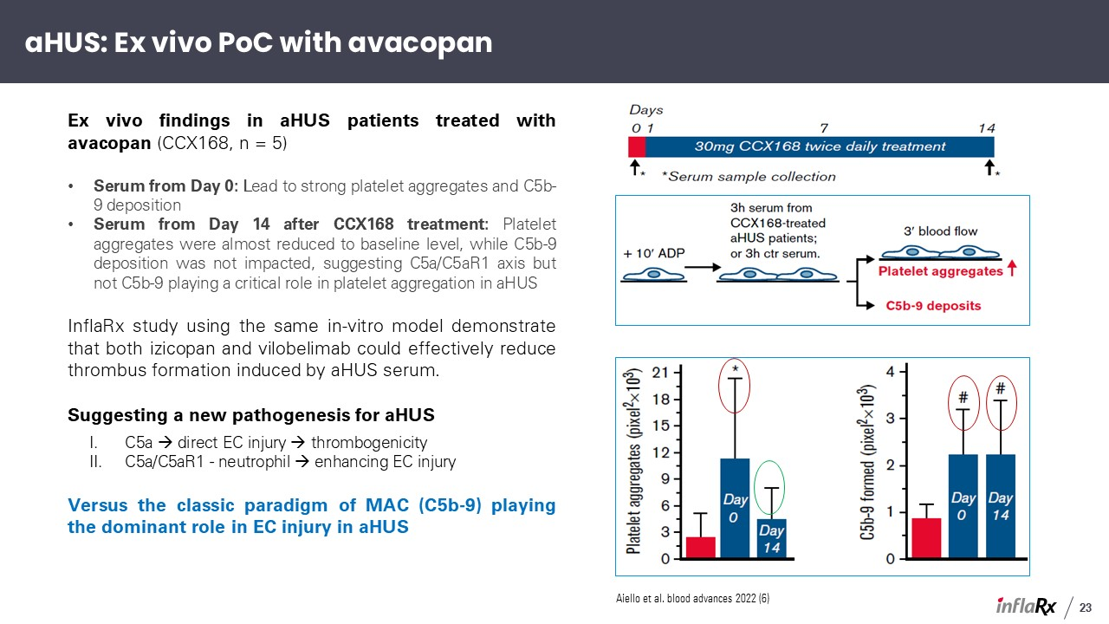
Ex vivo findings in aHUS patients treated with avacopan (CCX168, n = 5) Serum from Day 0: Lead to strong platelet aggregates and C5b-9 deposition Serum from Day 14 after CCX168 treatment: Platelet aggregates were almost reduced to baseline level, while C5b-9 deposition was not impacted, suggesting C5a/C5aR1 axis but not C5b-9 playing a critical role in platelet aggregation in aHUS InflaRx study using the same in-vitro model demonstrate that both izicopan and vilobelimab could effectively reduce thrombus formation induced by aHUS serum. Suggesting a new pathogenesis for aHUS C5a → direct EC injury → thrombogenicity C5a/C5aR1 - neutrophil → enhancing EC injury Versus the classic paradigm of MAC (C5b-9) playing the dominant role in EC injury in aHUS Aiello et al. blood advances 2022 (6) aHUS: Ex vivo PoC with avacopan 23

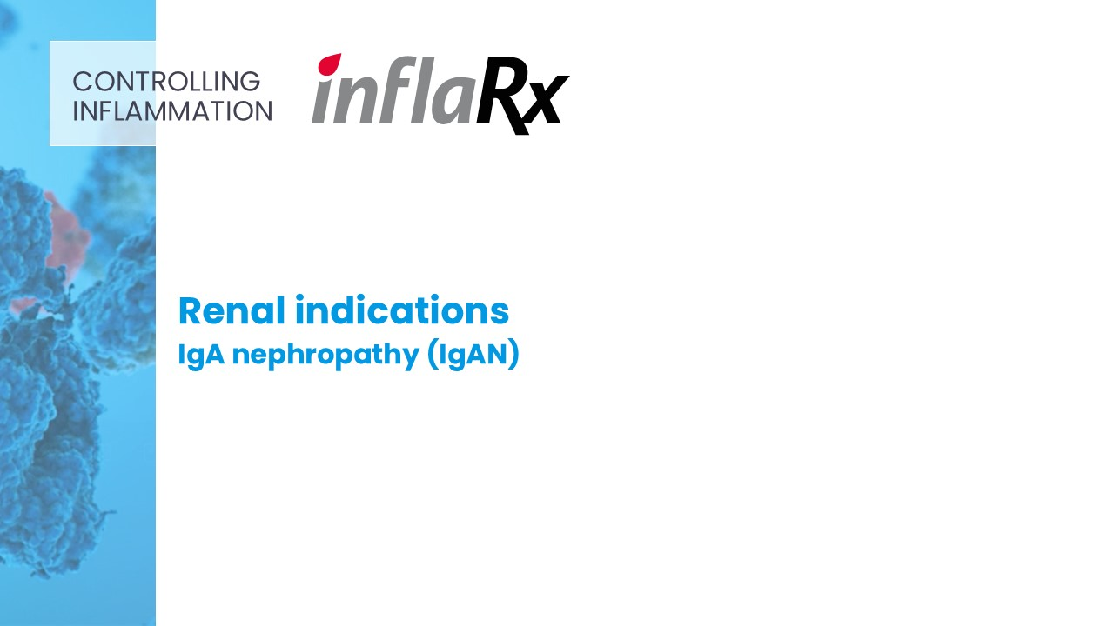
Renal indications IgA nephropathy (IgAN) CONTROLLING INFLAMMATION

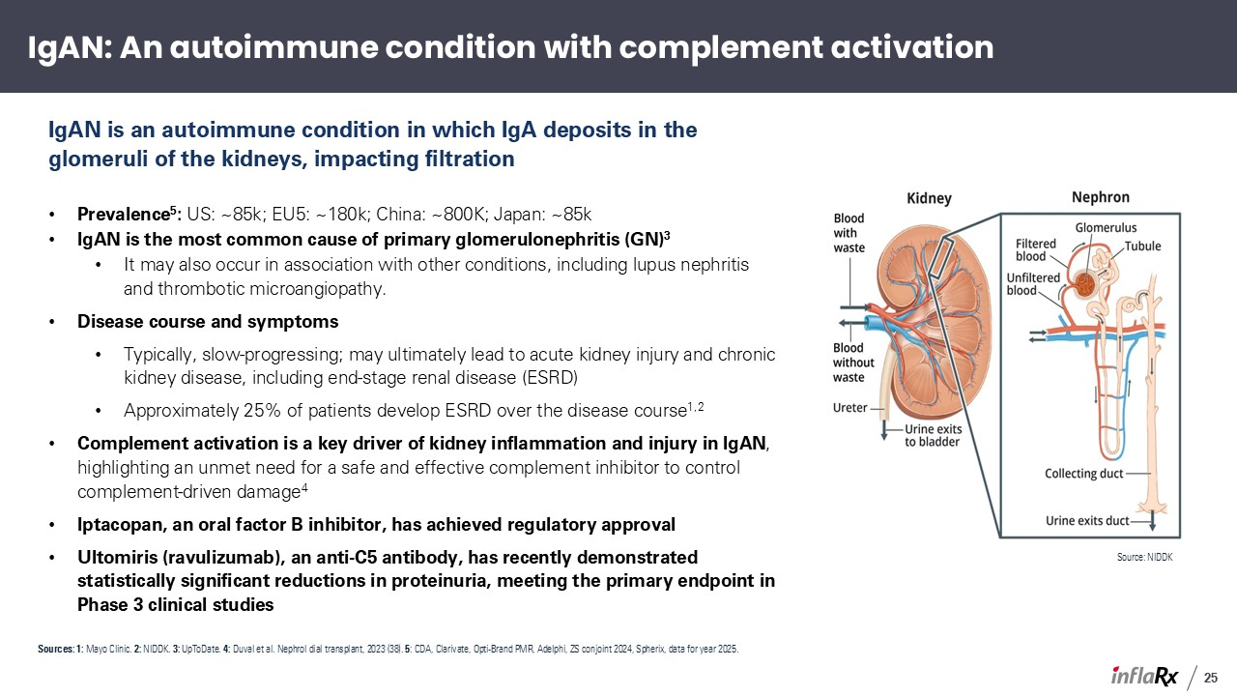
IgAN is an autoimmune condition in which IgA deposits in the glomeruli of the kidneys, impacting filtration Prevalence5: US: ~85k; EU5: ~180k; China: ~800K; Japan: ~85k IgAN is the most common cause of primary glomerulonephritis (GN)3 It may also occur in association with other conditions, including lupus nephritis and thrombotic microangiopathy. Disease course and symptoms Typically, slow-progressing; may ultimately lead to acute kidney injury and chronic kidney disease, including end-stage renal disease (ESRD) Approximately 25% of patients develop ESRD over the disease course1,2 Complement activation is a key driver of kidney inflammation and injury in IgAN, highlighting an unmet need for a safe and effective complement inhibitor to control complement-driven damage4 Iptacopan, an oral factor B inhibitor, has achieved regulatory approval Ultomiris (ravulizumab), an anti-C5 antibody, has recently demonstrated statistically significant reductions in proteinuria, meeting the primary endpoint in Phase 3 clinical studies Source: NIDDK Sources: 1: Mayo Clinic. 2: NIDDK. 3: UpToDate. 4: Duval et al. Nephrol dial transplant, 2023 (38). 5: CDA, Clarivate, Opti-Brand PMR, Adelphi, ZS conjoint 2024, Spherix, data for year 2025. IgAN: An autoimmune condition with complement activation 25

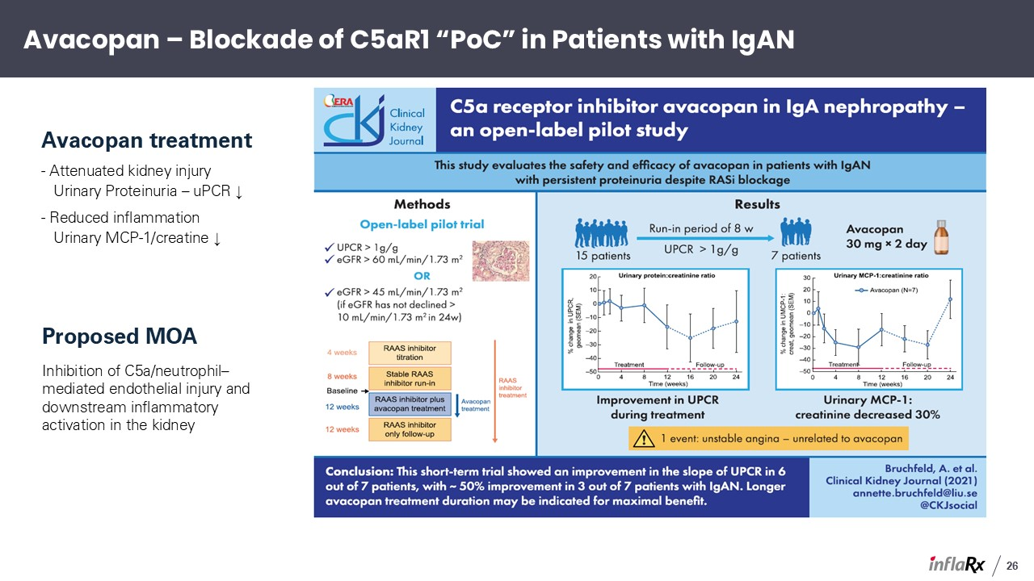
Avacopan treatment - Attenuated kidney injury Urinary Proteinuria – uPCR ↓ - Reduced inflammation Urinary MCP-1/creatine ↓ Proposed MOA Inhibition of C5a/neutrophil–mediated endothelial injury and downstream inflammatory activation in the kidney Avacopan – Blockade of C5aR1 “PoC” in Patients with IgAN 26

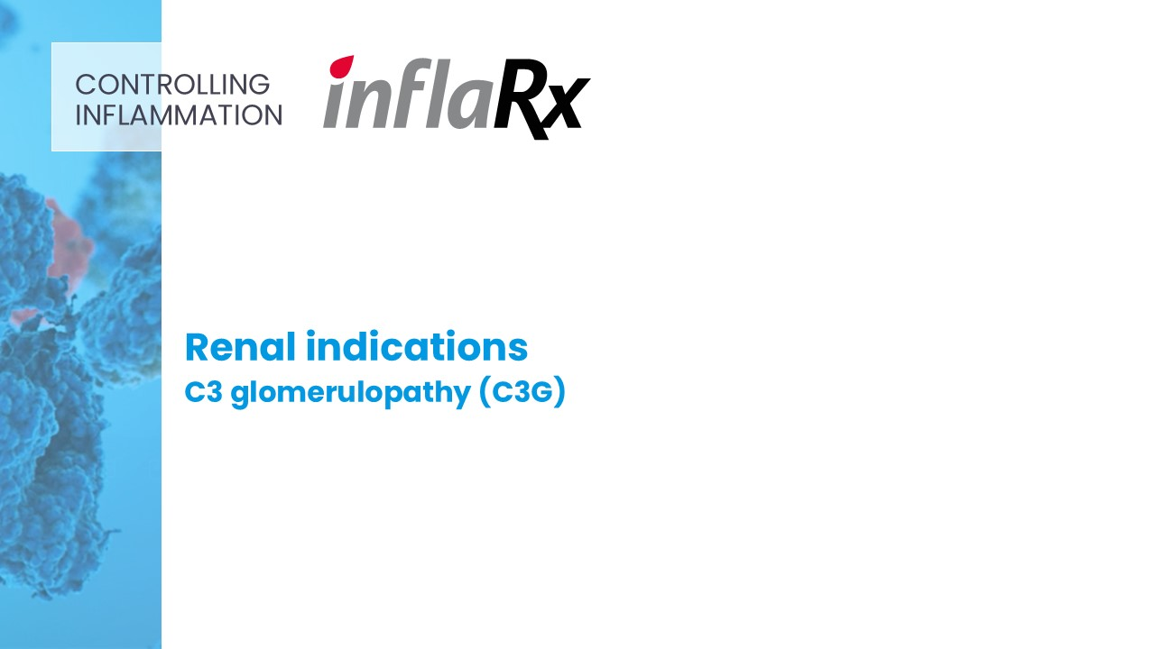
Renal indications C3 glomerulopathy (C3G) CONTROLLING INFLAMMATION

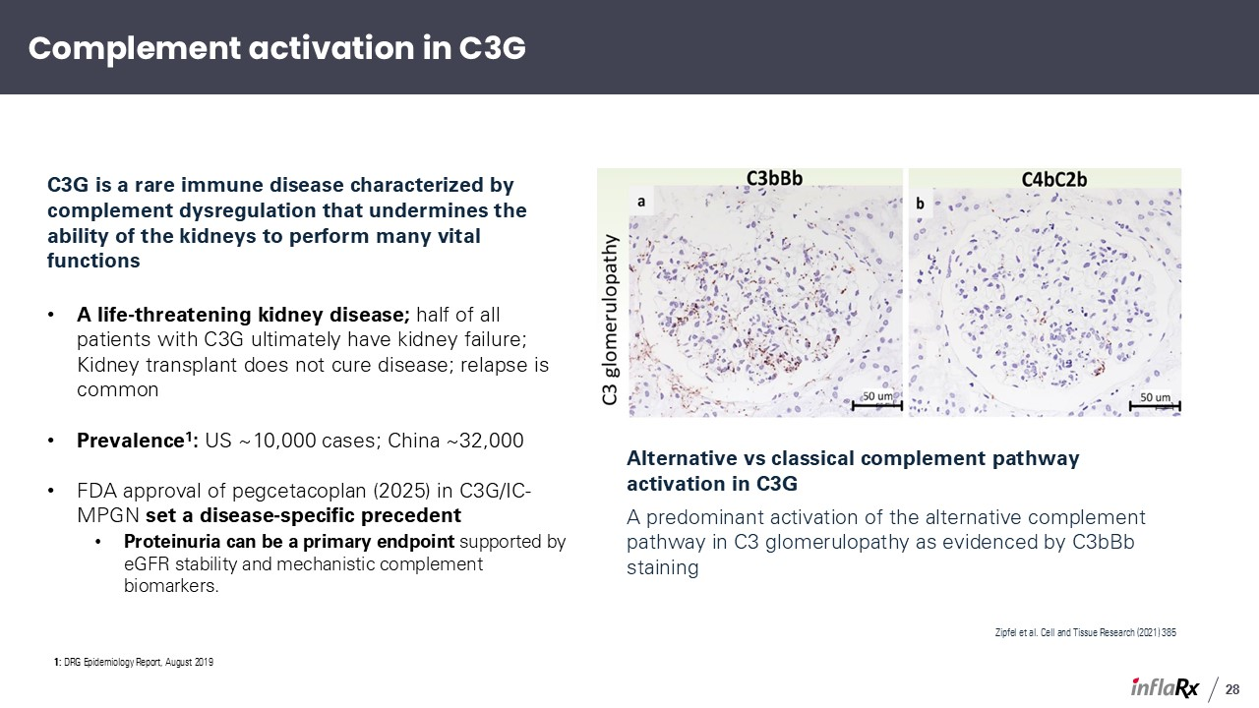
C3G is a rare immune disease characterized by complement dysregulation that undermines the ability of the kidneys to perform many vital functions A life-threatening kidney disease; half of all patients with C3G ultimately have kidney failure; Kidney transplant does not cure disease; relapse is common Prevalence1: US ~10,000 cases; China ~32,000 FDA approval of pegcetacoplan (2025) in C3G/IC-MPGN set a disease-specific precedent Proteinuria can be a primary endpoint supported by eGFR stability and mechanistic complement biomarkers. Alternative vs classical complement pathway activation in C3G A predominant activation of the alternative complement pathway in C3 glomerulopathy as evidenced by C3bBb staining Zipfel et al. Cell and Tissue Research (2021) 385 Complement activation in C3G 28 1: DRG Epidemiology Report, August 2019

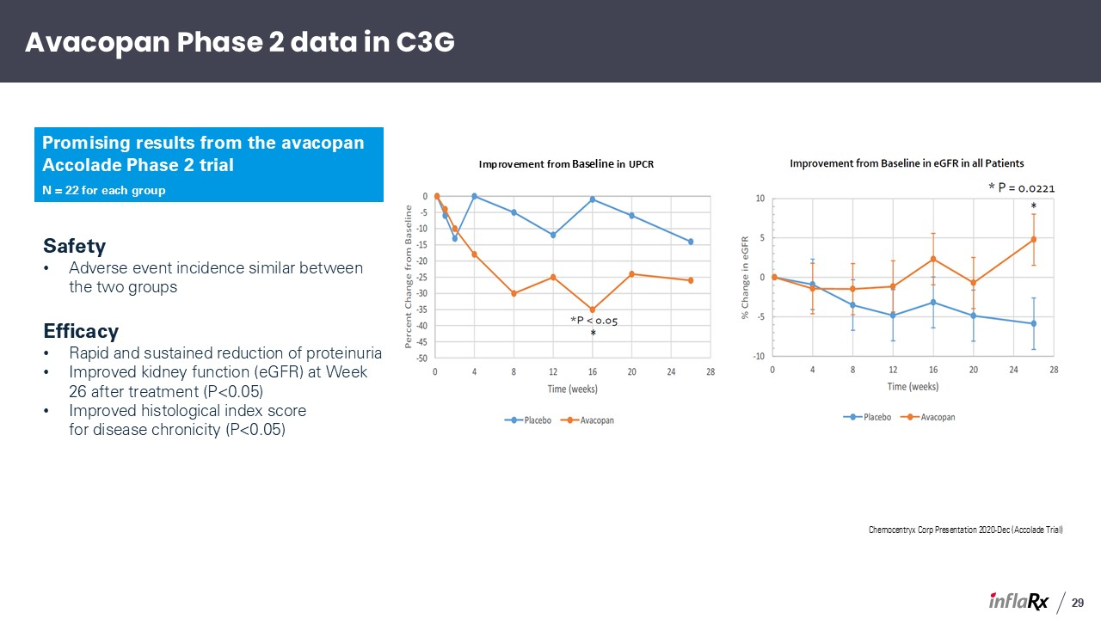
Chemocentryx Corp Presentation 2020-Dec (Accolade Trial) Safety Adverse event incidence similar between the two groups Efficacy Rapid and sustained reduction of proteinuria Improved kidney function (eGFR) at Week 26 after treatment (P<0.05) Improved histological index score for disease chronicity (P<0.05) Improvement from Baseline in UPCR Avacopan Phase 2 data in C3G Promising results from the avacopan Accolade Phase 2 trial N = 22 for each group 29

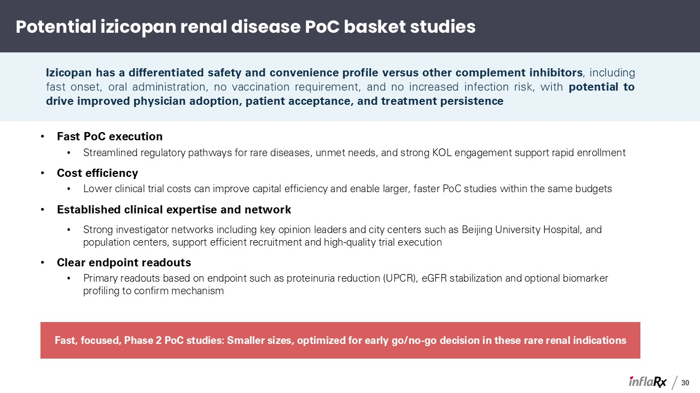
Fast PoC execution Streamlined regulatory pathways for rare diseases, unmet needs, and strong KOL engagement support rapid enrollment Cost efficiency Lower clinical trial costs can improve capital efficiency and enable larger, faster PoC studies within the same budgets Established clinical expertise and network Strong investigator networks including key opinion leaders and city centers such as Beijing University Hospital, and population centers, support efficient recruitment and high-quality trial execution Clear endpoint readouts Primary readouts based on endpoint such as proteinuria reduction (UPCR), eGFR stabilization and optional biomarker profiling to confirm mechanism Potential izicopan renal disease PoC basket studies Izicopan has a differentiated safety and convenience profile versus other complement inhibitors, including fast onset, oral administration, no vaccination requirement, and no increased infection risk, with potential to drive improved physician adoption, patient acceptance, and treatment persistence Fast, focused, Phase 2 PoC studies: Smaller sizes, optimized for early go/no-go decision in these rare renal indications 30

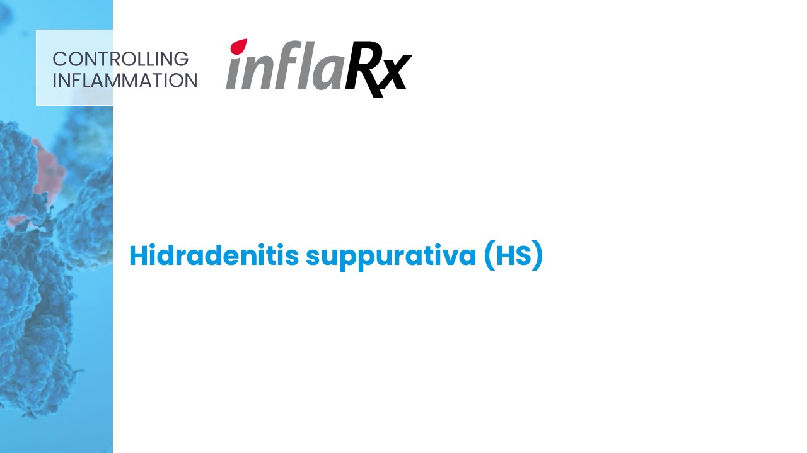
Hidradenitis suppurativa (HS) CONTROLLING INFLAMMATION

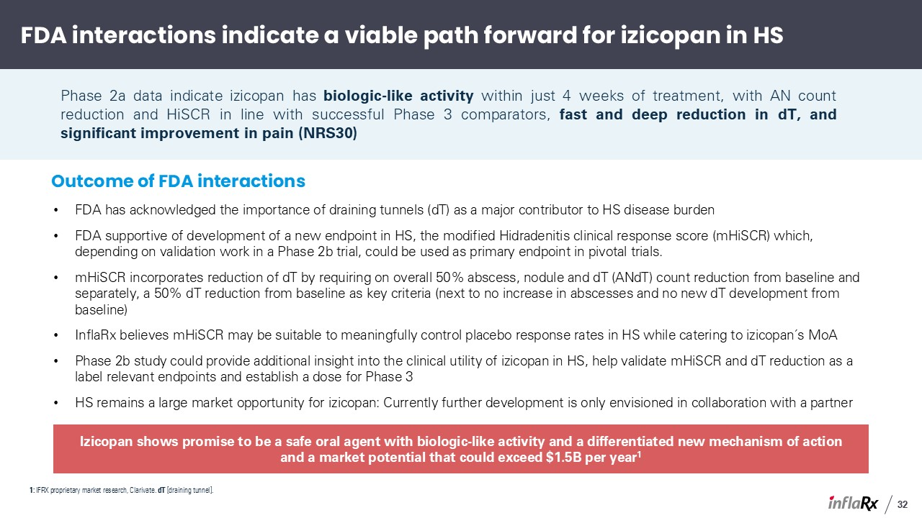
FDA has acknowledged the importance of draining tunnels (dT) as a major contributor to HS disease burden FDA supportive of development of a new endpoint in HS, the modified Hidradenitis clinical response score (mHiSCR) which, depending on validation work in a Phase 2b trial, could be used as primary endpoint in pivotal trials. mHiSCR incorporates reduction of dT by requiring on overall 50% abscess, nodule and dT (ANdT) count reduction from baseline and separately, a 50% dT reduction from baseline as key criteria (next to no increase in abscesses and no new dT development from baseline) InflaRx believes mHiSCR may be suitable to meaningfully control placebo response rates in HS while catering to izicopan´s MoA Phase 2b study could provide additional insight into the clinical utility of izicopan in HS, help validate mHiSCR and dT reduction as a label relevant endpoints and establish a dose for Phase 3 HS remains a large market opportunity for izicopan: Currently further development is only envisioned in collaboration with a partner FDA interactions indicate a viable path forward for izicopan in HS Phase 2a data indicate izicopan has biologic-like activity within just 4 weeks of treatment, with AN count reduction and HiSCR in line with successful Phase 3 comparators, fast and deep reduction in dT, and significant improvement in pain (NRS30) Izicopan shows promise to be a safe oral agent with biologic-like activity and a differentiated new mechanism of action and a market potential that could exceed $1.5B per year1 1: IFRX proprietary market research, Clarivate. dT [draining tunnel]. Outcome of FDA interactions 32

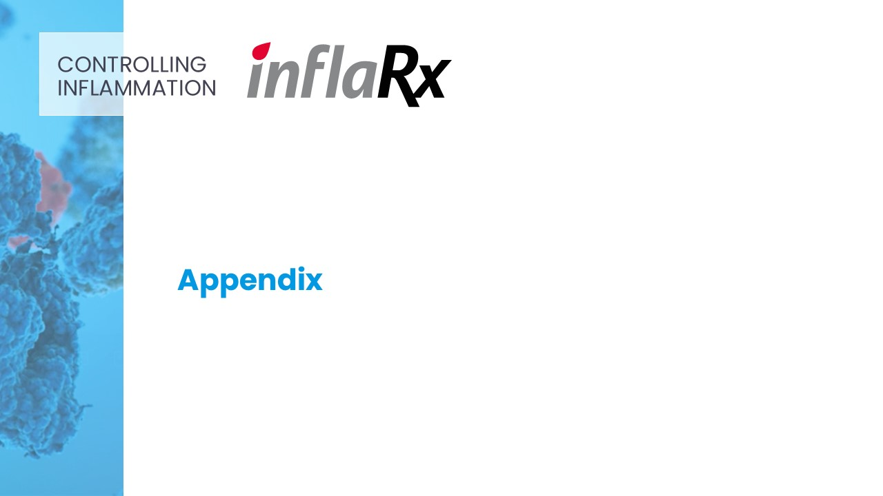
Appendix CONTROLLING INFLAMMATION

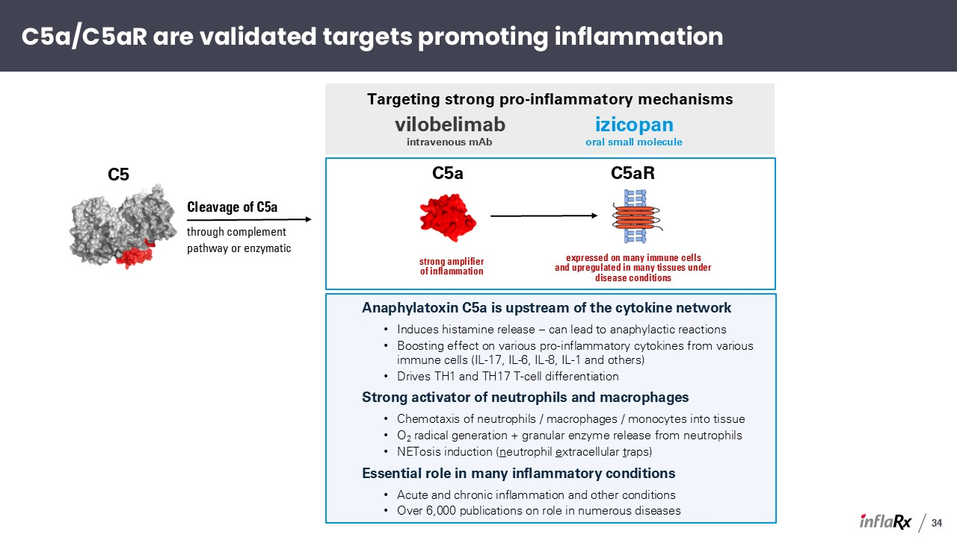
Anaphylatoxin C5a is upstream of the cytokine network Induces histamine release – can lead to anaphylactic reactions Boosting effect on various pro-inflammatory cytokines from various immune cells (IL-17, IL-6, IL-8, IL-1 and others) Drives TH1 and TH17 T-cell differentiation Strong activator of neutrophils and macrophages Chemotaxis of neutrophils / macrophages / monocytes into tissue O2 radical generation + granular enzyme release from neutrophils NETosis induction (neutrophil extracellular traps) Essential role in many inflammatory conditions Acute and chronic inflammation and other conditions Over 6,000 publications on role in numerous diseases C5a strong amplifierof inflammation C5aR expressed on many immune cells and upregulated in many tissues under disease conditions Targeting strong pro-inflammatory mechanisms vilobelimab intravenous mAb izicopan oral small molecule C5 Cleavage of C5a through complement pathway or enzymatic C5a/C5aR are validated targets promoting inflammation 34

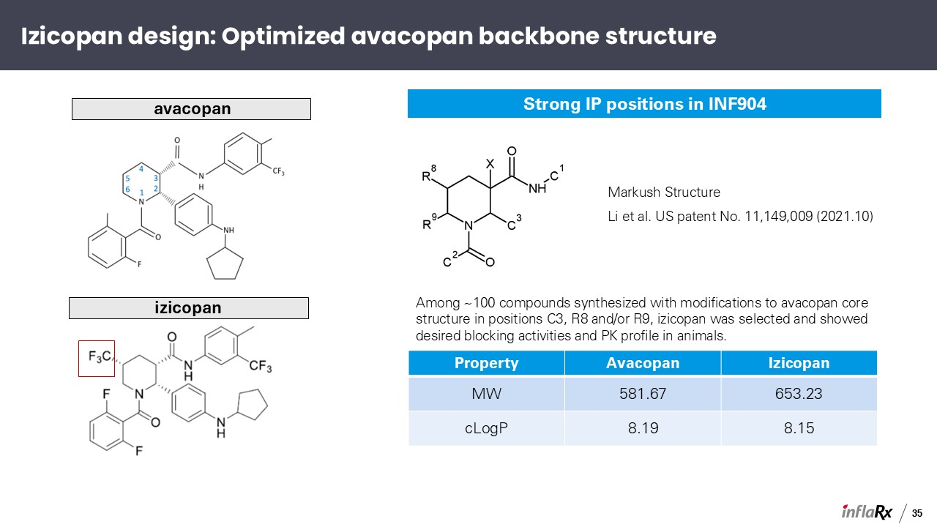
Strong IP positions in INF904 avacopan Among ~100 compounds synthesized with modifications to avacopan core structure in positions C3, R8 and/or R9, izicopan was selected and showed desired blocking activities and PK profile in animals. Property Avacopan Izicopan MW 581.67 653.23 cLogP 8.19 8.15 Markush Structure Li et al. US patent No. 11,149,009 (2021.10) izicopan Izicopan design: Optimized avacopan backbone structure 35

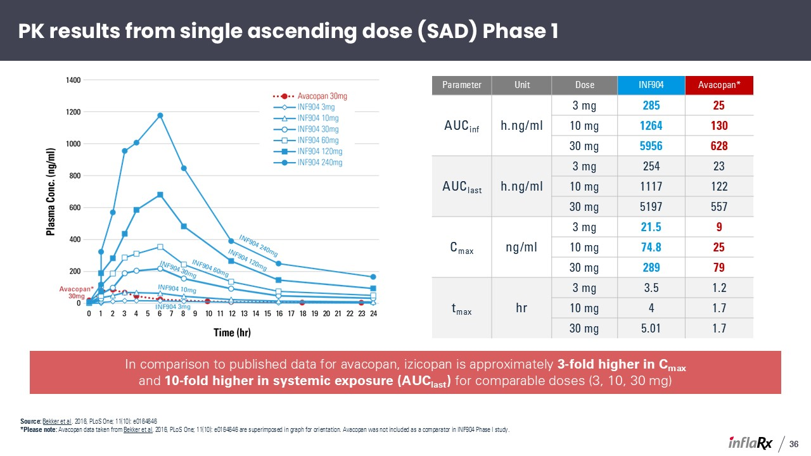
Parameter Unit Dose INF904 Avacopan* AUCinf h.ng/ml 3 mg 285 25 10 mg 1264 130 30 mg 5956 628 AUClast h.ng/ml 3 mg 254 23 10 mg 1117 122 30 mg 5197 557 Cmax ng/ml 3 mg 21.5 9 10 mg 74.8 25 30 mg 289 79 tmax hr 3 mg 3.5 1.2 10 mg 4 1.7 30 mg 5.01 1.7 In comparison to published data for avacopan, izicopan is approximately 3-fold higher in Cmax and 10-fold higher in systemic exposure (AUClast) for comparable doses (3, 10, 30 mg) PK results from single ascending dose (SAD) Phase 1 36 Source: Bekker et al. 2016, PLoS One; 11(10): e0164646 *Please note: Avacopan data taken from Bekker et al. 2016, PLoS One; 11(10): e0164646 are superimposed in graph for orientation. Avacopan was not included as a comparator in INF904 Phase I study.

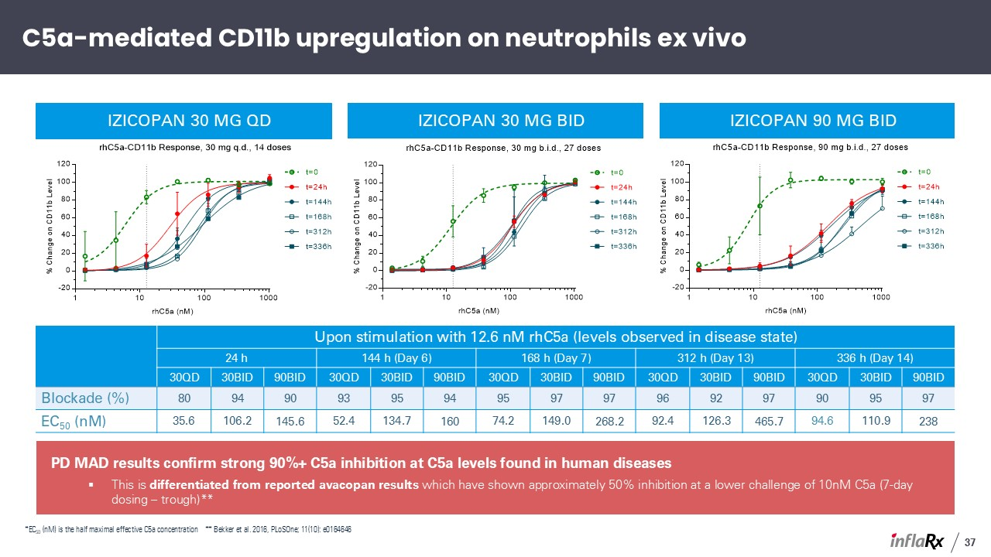
PD MAD results confirm strong 90%+ C5a inhibition at C5a levels found in human diseases This is differentiated from reported avacopan results which have shown approximately 50% inhibition at a lower challenge of 10nM C5a (7-day dosing – trough)** Upon stimulation with 12.6 nM rhC5a (levels observed in disease state) 24 h 144 h (Day 6) 168 h (Day 7) 312 h (Day 13) 336 h (Day 14) C5a (nM) 30QD 30BID 90BID 30QD 30BID 90BID 30QD 30BID 90BID 30QD 30BID 90BID 30QD 30BID 90BID Blockade (%) 80 94 90 93 95 94 95 97 97 96 92 97 90 95 97 EC50 (nM) 35.6 106.2 145.6 52.4 134.7 160 74.2 149.0 268.2 92.4 126.3 465.7 94.6 110.9 238 izicopan 30 mg QD izicopan 30 mg BID izicopan 90 mg BID C5a-mediated CD11b upregulation on neutrophils ex vivo 37 *EC50 (nM) is the half maximal effective C5a concentration ** Bekker et al. 2016, PLoSOne; 11(10): e0164646

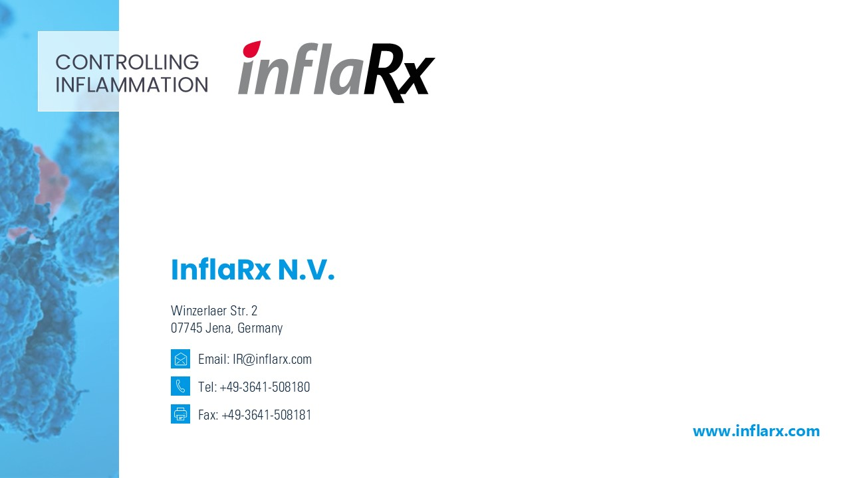
InflaRx N.V. CONTROLLING INFLAMMATION Email: IR@inflarx.com Tel: +49-3641-508180 Fax: +49-3641-508181 www.inflarx.com Winzerlaer Str. 207745 Jena, Germany

