6-K 1 ef20058026_6k.htm 6-K

UNITED STATES
SECURITIES AND EXCHANGE COMMISSION
WASHINGTON, D.C. 20549

FORM 6-K

Report of Foreign Private
Issuer Pursuant to Rule
13a-16 or 15d-16 of the
Securities Exchange Act
of 1934
For the month of May 2025
Commission File
Number: 001-38283

InflaRx N.V.
(Exact name of Registrant as Specified in Its Charter)

Winzerlaer Str. 2
07745 Jena,
Germany
(+49) 3641508180

(Address of principal executive offices)

Indicate by check mark whether the registrant files or will file annual reports under cover of Form 20-F or Form 40-F.

Form 20-F ☒ Form 40-F ☐

INCORPORATION BY REFERENCE

On November 10, 2025, InflaRx N.V. (the “Company”) issued a press release titled “InflaRx Reports Positive Phase 2a Data for INF904 in Hidradenitis Suppurative (HS) and Chronic Spontaneous Urticaria (CSU).”

The Company previously announced that it is developing INF904, an orally administered small-molecule C5aR inhibitor, for which the Company has completed a Phase 1 study in healthy volunteers. The Company initially focused on hidradenitis suppurativa (“HS”), and chronic spontaneous urticaria (“CSU”). On November 10, 2025, the Company announced topline results for INF904 from the Company’s Phase 2a basket study in these indications. The study is evaluating the safety and pharmacokinetics/ pharmacodynamics profile of INF904, with efficacy evaluated as an exploratory endpoint. Efficacy data were data reported for 29 of 31 patients in HS and 30 of 31 patients in CSU. Safety data were reported from a total of 33 patients in each indication. Doses being studied are 60 mg, 90 mg and 120 mg twice daily for HS and 60 mg and 120 mg twice daily for CSU.

In HS, clinical endpoints included reduction in abscesses and nodule (“AN”) counts draining tunnel (“dT”) counts, pain reduction (measured per the Numeric Rating Scale 30 or NRS30), improvement in Dermatology Life Quality Index (“DLQI”) and measurement of the Hidradenitis Suppurativa Clinical Response (“HiSCR”). Patients in the trial demonstrated rapid and clinically meaningful reductions in AN and DT counts, improvements in NRS30 and DLQI, and HiSCR improvements observed at the end of treatment that continued to deepen four weeks after the treatment period. Efficacy data at 4 weeks were largely in line with data reported for a similar timepoint from clinical studies for approved HS therapies. No serious adverse events or safety signals were reported across all doses.

In CSU, endpoints included change from baseline in Urticaria Activity Score over 7 days (“UAS7”) and Urticaria Control Test (“UCT7”), and responder rate analyses, with additional subset analyses conducted in several study subpopulations. Reported improvements in clinical measures such as UAS7 achieved the highest reduction in the 60 mg dosing cohort (UAS7 change from baseline of -13.7 points at week 4), and indicate a level of activity that exceeds average historically reported placebo levels and is generally within the range of existing approved CSU drugs. Furthermore, in patients with severe CSU at baseline (defined as UAS7 of 28–42; n=23), the 60 mg dose reduced UAS7 by 15.4 points, and in patients who presented with angioedema at baseline (n=3) the reduction of UAS7 was 18.7 points. Additional efficacy analyses in patients with high IgE (n=22) and low IgE (n=6) at baseline showed that INF904 appeared equally effective in both patient populations. Improvements in efficacy measures were generally rapid beginning from Week 1 and generally deepened over the four 4 -week treatment period. Patients continued to benefit from INF904 four weeks after the last dose, as measured by reduction in UAS7. Across all doses, no serious adverse events or safety signals were reported.

InflaRx Data

These topline results are based on the number of patients indicated and are subject to final data review and quality checks. For HS, two patients (one in the 60 mg bid dosing group and one in the 90 mg bid dosing group) are still completing treatment and are excluded from the data presented. For CSU, one patient in the 120 mg bid dosing group is still under treatment and is excluded from the data presented. While the Company does not expect the pending data from such patients to materially change the overall efficacy trends, particularly as the most pronounced efficacy in HS was observed in the 120 mg bid dosing group, which is unaffected, minor changes may occur.

Final changes and corrections may occur upon full data review and quality checks, but the Company does not believe any such changes or corrections will have a material impact on the reported efficacy or safety trends. All data should be considered preliminary until the full dataset is available and final analyses are complete. The Company expects to provide an update as soon as the remaining data are incorporated.

Third-Party Data

We have not conducted head-to-head clinical trial comparisons between INF904 and any third-party drug candidate or approved drug. Any third-party data displayed or referenced are intended solely for comparative orientation and are based on published data from various sources, including original publications, press releases, abstracts, posters, approval reviews and others. Except for a separate comparison to reported data from the use of avacopan in HS, all comparisons are focused on available data from drug candidates that are approved. These comparisons are not derived from head-to-head trials and the data displayed are from studies conducted under different protocols, with different inclusion and exclusion criteria, at different sites and at different times, among other differences. As such, the value of any such comparison may be limited, and we are unable to make direct comparative claims between INF904 and third-party drug candidates or approved drugs. We make no representation regarding the completeness of such comparative data and reference the sources of our comparisons where applicable.

A copy of the press release and a copy of the Company’s presentation announcing the results are attached as Exhibit 99.1 and Exhibit 99.2, respectively. Both Exhibit 99.1 and 99.2 shall not be deemed “filed” for purposes of Section 18 of the Securities Exchange Act of 1934, as amended (the “Exchange Act”), or otherwise subject to the liabilities of that section, nor shall it be deemed incorporated by reference in any filing under the Securities Act of 1933, as amended, or the Exchange Act.

FORWARD-LOOKING STATEMENTS

This Report contains forward-looking statements. All statements other than statements of historical fact are forward-looking statements, which are often indicated by terms such as “may,” “will,” “should,” “expect,” “plan,” “anticipate,” “could,” “intend,” “target,” “project,” “estimate,” “believe,” “predict,” “potential” or “continue,” among others. Forward-looking statements appear in a number of places throughout this Report and may include statements regarding our intentions, beliefs, projections, outlook, analyses, current expectations and the risks, uncertainties and other factors described under the headings, “Risk factors” and “Cautionary statement regarding forward looking statements,” in our periodic filings with the U.S. Securities and Exchange Commission. These statements speak only as of the date of this Report and involve known and unknown risks, uncertainties and other important factors that may cause our actual results, performance or achievements to be materially different from any future results, performance or achievements expressed or implied by the forward-looking statements. Given these risks, uncertainties and other factors, you should not place undue reliance on these forward-looking statements, and we assume no obligation to update these forward-looking statements, even if new information becomes available in the future, except as required by law.

EXHIBIT INDEX

Exhibit No. | Description
99.1 | Press Release, dated November 10, 2025.
99.2 | Corporate Presentation, dated November 10, 2025.

SIGNATURES

Pursuant to the requirements of the Securities Exchange Act of 1934, the registrant has duly caused this report to be signed on its behalf by the undersigned, thereunto duly authorized.

 | INFLARX N.V.
Date: November 10, 2025 | By: | /s/ Niels Riedemann
 |  | Name: Niels Riedemann
 |  | Title: Chief Executive Officer

EX-99.1 2 ef20058026_ex99-1.htm EXHIBIT 99.1

Exhibit 99.1

InflaRx Reports Positive Phase 2a Data for INF904 in
Hidradenitis Suppurative (HS) and
Chronic Spontaneous Urticaria (CSU)

 | • | Phase 2a data support oral C5aR inhibitor INF904 as a potentially transformational and best-in-class immunomodulatory agent, indicating strong potential for efficacy and no safety signals of concern
 | • | In HS, over 4 weeks of therapy, InflaRx observed rapid and clinically meaningful reductions in abscesses and nodules (ANs) and draining tunnels (dTs), robust HiSCR responses that continued to deepen four weeks after the treatment period, with substantial reductions in patient reported pain scores, overall demonstrating the potential for biologic-like efficacy
 | • | In CSU, InflaRx observed substantial reductions in the 7-day Urticaria Activity Score (UAS7) broadly across patients, and particularly in those with severe disease, as well as improved disease control as measured by the Urticaria Control Test (UCT7)
 | • | With a priority of enabling Phase 2b development for INF904 in HS, InflaRx continues ongoing clinical trial preparation towards its goal of Phase 2b initiation in 2026
 | • | Given INF904’s potential as a pipeline-in-a-product and increased industry interest in the C5aR mechanism of action, InflaRx continues to foster active dialog with potential collaborators in an effort to expedite the Company’s total development goals with INF904, and to also drive development in CSU and additional inflammatory disorders
 | • | InflaRx will host a webcast to discuss the topline data today at 8:00 AM EST / 2:00 PM CET

Jena, Germany, November 10, 2025 – InflaRx N.V. (Nasdaq: IFRX), a biopharmaceutical company pioneering anti-inflammatory therapeutics by targeting the complement system, today announced positive topline data from a Phase 2a basket study exploring INF904 in HS and CSU. Efficacy data were reported from 29 of 31 HS patients and from 30 of 31 CSU patients. The study is evaluating the safety and pharmacokinetics / pharmacodynamics profile of INF904, with efficacy measures evaluated as exploratory endpoints. InflaRx believes these data provide strong rationale for further development in both indications. The Phase 2a study continues toward completion of the 4-week post-treatment observation period, with the final results targeted for release at major scientific meetings. In addition, InflaRx intends to host a Capital Markets Event showcasing the promise of INF904 in the near future.

Prof. Niels C. Riedemann, Chief Executive Officer and Founder of InflaRx, commented: “The success of our Phase 2a trial with INF904 in hidradenitis suppurativa (HS) and chronic spontaneous urticaria (CSU) is a crucial milestone in demonstrating the compound’s strong safety profile and clinical activity as a potent anti-inflammatory agent. These data represent a pivotal moment for the company, underscoring the therapeutic promise of INF904 as a pipeline-in-a-product. As we move toward initiating Phase 2b in HS and broadening the INF904 clinical program in CSU and beyond, we look forward to further validating INF904’s differentiated profile and advancing its development for patients in need.”

Camilla Chong, MD, Chief Medical Officer of InflaRx, commented: "Results from our Phase 2a study indicate INF904’s positive safety profile to date and show promising signals of clinical benefit in both hidradenitis suppurativa and chronic spontaneous urticaria. We are particularly proud to have advanced this study to this stage in less than a year from study start, which was made possible thanks to the dedication of our clinical team and the excellent collaboration with investigators and their patients.”

Phase 2a data in HS
The Phase 2a trial is a multi-center, open-label study evaluating multiple INF904 dosing regimens over 4 weeks of treatment, with an additional 4-week follow-up period during which time patients are not dosed with INF904 (trial is 8 weeks total). The efficacy data reported today are from 29 patients from all three HS dosing cohorts who completed all 4 weeks of treatment (10 patients on 60 mg BID, 11 patients on 90 mg BID, and 8 patients on 120 mg BID), with additional data from patients (n=25) who to-date, have also completed the subsequent 4-week follow-up observation period off drug.

In HS, clinical endpoints included reduction in AN and dT counts, achievement of HiSCR, pain reduction (Numeric Rating Scale 30 (NRS30)) and improvement in Dermatology Life Quality Index (DLQI).

Across all dosing groups, INF904 induced rapid, meaningful and consistent reductions in ANs and dTs; in addition to improvements in measures such as HiSCR, IHS4, NRS30, and DLQI. Improvements in reported efficacy measures were largely rapid and consistent, beginning from Week 1, and deepened over the 4-week treatment period. All doses showed positive clinical activity and appeared strongest in the highest dosing cohort. The company believes efficacy data for INF904 at 4 weeks are largely in line with data reported for the same timepoint from clinical studies for approved HS therapies and compared favorably for reductions in dT and improvement in NRS30 response.

Furthermore, initial data reported from 25 HS patients who completed the 4-week off-drug follow-up period showed that HiSCR responses continued to deepen 4 weeks after the treatment period. Preliminary PK results from Week 8 indicate INF904 levels 4 weeks off drug may still offer C5aR blocking potential. In addition, InflaRx believes inhibiting C5aR may drive an improvement in the inflammatory environment which may confer longer lasting benefit.

Safety data from 33 HS patients were reported. No signal of safety concern was detected, with no reported serious adverse events (SAEs) and three adverse events in two patients reported as possibly-to-likely related to drug which all were mild (Grade 1) in nature.

Overall, InflaRx believes these data are strong evidence that INF904 is highly active in HS, with improvements in efficacy measures largely differentiated from historically reported placebo, and in line with reported improvements at the 4-week time point for therapies which have successfully completed Phase 3 trials or received approval.

Given this positive biologic-like emerging clinical profile, with rapid, consistent and significant reductions in all lesion counts, total inflammatory burden (TIB), and patient reported outcomes (in particular NRS30 Skin Pain), as well as an addressable market for INF904 that InflaRx believes could well exceed $1 billion, the Company has a goal of progressing clinical development into a Phase 2b trial in 2026.

Exhibit 1: INF904 in HS at 4 weeks, unless otherwise noted.

 | 60 mg BID | 90 mg BID | 120 mg BID | All doses  combined
AN (CFB) | -4.2 | -3.6 | -8.1 | -5.1
dT (pts with ≥1 dT)  n = 21 | -1.0 | -1.3 | -2.2 | -1.4
dT100  n = 21 | 14% | 25% | 50% | 29%
ANdT (CFB) | -4.9 | -4.5 | -9.8 | -6.1
HiSCR50 | 20% | 27% | 38% | 28%
HiSCR50  Week 8 (n = 25) | 25% | 44% | 63% | 44%
IHS4 (CFB) | -7.1 | -8.4 | -18.6 | -10.8
NRS30 | 60% | 64% | 75% | 66%
DLQI (CFB) | -5.0 | -2.9 | -10.1 | -5.6

CFB = Change from baseline.
AN =d Combined abscesses + nodules count.
dT = Draining tunnel count.
dT100 = Percent of patients with 100% reduction in draining tunnels.
HiSCR50 = Hidradenitis Suppurativa Clinical Response with at least a 50% reduction.
IHS4 = International Hidradenitis Suppurativa Severity Score System.
NRS30 = Numerical Rating Scale with at least 30% and at least 2-point reduction in skin pain.
DLQI = Dermatology Quality of Life Index.

Professor John Ingram, Clinical Professor & Consultant Dermatologist, Cardiff University and Specialty Lead for Dermatology, Health and Care Research Wales, commented: “These data in hidradenitis suppurativa (HS) are encouraging, demonstrating the potential for INF904 to rapidly and substantially reduce total inflammatory burden (TIB) - abscesses, nodules, and draining tunnels. These findings suggest INF904 could meaningfully lessen the burden faced by HS patients, many of whom continue to suffer despite the relatively small set of approved therapies currently available. The improvements observed in NRS30 and DLQI further underscore INF904's potential to deliver a differentiated clinical benefit compared with currently available treatments. Given the pressing need for novel mechanisms of action, and INF904’s emerging clinical profile as a well-tolerated and potentially effective oral therapy, I am optimistic about its advancement into later-stage development and its potential to address an important unmet need in HS.”

Phase 2a data in CSU
The Phase 2a trial is a multi-center, open-label study evaluating multiple INF904 dosing regimens over 4 weeks of treatment, with an additional 4-week follow-up period during which time patients are not dosed with INF904 (trial is 8 weeks total). The efficacy data reported today are from 30 patients (14 patients on 60 mg BID and 16 patients on 120 mg BID) that completed all 4 weeks of treatment, with additional data from patients (n=23) who to-date, have also completed the subsequent 4-week follow-up observation period off drug.

In CSU, clinical endpoints included change from baseline in UAS7, UCT7 and responder rate analyses, with additional subset analyses conducted in several study subpopulations.

Reported improvements in clinical measures such as UAS7 appeared generally higher in the 60 mg dosing cohort (UAS7 change from baseline of -13.7 points at Week 4) and indicate a level of activity that exceeds average historically reported placebo levels, and is within the range of existing approved CSU therapies. Furthermore, in patients with severe CSU at baseline (UAS7 of 28–42, n=23), the 60mg dose reduced UAS7 by 15.4 points, and in patients who presented with angioedema (n=3) the reduction of UAS7 was 18.7 points. Additional efficacy analyses in patients with high IgE (n=22) and low IgE (n=6) at baseline showed that INF904 appeared equally effective in both patient populations.

Furthermore, initial data reported from 23 CSU patients who completed the 4-week off-drug observational follow-up period, indicated that patients continued to benefit from INF904 four weeks after the last dose, with responses in the 60mg dosing cohort showing a mean absolute UAS7 reduction of 16.7 points. InflaRx believes that INF904’s ability to drive durable improvements within the inflammatory environment could provide deepened clinical benefit with long-term dosing.

Safety data from 33 CSU patients were reported. No signal of safety concern was detected, with no reported SAEs and one adverse event reported as possibly related to drug which was mild (Grade 1) in nature.

Overall, InflaRx believes these data suggest that INF904 is active in CSU and not only differentiated from reported historical placebo rates, but potentially within the range of currently approved CSU therapies. These data further indicate that UAS7 decreases may deepen with longer-term treatment.

Given this positive emerging clinical profile, and an addressable market for INF904 that InflaRx believes could well exceed $1 billion, the company is targeting further development for INF904 in CSU via its active engagement with potential partners.

Exhibit 2: INF904 in CSU at 4 weeks, unless otherwise noted.

 | 60 mg BID | 120 mg BID | All doses  combined
UAS7 (CFB) | -13.7 | -7.9 | -10.4
UAS7 (CFB)  8 weeks (n = 23) | -16.3 | -7.1 | -11.1
UAS7 (CFB)  Severe CSU (n = 23) | -15.4 | -8.8 | -12.0
UCT7 (CFB) | 4.9 | 4.9 | 4.9
UCT7≥ 12 | 31% | 25% | 29%

CFB = Change from baseline.
UAS7 = Weekly Urticaria Activity Score over a 7-day period.
Severe CSU = Baseline UAS7 of 28 - 42
UCT7 = 7-day recall version of the Urticaria Control Test.

Martin Metz, MD, Professor of Dermatology and Deputy Director of the Institute of Allergology | Charité – Universitätsmedizin, Berlin, Germany, commented: “The Phase 2a data for INF904 in chronic spontaneous urticaria (CSU) are encouraging, indicating clinical activity and safety. Furthermore, by inhibiting the C5a receptor, INF904 appears to be acting on the inflammation environment underlying urticaria, which may further benefit from continued dosing. Given the unmet need in CSU, and the potential for INF904 as an effective and safe oral agent to benefit a significant number of patients, further exploration in CSU is clearly warranted.”

Efficacy data were reported from 29 of 31 HS patients and 30 of 31 CSU patients, with two HS patients (60 mg and 90 mg) and one CSU patient (120 mg) remaining. The Phase 2a study continues toward completion of the 4-week post-treatment observation period, with the final results targeted for release at major scientific meetings. Enrollment in a third CSU dosing cohort (120 mg) in patients refractory to anti-IgE therapy is ongoing. Data from this last cohort in CSU will be announced in due course.

Webcast
InflaRx will host a webcast/conference call accompanied by a slide presentation today at 8:00 AM EST / 2:00 PM CET. To participate in the call, participants may pre-register here to receive an invite link and dial-in details. The live webcast and audio archive of the presentation can be accessed on the InflaRx website at https://www.inflarx.de/home/investors/events.html.

Third-party data
We have not conducted head-to-head clinical trial comparisons between INF904 and any third-party drug candidate or approved drug. Any third-party data displayed or referenced are intended solely for comparative orientation and are based on published data from various sources, including original publications, press releases, abstracts, posters, approval reviews and others. Except for a separate comparison to reported data from the use of avacopan in HS, all comparisons are focused on available data from drug candidates that are approved. These comparisons are not derived from head-to-head trials and the data displayed are from studies conducted under different protocols, with different inclusion and exclusion criteria, at different sites and at different times, among other differences. As such, the value of any such comparison may be limited, and we are unable to make direct comparative claims between INF904 and third-party drug candidates or approved drugs. We make no representation regarding the completeness of such comparative data and reference the sources of our comparisons where applicable.

InflaRx data
The topline results presented in this press release are based on the number of patients indicated and are subject to final data review and quality checks. For HS, two patients (one in the 60 mg bid dosing group and one in the 90 mg bid dosing group) are still completing treatment and are therefore excluded from the data presented. For CSU, one patient in the 120 mg bid dosing group is still under treatment and is therefore excluded from the data presented. While we do not expect the pending data from such patients to materially change the overall efficacy trends, particularly as the most pronounced efficacy in HS was observed in the 120 mg bid dosing group, which is unaffected, minor changes may occur. Final changes and corrections may occur upon full data review and quality checks, but we do not believe any such changes or corrections will have a material impact on the reported efficacy or safety trends.

About INF904
INF904 is an orally administered, small molecule inhibitor of the C5a receptor Ca5R1 that has shown anti-inflammatory therapeutic effects in several pre-clinical disease models. Further, in contrast to the marketed C5aR inhibitor, in vitro experiments demonstrated that INF904 has minimal inhibition of the cytochrome P450 3A4/5 (CYP3A4/5) enzymes, which play an important role in the metabolism of a variety of metabolites and drugs, including glucocorticoids. Reported results from a first-in-human study demonstrated that INF904 is well tolerated in treated subjects and exhibits no safety signals of concern in single doses ranging from 3 mg to 240 mg or multiple doses ranging from 30 mg once per day to 90 mg twice per day for 14 days. Pharmacokinetic / pharmacodynamic data support the best-in-class potential of INF904 with a ≥90% blockade of C5a-induced neutrophil activation achieved over the 14-day dosing period.

About InflaRx N.V.
InflaRx (Nasdaq: IFRX) is a biopharmaceutical company pioneering anti-inflammatory therapeutics by applying its proprietary anti-C5a and anti-C5aR technologies to discover, develop and commercialize highly potent and specific inhibitors of the complement activation factor C5a and its receptor, C5aR. C5a is a powerful inflammatory mediator involved in the progression of a wide variety of inflammatory diseases. InflaRx has developed vilobelimab, a novel, intravenously delivered, first-in-class, anti-C5a monoclonal antibody that selectively binds to free C5a and has demonstrated disease-modifying clinical activity and tolerability in multiple clinical studies. InflaRx is also developing INF904, an orally administered small molecule inhibitor of C5a-induced signaling via the C5a receptor.

InflaRx was founded in 2007, and the group has offices and subsidiaries in Jena and Munich, Germany, as well as Ann Arbor, MI, USA. For further information, please visit www.inflarx.de. InflaRx GmbH (Germany) and InflaRx Pharmaceuticals Inc. (USA) are wholly owned subsidiaries of InflaRx N.V. (together, InflaRx).

Contacts:
InflaRx N.V. | MC Services AG
Jan Medina, CFA  Vice President, Head of Investor Relations  Email: IR@inflarx.de | Katja Arnold, Laurie Doyle, Dr. Regina Lutz  Email: inflarx@mc-services.eu  Europe: +49 89-210 2280  U.S.: +1-339-832-0752


FORWARD-LOOKING STATEMENTS
This press release contains forward-looking statements. All statements other than statements of historical fact are forward-looking statements, which are often indicated by terms such as “may,” “will,” “should,” “expect,” “plan,” “anticipate,” “could,” “intend,” “target,” “estimate,” “believe,” “predict,” “potential” or “continue,” among others. Forward-looking statements appear in a number of places throughout this press release and may include statements regarding our intentions, beliefs, projections, outlook, analyses and current expectations concerning, among other things: the receptiveness of INF904 as a treatment for HS and CSU by patients and hospitals and related treatment recommendations by medical/healthcare institutes and other third-party organizations; our ability to successfully secure distribution channels and commercialize GOHIBIC (vilobelimab) as a treatment for COVID-19 patients and our ability to positively influence treatment recommendations by U.S. and European hospitals, guideline bodies and other third-party organizations; our expectations regarding the size of the patient populations for, market opportunity for, coverage and reimbursement for, estimated returns and return accruals for, and clinical utility of GOHIBIC (vilobelimab) in its approved or authorized indication or for vilobelimab and any other product candidates, under the Emergency Use Authorization and in the future if approved for commercial use in the United States, Europe or elsewhere; our ability to successfully implement The InflaRx Commitment Program, the success of our future clinical trials for vilobelimab’s treatment of debilitating or life-threatening inflammatory indications, including acute respiratory distress syndrome and other indications, and any other product candidates, including INF904, and whether such clinical results will reflect results seen in previously conducted pre-clinical studies and clinical trials; the timing, progress and results of preclinical studies and clinical trials of vilobelimab, INF904 and any other product candidates, including for the development of vilobelimab in several indications, including to obtain full approval of GOHIBIC (vilobelimab) for COVID-19 and other virally induced ARDS, to treat HS and CSU, and statements regarding the timing of initiation and completion of studies or trials and related preparatory work, the period during which the results of the trials will become available, the costs of such trials and our research and development programs generally; our interactions with and the receptiveness and approval by regulators regarding the results of clinical trials and potential regulatory approval or authorization pathways, including our biologics license application submission for GOHIBIC (vilobelimab); the timing and outcome of any discussions or submission of filings for regulatory approval or authorization of vilobelimab, INF904 or any other product candidate, and the timing of and our ability to obtain and maintain full regulatory approval, the EUA and/or market authorization of vilobelimab or GOHIBIC (vilobelimab) for any indication; our ability to leverage our proprietary anti-C5a and anti-C5aR technologies to discover and develop therapies to treat complement-mediated autoimmune and inflammatory diseases; our ability to protect, maintain and enforce our intellectual property protection for vilobelimab, INF904 and any other product candidates, and the scope of such protection; whether the U.S. Food and Drug Administration, the European Medicines Agency or any comparable foreign regulatory authority will accept or agree with the number, design, size, conduct or implementation of our clinical trials, including any proposed primary or secondary endpoints for such trials; the success of our future clinical trials for vilobelimab, INF904 and any other product candidates and whether such clinical results will reflect results seen in previously conducted preclinical studies and clinical trials; our expectations regarding the size of the patient populations for, the market opportunity for, the medical need for and clinical utility of vilobelimab, INF904 or any other product candidates, if approved or authorized for commercial use; our manufacturing capabilities and strategy, including the scalability and cost of our manufacturing methods and processes and the optimization of our manufacturing methods and processes, and our ability to continue to rely on our existing third-party manufacturers and our ability to engage additional third-party manufacturers for our planned future clinical trials and for commercial supply of vilobelimab and for the finished product GOHIBIC (vilobelimab) in the United States and Europe; our estimates of our expenses, ongoing losses, future revenue, capital requirements and our needs for or ability to obtain additional financing; our expectations regarding the scope of any approved indication for vilobelimab; our ability to defend against liability claims resulting from the testing of our product candidates in the clinic or, if, approved or authorized, any commercial sales; if any of our product candidates obtain regulatory approval or authorization, our ability to comply with and satisfy ongoing drug regulatory obligations and continued regulatory overview; our ability to comply with enacted and future legislation in seeking marketing approval or authorization and commercialization; our future growth and ability to compete, which depends on our retaining key personnel and recruiting additional qualified personnel; our competitive position and the development of and projections relating to our competitors in the development of C5a and C5aR inhibitors and other therapeutic products being developed in similar medical conditions in which vilobelimab, INF904 or any other of our product candidates is being developed or our industry; and the risks, uncertainties and other factors described under the heading “Risk Factors” in our periodic filings with the U.S. Securities and Exchange Commission. These statements speak only as of the date of this press release and involve known and unknown risks, uncertainties and other important factors that may cause our actual results, performance or achievements to be materially different from any future results, performance or achievements expressed or implied by the forward-looking statements. Given these risks, uncertainties and other factors, you should not place undue reliance on these forward-looking statements, and we assume no obligation to update these forward-looking statements, even if new information becomes available in the future, except as required by law.

EX-99.2 3 ef20058026_ex99-2.htm EXHIBIT 99.2

Exhibit 99.2

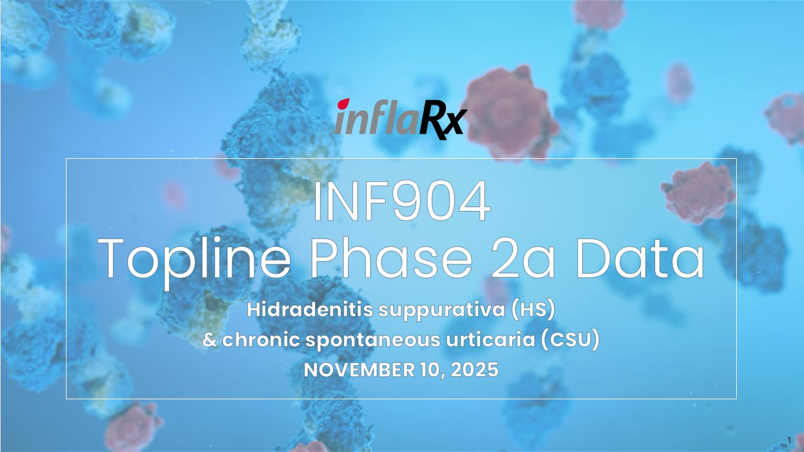
INF904 Topline Phase 2a Data Hidradenitis suppurativa (HS) & chronic spontaneous urticaria (CSU) NOVEMBER 10, 2025 1


Speakers 2 Niels Riedemann, M.D., Ph.D. Chief Executive Officer, Founder, InflaRx Camilla Chong, M.D. Chief Medical Officer, InflaRx Prof. John Ingram Clinical Professor & Consultant Dermatologist, Cardiff University & Specialty Lead for Dermatology, Health and Care Research Wales Thomas Taapken, Ph.D. Chief Financial Officer, InflaRx JAN Medina, cfa Vice President, Head of IR, InflaRx

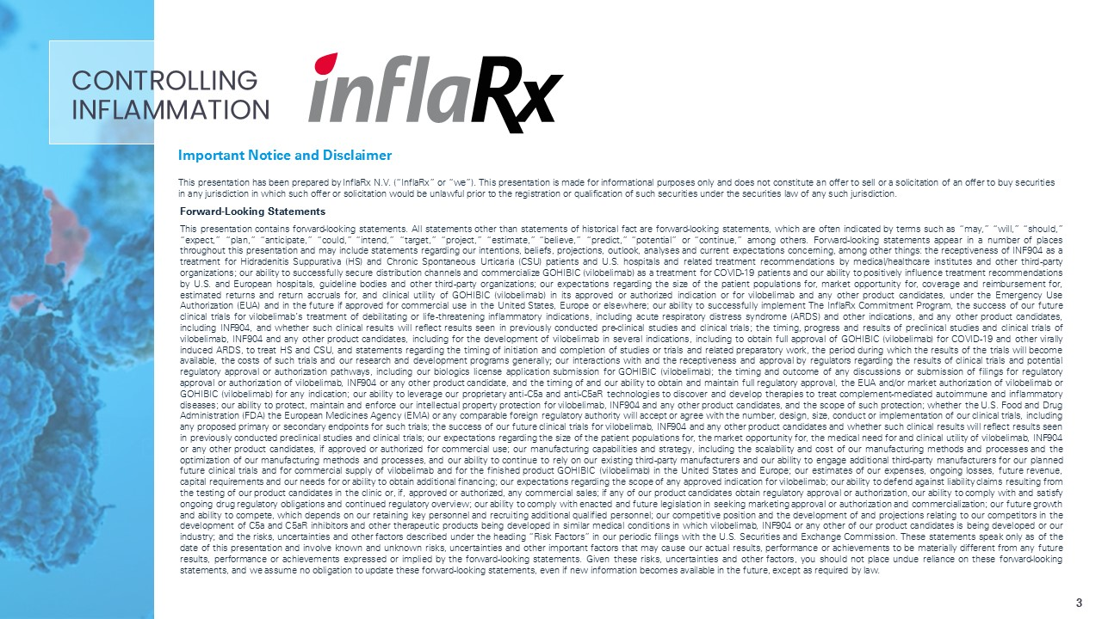
Important Notice and Disclaimer This presentation has been prepared by InflaRx N.V. (“InflaRx” or “we”). This presentation is made for informational purposes only and does not constitute an offer to sell or a solicitation of an offer to buy securities in any jurisdiction in which such offer or solicitation would be unlawful prior to the registration or qualification of such securities under the securities law of any such jurisdiction. Forward-Looking Statements This presentation contains forward-looking statements. All statements other than statements of historical fact are forward-looking statements, which are often indicated by terms such as “may,” “will,” “should,” “expect,” “plan,” “anticipate,” “could,” “intend,” “target,” “project,” “estimate,” “believe,” “predict,” “potential” or “continue,” among others. Forward-looking statements appear in a number of places throughout this presentation and may include statements regarding our intentions, beliefs, projections, outlook, analyses and current expectations concerning, among other things: the receptiveness of INF904 as a treatment for Hidradenitis Suppurativa (HS) and Chronic Spontaneous Urticaria (CSU) patients and U.S. hospitals and related treatment recommendations by medical/healthcare institutes and other third-party organizations; our ability to successfully secure distribution channels and commercialize GOHIBIC (vilobelimab) as a treatment for COVID-19 patients and our ability to positively influence treatment recommendations by U.S. and European hospitals, guideline bodies and other third-party organizations; our expectations regarding the size of the patient populations for, market opportunity for, coverage and reimbursement for, estimated returns and return accruals for, and clinical utility of GOHIBIC (vilobelimab) in its approved or authorized indication or for vilobelimab and any other product candidates, under the Emergency Use Authorization (EUA) and in the future if approved for commercial use in the United States, Europe or elsewhere; our ability to successfully implement The InflaRx Commitment Program, the success of our future clinical trials for vilobelimab’s treatment of debilitating or life-threatening inflammatory indications, including acute respiratory distress syndrome (ARDS) and other indications, and any other product candidates, including INF904, and whether such clinical results will reflect results seen in previously conducted pre-clinical studies and clinical trials; the timing, progress and results of preclinical studies and clinical trials of vilobelimab, INF904 and any other product candidates, including for the development of vilobelimab in several indications, including to obtain full approval of GOHIBIC (vilobelimab) for COVID-19 and other virally induced ARDS, to treat HS and CSU, and statements regarding the timing of initiation and completion of studies or trials and related preparatory work, the period during which the results of the trials will become available, the costs of such trials and our research and development programs generally; our interactions with and the receptiveness and approval by regulators regarding the results of clinical trials and potential regulatory approval or authorization pathways, including our biologics license application submission for GOHIBIC (vilobelimab); the timing and outcome of any discussions or submission of filings for regulatory approval or authorization of vilobelimab, INF904 or any other product candidate, and the timing of and our ability to obtain and maintain full regulatory approval, the EUA and/or market authorization of vilobelimab or GOHIBIC (vilobelimab) for any indication; our ability to leverage our proprietary anti-C5a and anti-C5aR technologies to discover and develop therapies to treat complement-mediated autoimmune and inflammatory diseases; our ability to protect, maintain and enforce our intellectual property protection for vilobelimab, INF904 and any other product candidates, and the scope of such protection; whether the U.S. Food and Drug Administration (FDA) the European Medicines Agency (EMA) or any comparable foreign regulatory authority will accept or agree with the number, design, size, conduct or implementation of our clinical trials, including any proposed primary or secondary endpoints for such trials; the success of our future clinical trials for vilobelimab, INF904 and any other product candidates and whether such clinical results will reflect results seen in previously conducted preclinical studies and clinical trials; our expectations regarding the size of the patient populations for, the market opportunity for, the medical need for and clinical utility of vilobelimab, INF904 or any other product candidates, if approved or authorized for commercial use; our manufacturing capabilities and strategy, including the scalability and cost of our manufacturing methods and processes and the optimization of our manufacturing methods and processes, and our ability to continue to rely on our existing third-party manufacturers and our ability to engage additional third-party manufacturers for our planned future clinical trials and for commercial supply of vilobelimab and for the finished product GOHIBIC (vilobelimab) in the United States and Europe; our estimates of our expenses, ongoing losses, future revenue, capital requirements and our needs for or ability to obtain additional financing; our expectations regarding the scope of any approved indication for vilobelimab; our ability to defend against liability claims resulting from the testing of our product candidates in the clinic or, if, approved or authorized, any commercial sales; if any of our product candidates obtain regulatory approval or authorization, our ability to comply with and satisfy ongoing drug regulatory obligations and continued regulatory overview; our ability to comply with enacted and future legislation in seeking marketing approval or authorization and commercialization; our future growth and ability to compete, which depends on our retaining key personnel and recruiting additional qualified personnel; our competitive position and the development of and projections relating to our competitors in the development of C5a and C5aR inhibitors and other therapeutic products being developed in similar medical conditions in which vilobelimab, INF904 or any other of our product candidates is being developed or our industry; and the risks, uncertainties and other factors described under the heading “Risk Factors” in our periodic filings with the U.S. Securities and Exchange Commission. These statements speak only as of the date of this presentation and involve known and unknown risks, uncertainties and other important factors that may cause our actual results, performance or achievements to be materially different from any future results, performance or achievements expressed or implied by the forward-looking statements. Given these risks, uncertainties and other factors, you should not place undue reliance on these forward-looking statements, and we assume no obligation to update these forward-looking statements, even if new information becomes available in the future, except as required by law. CONTROLLING INFLAMMATION 3

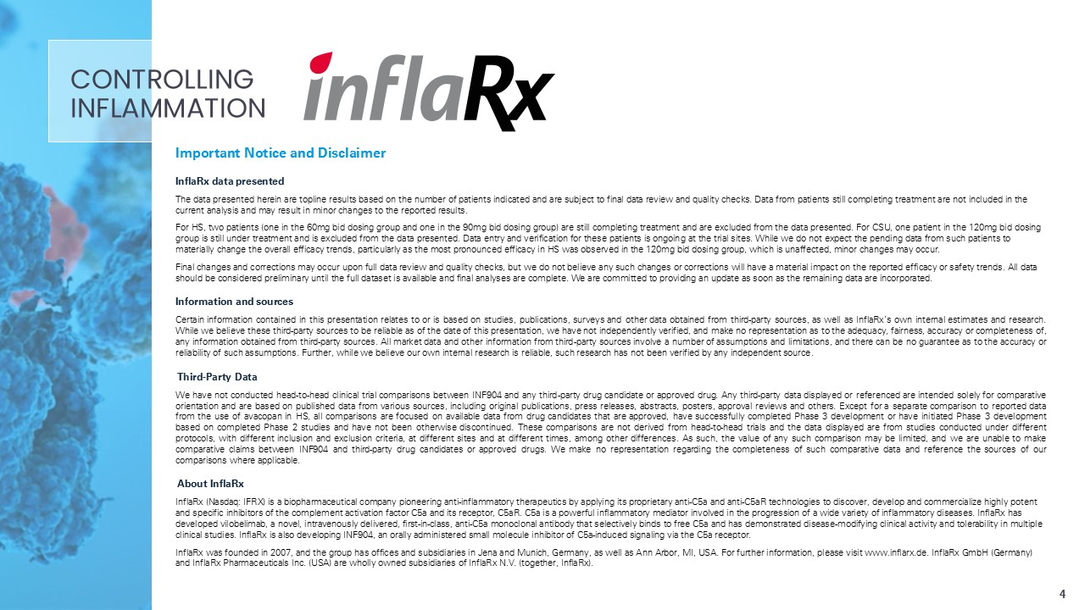
Important Notice and Disclaimer InflaRx data presented The data presented herein are topline results based on the number of patients indicated and are subject to final data review and quality checks. Data from patients still completing treatment are not included in the current analysis and may result in minor changes to the reported results. For HS, two patients (one in the 60mg bid dosing group and one in the 90mg bid dosing group) are still completing treatment and are excluded from the data presented. For CSU, one patient in the 120mg bid dosing group is still under treatment and is excluded from the data presented. Data entry and verification for these patients is ongoing at the trial sites. While we do not expect the pending data from such patients to materially change the overall efficacy trends, particularly as the most pronounced efficacy in HS was observed in the 120mg bid dosing group, which is unaffected, minor changes may occur. Final changes and corrections may occur upon full data review and quality checks, but we do not believe any such changes or corrections will have a material impact on the reported efficacy or safety trends. All data should be considered preliminary until the full dataset is available and final analyses are complete. We are committed to providing an update as soon as the remaining data are incorporated. Information and sources Certain information contained in this presentation relates to or is based on studies, publications, surveys and other data obtained from third-party sources, as well as InflaRx’s own internal estimates and research. While we believe these third-party sources to be reliable as of the date of this presentation, we have not independently verified, and make no representation as to the adequacy, fairness, accuracy or completeness of, any information obtained from third-party sources. All market data and other information from third-party sources involve a number of assumptions and limitations, and there can be no guarantee as to the accuracy or reliability of such assumptions. Further, while we believe our own internal research is reliable, such research has not been verified by any independent source. Third-Party Data We have not conducted head-to-head clinical trial comparisons between INF904 and any third-party drug candidate or approved drug. Any third-party data displayed or referenced are intended solely for comparative orientation and are based on published data from various sources, including original publications, press releases, abstracts, posters, approval reviews and others. Except for a separate comparison to reported data from the use of avacopan in HS, all comparisons are focused on available data from drug candidates that are approved, have successfully completed Phase 3 development or have initiated Phase 3 development based on completed Phase 2 studies and have not been otherwise discontinued. These comparisons are not derived from head-to-head trials and the data displayed are from studies conducted under different protocols, with different inclusion and exclusion criteria, at different sites and at different times, among other differences. As such, the value of any such comparison may be limited, and we are unable to make comparative claims between INF904 and third-party drug candidates or approved drugs. We make no representation regarding the completeness of such comparative data and reference the sources of our comparisons where applicable. About InflaRx InflaRx (Nasdaq: IFRX) is a biopharmaceutical company pioneering anti-inflammatory therapeutics by applying its proprietary anti-C5a and anti-C5aR technologies to discover, develop and commercialize highly potent and specific inhibitors of the complement activation factor C5a and its receptor, C5aR. C5a is a powerful inflammatory mediator involved in the progression of a wide variety of inflammatory diseases. InflaRx has developed vilobelimab, a novel, intravenously delivered, first-in-class, anti-C5a monoclonal antibody that selectively binds to free C5a and has demonstrated disease-modifying clinical activity and tolerability in multiple clinical studies. InflaRx is also developing INF904, an orally administered small molecule inhibitor of C5a-induced signaling via the C5a receptor. InflaRx was founded in 2007, and the group has offices and subsidiaries in Jena and Munich, Germany, as well as Ann Arbor, MI, USA. For further information, please visit www.inflarx.de. InflaRx GmbH (Germany) and InflaRx Pharmaceuticals Inc. (USA) are wholly owned subsidiaries of InflaRx N.V. (together, InflaRx). CONTROLLING INFLAMMATION 4

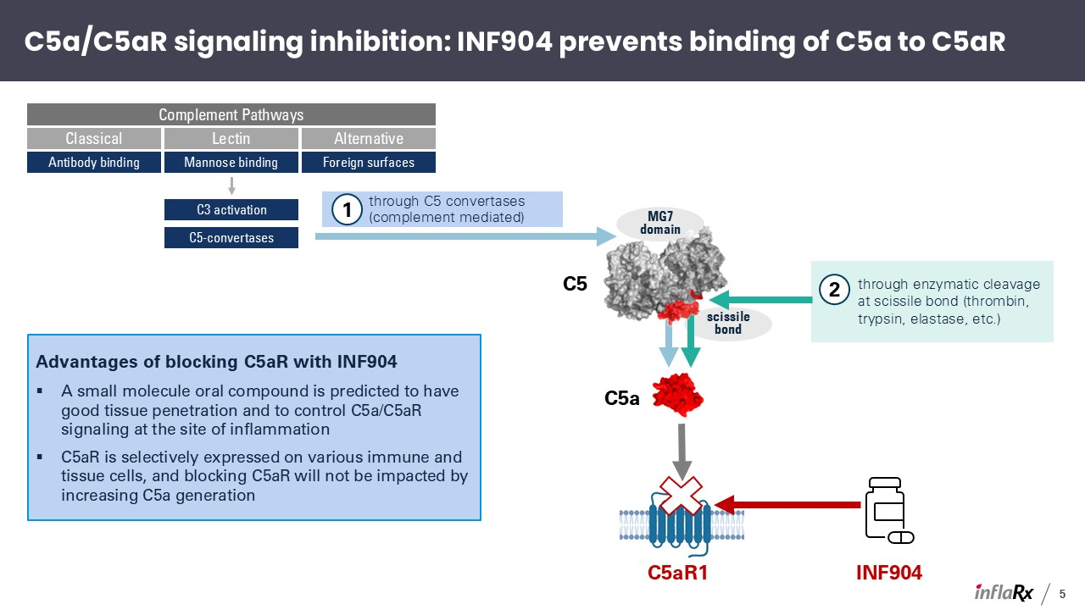
C5a/C5aR signaling inhibition: INF904 prevents binding of C5a to C5aR Advantages of blocking C5aR with INF904 A small molecule oral compound is predicted to have good tissue penetration and to control C5a/C5aR signaling at the site of inflammation C5aR is selectively expressed on various immune and tissue cells, and blocking C5aR will not be impacted by increasing C5a generation scissile bond MG7 domain C5a C5aR1 through C5 convertases (complement mediated) through enzymatic cleavage at scissile bond (thrombin, trypsin, elastase, etc.) Classical Lectin Alternative Complement Pathways Antibody binding Mannose binding Foreign surfaces C3 activation C5-convertases 1 2 C5 INF904 5

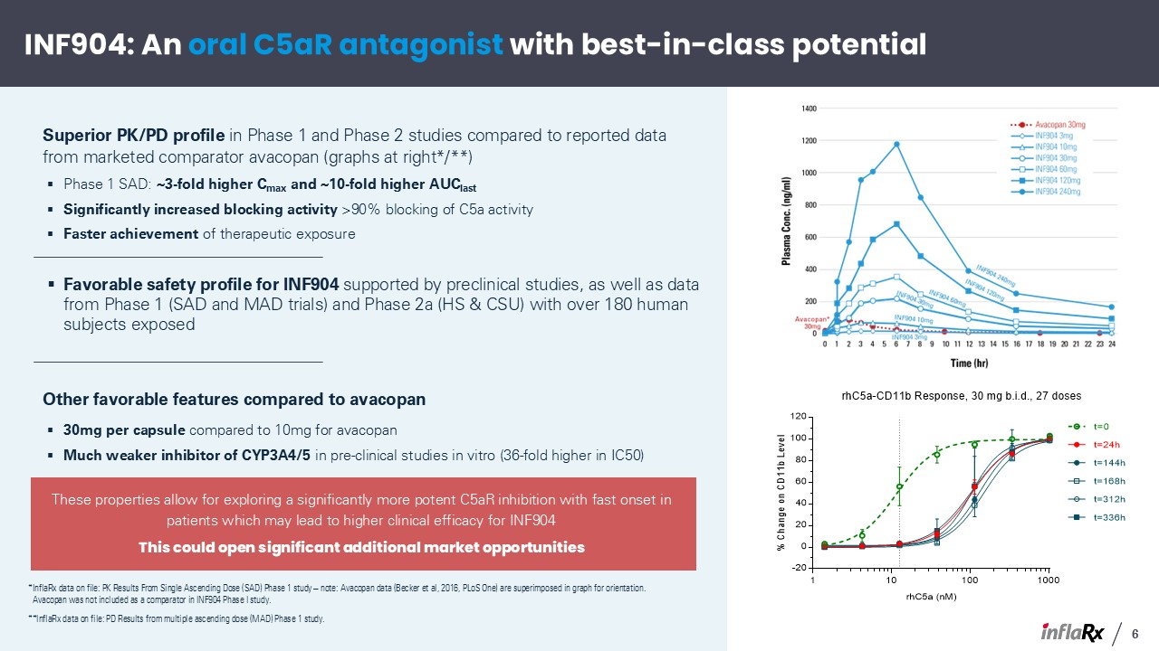
*InflaRx data on file: PK Results From Single Ascending Dose (SAD) Phase 1 study – note: Avacopan data (Becker et al, 2016, PLoS One) are superimposed in graph for orientation. Avacopan was not included as a comparator in INF904 Phase I study. **InflaRx data on file: PD Results from multiple ascending dose (MAD) Phase 1 study. INF904: An oral C5aR antagonist with best-in-class potential 6 These properties allow for exploring a significantly more potent C5aR inhibition with fast onset in patients which may lead to higher clinical efficacy for INF904 This could open significant additional market opportunities Superior PK/PD profile in Phase 1 and Phase 2 studies compared to reported data from marketed comparator avacopan (graphs at right*/**) Phase 1 SAD: ~3-fold higher Cmax and ~10-fold higher AUClast Significantly increased blocking activity >90% blocking of C5a activity Faster achievement of therapeutic exposure Favorable safety profile for INF904 supported by preclinical studies, as well as data from Phase 1 (SAD and MAD trials) and Phase 2a (HS & CSU) with over 180 human subjects exposed Other favorable features compared to avacopan 30mg per capsule compared to 10mg for avacopan Much weaker inhibitor of CYP3A4/5 in pre-clinical studies in vitro (36-fold higher in IC50)

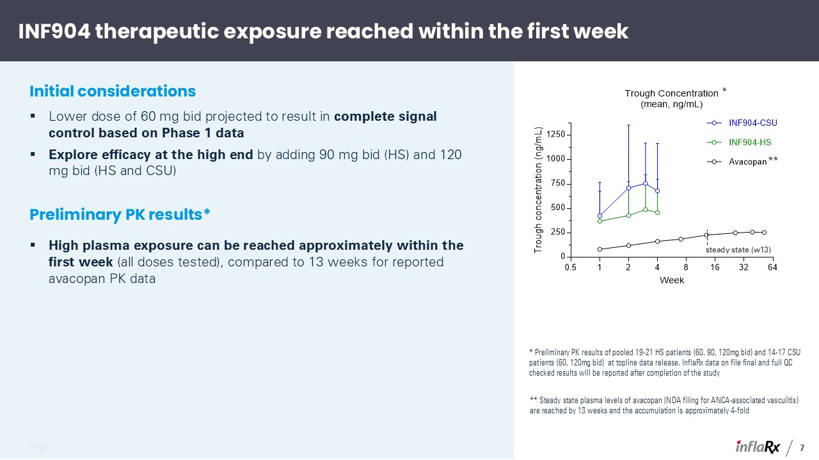
INF904 therapeutic exposure reached within the first week Page 7 Lower dose of 60 mg bid projected to result in complete signal control based on Phase 1 data Explore efficacy at the high end by adding 90 mg bid (HS) and 120 mg bid (HS and CSU) Preliminary PK results* * Preliminary PK results of pooled 19-21 HS patients (60, 90, 120mg bid) and 14-17 CSU patients (60, 120mg bid) at topline data release. InflaRx data on file final and full QC checked results will be reported after completion of the study ** Steady state plasma levels of avacopan (NDA filing for ANCA-associated vasculitis) are reached by 13 weeks and the accumulation is approximately 4-fold Initial considerations 7 High plasma exposure can be reached approximately within the first week (all doses tested), compared to 13 weeks for reported avacopan PK data * ** steady state (w13)

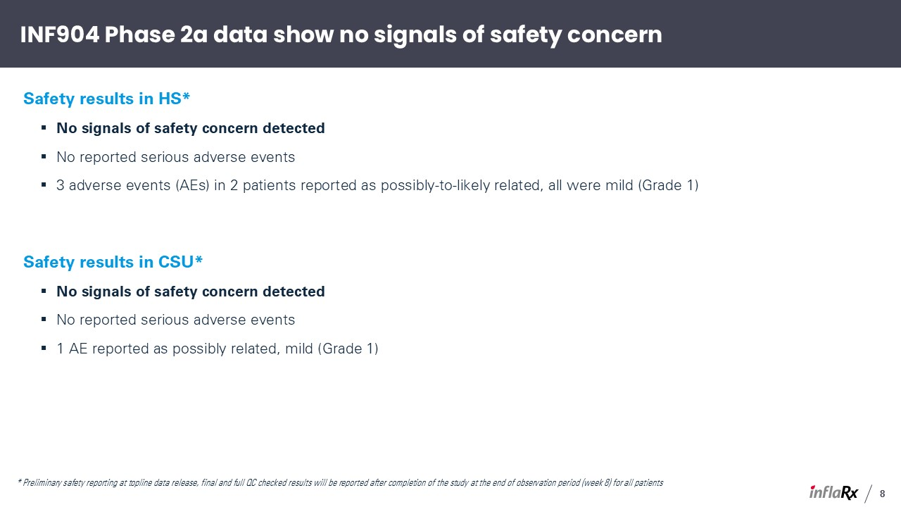
* Preliminary safety reporting at topline data release, final and full QC checked results will be reported after completion of the study at the end of observation period (week 8) for all patients INF904 Phase 2a data show no signals of safety concern Safety results in HS* No signals of safety concern detected No reported serious adverse events 3 adverse events (AEs) in 2 patients reported as possibly-to-likely related, all were mild (Grade 1) Safety results in CSU* No signals of safety concern detected No reported serious adverse events 1 AE reported as possibly related, mild (Grade 1) 8

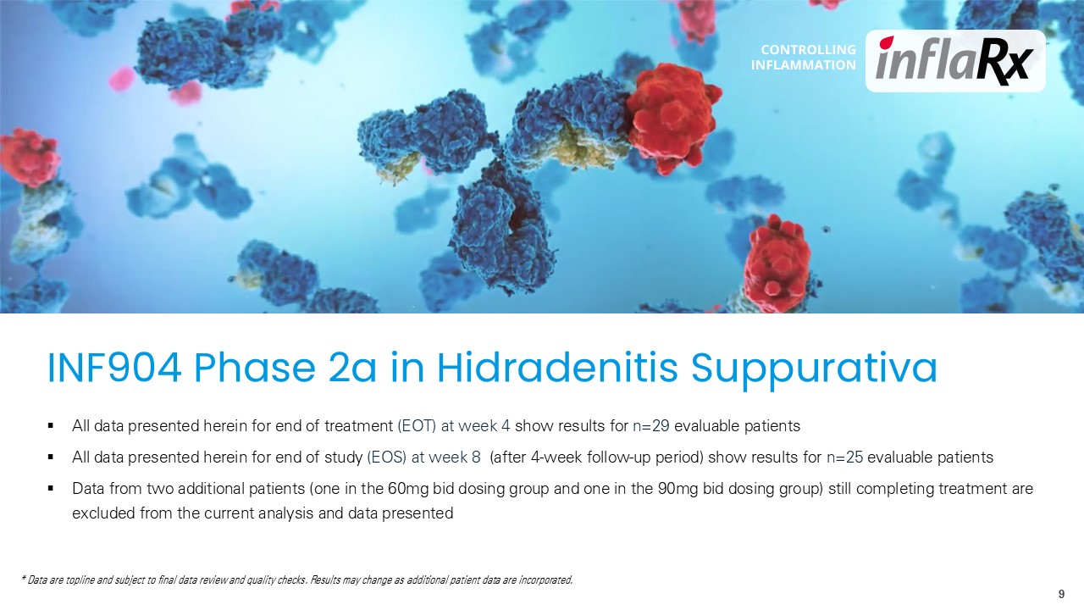
INF904 Phase 2a in Hidradenitis Suppurativa 9 All data presented herein for end of treatment (EOT) at week 4 show results for n=29 evaluable patients All data presented herein for end of study (EOS) at week 8 (after 4-week follow-up period) show results for n=25 evaluable patients Data from two additional patients (one in the 60mg bid dosing group and one in the 90mg bid dosing group) still completing treatment are excluded from the current analysis and data presented * Data are topline and subject to final data review and quality checks. Results may change as additional patient data are incorporated.

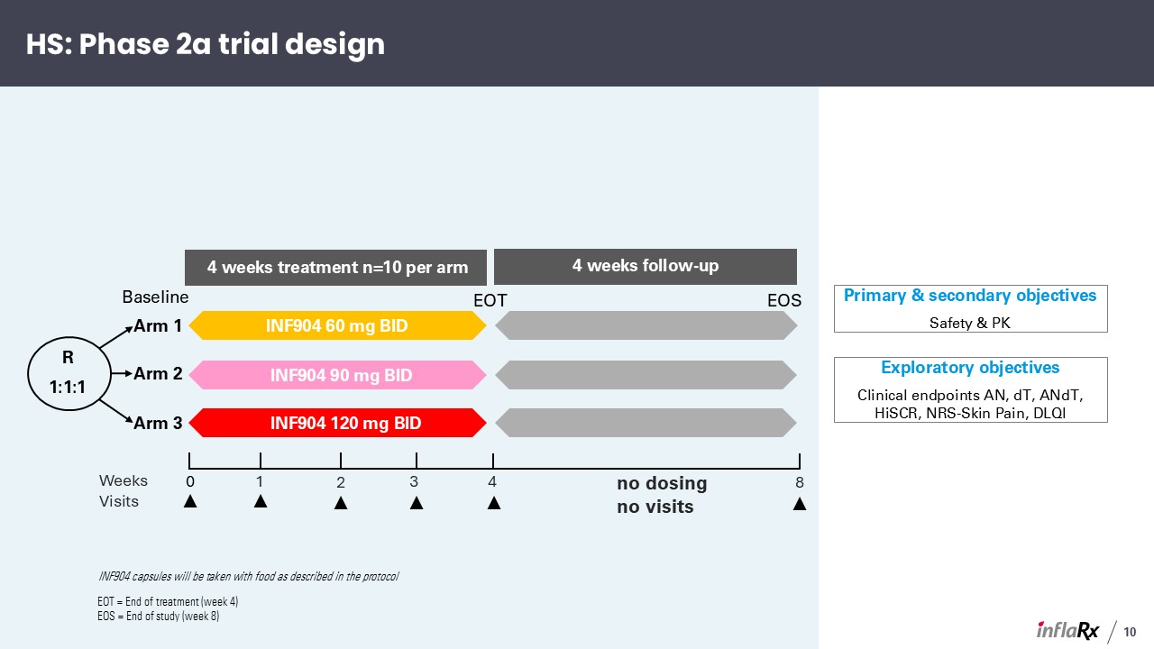
HS: Phase 2a trial design Arm 1 Arm 2 Arm 3 4 weeks treatment n=10 per arm 4 weeks follow-up INF904 60 mg BID INF904 90 mg BID INF904 120 mg BID R 1:1:1 Baseline EOT EOS Primary & secondary objectives Safety & PK Exploratory objectives Clinical endpoints AN, dT, ANdT, HiSCR, NRS-Skin Pain, DLQI 10 INF904 capsules will be taken with food as described in the protocol 4 8 Weeks 3 2 1 0 Visits no dosing no visits EOT = End of treatment (week 4) EOS = End of study (week 8)

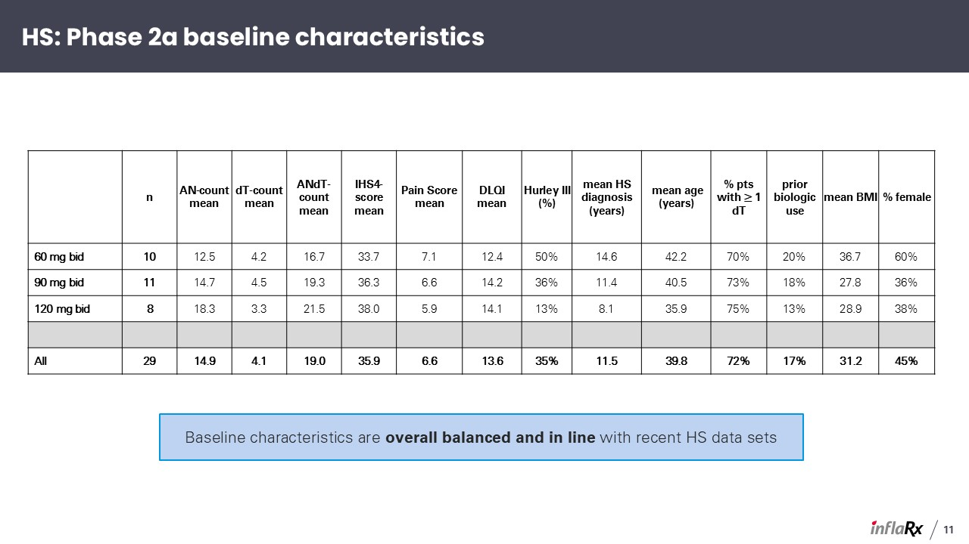
HS: Phase 2a baseline characteristics 11 n AN-count mean dT-count mean ANdT-count mean IHS4-score mean Pain Score mean DLQI mean Hurley III (%) mean HS diagnosis (years) mean age (years) % pts with ≥ 1 dT prior biologic use mean BMI % female 60 mg bid 10 12.5 4.2 16.7 33.7 7.1 12.4 50% 14.6 42.2 70% 20% 36.7 60% 90 mg bid 11 14.7 4.5 19.3 36.3 6.6 14.2 36% 11.4 40.5 73% 18% 27.8 36% 120 mg bid 8 18.3 3.3 21.5 38.0 5.9 14.1 13% 8.1 35.9 75% 13% 28.9 38% All 29 14.9 4.1 19.0 35.9 6.6 13.6 35% 11.5 39.8 72% 17% 31.2 45% Baseline characteristics are overall balanced and in line with recent HS data sets

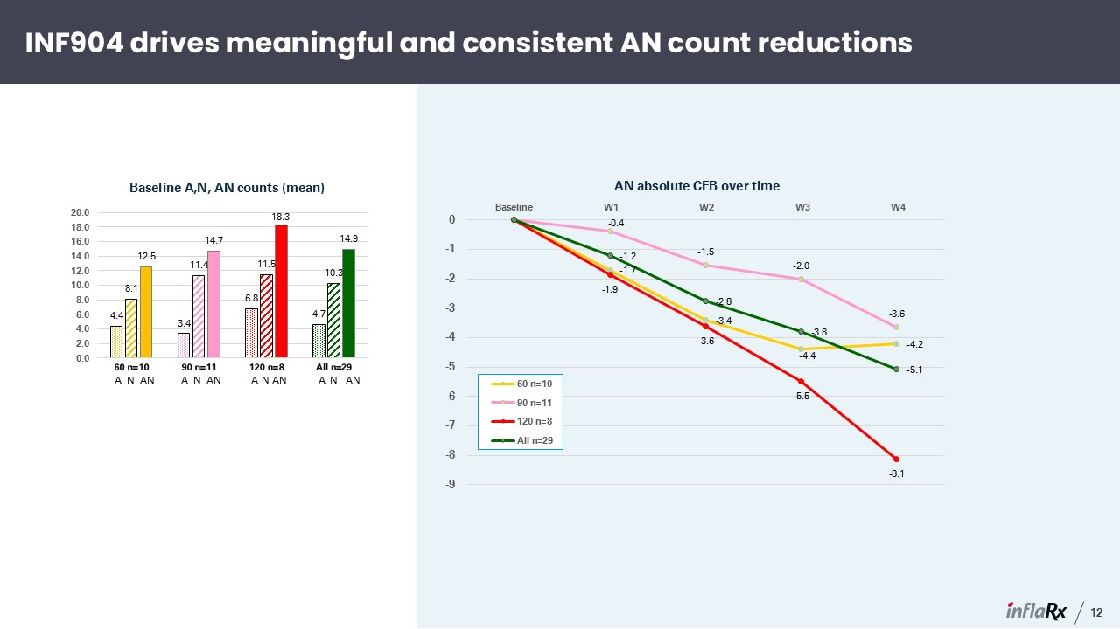
INF904 drives meaningful and consistent AN count reductions 12 A N AN A N AN A N AN A N AN

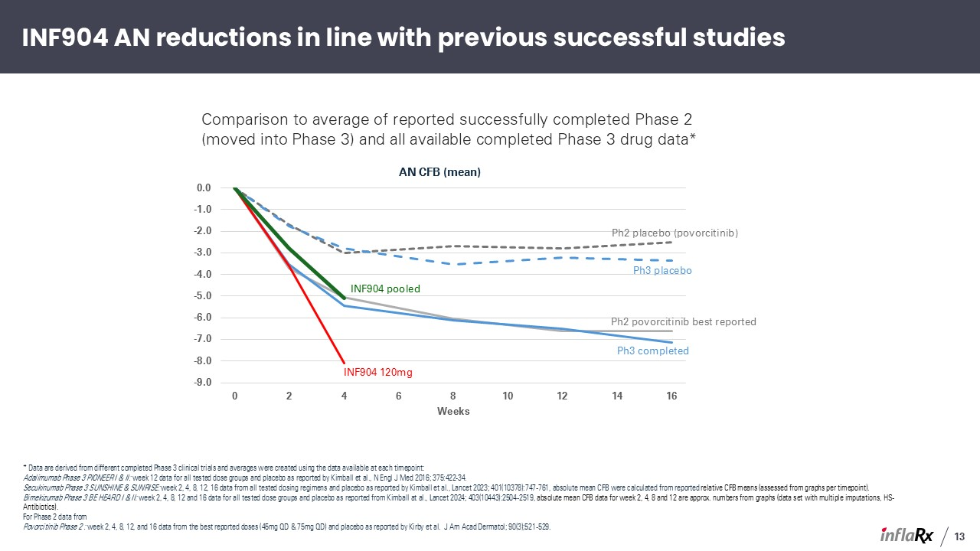
13 Comparison to average of reported successfully completed Phase 2 (moved into Phase 3) and all available completed Phase 3 drug data* * Data are derived from different completed Phase 3 clinical trials and averages were created using the data available at each timepoint: Adalimumab Phase 3 PIONEER I & II: week 12 data for all tested dose groups and placebo as reported by Kimball et al., N Engl J Med 2016; 375:422-34. Secukinumab Phase 3 SUNSHINE & SUNRISE: week 2, 4, 8, 12, 16 data from all tested dosing regimens and placebo as reported by Kimball et al., Lancet 2023; 401(10378):747-761, absolute mean CFB were calculated from reported relative CFB means (assessed from graphs per timepoint). Bimekizumab Phase 3 BE HEARD I & II: week 2, 4, 8, 12 and 16 data for all tested dose groups and placebo as reported from Kimball at al., Lancet 2024; 403(10443):2504-2519, absolute mean CFB data for week 2, 4, 8 and 12 are approx. numbers from graphs (data set with multiple imputations, HS-Antibiotics). For Phase 2 data from Povorcitinib Phase 2 : week 2, 4, 8, 12, and 16 data from the best reported doses (45mg QD & 75mg QD) and placebo as reported by Kirby et al. J Am Acad Dermatol; 90(3);521-529. INF904 AN reductions in line with previous successful studies Ph3 placebo Ph2 placebo (povorcitinib) Ph2 povorcitinib best reported Ph3 completed INF904 120mg INF904 pooled

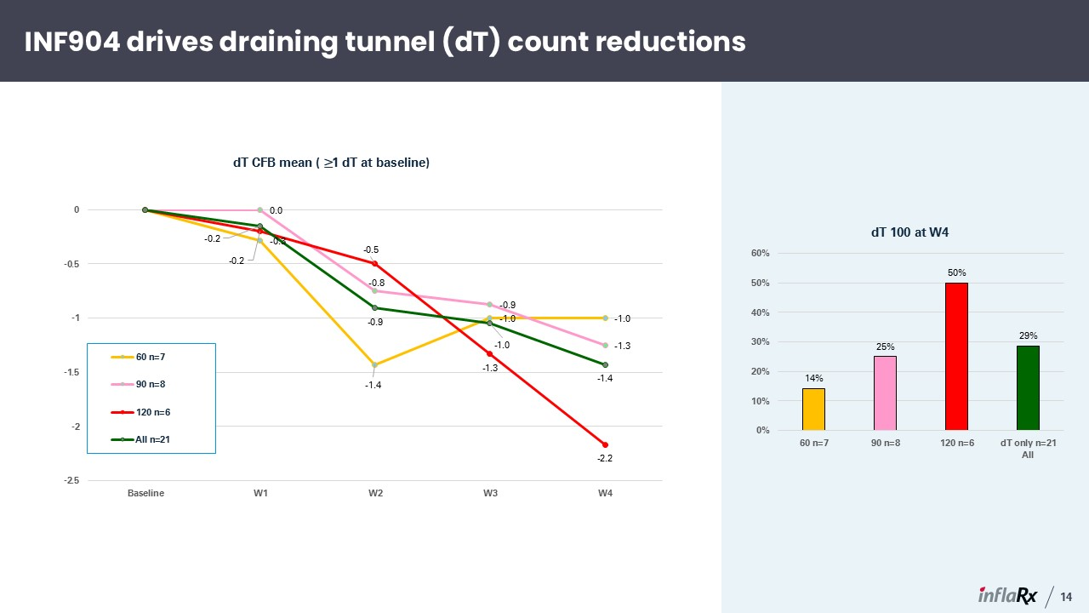
INF904 drives draining tunnel (dT) count reductions 14 All n=21 All

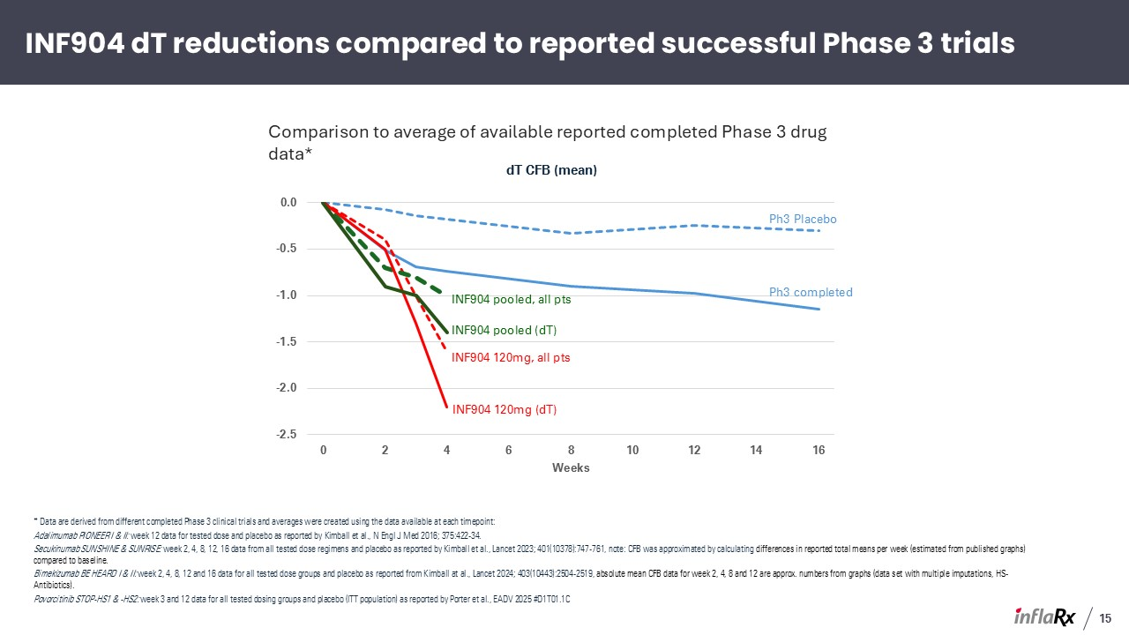
INF904 dT reductions compared to reported successful Phase 3 trials * Data are derived from different completed Phase 3 clinical trials and averages were created using the data available at each timepoint: Adalimumab PIONEER I & II: week 12 data for tested dose and placebo as reported by Kimball et al., N Engl J Med 2016; 375:422-34. Secukinumab SUNSHINE & SUNRISE: week 2, 4, 8, 12, 16 data from all tested dose regimens and placebo as reported by Kimball et al., Lancet 2023; 401(10378):747-761, note: CFB was approximated by calculating differences in reported total means per week (estimated from published graphs) compared to baseline. Bimekizumab BE HEARD I & II: week 2, 4, 8, 12 and 16 data for all tested dose groups and placebo as reported from Kimball at al., Lancet 2024; 403(10443):2504-2519, absolute mean CFB data for week 2, 4, 8 and 12 are approx. numbers from graphs (data set with multiple imputations, HS-Antibiotics). Povorcitinib STOP-HS1 & -HS2: week 3 and 12 data for all tested dosing groups and placebo (ITT population) as reported by Porter et al., EADV 2025 #D1T01.1C Comparison to average of available reported completed Phase 3 drug data* Ph3 Placebo Ph3 completed INF904 120mg, all pts INF904 pooled, all pts INF904 120mg (dT) INF904 pooled (dT) 15

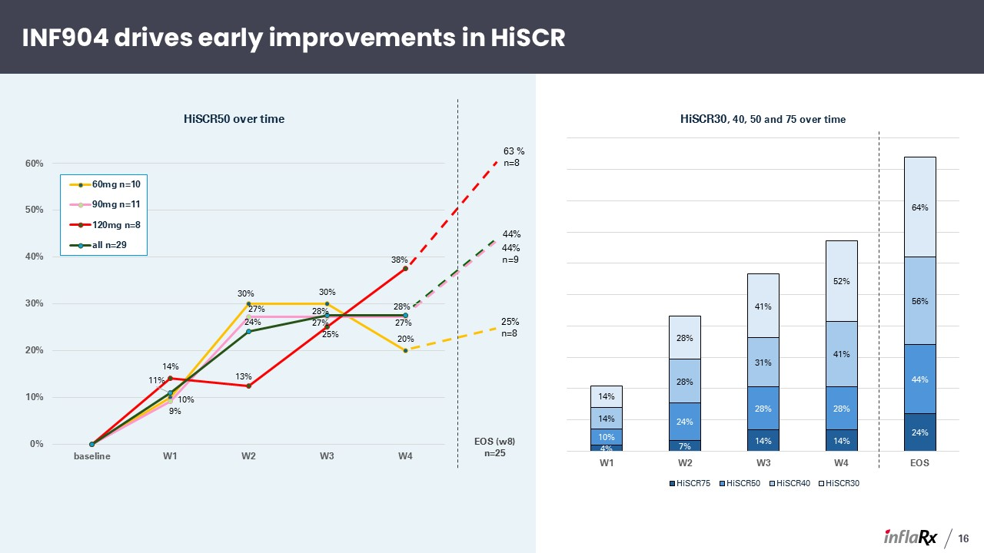
INF904 drives early improvements in HiSCR 16 44% EOS (w8) n=25 63 % n=8 44% n=9 25% n=8

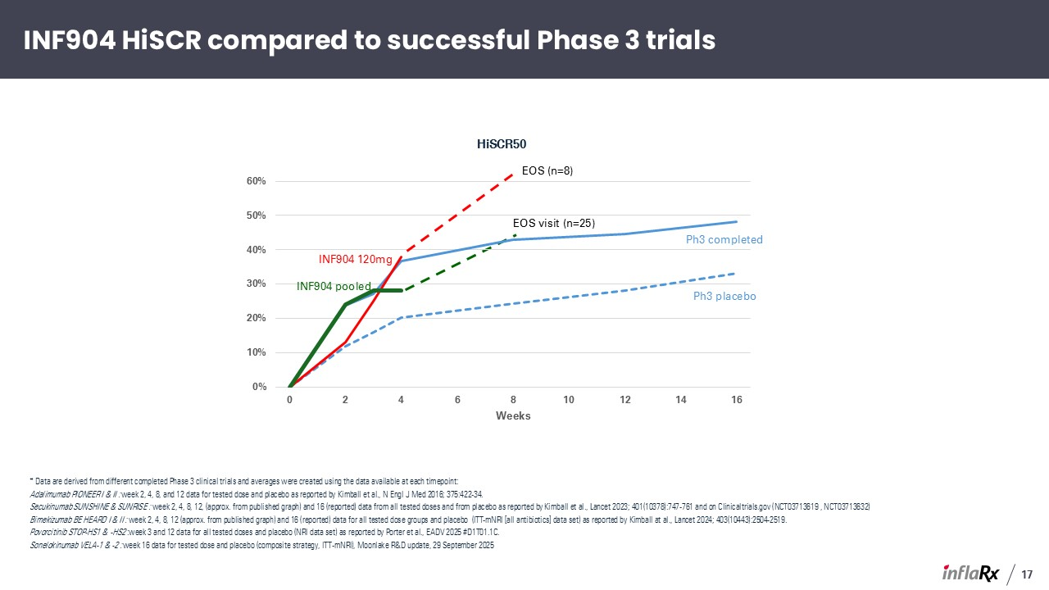
INF904 HiSCR compared to successful Phase 3 trials 17 * Data are derived from different completed Phase 3 clinical trials and averages were created using the data available at each timepoint: Adalimumab PIONEER I & II : week 2, 4, 8, and 12 data for tested dose and placebo as reported by Kimball et al., N Engl J Med 2016; 375:422-34. Secukinumab SUNSHINE & SUNRISE : week 2, 4, 8, 12, (approx. from published graph) and 16 (reported) data from all tested doses and from placebo as reported by Kimball et al., Lancet 2023; 401(10378):747-761 and on Clinicaltrials.gov (NCT03713619 , NCT03713632) Bimekizumab BE HEARD I & II : week 2, 4, 8, 12 (approx. from published graph) and 16 (reported) data for all tested dose groups and placebo (ITT-mNRI [all antibiotics] data set) as reported by Kimball at al., Lancet 2024; 403(10443):2504-2519. Povorcitinib STOP-HS1 & -HS2 :week 3 and 12 data for all tested doses and placebo (NRI data set) as reported by Porter et al., EADV 2025 #D1T01.1C. Sonelokinumab VELA-1 & -2 : week 16 data for tested dose and placebo (composite strategy, ITT-mNRI), Moonlake R&D update, 29 September 2025 Ph3 placebo Ph3 completed INF904 120mg INF904 pooled EOS visit (n=25) EOS (n=8)

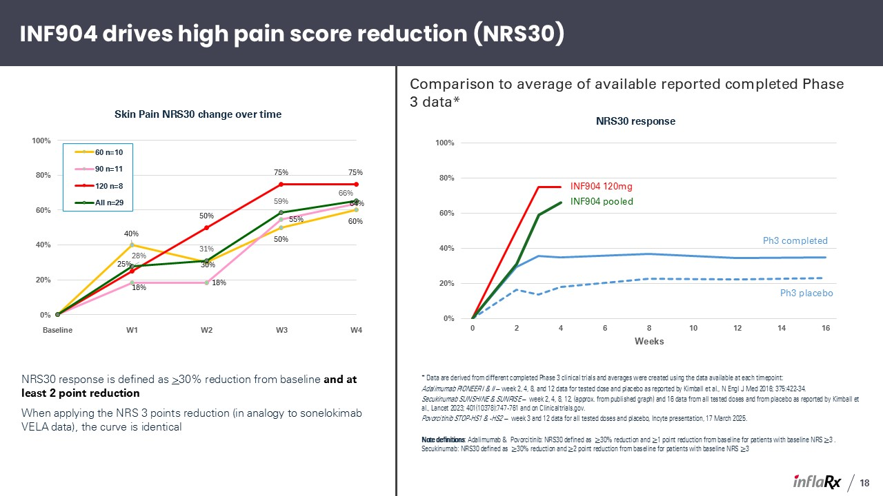
INF904 drives high pain score reduction (NRS30) NRS30 response is defined as >30% reduction from baseline and at least 2 point reduction When applying the NRS 3 points reduction (in analogy to sonelokimab VELA data), the curve is identical 18 * Data are derived from different completed Phase 3 clinical trials and averages were created using the data available at each timepoint: Adalimumab PIONEER I & II – week 2, 4, 8, and 12 data for tested dose and placebo as reported by Kimball et al., N Engl J Med 2016; 375:422-34. Secukinumab SUNSHINE & SUNRISE – week 2, 4, 8, 12, (approx. from published graph) and 16 data from all tested doses and from placebo as reported by Kimball et al., Lancet 2023; 401(10378):747-761 and on Clinicaltrials.gov. Povorcitinib STOP-HS1 & -HS2 – week 3 and 12 data for all tested doses and placebo, Incyte presentation, 17 March 2025. Note definitions: Adalimumab & Povorcitinib: NRS30 defined as ≥30% reduction and ≥1 point reduction from baseline for patients with baseline NRS ≥3 . Secukinumab: NRS30 defined as ≥30% reduction and ≥2 point reduction from baseline for patients with baseline NRS ≥3 Comparison to average of available reported completed Phase 3 data* Ph3 placebo Ph3 completed INF904 120mg INF904 pooled

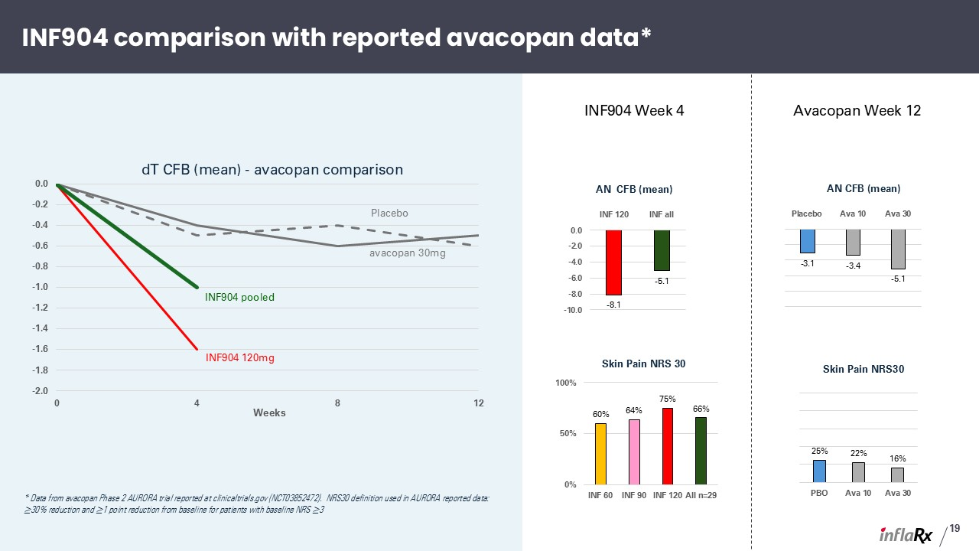
INF904 comparison with reported avacopan data* 19 * Data from avacopan Phase 2 AURORA trial reported at clinicaltrials.gov (NCT03852472). NRS30 definition used in AURORA reported data: ≥30% reduction and ≥1 point reduction from baseline for patients with baseline NRS ≥3 Placebo INF904 120mg INF904 pooled avacopan 30mg INF904 Week 4 Avacopan Week 12

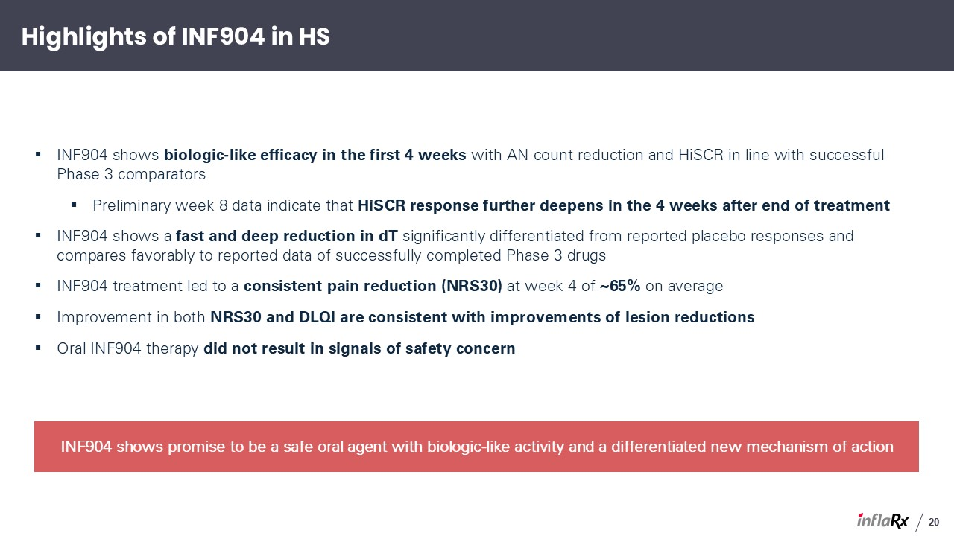
Highlights of INF904 in HS 20 INF904 shows biologic-like efficacy in the first 4 weeks with AN count reduction and HiSCR in line with successful Phase 3 comparators Preliminary week 8 data indicate that HiSCR response further deepens in the 4 weeks after end of treatment INF904 shows a fast and deep reduction in dT significantly differentiated from reported placebo responses and compares favorably to reported data of successfully completed Phase 3 drugs INF904 treatment led to a consistent pain reduction (NRS30) at week 4 of ~65% on average Improvement in both NRS30 and DLQI are consistent with improvements of lesion reductions Oral INF904 therapy did not result in signals of safety concern INF904 shows promise to be a safe oral agent with biologic-like activity and a differentiated new mechanism of action

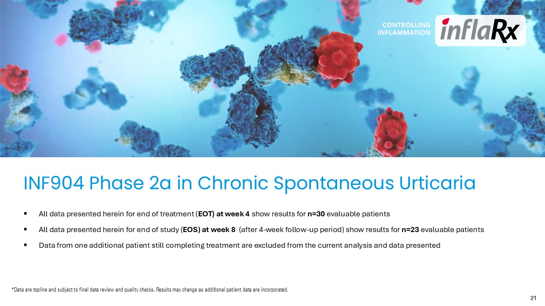
INF904 Phase 2a in Chronic Spontaneous Urticaria 21 All data presented herein for end of treatment (EOT) at week 4 show results for n=30 evaluable patients All data presented herein for end of study (EOS) at week 8 (after 4-week follow-up period) show results for n=23 evaluable patients Data from one additional patient still completing treatment are excluded from the current analysis and data presented *Data are topline and subject to final data review and quality checks. Results may change as additional patient data are incorporated.

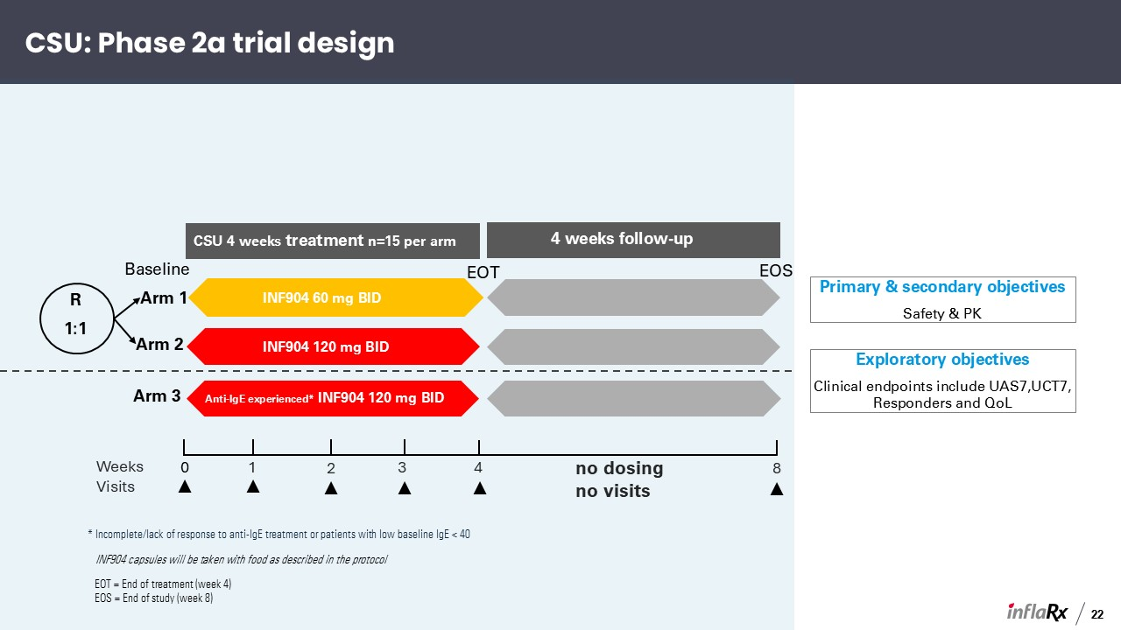
Arm 1 Arm 2 Arm 3 CSU 4 weeks treatment n=15 per arm 4 weeks follow-up INF904 60 mg BID INF904 60 mg BID n=10 R 1:1 Baseline EOT EOS INF904 120 mg BID Anti-IgE experienced* INF904 120 mg BID CSU: Phase 2a trial design Primary & secondary objectives Safety & PK Exploratory objectives Clinical endpoints include UAS7,UCT7, Responders and QoL * Incomplete/lack of response to anti-IgE treatment or patients with low baseline IgE < 40 4 8 Weeks 3 2 1 0 Visits no dosing no visits 22 INF904 capsules will be taken with food as described in the protocol EOT = End of treatment (week 4) EOS = End of study (week 8)

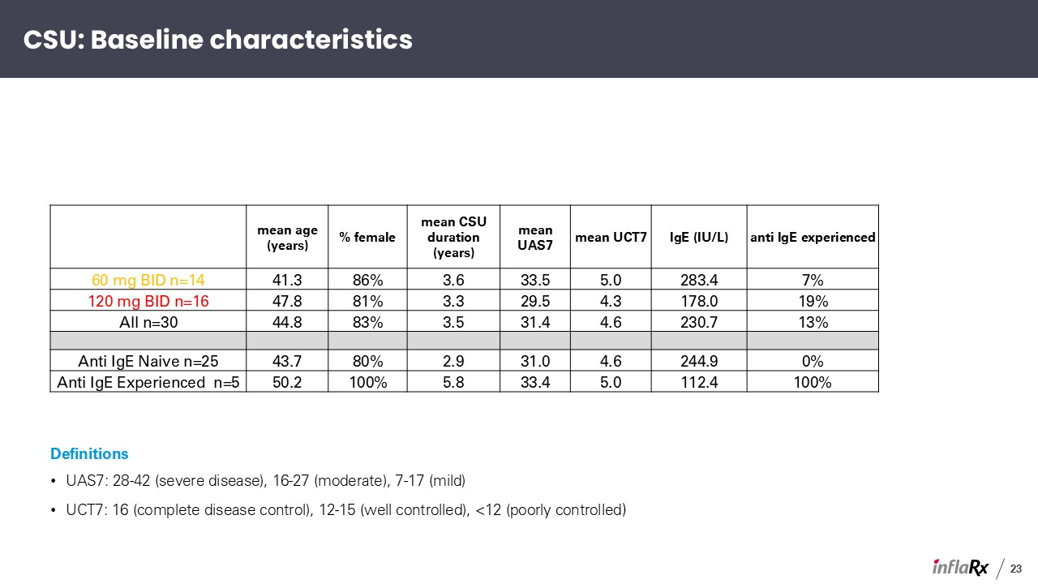
23 CSU: Baseline characteristics mean age (years) % female mean CSU duration (years) mean UAS7 mean UCT7 IgE (IU/L) anti IgE experienced 60 mg BID n=14 41.3 86% 3.6 33.5 5.0 283.4 7% 120 mg BID n=16 47.8 81% 3.3 29.5 4.3 178.0 19% All n=30 44.8 83% 3.5 31.4 4.6 230.7 13% Anti IgE Naive n=25 43.7 80% 2.9 31.0 4.6 244.9 0% Anti IgE Experienced n=5 50.2 100% 5.8 33.4 5.0 112.4 100% Definitions UAS7: 28-42 (severe disease), 16-27 (moderate), 7-17 (mild) UCT7: 16 (complete disease control), 12-15 (well controlled), <12 (poorly controlled)

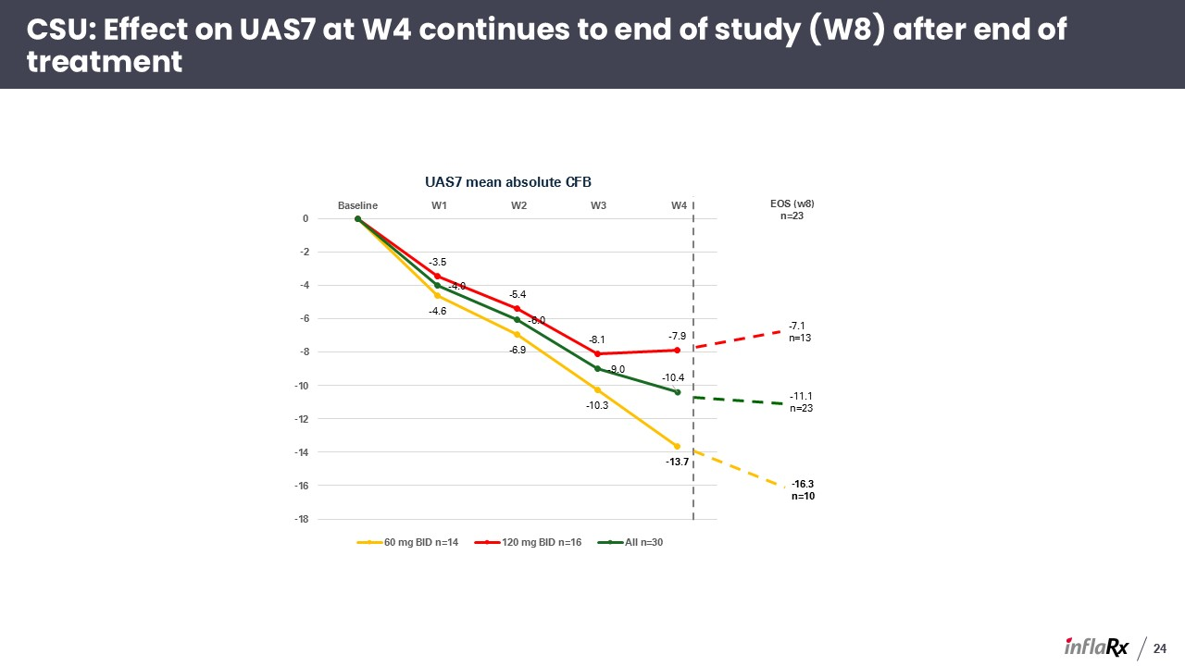
24 CSU: Effect on UAS7 at W4 continues to end of study (W8) after end of treatment -16.3 n=10 EOS (w8) n=23 -7.1 n=13 -11.1 n=23

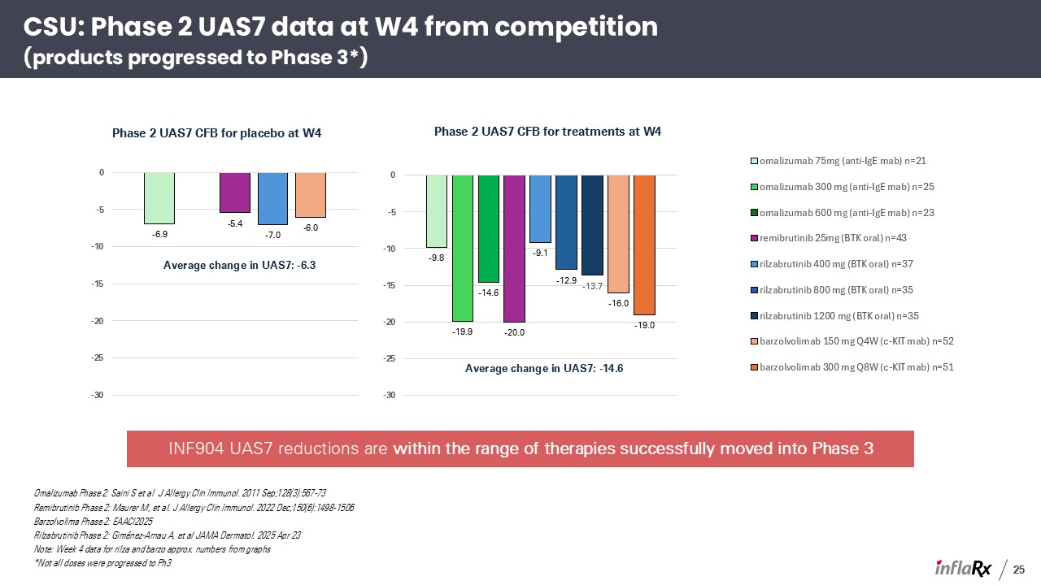
CSU: Phase 2 UAS7 data at W4 from competition(products progressed to Phase 3*) Omalizumab Phase 2: Saini S et al J Allergy Clin Immunol. 2011 Sep;128(3):567-73 Remibrutinib Phase 2: Maurer M, et al. J Allergy Clin Immunol. 2022 Dec;150(6):1498-1506 Barzolvolima Phase 2: EAACI2025 Rilzabrutinib Phase 2: Giménez-Arnau A, et al JAMA Dermatol. 2025 Apr 23 Note: Week 4 data for rilza and barzo approx. numbers from graphs *Not all doses were progressed to Ph3 Average change in UAS7: -6.3 Average change in UAS7: -14.6 25 INF904 UAS7 reductions are within the range of therapies successfully moved into Phase 3

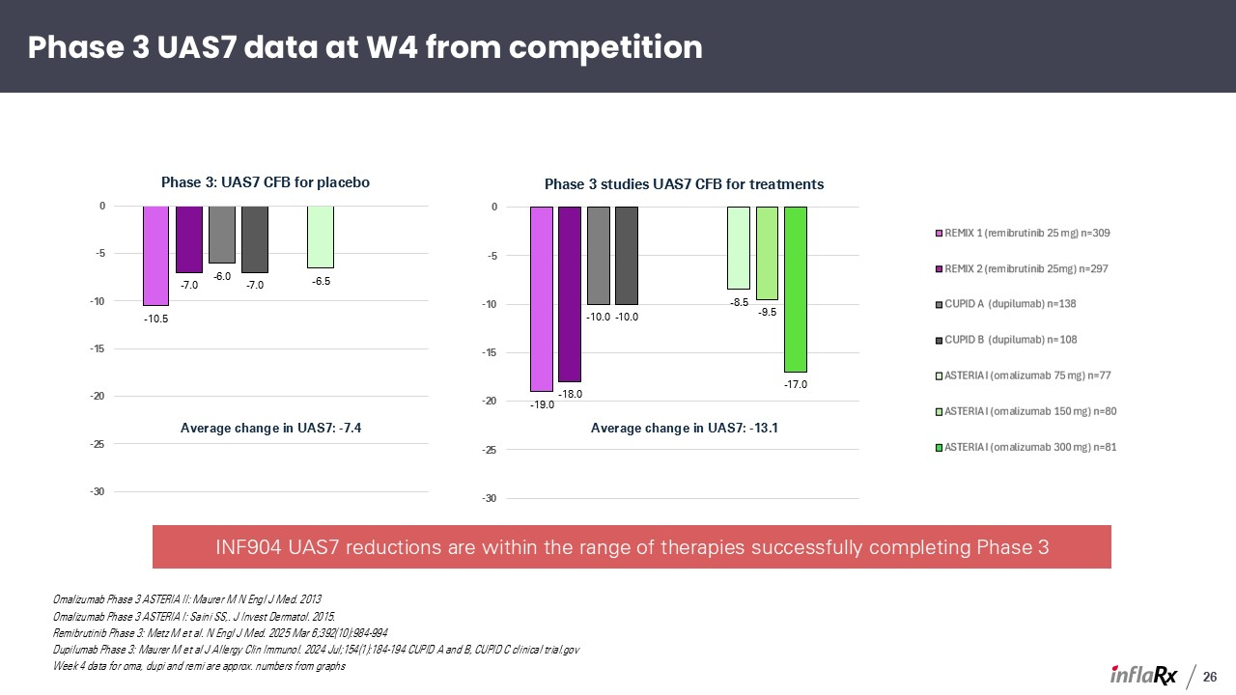
Phase 3 UAS7 data at W4 from competition Omalizumab Phase 3 ASTERIA II: Maurer M N Engl J Med. 2013 Omalizumab Phase 3 ASTERIA I: Saini SS,. J Invest Dermatol. 2015. Remibrutinib Phase 3: Metz M et al. N Engl J Med. 2025 Mar 6;392(10):984-994 Dupilumab Phase 3: Maurer M et al J Allergy Clin Immunol. 2024 Jul;154(1):184-194 CUPID A and B, CUPID C clinical trial.gov Week 4 data for oma, dupi and remi are approx. numbers from graphs Average change in UAS7: -13.1 Average change in UAS7: -7.4 26 INF904 UAS7 reductions are within the range of therapies successfully completing Phase 3

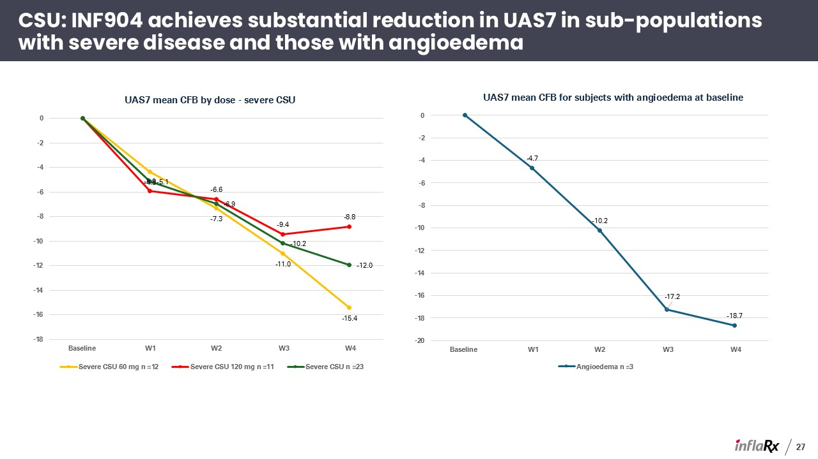
27 CSU: INF904 achieves substantial reduction in UAS7 in sub-populations with severe disease and those with angioedema

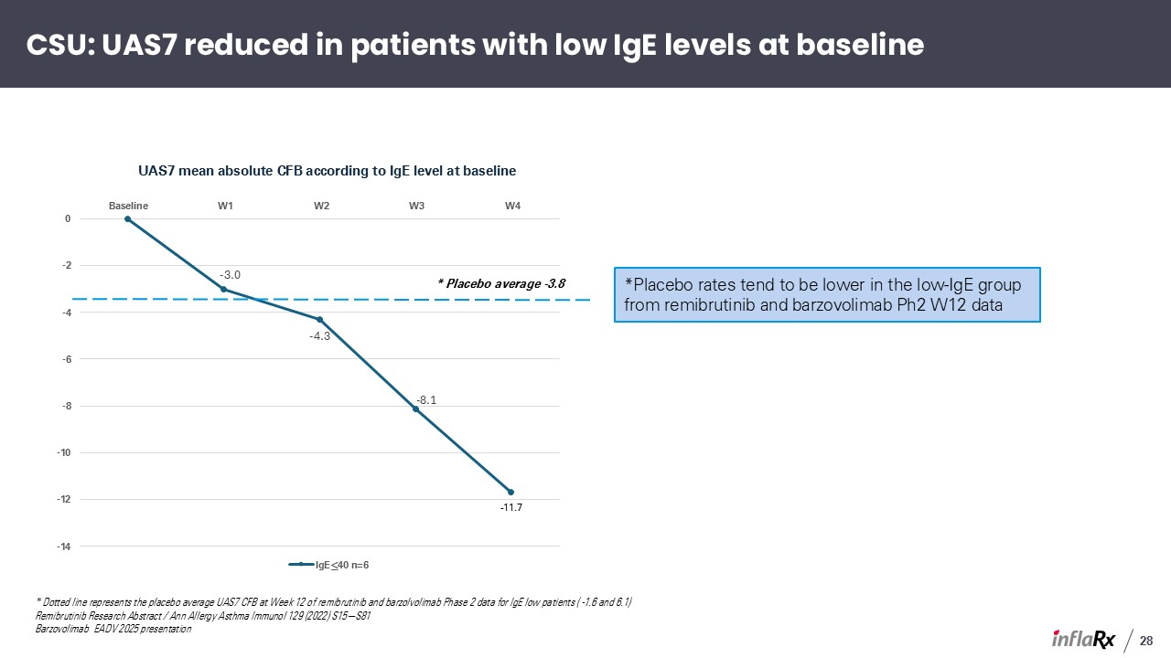
28 CSU: UAS7 reduced in patients with low IgE levels at baseline * Dotted line represents the placebo average UAS7 CFB at Week 12 of remibrutinib and barzolvolimab Phase 2 data for IgE low patients ( -1.6 and 6.1) Remibrutinib Research Abstract / Ann Allergy Asthma Immunol 129 (2022) S15−S81 Barzovolimab EADV 2025 presentation *Placebo rates tend to be lower in the low-IgE group from remibrutinib and barzovolimab Ph2 W12 data * Placebo average -3.8

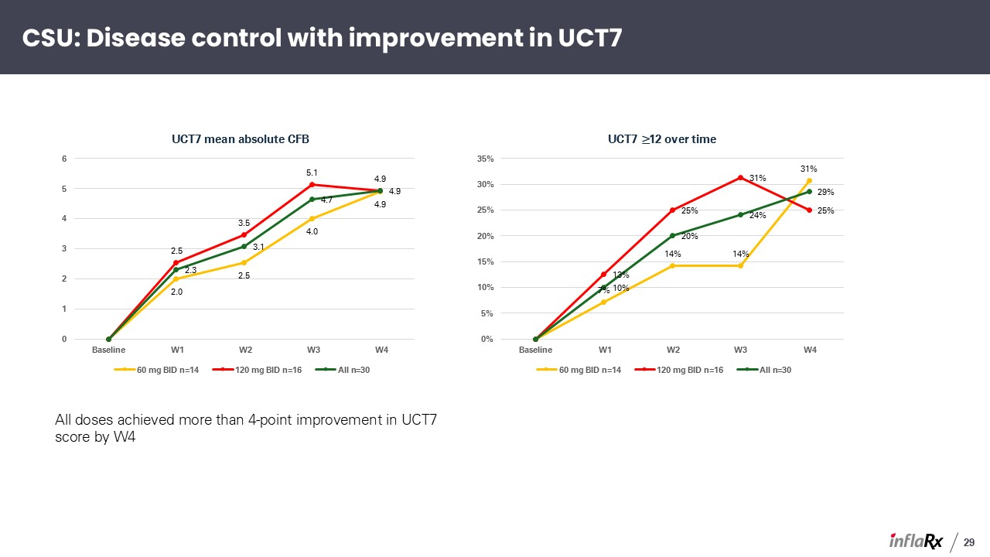
All doses achieved more than 4-point improvement in UCT7 score by W4 29 CSU: Disease control with improvement in UCT7

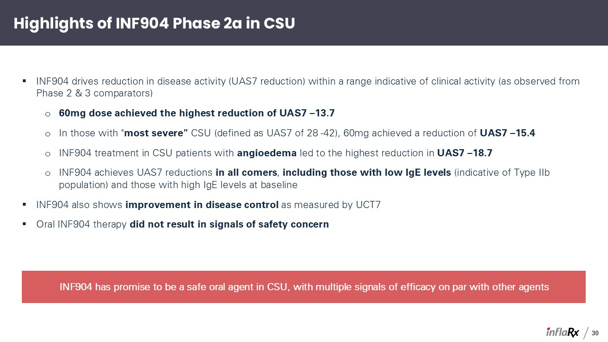
Highlights of INF904 Phase 2a in CSU INF904 drives reduction in disease activity (UAS7 reduction) within a range indicative of clinical activity (as observed from Phase 2 & 3 comparators) 60mg dose achieved the highest reduction of UAS7 –13.7 In those with "most severe" CSU (defined as UAS7 of 28 -42), 60mg achieved a reduction of UAS7 –15.4 INF904 treatment in CSU patients with angioedema led to the highest reduction in UAS7 –18.7 INF904 achieves UAS7 reductions in all comers, including those with low IgE levels (indicative of Type IIb population) and those with high IgE levels at baseline INF904 also shows improvement in disease control as measured by UCT7 Oral INF904 therapy did not result in signals of safety concern 30 INF904 has promise to be a safe oral agent in CSU, with multiple signals of efficacy on par with other agents

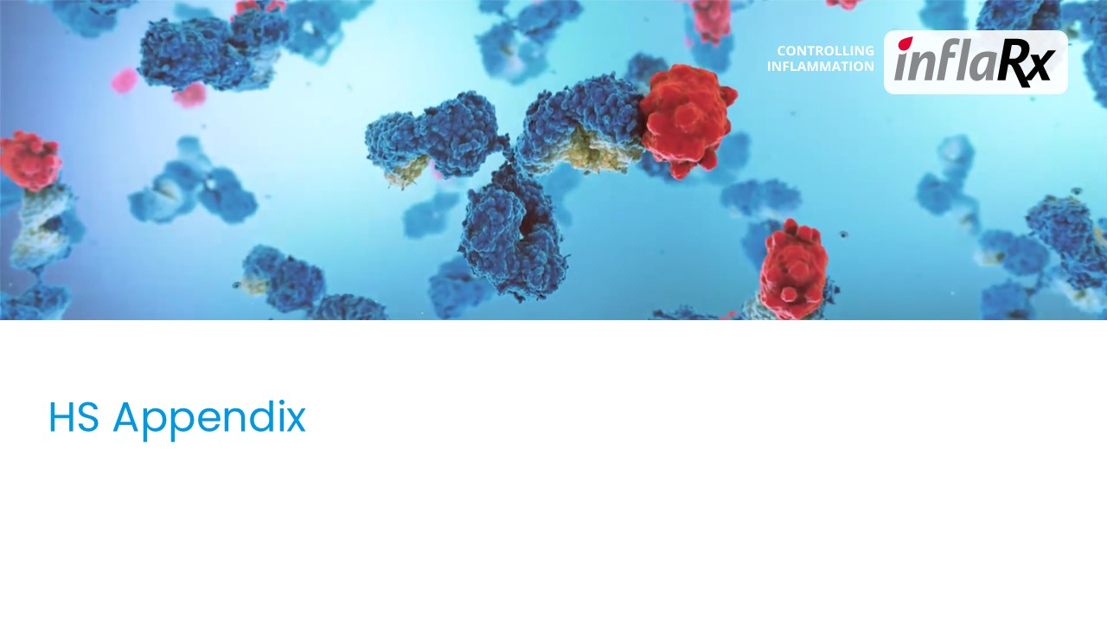
HS Appendix

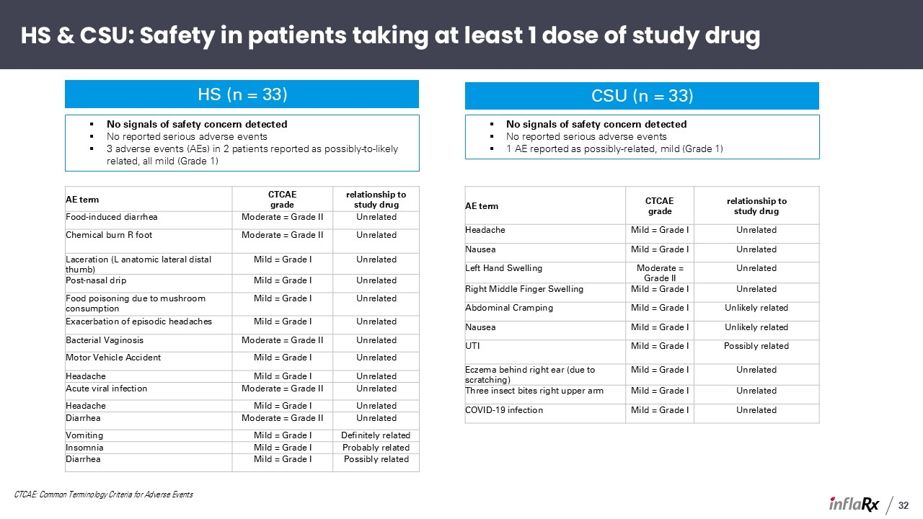
HS & CSU: Safety in patients taking at least 1 dose of study drug AE term CTCAEgrade relationship tostudy drug Headache Mild = Grade I Unrelated Nausea Mild = Grade I Unrelated Left Hand Swelling Moderate = Grade II Unrelated Right Middle Finger Swelling Mild = Grade I Unrelated Abdominal Cramping Mild = Grade I Unlikely related Nausea Mild = Grade I Unlikely related UTI Mild = Grade I Possibly related Eczema behind right ear (due to scratching) Mild = Grade I Unrelated Three insect bites right upper arm Mild = Grade I Unrelated COVID-19 infection Mild = Grade I Unrelated 32 CSU (n = 33) HS (n = 33) AE term CTCAEgrade relationship tostudy drug Food-induced diarrhea Moderate = Grade II Unrelated Chemical burn R foot Moderate = Grade II Unrelated Laceration (L anatomic lateral distal thumb) Mild = Grade I Unrelated Post-nasal drip Mild = Grade I Unrelated Food poisoning due to mushroom consumption Mild = Grade I Unrelated Exacerbation of episodic headaches Mild = Grade I Unrelated Bacterial Vaginosis Moderate = Grade II Unrelated Motor Vehicle Accident Mild = Grade I Unrelated Headache Mild = Grade I Unrelated Acute viral infection Moderate = Grade II Unrelated Headache Mild = Grade I Unrelated Diarrhea Moderate = Grade II Unrelated Vomiting Mild = Grade I Definitely related Insomnia Mild = Grade I Probably related Diarrhea Mild = Grade I Possibly related No signals of safety concern detected No reported serious adverse events 3 adverse events (AEs) in 2 patients reported as possibly-to-likely related, all mild (Grade 1) No signals of safety concern detected No reported serious adverse events 1 AE reported as possibly-related, mild (Grade 1) CTCAE: Common Terminology Criteria for Adverse Events

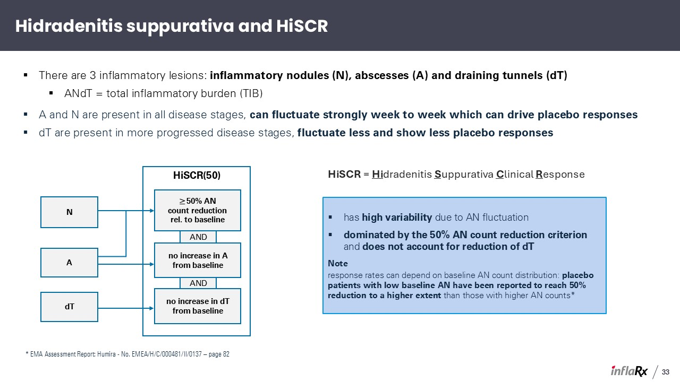
Hidradenitis suppurativa and HiSCR There are 3 inflammatory lesions: inflammatory nodules (N), abscesses (A) and draining tunnels (dT) ANdT = total inflammatory burden (TIB) A and N are present in all disease stages, can fluctuate strongly week to week which can drive placebo responses dT are present in more progressed disease stages, fluctuate less and show less placebo responses dT N A HiSCR(50) ≥ 50% AN count reduction rel. to baseline no increase in dT from baseline no increase in A from baseline AND AND HiSCR = Hidradenitis Suppurativa Clinical Response * EMA Assessment Report: Humira - No. EMEA/H/C/000481/II/0137 – page 82 33 has high variability due to AN fluctuation dominated by the 50% AN count reduction criterion and does not account for reduction of dT Note response rates can depend on baseline AN count distribution: placebo patients with low baseline AN have been reported to reach 50% reduction to a higher extent than those with higher AN counts*

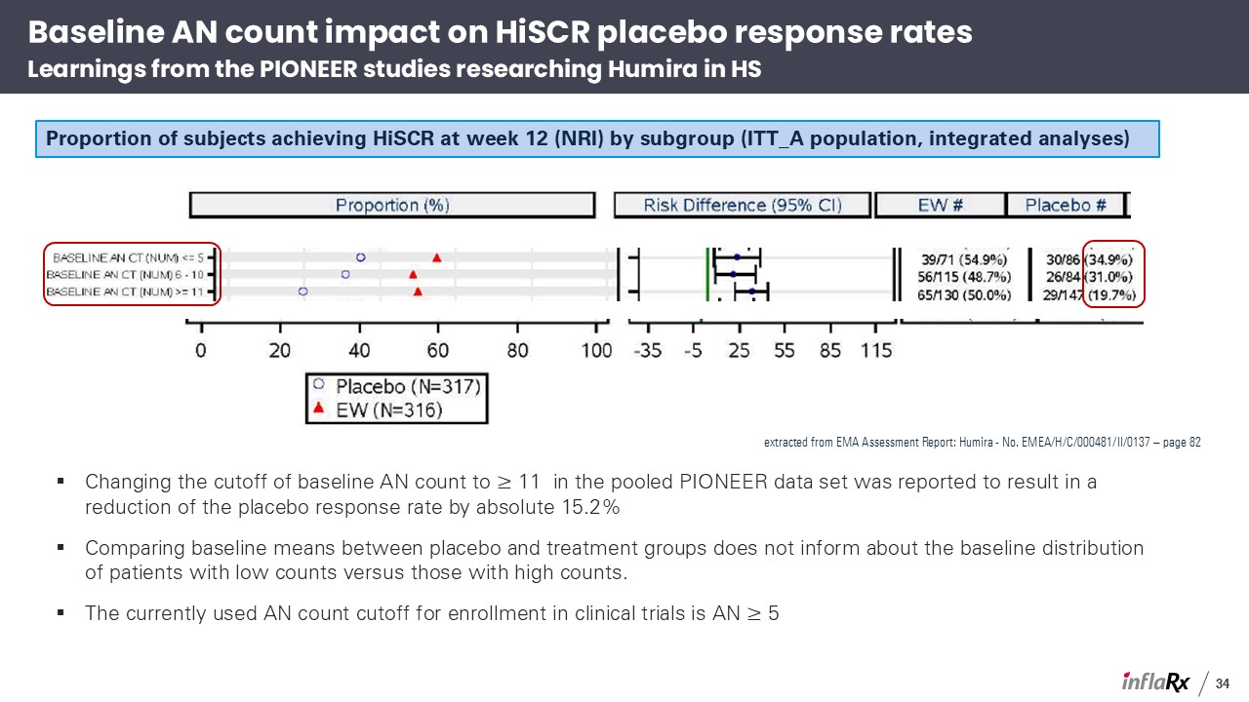
extracted from EMA Assessment Report: Humira - No. EMEA/H/C/000481/II/0137 – page 82 Changing the cutoff of baseline AN count to ≥ 11 in the pooled PIONEER data set was reported to result in a reduction of the placebo response rate by absolute 15.2% Comparing baseline means between placebo and treatment groups does not inform about the baseline distribution of patients with low counts versus those with high counts. The currently used AN count cutoff for enrollment in clinical trials is AN ≥ 5 Baseline AN count impact on HiSCR placebo response ratesLearnings from the PIONEER studies researching Humira in HS Proportion of subjects achieving HiSCR at week 12 (NRI) by subgroup (ITT_A population, integrated analyses) 34

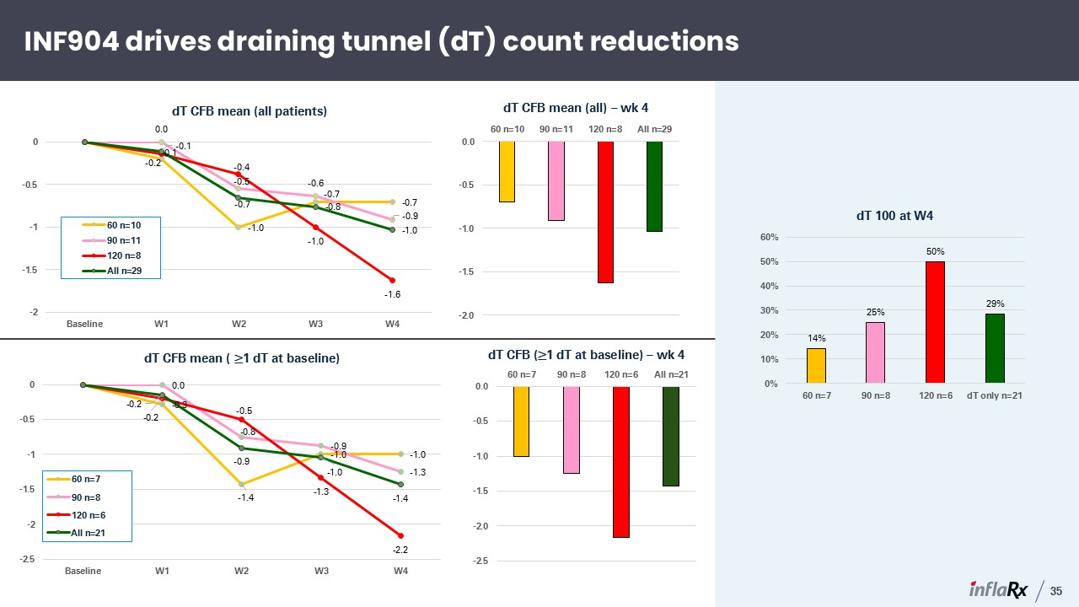
INF904 drives draining tunnel (dT) count reductions 35 All n=21

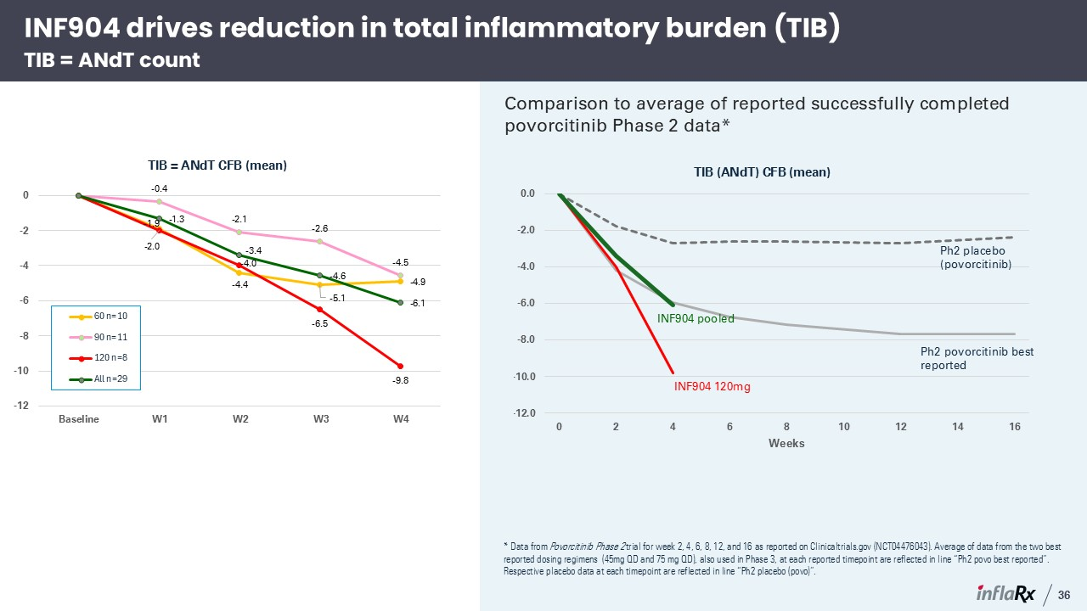
Comparison to average of reported successfully completed povorcitinib Phase 2 data* INF904 drives reduction in total inflammatory burden (TIB)TIB = ANdT count 36 * Data from Povorcitinib Phase 2 trial for week 2, 4, 6, 8, 12, and 16 as reported on Clinicaltrials.gov (NCT04476043). Average of data from the two best reported dosing regimens (45mg QD and 75 mg QD), also used in Phase 3, at each reported timepoint are reflected in line “Ph2 povo best reported”. Respective placebo data at each timepoint are reflected in line “Ph2 placebo (povo)”. Ph2 placebo (povorcitinib) Ph2 povorcitinib best reported INF904 120mg INF904 pooled

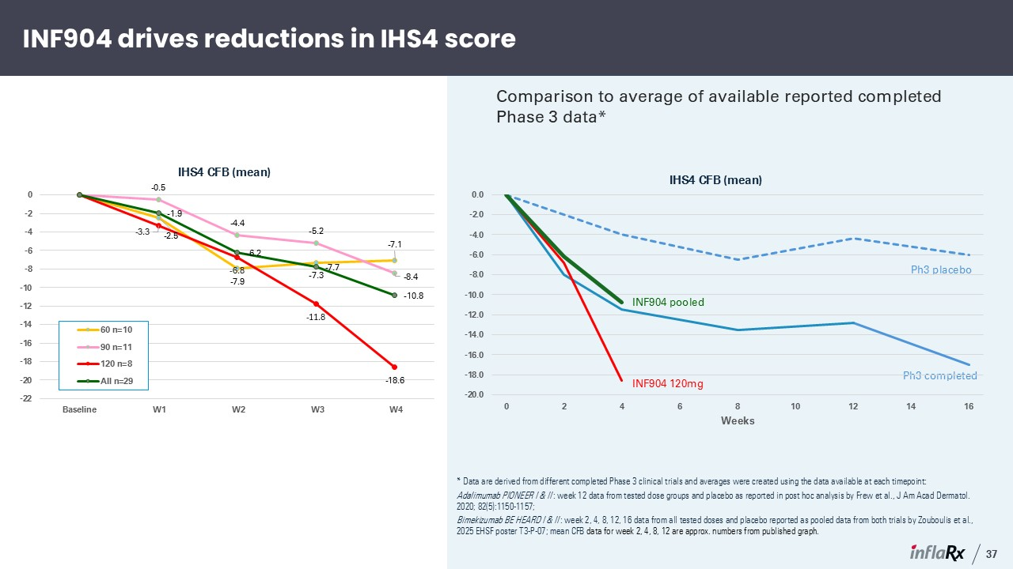
INF904 drives reductions in IHS4 score 37 * Data are derived from different completed Phase 3 clinical trials and averages were created using the data available at each timepoint: Adalimumab PIONEER I & II : week 12 data from tested dose groups and placebo as reported in post hoc analysis by Frew et al., J Am Acad Dermatol. 2020; 82(5):1150-1157; Bimekizumab BE HEARD I & II : week 2, 4, 8, 12, 16 data from all tested doses and placebo reported as pooled data from both trials by Zouboulis et al., 2025 EHSF poster T3-P-07; mean CFB data for week 2, 4, 8, 12 are approx. numbers from published graph. Comparison to average of available reported completed Phase 3 data* Ph3 placebo Ph3 completed INF904 120mg INF904 pooled

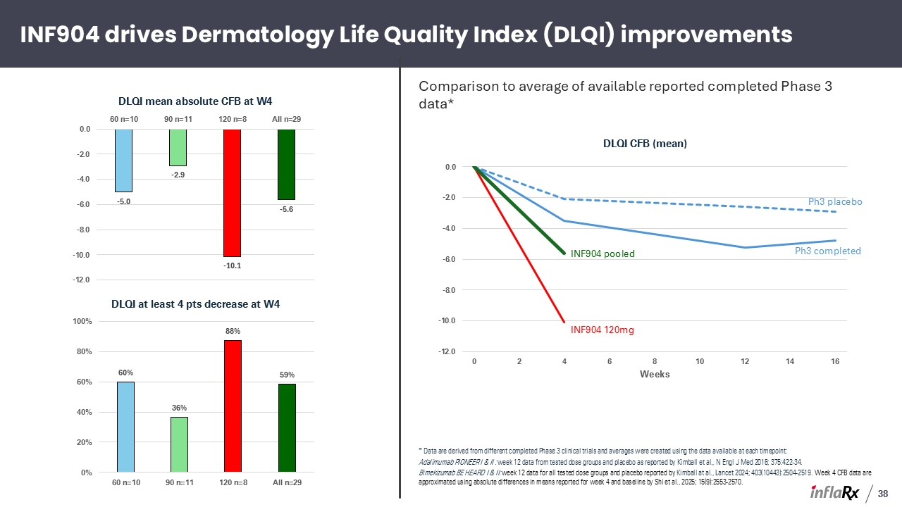
INF904 drives Dermatology Life Quality Index (DLQI) improvements 38 * Data are derived from different completed Phase 3 clinical trials and averages were created using the data available at each timepoint: Adalimumab PIONEER I & II : week 12 data from tested dose groups and placebo as reported by Kimball et al., N Engl J Med 2016; 375:422-34. Bimekizumab BE HEARD I & II: week 12 data for all tested dose groups and placebo reported by Kimball at al., Lancet 2024; 403(10443):2504-2519. Week 4 CFB data are approximated using absolute differences in means reported for week 4 and baseline by Shi et al., 2025; 15(9):2553-2570. Comparison to average of available reported completed Phase 3 data* Ph3 placebo Ph3 completed INF904 120mg INF904 pooled

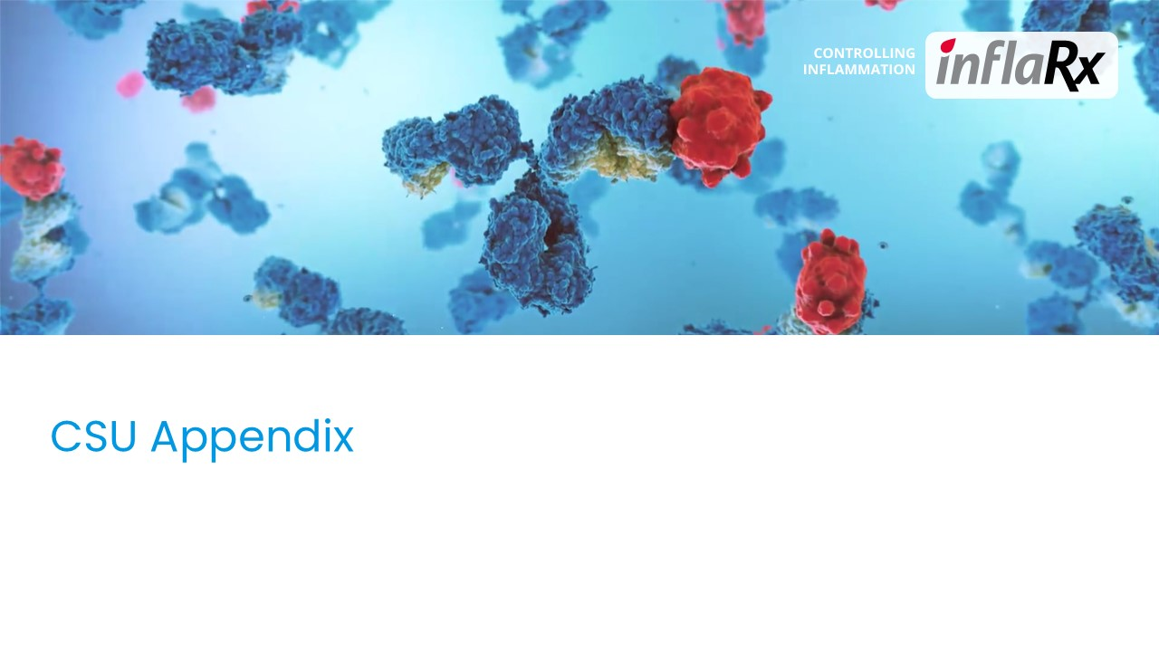
CSU Appendix

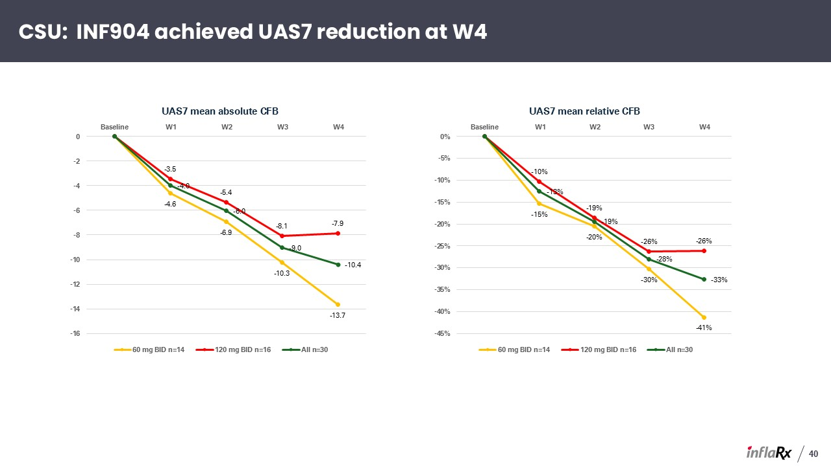
CSU: INF904 achieved UAS7 reduction at W4 40

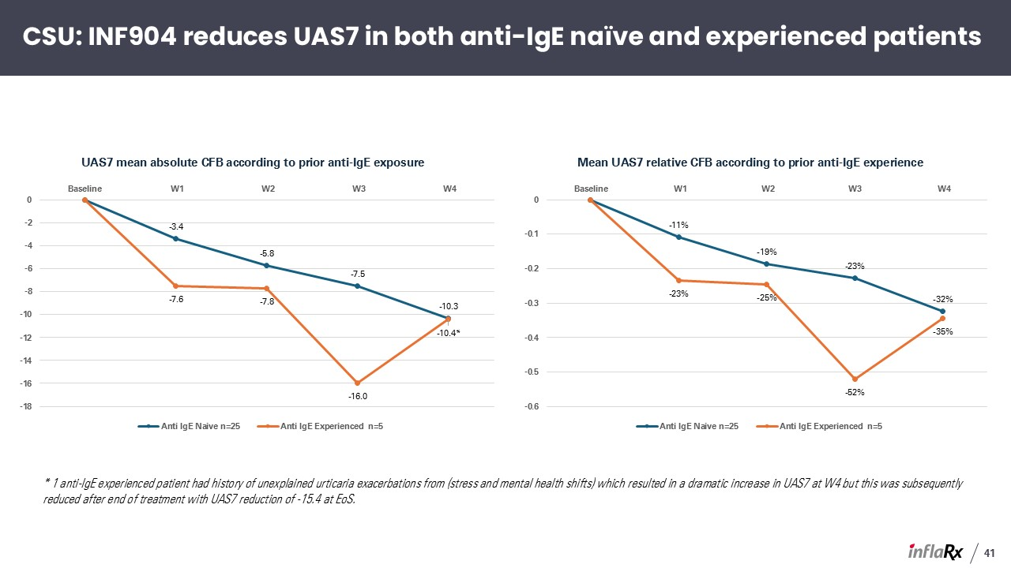
41 CSU: INF904 reduces UAS7 in both anti-IgE naïve and experienced patients * 1 anti-IgE experienced patient had history of unexplained urticaria exacerbations from (stress and mental health shifts) which resulted in a dramatic increase in UAS7 at W4 but this was subsequently reduced after end of treatment with UAS7 reduction of -15.4 at EoS.

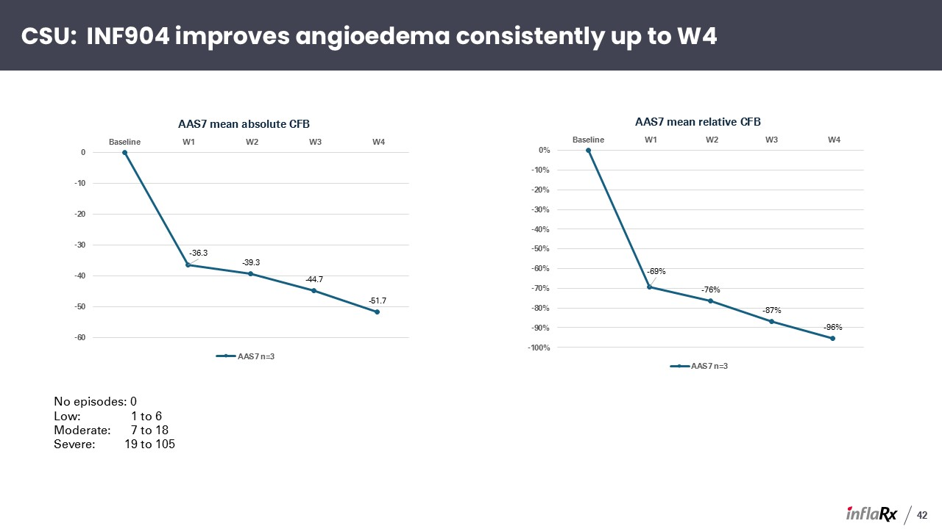
No episodes: 0 Low: 1 to 6 Moderate: 7 to 18 Severe: 19 to 105 42 CSU: INF904 improves angioedema consistently up to W4

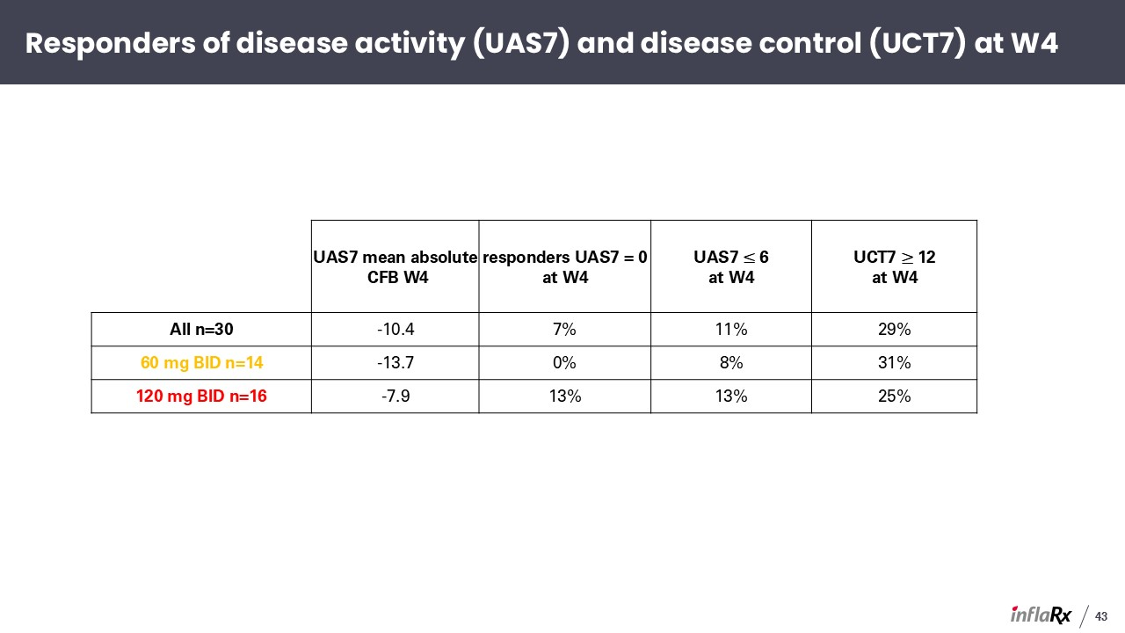
Responders of disease activity (UAS7) and disease control (UCT7) at W4 43 UAS7 mean absolute CFB W4 responders UAS7 = 0 at W4 UAS7 ≤ 6 at W4 UCT7 ≥ 12 at W4 All n=30 -10.4 7% 11% 29% 60 mg BID n=14 -13.7 0% 8% 31% 120 mg BID n=16 -7.9 13% 13% 25%

